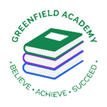
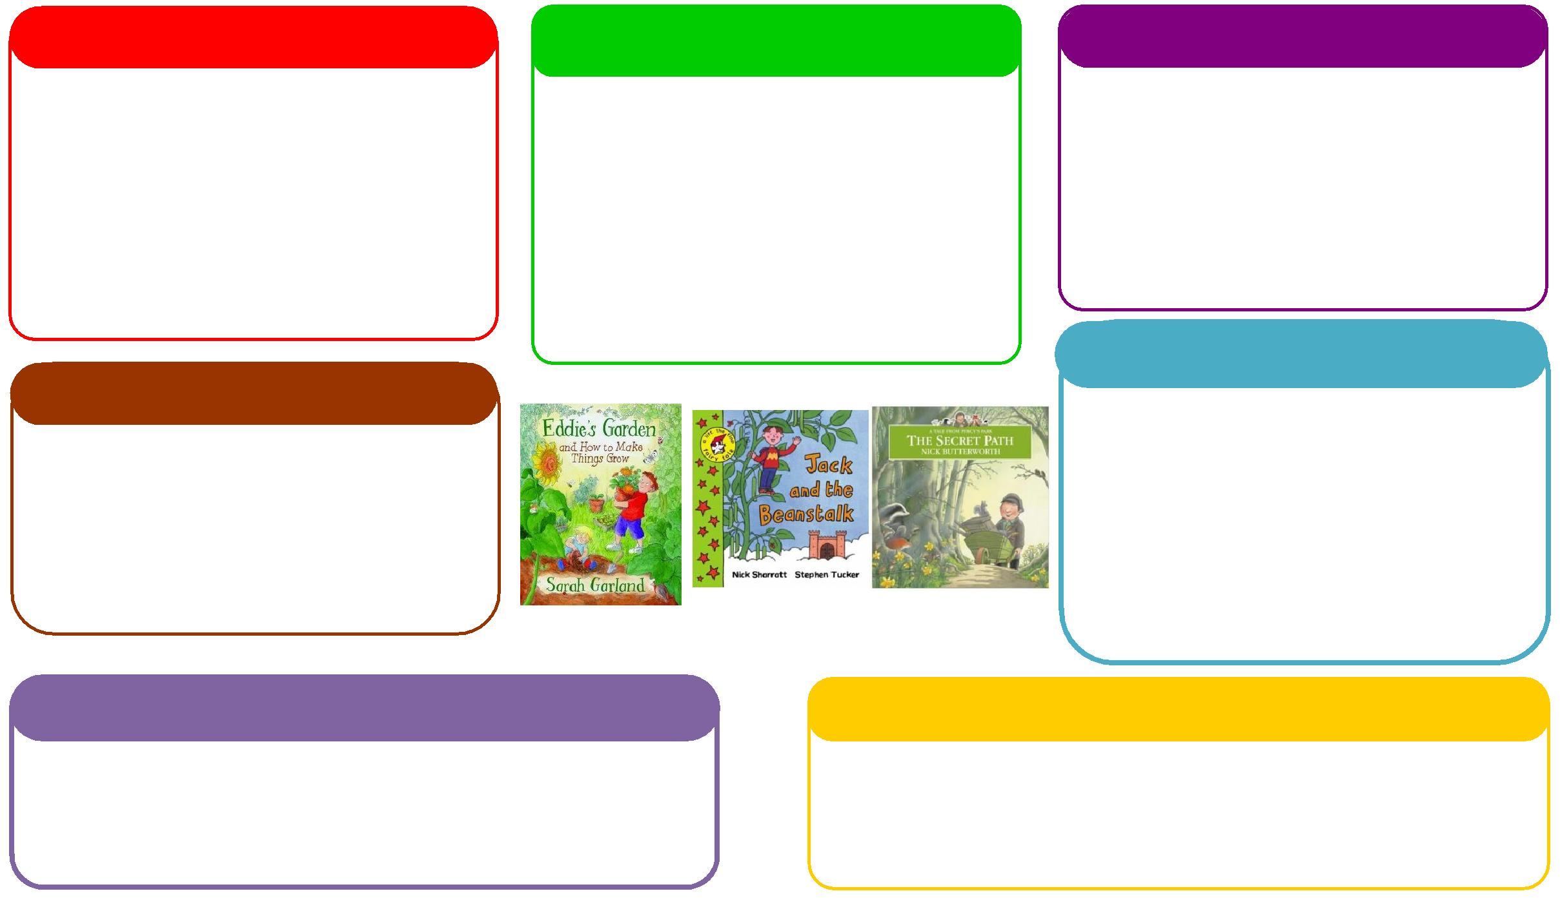
This half term we will be:

- Exploring our different senses,
- Looking at seasonal changes,
- Looking at our local area which will lead onto map work,
- Showing baby photos of ourselves and discussing changes over time.

Expressive Arts and Design
Personal, Social and Emotional Development
Understanding the World
Physical
Mathematics
Communication and Language
English
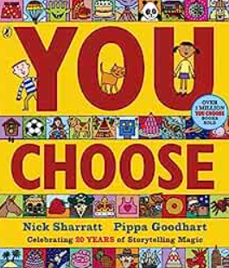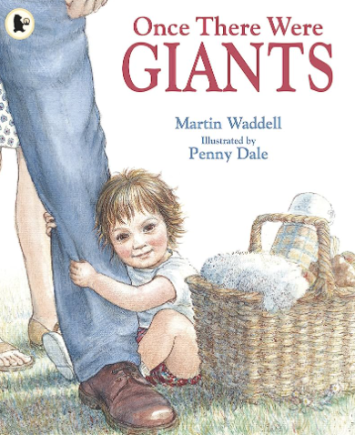
This half term we will be:

- Counting different amounts of children in the class,
- Singing lots of number songs
- Counting candles in playdough cakes
- Exploring a variety of autumnal objects and sorting them in different ways,
- Going on a shape walk

This half term we will be:

- Looking at baby photos of ourselves and discussing how we have changed,
- Talking about similarities and differences between people in the class,
- Talking about our families
- Going on an autumn walk and discussing what we can see.

Learning Letter Autumn 1 EYFS
Me and My Family
This half term we will be:
- Painting self-portraits,
- Making music with our bodies,

- Junk modelling buildings from our local area.

This half term we will be:
- Learning the rules and routines of the classroom,
- Sharing our feelings during 'It's Good To Be Me' time,

- Working together to solve problems.

This half term we will be:

- Singing songs and rhymes,

- Labelling different parts of our body,

- Reading lots of books,
- Writing our names,
- Writing down the initial sound in words,
- Reading and writing cvc words.

This half term we will be:

- Practising our letter formation,

- Learning how to use the outdoor area safely,
- Learning how to keep our bodies healthy,
- Focusing on fine motor skills when combining materials during junk modelling.

EYFS Weekly Home Learning Tasks

READING
Please share your child’s reading book with them, as 10-15 minutes of reading every day at home can make a lot of difference to your child's reading ability.
Your child MUST bring their book bag into school every day so an adult can read with them on their reading day, and any extra days if there is an opportunity.
MATHS
Whilst you’re out and about have a look what numbers you can see around you. Can you see numbers on lampposts and cars? Can you see numbers on shop windows, pavements or houses? There are numbers everywhere! Talk to your grownup about the numbers you can see.
Go on a nature walk to your nearest park or open green area. What natural objects can you find? Can you describe their shape? Group the curved objects and the straight objects.

EYFS Half Term Learning Project

Create a face using different materials and bring it in to show the class. What might you use for the nose? Would grass make good hair? We can’t wait to see your creation!

