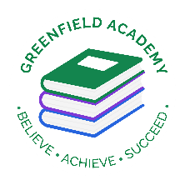
Greenfield Primary Academy
Year 4
Summer Term 1 Learning Letter 2024
In Maths we are learning about…
Place value: We will be continuing to use place value with 4 digit numbers and we will also be learning Roman Numerals
Addition and Subtraction: We will continue to use formal calculations to add and subtract larger numbers.
Fractions: We will be adding and subtracting fractions
Position and Direction; Describe position on a 2D grid
Time: Read, write and converting time between analogue and digital
Tables and line graphs: We will interpret and present discrete and continuous data.
Memorise times tables. The children will be having a formal assessment of their times tables VERY SOON, and will need to know both the multiplication and division facts for all tables up to 12. Children need to use TTRockstars daily at home, and we will have an assessment in school each week.

In English we are learning to …
Write in different ways: We will learn about reading and writing myths and legends. We will use the story Romulus and Remus’ for this. We will also use @The Roman Soldier Handbook to find out and write reports on Roman soldiers and we will be writing instructions. We will also study the epic poem ‘Beowulf’
Read more fluently: this term we will continue comprehension lessons three times a week. We will be learning to answer literal, deductive and inference questions. Your child has a reading book and will also have access to MyOn – our online reading program. We try to read with them at least once a week.
Understand Grammar: We will consolidate our knowledge of prepositions, and will start to look at using brackets to add extra detail to sentences. We will look at the Present Perfect form of verbs (for things that have started and are still going on – she has lived in Liverpool for five years.
Comparative and superlative
Determiners- a, an, the

off
In RE we are learning about…..
What can we learn from religions about deciding what is right and wrong? We will:

Give examples of rules for living from religions and suggest ways in which they might help believers with difficult decisions.
Make connections between stories of temptation and why people can find it difficult to be good.
Give examples of ways in which some inspirational people have been guided by their religion. Discuss their own and others’ ideas about how people decide right and wrong.
In Design Technology we are learning to …

• Design a project that is strong and aesthetically pleasing
• Make a product using suitable materials that meets the design brief
• Look at our work and improve on our designs as we make it.
• Evaluate whether our work has met the design brief and talk about how we can improve next time.

We will be making Roman dolls and developing our sewing skills.
Our Learning Theme is …

Invaders and Settlers

Teeth and Digestion

In Science we are learning that …
- To identify and describe the functions of teeth
- To learn how to look after teeth and why it is important
- To know that some food damages teeth and should be avoided or limited
- To name the main parts of the digestive system
- To identify the function of these parts
- To carry out scientific experiments

In History we are learning to …
- Place some historical periods in a chronological (time) order
- Use historic terms related to the period of study.
- Use sources of information in ways that go beyond simple observations to answer questions about the past.
- Use a variety of sources to find out about aspects of life in the past.
- Communicate learning in an organised and structured way, using appropriate terminology.
- Describe a study of Anglo-Saxon life and achievements and their influence on Britain.

In RHE/ PSHE we are learning about … Health and Well Being.
In Year 4, the children will look at how their body has or will begin to change soon and the different emotions that may come along with this. As they look at changes while they grow, they will also look at the importance of good quality sleep for good health and re-visit dental health and why they should continue with regular brushing, flossing and visits to the dentist especially as they lose their teeth and get their final set that will have to last all their adult life.

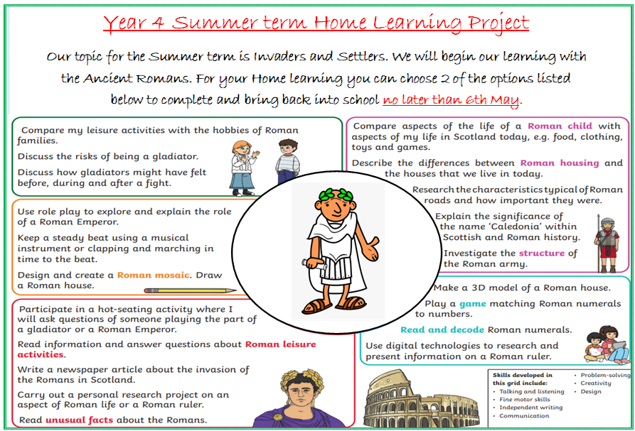
READING
Please share your child’s reading book with them, as 10-15 minutes of reading every day at home can make a lot of difference to your child's reading ability.
Your child MUST bring their book bag into school every day so an adult can read with them on their reading day, and any extra days if there is an opportunity.
Each child will have a reading book, and an extra book from the class library.
Every child will have an online Myon account where they can read books and answer questions. This is in addition to their daily reading book task.
MATHS
Every child has a TTRockstars and Sumdog account. They can use these to practise their times tables facts online. 10 minutes every day will mean that they are ready for their times tables test next term.

Our Home Learning Project fits in with Our topic for the Summer term, which is Invaders and Settlers. We will begin our learning with the Ancient Romans. For your Home learning you can choose 2 of the options listed on the sheet to complete and bring back into school no later than 6th May.

Year 4 Half Term Home Learning Project
Year 4 Weekly Home Learning Tasks

