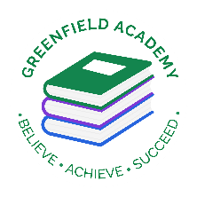
Greenfield Primary Academy
Year 5
Summer 2 Term Learning Letter 2023
In English we are studying, Twelfth Night, The Moth and Spiderwick Chronicles. Our focus will be:
- Playscripts
- Story boards
- Non-chronological report
- Creature description
- Explanation text.

In Math we are studying:
- Angles – acute, obtuse, reflex,
- Right angles, angles in a straight line
- Triangles
- Quadrilateral
- Statistics

In RE we are studying: Green religion? How and why should religious communities do more to care for the Earth?
- Does Earth belong to God?
- Muslims and environment.
- Christians and environment
- Hindus and environment
- Jewish and environment

In D.T we will learn how to make moving toys.
- Toys with cam mechanisms
- Different types of cams
- Design a toy with cam mechanism
- Make cam mechanism toys.

Our Learning Theme is
The Victorians
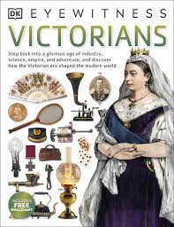

In Science we are studying Living things.
- Differences in life cycles
- Explore Jane Goodall and her work with Chimpanzees
- Create own animal and write a non-chronological report including life cycle.
In History we are studying The Victorians.
- Explore Banardo
- How attitudes to children changed over time.
- Victorian time inventions
- Greatest impact from Victorian time.
- Impact of Victorian period on present day.

In RHE/ PSHE out theme is Health and Well-being. We will be studying how we change and grow.
- What makes up health. . Know where to seek help for health
- Physical illness . Recognise change in bodies
- Effects of lack of sleep . Understand emotional changes

In Year 5 there is a certain expectation when it comes to Home Learning. Please see this outlined below:
Individual Reading Books
All children must read a few pages each night at home and write a comment in their reading diary.
MyOn
Children are expected to complete MyOn reading everyday with books of their choice online.
TT Rockstars
Children will be set 25mins (5 mins daily) of TTRockstars to practise their times tables.
SumDog
Children will be set a task on SumDog where they have 50 questions to answer based on their learning in class that week.
Spellings
Children will have spelling practise to complete based on those words they found tricky in the lesson that week and a spelling quiz on Purple Mash.
Home Learning is set on a Friday and is expected to be completed by Tuesday morning.

No half term project.
We would like children to spend time practicing their lines for the performance of Shakespeare’s Twelfth Night which will take place at the Middleton Arena on the 19th July at 6pm.
Ticket information will be coming soon.
Year 5 Half Term Learning Project
Year 5 Weekly Home Learning Tasks

