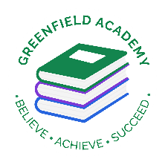
Greenfield Primary Academy
Year 5
Spring 2 Term Learning Letter 2022
In Math we are studying Fractions.
- Equivalent fractions
- Improper and mixed fractions
- Comparing and ordering fractions
- Number sequences
- Adding and subtracting fractions
- Fractions of amounts.

In English we are studying Shakespeare’s Twelfth Night
Our writing focuses will be:
- Diary entries
- Setting descriptions
- Retelling a story
- Love poems/speech

Our Learning Theme is …
France
Rivers


In RE we are studying: What would Jesus do? Can we live by the values of Jesus in the 21st Century?
- Mission Statement
- How Jesus taught love
- Forgiveness
- Justice and Fairness.

In Art we are studying Landscapes.
- Comparing artists
- Looking at perspectives.
- Recreating images.
- Design/paint own landscape

In Science we are studying properties and material.
- Comparing materials
- Thermal conductors and insulators
- Electrical conductors

In Geography we are studying Rivers.
- Water Cycle
- Where does water come from?
- River System
- How rivers change shape and why?
- Why we use rivers
- Comparing rivers.

In RHE/ PSHE we are studying the effects of drugs, alcohol and Tobacco.
- Understand drugs and the effects.
- Effects of smoking
- Effects of Alcohol

In Year 5 there is a certain expectation when it comes to Home Learning. Please see this outlined below:
Individual Reading Books
All children must read a few pages each night at home and write a comment in their reading diary.
MyOn
Children are expected to complete MyOn reading everyday with books of their choice online.
TT Rockstars
Children will be set 25mins (5 mins daily) of TTRockstars to practise their times tables.
SumDog
Children will be set a task on SumDog where they have 50 questions to answer based on their learning in class that week.
Spellings
Children will have spelling practise to complete based on those words they found tricky in the lesson that week and a spelling quiz on Purple Mash.
Home Learning is set on a Friday and is expected to be completed by Tuesday morning.

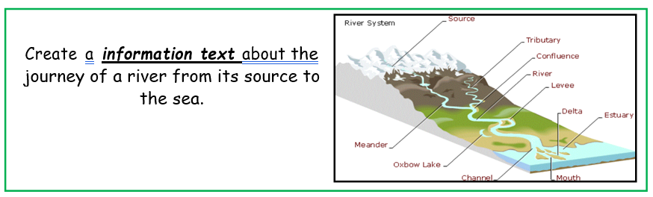
Year 5 Half Term Learning Project
Year 5 Weekly Home Learning Tasks

