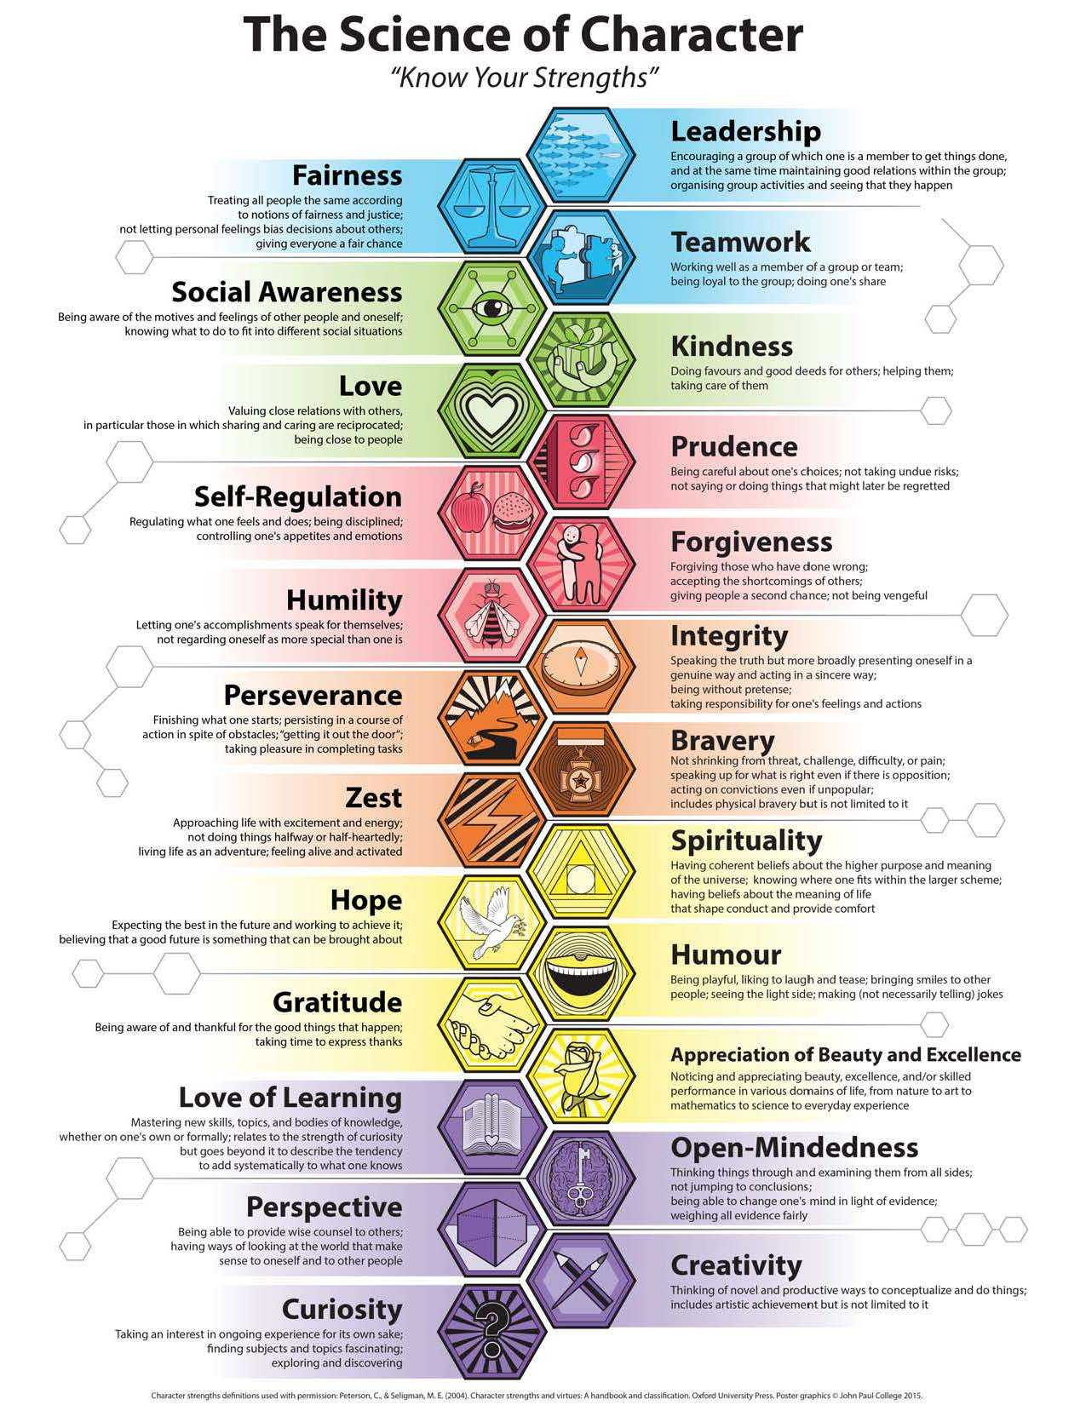
engths
Strengths of Self
Community Strengths
Strengths of Others
Head Strengths
Wisdom
Spiritual Strengths
Transcendence
Courage
Humanity
Temperance
Justice
Heart Strengths

