
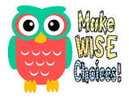
Behaviour Booklet

MAKING OUR EXPECTATIONS OF BEHAVIOUR CLEAR TO ALL
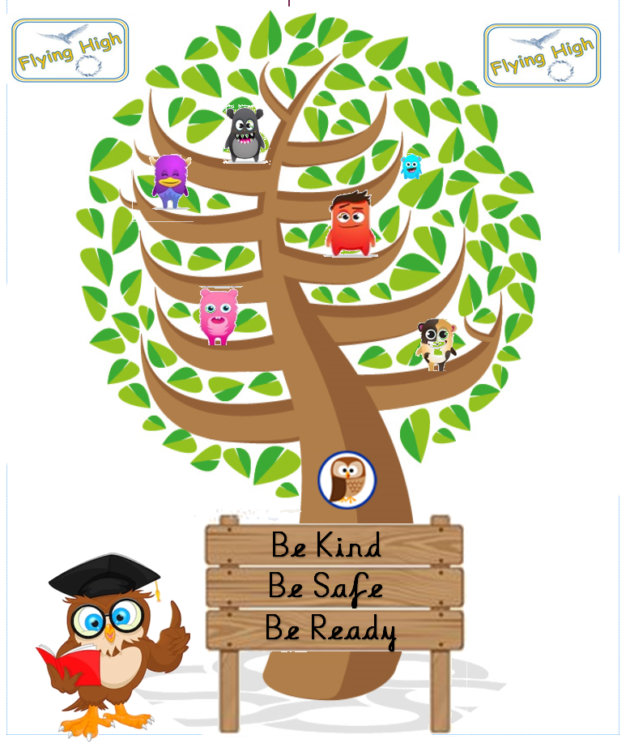

In conjunction with the Behaviour policy and the School Behaviour management policy, please find attached the expected behaviour that all staff, children and visitors must adhere to at all times.


When children make wise choices and do all these things, Carlyle staff will-
- give lots of positive praise, smiles and thumbs up
- give stickers
- give DOJO points which will lead to individual prizes each week and great team prizes each half term
- tell your family when they see them and send a postcard home to tell everyone how super your behaviour is.
- Choose children to have ‘Afternoon Tea’ with the Deputy Head and Headteacher – with cake!
- Choose children for The Pledge Celebration Event

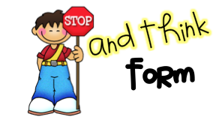

If children don’t make wise choices and do not do all the things we expect, Carlyle staff might need to-
- Speak to you about your poor choices and explain better choices
- Talk to you about what you should have done differently
- Give you time to think – REFLECT- about your behaviour choices and how to improve them, this might be in a different class
- Make you miss your play or lunch outside time
- Talk to your parents about your poor choices & behaviour
- Talk to the Deputy Headteacher or Headteacher about your behaviour
Dining Hall
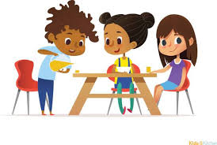

In the DINING HALL we expect children to:-
- walk in quietly, in single file
- go around the tables to line up quietly
- say please and thank you to adults
- stay seated
- tuck your chair in
- not drop food on the floor
- use knives, forks and spoons

Adults will:-
Swop around the order of classes to make it fair
Help you cut up your food
Say ‘well done’ and give stickers sometimes for clean plates

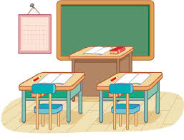
Classrooms

In the CLASSROOMS we expect children to:-
- sit on their bottom
- use kind hands and words
- put their hand up to speak to adults
- have equipment ready
- show good listening
- use the right noise/voice level

Adults will:-
Reward you with Dojo points
Thank you for your behaviour
Provide opportunities for you learn effectively
Respect your property


Around School

In the CORRIDORS & AROUND SCHOOL we expect children to:-
- walk sensibly in single file
- keep hands out of pockets
- walk on the left
- use quiet voices

Adults will:-

Set the example and show you how to move around school
Praise you for following the rules
Give Dojos to children who follow the rules

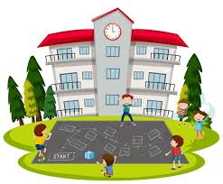
Playground

In the PLAYGROUND/OUTSIDE we expect children to:-
- not play fight
- use equipment respectfully
- put litter in the bins
- stop and stand still for the first whistle then tidy equipment away
- stop again for the second whistle and wait to be told to walk to your line – in silence.
- stand in your line in silence until told to walk in
- walk in single file - Class 7 & 8 to use outside classroom doors
Adults will:-
Organise and play with you
Help you resolve any issues with your friends
Watch you walk in from playtime from the classroom door (Class 7 & 8 to use outside classroom doors)
Collect you from lunch play (Class 7 & 8 to use outside classroom doors)
Make sure class 7 and 8 doors are unlocked at end of play and lunchtime

