Area of Learning: Plants and growth | KS1: Year 2 | Biology
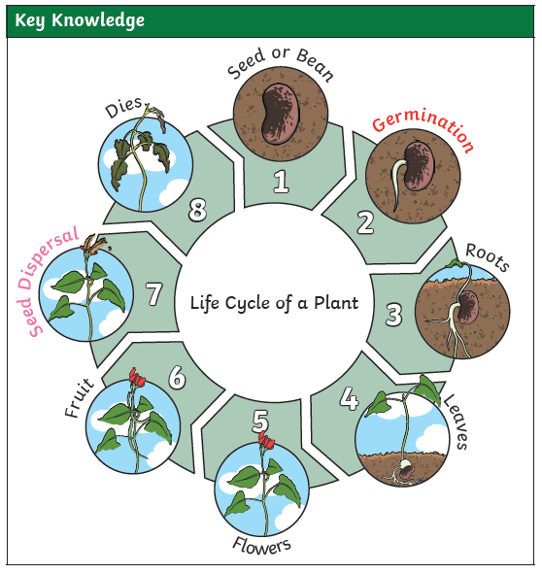
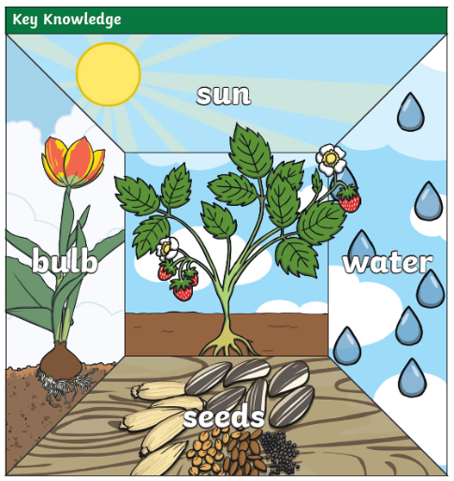
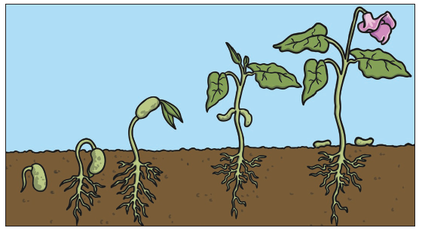

What I already know:
Year 1
Identify and name a variety of common wild and garden plants, including deciduous and evergreen trees (Name plants in our school grounds. Name trees in our school grounds).
Identify and describe the basic structure of a variety of common flowering plants, including trees (at least: flower, leaf, root, stem, trunk, seed, branch and petal).
Vocabulary
germination | When the conditions are right the seed absorbs the water and swells and the tiny new plant burst out of its shell. This is called germination.
seeds | Seeds are made by a plant so that new plants can grow. Each seed has the potential to grow into a new plant.
shoot | A shoot grows upwards from the seed or plant to find sunlight.
root | The part of a plant that goes underground and moves water and nourishment from the soil to the plant.
bulbs | A bulb is an underground bud or stem of a plant that allows it to rest and wait for good growing conditions.
sunlight | All plants need light from the sun to grow well. Some plants need lots of sunlight. Some plants only need a little sunlight.
water | All plants need water to grow. Without water, seeds and bulbs will not germinate.
temperature | Temperature is how warm or cold something or somewhere is. Some plants like cooler temperatures and some plants like warmer temperatures.
nutrition | Food or nourishment. Plants make their own food in their leaves using sunlight.

Knowledge that you will learn:
To be able to identify and name a variety of plants
To observe and describe how seeds and bulbs grow into mature plants
To find out and describe how plants need water, light and a suitable temperature to grow and stay healthy (and how changing these affects the plant)
To know that plants are living and eventually die.
Working Scientifically Skills:
Enquiry Type - Plants – Light and Dark – Comparative Test
Gather, record and classify
Enquiry Type - Bulbs and Seeds – Observation Over Time
Make observations
Gather, record and classify
Ask questions
Take measurements

