Area of Learning: Habitats and microhabitats | KS1: Year 2 | Biology
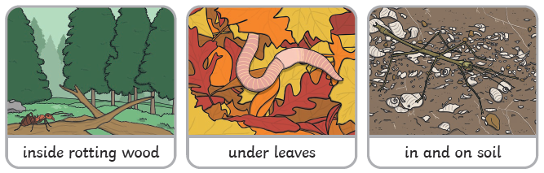
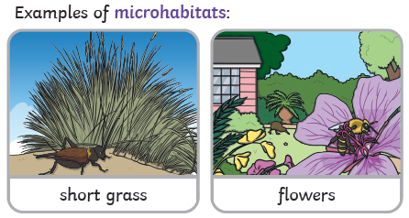
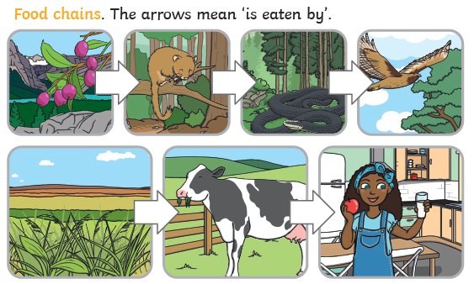
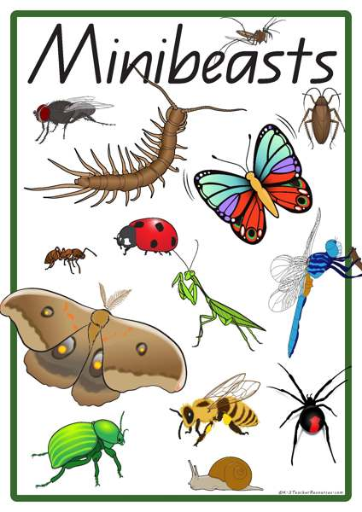

What I already know:
Prior Learning:
Year 2
I know the differences between things that are living, dead, and things that have never been alive.
I know that most living things live in habitats to which they are suited and describe how different habitats provide for the basic needs of different kinds of animals and plants, and how they depend on each other.
Year 1
I know that humans are animals.
I can compare and describe differences in my own features (eye, hair, skin colour, etc.).
I know that humans have many similarities.
I can identify, name, draw and label the basic parts of the human body and say which part of the body is associated with each sense.
I can identify and name a variety of common animals including some fish, some amphibians, some reptiles, some birds and some mammals.
I can identify and name a variety of common animals that are carnivores, herbivores and omnivores (i.e. according to what they eat).

Vocabulary
life processes | These are things that all living things do. They move, breathe, sense, grow, make babies, get rid of waste and get their energy from food.
habitat | The natural home of an animal or plant.
food chain | A food chain shows how each animal gets its food. Food chains are one of the ways that living things depend on each other to stay alive.
food source | This is the place that a living thing’s food comes from.
microhabitat | A small habitat in places like under a rock, under leaves or on a branch. Minibeasts live in microhabitats. The microhabitats have everything that they need to survive.
depend | Many things in a habitat depend on each other. This means that they need each other for different things.
survive | This means to stay alive.
minibeast | A small invertebrate animal such as an insect or a spider.

Knowledge that you will learn:
Know that living things live in different habitats.
Know that they are suited to their habitat.
Know that animals depend on each other and plants.
Know some microhabitats (under leaves, in soil, rotting wood) and some of the creatures that can be found there (woodlice, spiders, worms)
Know whether something is alive, dead or never been alive and why.
Working Scientifically Skills:
- Gather, record and classify
- Answer questions and make conclusions
- Make observations

