Area of Learning: Habitats | KS1: Year 2 | Biology
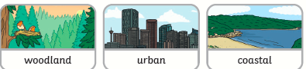
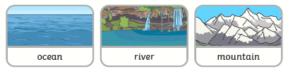
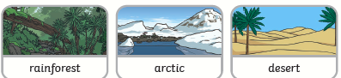

What I already know:
Prior Learning:
Year 1
I can name some fish like goldfish, tuna, shark and eel. I can name some amphibians like a frog, toad, newt and salamander. I can name some reptiles like a snake, tortoise, lizard and alligator). I can name some birds like penguin, chicken, seagull and robin). I can name some mammals like human, mouse, dog and cow.
I know that carnivores eat meat, herbivores eat plants and omnivores eat both.
Group together animals according to their different features.
I can recognise similarities between animals and group them according to their features.
I can describe and compare different common animals such as fish, amphibians, reptiles, birds and mammals.

Vocabulary
life processes | These are things that all living things do. They move, breathe, sense, grow, make babies, get rid of waste and get their energy from food.
living | A plant or animal that is alive.
dead | Something that has been alive but isn’t anymore.
grow | Living things develop by increasing in size and changing physically.
feed | Take in food
offspring | Young of a plant or animal.
habitat | The natural home of an animal or plant.
food chain | A food chain shows how each animal gets its food. Food chains are one of the ways that living things depend on each other to stay alive.
food source | This is the place that a living thing’s food comes from.
carnivore | An animal that eats other animals is a carnivore.
herbivore | An animal that eats plants is a herbivore.
omnivore | An animal that eats both plants and animals is an omnivore.

Knowledge that you will learn:
Know that living things live in different habitats such as woodland, urban, coastal, rainforest, arctic, desert, ocean, river and mountain.
Know that they are suited to their habitat such as whales have blubber to survive in cold water.

Working Scientifically Skills:
- Gather, record and classify
- Answer questions and make conclusions
- Make observations

