Area of Learning: Plants and growth | KS1: Year 2 | Biology
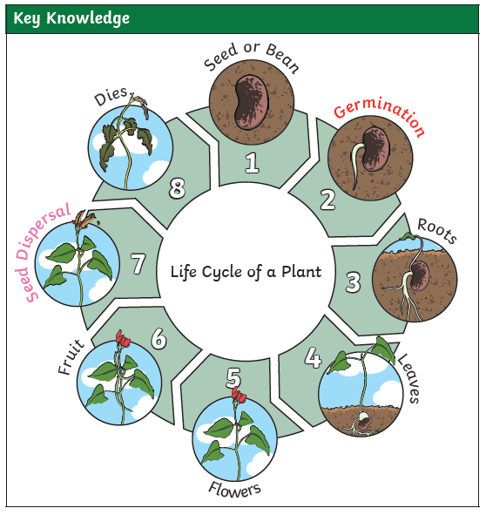
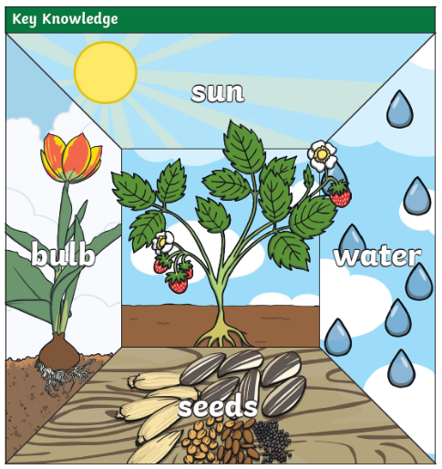
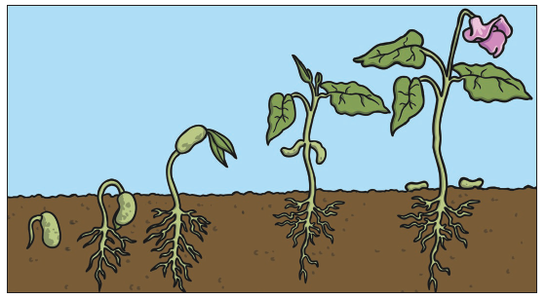

What I should already know:
Year 1
Identify and name a variety of common wild and garden plants, including deciduous and evergreen trees (Name plants in our school grounds. Name trees in our school grounds).
Identify and describe the basic structure of a variety of common flowering plants, including trees (at least: flower, leaf, root, stem, trunk, seed, branch and petal).

Knowledge that you will learn:
Know that plants need enough water, enough light and a suitable temperature to grow.
Know that plants are living and eventually die.
Learn which conditions produce the best growth in different plants.

Working Scientifically Skills:
Make observations
Ask questions
Take measurements
Gather, record and classify

Vocabulary
enough | When you have just the right amount of something. Not too much and not too little of something.
germination | When the conditions are right the seed soaks up the water and swells and the tiny new plant burst out of its shell. This is called germination.
sprout | When a plant sprouts, it grows new shoots.
shoot | A shoot grows upwards from the seed or plant to find sunlight.
root | The part of a plant that goes underground and moves water and nourishment from the soil to the plant.
sunlight | All plants need light from the sun to grow well. Some plants need lots of sunlight. Some plants only need a little sunlight.
water | All plants need water to grow. Without water, seeds and bulbs will not germinate.
temperature | Temperature is how warm or cold something or somewhere is. Some plants like cooler temperatures and some plants like warmer temperatures.
nutrition | Food or nourishment. Plants make their own food in their leaves using sunlight.

