Area of Learning: Everyday Materials | KS1: Year 2 | Physics
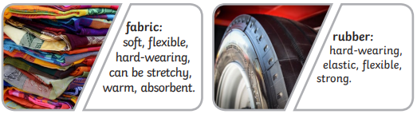
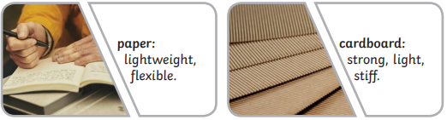
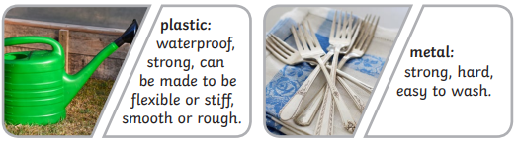
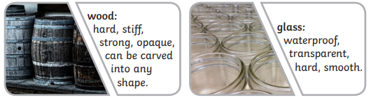

What I should already know:
Year 1
Distinguish between an object and the material from which it is made.
Identify and name a variety of everyday materials, including wood, plastic, glass, metal, water, rock, brick, paper and cardboard.
Describe the simple physical properties of a variety of everyday materials.
Compare and group together a variety of everyday materials on the basis of their simple physical properties.

Vocabulary
materials | Materials are what objects are made from.
transparent | Allows light to pass through so that objects can be seen clearly.
translucent | Allows light but not detailed shapes to be seen clearly.
opaque | Not able to be seen through. Opposite of transparent.
Independent variable | The part of the experiment that will be changed.
Dependent variable | The part of the experiment that will be measured.
Controlled variable | The parts of the experiment that will be kept the same.
suitability | Suitability means having the properties which are right for a particular purpose.
properties | This is what a material is like and how it behaves (soft, hard, flexible or stiff).
Fair test | Changing only one part of the experiment and keeping all of the rest of the parts the same.
Knowledge that you will learn:
Identify and compare the suitability of a variety of everyday materials, including wood, metal, plastic, glass, brick, water, rock, paper and cardboard for particular uses.
Find out how the shapes of solid objects made from some materials can be changed by squashing, bending, twisting and stretching (applying a force)
Some materials can be found naturally; others have to be made.

You will work scientifically by:
Making observations
Identifying and classifying
Performing simple tests
Gather, record and classify
Make observations
Take measurements
Ask questions
Answer questions and make conclusions
