Reception | Outside Inside Autumn 1 |  |  |  |  |  |  |  |  | Knowing Yourself Autumn 2
Planning Sequence | 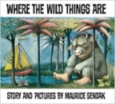  Where the Wild Things Are  Maurice Sendak |  |  | 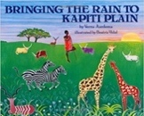  Bringing the Rain to Kapiti Plain  Verma Aardema |  |  | 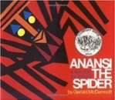  OR Anansi  Gerald McDermott |  |  | 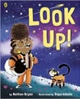  Look up!  Nathan Bryon and Dapo Adeola |  | 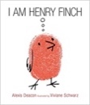  I am Henry Finch  Alexis Deacon |  | 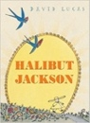  OR Halibut Jackson  David Lucas
Theme/Term | Talents & powers Spring 1 |  |  |  |  |  |  |  |  | Sowing a seed Spring 2
Planning Sequence | 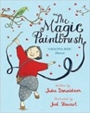  The Magic Paintbrush  Julia Donaldson and Joel Stewart |  |  | 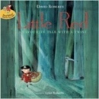  Little Red  Lynn Roberts and David Roberts |  |  | 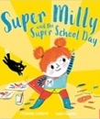  OR Super Milly and the Super School Day  Stephanie Clarkson |  |  | 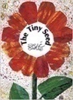  The Tiny Seed  Eric Carle |  | 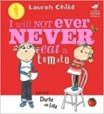  I Will Not Ever Never Eat a Tomato  Lauren Child |  | 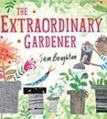  OR The Extraordinary Gardener  Sam Boughton
Theme/Term | Strength of mind Summer 1 |  |  |  |  |  |  |  |  | Family & friends Summer 2
Planning Sequence | 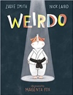  Weirdo  Zadie Smith and Nick Laird |  | 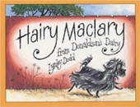  Hairy Maclary from Donaldson’s Dairy  Lynley Dodd |  |  |  |  | 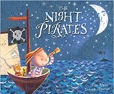  OR The Night Pirates  Pete Harris and Deborah Allwright |  | 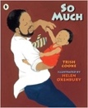  So Much  Trish Cooke and Helen Oxenbury |  | 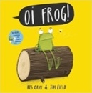  Oi! Frog  Kes Gray and Jim Field |  | 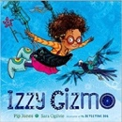  OR Izzy Gizmo  Pip Jones
Year 1 | Journeys & exploration Autumn 1 |  |  |  |  |  |  |  |  | Heroes & villains Autumn 2
Planning Sequence/  Spelling Seed Text | 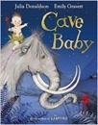  Cave Baby  Julia Donaldson and Emily Gravett | 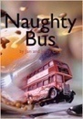  OR Naughty Bus  Jan Oke and Jerry Oke |  |  |  | 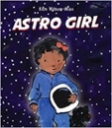  Astro Girl  Ken Wilson-Max |  |  | 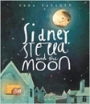  OR Sidney, Stella and the Moon  Emma Yarlett | 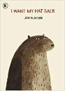  I Want My Hat Back  Jon Klassen |  | 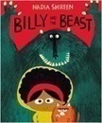  Billy and the Beast  Nadia Shireen |  | 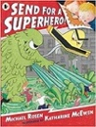  OR Send for a Superhero  Michael Rosen & Katharine McEwan
Theme/Term | Similarities & differences Spring 1 |  |  |  |  |  |  |  |  | Nature & environment Spring 2
Planning Sequence/  Spelling Seed Text | 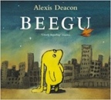  Beegu  Alexis Deacon |  |  | 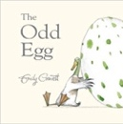  The Odd Egg  Emily Gravett |  |  | 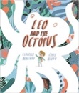  OR Leo and the Octopus  Isabelle Marinov |  |  | 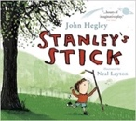  Stanley’s Stick  John Hegley and Neal Layton |  | 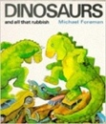  Dinosaurs and all that Rubbish  Michael Foreman |  | 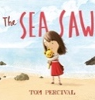  OR The Sea Saw  Tom Percival
Theme/Term | Friendship & kindness Summer 1 |  |  |  |  |  |  |  |  | Imagination & creativity Summer 2
Planning Sequence/  Spelling Seed Text | 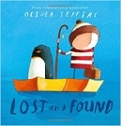  Lost and Found  Oliver Jeffers |  | 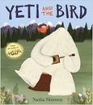  Yeti and the Bird  Nadia Shireen |  |  |  |  | 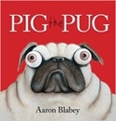  OR Pig the Pug  Aaron Blabey  How to be a Dog  Jo Williamson |  | 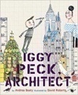  Iggy Peck, Architect  Andrea Beatty and David Roberts |  | 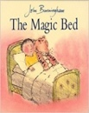  The Magic Bed  John Burningham |  | 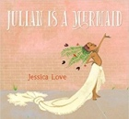  OR Julian is a Mermaid  Jessica Love
Year 2 | A twist in the tale Autumn 1 |  |  |  |  |  |  |  |  | Creation & conservation Autumn 2
Planning Sequence/  Spelling Seed Text | 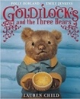  Goldilocks & the Three Bears  Lauren Child |  |  | 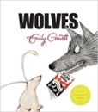  Wolves  Emily Gravett |  |  | 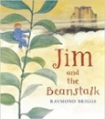  OR Jim and the Beanstalk  Raymond Briggs |  |  | 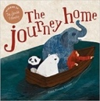  The Journey Home  Frann Preston-Gannon |  | 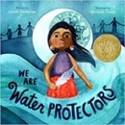  We Are Water Protectors  Carole Lindstrom |  | 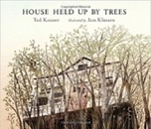  OR House Held Up By Trees  Ted Kooser
Literary Leaf Text | 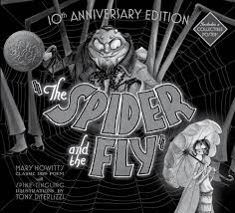  The Spider and the Fly  Mary Howitt and Tony DiTerlizzi |  |  |  |  | 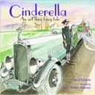  Cinderella An Art Deco Fairy Tale  Lynn Roberts and David Roberts |  |  |  | 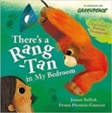  There’s a Rang-Tan in my Bedroom  James Sellick |  | 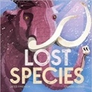  Lost Species  Jess French |  | 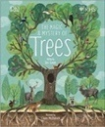  OR The Magic and Mystery of Trees  Jen Green
Theme/Term | Bravery vs. fear Spring 1 |  |  |  |  |  |  |  |  | Change & relationships Spring 2
Planning Sequence/  Spelling Seed Text | 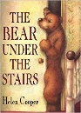  The Bear Under the Stairs  Helen Cooper |  |  | 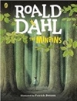  The Minpins  Roald Dahl |  |  | 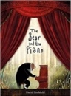  OR The Bear and the Piano  David Litchfield |  |  | 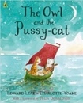  The Owl and the Pussy-cat  Edward Lear |  | 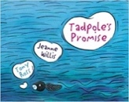  Tadpole’s Promise  Jeanne Willis |  | 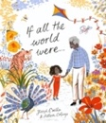  OR If All the World Were…  Joseph Coelho
Literary Leaf Text | 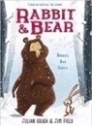  Rabbit and Bear by Julian Gough & Jim Field |  |  | 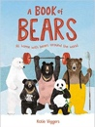  A Book of Bears  Katie Viggers |  |  | 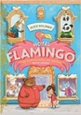  OR Hotel Flamingo  Alex Milway |  |  | 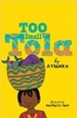  Too Small Tola  Atinuke |  |  | 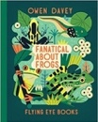  Fanatical about Frogs  Owen Davey
Theme/Term | Fictonal Worlds & fantasy Summer 1 |  |  |  |  |  |  |  |  | Urban metropolis Summer 2
Planning Sequence/  Spelling Seed Text | 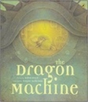  The Dragon Machine  Helen Ward |  | 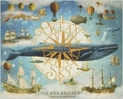  Ocean Meets Sky  Eric Fan and Terry Fan |  |  |  |  | 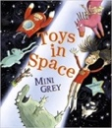  Or Toys in Space  Mini Grey |  | 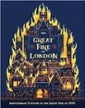  The Great Fire of London  Emma Adams |  | 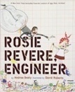  Rosie Revere, Engineer  Andrea Beatty |  | 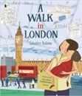  OR A Walk in London  Salvatore Rubbino
Literary Leaf Text | 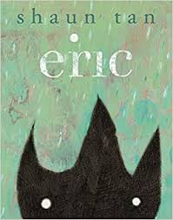  Eric  Shaun Tan |  |  |  | 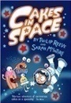  Cakes in Space  Philip Reeve |  |  |  |  | 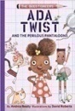  Ada Twist and the Perilous Pantaloons  Andrea Beaty |  |  | 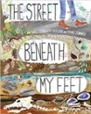  The Street Beneath my Feet  Charlotte Guillian
Year 3 | Magic & wonder Autumn 1 |  |  |  |  |  |  |  |  | Dreams & curiosity Autumn 2
Planning Sequence/  Spelling Seed Text | 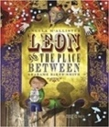  Leon and the Place Between  Angela McAllister |  | 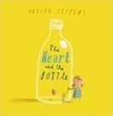  The Heart and the Bottle  Oliver Jeffers |  |  |  |  | 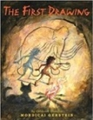  OR The First Drawing  Mordicai Gerstein |  | 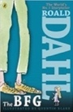  The BFG  Roald Dahl |  | 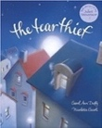  The Tear Thief  Carol Ann Duffy |  | 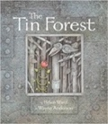  OR The Tin Forest  Helen Ward
Literary Leaf Text | 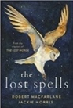  The Lost Spells  Robert MacFarlane |  |  |  | 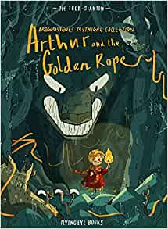  Arthur and the Golden Rope  Joe Todd Stanton |  |  |  |  | 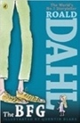  The BFG  Roald Dahl |  |  | 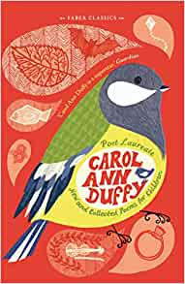  New and Collected Poems for Children  Carol Ann Duffy
Theme/Term | Disaster, hope & healing Spring 1 |  |  |  |  |  |  |  |  | Overcoming adversity Spring 2
Planning Sequence/  Spelling Seed Text | 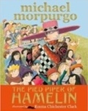  The Pied Piper of Hamelin  Michael Morpurgo |  |  | 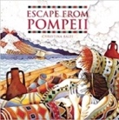  Escape from Pompeii  Christina Balit |  |  | 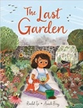  OR The Last Garden  Rachel Ip |  |  | 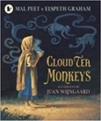  Cloud Tea Monkeys  Mal Peet | 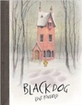  OR Black Dog  Levi Pinfold |  | 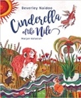  Cinderella of the Nile  Beverley Naidoo |  | 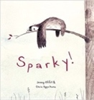  OR Sparly  Jenny Offil
Literary Leaf Text | 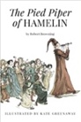  The Pied Piper of Hamelin  Robert Browning |  |  |  | 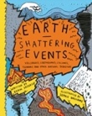  Earth Shattering Events  Robin Jacobs |  |  |  |  | 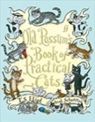  Old Possum’s Book of Practical Cats  T. S. Eliot |  |  | 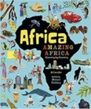  Africa, Amazing Africa  Atinuke
Theme/Term | From mystery to discovery Summer 1 |  |  |  |  |  |  |  |  | Confidence & caution Summer 2
Planning Sequence/  Spelling Seed Text | 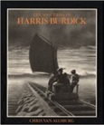  The Mysteries of Harris Burdick  Chris Van Allsberg |  | 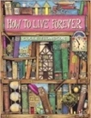  How to Live Forever  Colin Thompson |  |  |  |  | 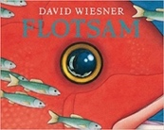  OR Flotsam  David Wiesner |  | 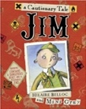  Jim, A Cautionary Tale  Hilaire Belloc |  | 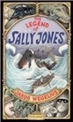  The Legend of Sally Jones  Jakob Wegelius |  | 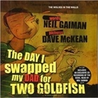  OR The Day I Swapped my Dad for Two Goldfish  Neil Gaiman
Literary Leaf Text | 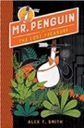  Mr Penguin and the Lost Treasure  Alex T. Smith |  |  |  | 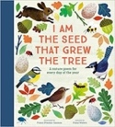  I am the Seed that Grew the Tree  Fiona Waters |  |  |  |  | 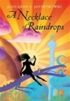  A Necklace of Raindrops  Joan Aiken |  |  | 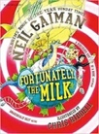  Fortunately, the Milk  Neil Gaiman
Year 4 | Finding Freedom Autumn 1 |  |  |  |  |  |  |  |  | Invention & innovation Autumn 2
Planning Sequence/  Spelling Seed Text | 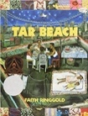  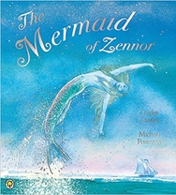  Tar Beach  Faith Ringgold |  | 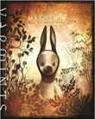  Varmints  Helen Ward |  |  |  |  | 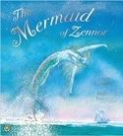  OR The Mermaid of Zennor  Charles Causley |  | 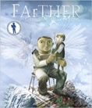  FArTHER  Grahame Baker Smith |  | 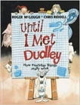  Until I Met Dudley  Roger McGough and Chris Riddell |  | 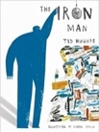  OR The Iron Man  Ted Hughes
Literary Leaf Text | 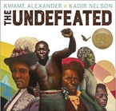  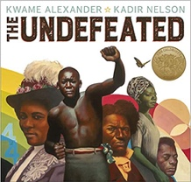  Undefeated  Kwame Alexander |  |  |  | 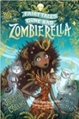  Zombierella  Joseph Coelho |  |  |  |  | 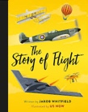  The Story of Flight  Jakob Whitfields |  |  | 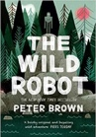  The Wild Robot  Peter Brown
Theme/Term | Darkness & light Spring 1 |  |  |  |  |  |  |  |  | Taking courage Spring 2
Planning Sequence/  Spelling Seed Text | 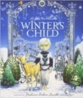  Winter’s Child  Angela McAllister |  |  | 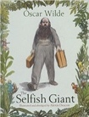  The Selfish Giant  Oscar Wilde |  |  | 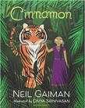  OR Cinnamon  Neil Gaiman |  |  | 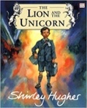  The Lion and the Unicorn  Shirley Hughes |  | 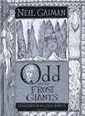  Odd and the Frost Giants  Neil Gaiman |  | 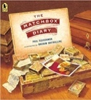  OR The Matchbox Diary  Paul Fleischman
Literary Leaf Text | 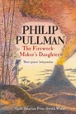  The Firework Maker's Daughter  Philip Pullman |  |  |  | 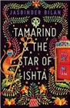  Tamarind and the Star of Ishta  Jasbinder Bilan |  |  |  |  | 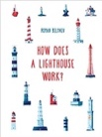  How Does a Lighthouse Work?  Roman Belyaev |  | 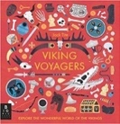  Viking Voyagers  Jack Tite |  | 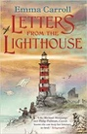  OR Letters from the Lighthouse  Emma Carroll
Theme/Term | Exploration & discovery Summer 1 |  |  |  |  |  |  |  |  | Different worlds Summer 2
Planning Sequence/  Spelling Seed Text | 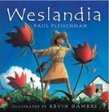  Weslandia  Paul Fleischman | 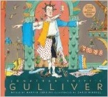  OR Jonathan Swift’s Gulliver  Martin Jenkins |  |  |  | 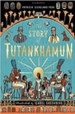  The Story of Tutankhamun  Patricia Cleveland-Peck |  |  | OR Shackleton’s Journey  William Grill  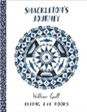 | 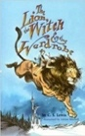  The Lion the Witch and the Wardrobe  C. S. Lewis |  | 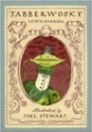  Jabberwocky  Lewis Carroll |  | 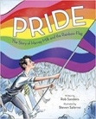  OR Pride: The Story of Harvey Milk and the Rainbow Flag  Rob Sanders
Literary Leaf Text | 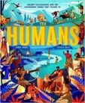  The Humans: Ancient civilisations  Jonny Marx |  |  |  |  | 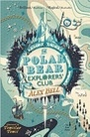  The Polar Bear Explorers' Club  Alex Bell |  |  |  | The Lion the Witch and the Wardrobe  C. S. Lewis |  |  | 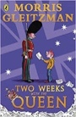  Two Weeks with the Queen  Morris Gleitzman

Year 5 | Ambition & desire Autumn 1 |  |  |  |  |  |  |  |  | Power vs. principles Autumn 2
Planning Sequence/  Spelling Seed Text | 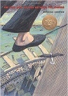  The Man Who Walked Between the Towers  Mordicai Gerstein |  | 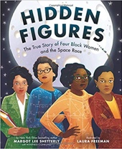  Hidden Figures  Margot Lee Shetterly  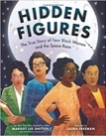 |  |  |  |  | 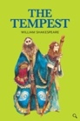  OR  The Tempest  William Shakespeare |  |   Robot Girl  Malorie Blackman |  | 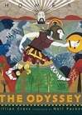  The Odyssey  Gillian Cross |  | 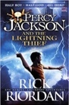  OR Percy Jackson  Rick Riordan
Literary Leaf Text | 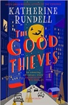  The Good Thieves  Katherine Rundell |  |  | 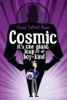  Cosmic Frank Cottrell Boyce |  |  | 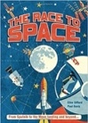  The Race for Space  Clive Gifford |  |  | 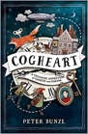  Cogheart  Peter Bunzl |  | 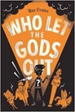  Who Let the Gods Out  Maz Evans |  | 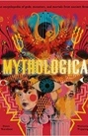  OR Mythologica  Dr. Stephen P. Kershaw
Theme/Term | Belonging & acceptance Spring 1 |  |  |  |  |  |  |  |  | Legends & folklore Spring 2
Planning Sequence/  Spelling Seed Text | 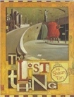  The Lost Thing  Shaun Tan |  |  | 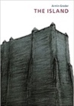  The Island  Armin Greder |  |  | 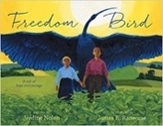  OR Freedom Bird  Jerdine Nolen |  |  | 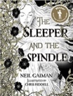  The Sleeper and the Spindle  Neil Gaiman and Chris Riddell |  | 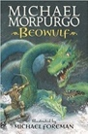  Beowulf  Michael Morpurgo |  | 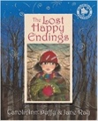  OR The Lost Happy Endings  Carol Ann Duffy
Literary Leaf Text | 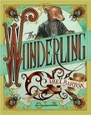  The Wonderling  Mira Bartok |  |  | 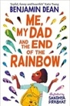  Me, My Dad and the End of the Rainbow  Benjamin Dean |  |  | 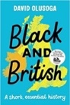  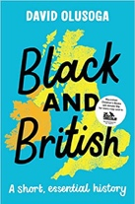  Black and British: A short, essential history  David Olusoga |  |  | 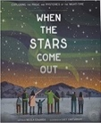  When the Stars Come Out  Nicola Edwards |  | 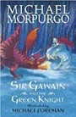  Sir Gawain and the Green Knight  Michael Morpurgo |  |   OR The Listeners  Walter de la Mare
Theme/Term | Lessons from history Summer 1 |  |  |  |  |  |  |  |  | Mystery & truth Summer 2
Planning Sequence/  Spelling Seed Text | 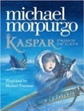  Kaspar, Prince of Cats  Michael Morpurgo | 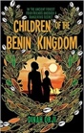  OR Children of the Benin Kingdom  Dina Orji |  |  |  | 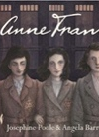  Anne Frank  Josephine Poole |  |  | 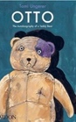  OR Otto, Autobiography of a Teddy-bear  Tomi Ungerer | 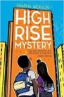  High Rise Mystery  Sharna Jackson | 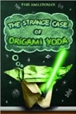  OR Origami Yoda  Tom Angleberger |  | 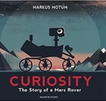  Curiosity  Markus Motum |  | 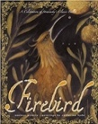  OR Firebird  Saviour Pirotta and Catherine Hyde
Literary Leaf Text | 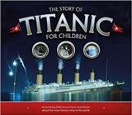  The Story of Titanic for Children Joe Fullman |  |  | 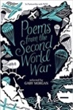  Poems from the Second World War  Gaby Morgan |  |  | 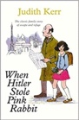  When Hitler Stole Pink Rabbit  Judith Kerr |  |  | 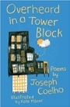  Overheard in a Tower Block  Joseph Coelho |  |  | 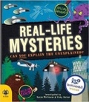  Real-life Mysteries: Can you explain the unexplained?  Susan Martineau and Vicky Barker
Year 6 | Migration & movement Autumn 1 |  |  |  |  |  |  |  |  | Evolution & inheritance Autumn 2
Planning Sequence/  Spelling Seed Text | 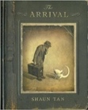  The Arrival  Shaun Tan |  | 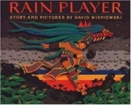  Rain Player  David Wisniewski |  |  |  |  | 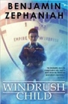  OR Windrush Child  Benjamin Zephaniah |  | 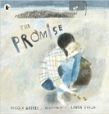  The Promise  Nicola Davies | 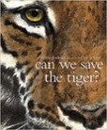  OR Can We Save the Tiger?  Martin Jenkins |  | 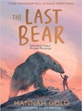  The Last Bear  Hannah Gold |  | 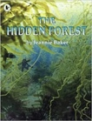  OR The Hidden Forest  Jeannie Baker
Literary Leaf Text | 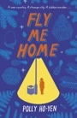  Fly Me Home  Polly Ho Yen |  |  |  | 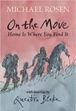  On the Move: Poems about Migration  Michael Rosen |  |  |  |  | 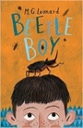  Beetle Boy  M. G. Leonard |  | 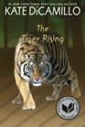  The Tiger Rising  Kate DiCamillo |  | 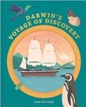  OR Darwin’s Voyage of Discover  Jake Williams
Theme/Term | Enterprise & activism Spring 1 |  |  |  |  |  |  |  |  | Utopia vs. dystopia Spring 2
Planning Sequence/  Spelling Seed Text | 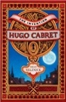  The Invention of Hugo Cabret  Brian Selznick |  |  | 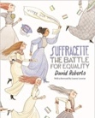  Suffragette: The Battle for Equality  David Roberts |  |  | 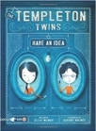  OR The Templeton Twins: Have an Idea  Ellis Weiner |  |  | 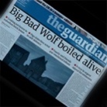  The Three Little Pigs Project  The Guardian |  | 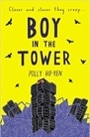  Boy in the Tower  Polly Ho-Yen |  | 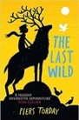  OR The Last Wild  Piers Torday
Literary Leaf Text | The Invention of Hugo Cabret  Brian Selznick |  |  |  | 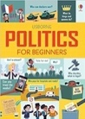  Politics for Beginners  Louie Stowell |  |  |  |  | 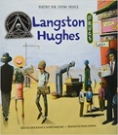  Poetry for Young People: Langston Hughes  Benny Andrews |  |  | 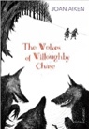  The Wolves of Willoughby Chase  Joan Aiken
Theme/Term | Fate vs. free will Summer 1 |  |  |  |  |  |  |  |  | Crossing borders Summer 2
Planning Sequence/  Spelling Seed Text | 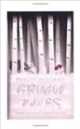  Grimm Tales for Young and Old  Phillip Pullman | 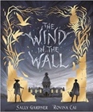  OR The Wind in the Wall  Sally Gardner |  |  |  | 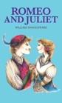  Romeo and Juliet  William Shakespeare |  |  | 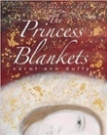  OR The Princess’ Blankets  Carol Ann Duffy | 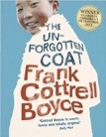  The Unfogotten Coat  Frank Cottrell Boyce | 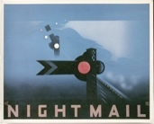  OR Night Mail  W H Auden |  | 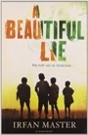  A Beautiful Lie  Irfan Master |  | 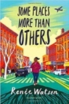  OR Some Places More Than Others  Renee Watson
Literary Leaf Text | Grimm Tales for Young and Old  Phillip Pullman |  |  |  |  | 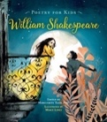  Poetry for Kids: William Shakespeare illustrated edition  William Shakespeare |  |  |  | 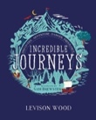  Incredible Journeys  Levison Wood |  | 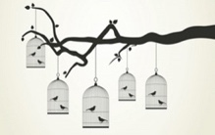  Caged Bird  Maya Angelou |  | 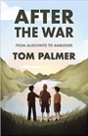  OR After the War: From Auschwitz to Ambleside  Tom Palmer

