Penwortham Primary School – Governor Details – Current Governors

Governor | Appointed by | Related to any school staff? | Relevant Business Interests | Governor of another educational establishment?
Miss Kate Penarski   | Governing Body |  | Headteacher
Mrs Pat Jones   | Governing Body Co-opted (01/09/2023) | - | CharLi Beauty –  Mother of owner
Mrs Jennifer Cunnigham   | Governing Body  Co-opted  (6.10.2025) |  | Deputy Headteacher
Miss Angela Flint   | Governing Body Co-opted (01/09/2023) | - | Channel Studios –Director  Drew Crawford Limited -Director  Member of staff | -
Mrs Rachel Duke  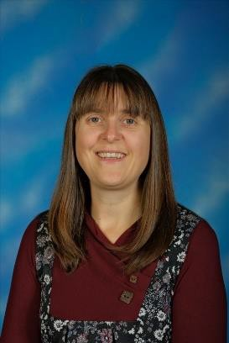 | Staff Governor (22/01/2025) |  | Member of staff

Mrs Mary McAulay   | Governing Body Co-opted (03/10/2023) | - | -
Mr Nigel Wright   | Elected by parents (From 17/10/2022 ) | - | - | -
Ms Jane Wilson   | Governing Body Co-opted  (from 14/11/23)
Mr Chris Day   | Parent Governor  3/12/25
Mrs Christina Davies   | Parent Governor 13/11/2022 |  | Fish 2 Photography - Owner
Mrs Marie Jones | LEA Governor (6.10.2025) |  | Purplempathy  Self Employed Psychotherapist | resignation date 2 February 2026
Mrs K Anderton | Co-Opted Governor (14.7.2025)

Mr Stewart Patterson   | Elected by parents 2/05/23 |  |  | Resigned 21.10.25 for Stewart
Mrs Zoe Kenealy   | Elected by Parents 11/10/2021 |  |  | Term of office ended 10.10.25 for Zoe

