
Penwortham Primary School
EYFS Long Term Plan 2025-2026
Key: Pre-School Reception All

 | Autumn 1 | Autumn 2 | Spring 1 | Spring 2 | Summer 1 | Summer 2
Potential | Ourselves | Let’s Celebrate | Wonderful world | Come Outside | Once upon a time | Under the Sea
Themes/ | Starting School | Harvest - Pumpkins | Winter | Life cycles | Traditional tales | Summer
Interests of children | Autumn / Halloween  Family People who help us | Christmas Around the  World Celebrations including | Arctic environments  Journeys / The world Chinese New Year | Outdoors  Gardening and flowers Spring | Jack and the  Beanstalk Garden Centers | Hot environments  Rock pools Mermaids / Pirates
 | Teddy bears | Diwali | Big School’s bird watch | Easter |  | Seaside
Possible | Class rules and routines | Diwali , Bonfire Night, | Valentine's Day, | World Book Day, Comic | International Museum | Father's Day , Sports
Celebrations & | Starting School, | Children in Need, | Lunar New Year / | Relief, Mother's Day, | Day, World Biscuit | Day,
Experiences | Halloween, Autumn,  Black History Month, | Remembrance Day,  Advent, Christmas, | Chinese New Year,  NSPCC Numbers day, | Pancake Day,  World Art Day, | Day,  World Food Safety | Transition,  Assessment
 | Fire service visit | Christmas Nativity | Safer Internet Day | Easter | day
Suggested Texts – Fiction and Non- Fiction | 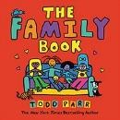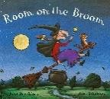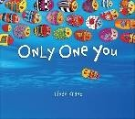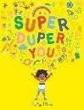 | 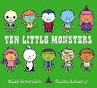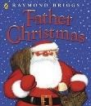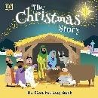 | 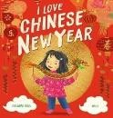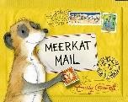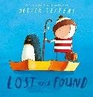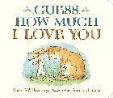 | 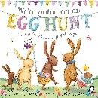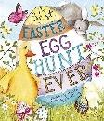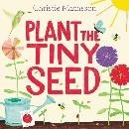 | 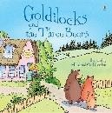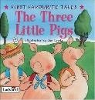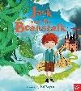 | 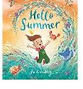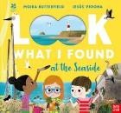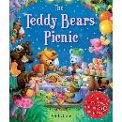
Key Questions/ | Who are we? | What is a celebration? | Where do I live?  What is the name of my town?  What do I live in? (House, flat, bungalow etc.) What is the world?  What is a map/globe? What is the blue? What is the green?  What country do I live in? What do homes look like in different parts of the world? Do all homes look  like mine? | What is Spring? | What is a book? | What is the beach?
learning | What do we look like?  Do we look the same? | What do you celebrate at  home? |  | What happens in Spring?  Can I see signs of Spring? | How do I handle books  carefully and look after | What are shells?  What lives in rock pools?
 | What is my body? | How do we celebrate |  | What is new life? | them? | What is the sea?
 | Names of simple body | birthdays? |  | Which animals are born in | What is a story? | What is water?
 | parts. | Who do you celebrate |  | Spring? | How can I listen | Where does it come
 | Where do we live? | with? |  | Can I match animals to | carefully to a story? | from?
 | Who can help me? | Do we all celebrate in the |  | their young? | Can I use pictures to | Why and how do people
 | What are senses? | same way? |  | Which plants grow in | help me tell a story? | travel on the sea?
 | What makes me special - | Let’s explore celebrations |  | Spring? | Can I act out a story? | Why and how do people
 | how am I unique? | - Baptisms, Christmas, |  | How can I care for them? | Can I use props to help | travel under the sea?
 | What am I good at? | Diwali, Remembrance |  | What is a season? | me retell a story? | What lives under the
 | Our families | Day, and Bonfire Night. |  | How is Spring different to | Can I sequence a story? | sea?
 | How has my body | Which celebrations are |  | other seasons? | What is my favourite | What do I already know
 | changed? | important to me? |  | What is a life cycle? | story? | about the sea?

 | Names of key body parts. | Which celebrations are | What is the weather like | How do plants grow? | Can I use books to help | What would I like to find
 | How do we use our | important to other people | in different countries? | What do they need to | me find out | out?
 | senses? | in our community and | What do people wear in | grow? | information? | How can I find out this
 |  | other countries? | hot/cold countries? | What are tadpoles? | What is a traditional | information?
 |  | How do people celebrate  special events in our country and beyond - Bonfire Night, Remembrance Day, Diwali, and Christmas.  Can we talk about the | What is a town/street/city/country? Which country do I live in? Where is my country on a map/globe?  What are the other | What happens in the  tadpole life cycle? What happens in the butterfly life cycle? What is a minibeast?  How can I find out more  about them? | tale?  What are characters? Are all characters the same?  How do the characters feel in the different  stories? | What could I find under  the sea?  Are there only sea creatures or other things? (Seaweed, shipwrecks etc.).  What could I learn about
 |  | similarities and | countries called? | How many minibeast can I | What is a setting? | sea creatures?
 |  | differences between the | Are all countries the | find? | Are all settings the | Are they all the same?
 |  | countries and | same? |  | same? | How are they different?
 |  | celebrations? (e.g., | Look at differences – |  | What is the beginning, | Who uses the sea? (Past
 |  | hotter/colder) | rainforests/deserts/Antar |  | middle, end of a story? | and present (sailors,
 |  |  | ctica |  | What were stories like | pirates etc.).
 |  |  | Which animals live in which countries? |  | many years ago?  Can I retell a story in my  own words? | How can I help look  after the sea?
 |  |  |  |  | Can I make up my own
 |  |  |  |  | story and write it?
Visits/ Visitors and Events | - Family transition days  - Different members of the family invited in  - Grandparents  - Autumn walks either in local grounds or to the park. | - Walk to the Post Office – post letter to Santa.  - Diwali day – celebrate with music, dancing, food, special clothing or a Hindu visitor.  - Invite parents in to talk about festivals and different  celebrations. | - Journey within the local area  e.g. a walk around the local area or a trip to the park, children’s entertainment area, church etc.  - Visit to the nearest zoo.  - Petting zoo in school. | - Spring walk  - Easter Egg hunt  - Tractor visit to the school.  - Visit a farm to see animals and their young/Ask a farmer to visit  - Gardening day – invite parents/helpers to grow new plants in the setting | - Visit a library  - Local Author to visit the school or class to read a story to the children. | - Visit an aquarium  - Visit the beach  - Ask a fisherman to visit  - Sea shanties  - Beach day in school e.g. dressing up, picnic.

 |  | - Harvest festival  - Bonfire Night experience  - Nativity performance  - Christmas Party | - Chinese New Year celebrations | - Discussion with a local farmer
Vocabulary | Myself, family, parents, same, different, special, | Celebrate, birthday, party, marry, birth, birthday, | Live, home, house, bungalow, flat, town, | Spring, new life, change, hatch, nest, grow, seed, | Story, book, page, cover, title, author, illustrator, | Water, rain, sea, land, beach, shell, rock pool,
 | friend, body, house, | present, Christmas, | country, earth, world, | bulb, plant, leaf, flower, | letters, words, pictures, | fish, fins, gills, seahorse,
 | home, job, helper, senses. | Diwali, remembrance, | map, globe, land, sea, | bug, environment | listening, first, next, last | shark, octopus, boat,
 | Unique, relations, similar, | bonfire, fireworks, enjoy, | weather, hot, cold, sun, | Habitat, life cycle, insect, | Traditional tale, | submarine
 | skeleton, skull, hearing, | happy, together, | rain, wind, snow, | thorax, abdomen, roots, | structure, beginning, | Ocean, habitat, tide,
 | see/sight, touch, smell, | Baptise, christening, | Street, city, community, | stem, petals, absorb, | middle, end, character, | coast, pollution,
 | taste. | tradition, anniversary, | travel, continent, desert, | oxygen, hydrate | setting, narrative, hero, | environment, recycle,
 |  | wedding, carnival, event, | rainforest, Arctic, |  | villain | pirate, lifeguard,
 |  | festival | Antarctic, North Pole, |  |  | coastguard
 |  |  | South Pole, boiling,
 |  |  | melting, freezing, frost,
 |  |  | seasons
Enhanced Provision Ideas | - Mark-making (faces, names)  - Paper plate faces – use mirrors to look at my different features  - Painting self- portraits, looking closely at my features  - Playdough faces  - Loose part faces  - Collage names  - Footprints and handprints – compare sizes  - Sensory exploration – textures, sounds, tasting, smells  - Junk model houses | - Autumn walk – collect leaves, take pictures, walk through crunchy leaves  - Leaf rubbing  - Make a stick man  - Pumpkin exploration  - Firework pictures, make the sounds  - Dance like firework  - Remembrance Day - make poppies, poppy printing (apples)  - Party Role Play –  make decorations  - Decorate birthday cakes  - Playdough cakes and candles | - Role play pancakes/frying pans in home corner  - Lemon bubbles – mixing and making bubbles – whisking, filling pouring, pipettes  - Decorate house numbers  - Globes - paper plates  - ice exploration – free the trapped animals  - Craft - animals living in Iceland  - Craft - African animals  - Creating a bag for Sunny the meerkat  - Chinese writing and numbers | - Spring colouring –  flowers/birds  - Take photos of signs of spring  - Observational drawing  - Daffodils  - Tissue paper sunflowers  - Blossom tree painting  - cotton buds  - Make bird feeders  - Bird watching –  binoculars  - Basic garden birds –  names and differences  - Plant seeds  - Beanstalk leaves to make a giant beanstalk  - Bean sorting/counting | - golden eggs collage  - make a castle  - make a cloud  - unifix measure beanstalks & giant feet  - Duplo beanstalks  - junk modelling pig and wolf characters  - construction – using different materials to build houses  - What’s the time Mr.  Wolf?  - Create your own troll  - Construction – using different materials to build bridges | - Shell sorting (bumpy/smooth)  - Counting shells – pics of numbered buckets  - Make a rock pool  - Starfish/crab/anem one craft  - Balancing pebbles  - Wave patterns in various media  - Salt & water experiment  - Make boats – pool noodle  - Floating/sinking  - How many bears can you put in your boat before it sinks

 | - Large body collage –  add labels  - Draw around each other with chalk/bricks  - Work based around  ‘My class is a family’  e.g. lolly stick houses and drawings of my family and my class | - Rangoli patterns  - Diwa lamps  - Santa’s workshop  role play  - Christmas activities  - Diwali Party  - Letters delivered to Santa  - Building Santa’s  sleigh | - Making a Chinese lantern  - Making a boat / vehicle. | - Bug hunt  - Make a bug house  - Wormery  - Butterfly paintings –  folding printing  - Measuring growth of sunflowers  - Lifecycles sorting and matching | - Lolly stick rafts for goats  - Grow real grass  - Fork painting –  brown bears  - Colour sorting bears  - Teddy Bears picnic  - Size sorting objects  - Collage ducks with feathers  - Paper plate swans  - Mark making with feathers  - Make porridge  - Make gingerbread men  - Make bread  - Exploring size and large objects the giant used | - Cardboard fish to decorate  - Bubble wrap fish printing  - Pattern fish with stamps  - Sea creature stampers  - Exploring patterns and creating my own  - Different textures  - Kim’s Game with  sea creatures  - Make sea creatures – jellyfish, shark, lobster etc.  - Cheerio octopus  - Animal sort – land or sea?
Parental Involvement | - All about me box / Show and tell box  - Parents reading stories in school  - WOW  moments  shared | - Family celebration photos shared in school.  - Parents talking about the celebrations they have  - Christmas Concerts | - Parents Evenings  - WOW moments shared  - Parents reading stories in school.  - Book looks for parents  to see children’s work. | - Seeds sent home for parents to plant with their children | - Parents joining in with Eid Celebrations  - Parents Evenings | - WOW moments shared  - Reports discussions  - Leavers Celebrations

 | Autumn 1 | Autumn 2 | Spring 1 | Spring 2 | Summer 1 | Summer 2

Communication and Language: Listening  Attention Understanding | Pre-School:  -Beginning to listen to stories and nursery rhymes.  -Beginning to listen to instructions given. - Listens during adult guided activities.  -Focusing on an activity of my own choice for a short period of time. - Beginning to show attention to the adults in my setting.  -Recognises and points to objects that are spoken to me. - Understands 1 key word instructions e.g. stop, drink.  Reception:  -Children are beginning to listen to other children in their setting.  -They listen during story time and show an interest in the books being read.  -Children sit on the carpet and show some attention – this may only be for a short time.  -Children can pay | Pre-School:  -Listens to simple stories.  -Listens to other people speaking to me.  -Focusing more attention on stories being told to them.  -Give attention to others who are speaking to me.  -Shows an understanding of text being read to them using the pictures. - Understands simple concepts such as  ‘big/small’.  Reception:  -Children are listening more on the carpet and when being spoke to by their teacher and peers.  -Children continue to listen to new stories that are shared with them.  -Children paying more attention on the carpet and during guided tasks. | Pre-School:  -Listens to others speaking and continues the conversation following on from what has been said.  -Paying attention when listening to longer stories.  -Switches attention between listening to others and completing a task.  -Recalling what happens in a story I have read. - Understanding a three key word sentence.  Reception:  -Children’s listening skills are continuing to develop and they are listening in lots of different situations such as carpet time, assembly, phonics and other lessons.  -Children showing a good level of attention and concentration. -  Children being attentive | Pre-School:  -Enjoying listening to longer stories.  -Pays more attention to what is happening in the stories being read.  -Focusing more attention on a chosen activity.  -Sits and listens during quieter or adult led activities when appropriate.  -Beginning to understand one step instructions and questions.  Reception:  -Children listen when both in and out of school and pay attention to the person talking.  -When out of school they know it is important to listen to keep safe – such as cars or Stanger danger.  -Children can maintain attention in different contexts. | Pre-School:  -Listens more carefully.  -Knows why we should listen.  -Knows they sometimes have to wait their turn when speaking.  -Understanding prepositional language e.g. on, under.  -Asking why things are happening.  Reception:  -Children’s listening skills continue to develop, they can listen in a range of situation and can listen while taking part in a guided task while remaining on task.  -Children are developing their attention skills to both | Pre-School:  :  -Listen attentively and respond to what they hear with relevant questions, comments, or actions.  -Maintain attention in whole class and small group contexts for a short time.  -May find it difficult to pay attention to more than one thing at a time.  -Follow 1 step instructions.  -Understand ‘why’  questions.  Reception:  -Children show good listening skills and can listen to one another, adults and new people with great skill.  -Children attend to others in play.  -Children show good levels of attention during learning tasks.

 | attention to one thing at a time.  -Children following simple 1 step instructions.  -Children understanding appropriate ‘why’ questions. | -Children understanding why they need to pay attention.  -Children following clear instructions with 2 parts. | during classroom tasks – both guided and independent.  -Children taking turns when speaking and responding to their peers and adults with a clear understanding of what has been said | -Children show attention to both peers and adults.  -Children asking questions to clarify understanding and confirm knowledge. - Children showing a good understanding of texts that have been read to them through their recall. | listen and continue with an activity.  -Children following clear instructions with 3 parts.  -Children using new knowledge and vocab in conversation and play. -Children showing an understand questions through their talk and actions. | -Children can retell a story showing a good understanding. - Children understanding and using a large number of words and new vocabulary in their conversations and during discussions
Communication and Language: Speaking | Pre-School:  -Links words together when speaking.  -Developing more speech sounds and pronunciation of sounds.  -I can use words to begin to communicate my needs.  Reception:  -Children speaking in simple sentences.  Children can say simple rhymes and sing songs and poems.  -Children speak to the adults and children in the class, they talk to other children during  their play. | Pre-School:  -Using words to communicate what I want and make myself understood.  -Asking ‘what’ questions. Using the terms ‘me, him, her’.  Reception:  -Children using expression to communicate meaning.  -Children starting conversations and speaking to familiar adults.  -Children taking turns and telling past events.  -Children learning | Pre-School:  -Answering ‘who, what, where’ questions.  - I can a recite Nursery Rhyme from memory.  -I am beginning to speak simple sentences.  -I am beginning to link  sentences with ‘and’.  Reception:  -Children using talk to pretend play.  -Children explaining things through speech.  -Children describing things through speech.  -Children talking in the past tense. | Pre-School:  -I can recite or retell a past event in my life to someone else.  -Asking ‘where’ and ‘who’ questions.  Reception:  -Children using talk to clarify their thinking and ideas.  -Children speaking in well-formed sentences.  -Children using speech to reason and problem solve.  -Children verbally  telling stories. | Pre-School:  -Using a wider range of vocabulary in my play.  -Singing some songs independently.  Reception:  -Children explaining how things work, what has happened and why.  -Children solving problems, reasoning with others and fixing friendship issues through speech. | Pre-School:  -Use simple sentences. -Sing a large repertoire of songs e.g. nursery rhymes or numbers songs.  -Use talk to organise themselves and their play.  Reception:  -Children creating an imaginary story of their own in play.  -Children speak clearly in well-formed sentences.  -Children using new vocabulary in  different contexts.

 |  | about rhyme and alliteration. |  |  | -Children adding detail to their sentences.  -Children describing things that have happened in their life  to others. | -Children use past, present, and future tenses in conversation with peers and adults.
 | Statutory Framework - The development of children’s spoken language underpins all seven areas of learning and development. Children’s back-and-forth interactions from an early age form the foundations for language and cognitive development. The number and quality of the conversations they have with adults and peers throughout the day in a language-rich environment is crucial. By commenting on what children are interested in or doing, and echoing back what they say with new vocabulary added, practitioners will build children's language effectively. Reading frequently to children, and engaging them actively in stories, non-fiction, rhymes and poems, and then providing them with extensive opportunities to use and embed new words in a range of contexts, will give children the opportunity to thrive. Through conversation, storytelling and role play, where children share their ideas with support and modelling from their teacher, and sensitive questioning that invites them to elaborate, children become comfortable using a rich range of vocabulary and language structures.
Personal, Social and Emotional  Self-Regulation | Pre-School:  -I can express when I feel happy, sad, tired or upset.  -I can find out about emotions through stories and discussions.  Reception:  -Children talk about their feelings to trusted adults or special friends.  -Children may come into school upset but can be comforted by adults.  -Children listen to the rules and expectation and begin to follow them. | Pre-School:  -I can sit nicely and keep my feet to myself.  -I can look after the toys and equipment at my setting.  Reception:  -Children are sharing more often or may comfort a friend who is upset.  -Children identify their own emotions and name them.  -Children begin to take turns and share resources and are developing patience and understanding that there is more than just them in the class. | Pre-School:  -I will talk about my feelings.  -I can wait my turn.  -I tidy up the resources that I have used.  -I am following the behaviour expectations of my nursery.  Reception:  -Children who are very upset know who they can talk to or know some ways to calm themselves down if needed.  -Children are becoming more proud of themselves for achieving things such as pupil of the week.  -Children know and follow the behavioural expectations of the school. | Pre-School:  -I know what ‘right’ choices are and I try my best to make the right choice.  -I can talk about my feelings and explore why I might be feeling this way.  Reception:  -Children have an adult in school they trust and will talk to.  -Children talk about their interests and likes and dislikes at school.  -Children are beginning to understand why listening is important to help us learn and keep us safe. | Pre-School:  -I can calm myself down using a strategy that works for me.  -I am managing my feelings.  -I show control with my emotions.  -I can think about how others feel.  Reception:  -Children try and share, take turns, reason and look after one another.  -They apologise if they hurt someone accidently or make someone else upset.  -Children will without question follows instructions from their teachers or school adults. | Pre-School:  -I am showing more control over my feelings and behaviours.  -I am showing more perseverance and resilience when facing a challenge.  -I can talk about the changes as I start school and how I feel.  Reception:  -Children show emotional maturity ready for the emotional resilience needed for KS1. - Children can use reason and resolutions with other children to keep games and play fair.  -Children are developing in independence and can manage their behaviour in a range of situations in school.

Personal, Social and Emotional Managing Self | Pre-School:  -I can take turns with other children with adult support.  -I can explore the classroom with adult support.  -I can use the toilet with adult support.  Reception:  -Children are developing an awareness of themselves and are forming their own opinions.  -Children are beginning to learn the classroom rules and are following these with some reminders.  -Children are becoming more independent at coming into school in the morning and getting ready for home at home time.  -They are using the toilet independently most of the time at school.  -They know it is okay to ask for help and will do  so. | Pre-School:  -I will have a go at new things.  -I am washing my hands after using the toilet with some reminders to do so.  Reception:  -Children are doing things for themselves – because they want to.  -They will say what they are doing and why they are doing it too.  -Children are using their preferences to choose what they would like to do at school.  -Children can put their coats on and are becoming more confident and skilled in using buttons and zips. | Pre-School:  :  -I am showing more independence and confidence in my setting and when exploring areas.  -I will use the visual timetable to know what is happening in my day.  Reception:  -Children have a good understanding of the behaviour expectations and guide others to follow.  -They are proud of what they can do and their achievements.  -Children are becoming much more independent – getting things for home, eating their dinner and snacks, asking for help, getting a drink when they want one.  -Children independently making healthy food choices such as at dinner time. | Pre-School:  -I can use the toilet independently.  -I can focus on my task for a longer period of time.  -I can talk about healthy food choices.  Reception:  -Children know what makes them happy and do these things, they know what keeps them healthy and will do these things when possible.  -Children looking after themselves at school (personal and hygiene needs).  -Children developing resilience and perseverance independently. | Pre-School:  -I can manage when routines change.  -I can talk about why we need to wash our hands.  -I can play nicely with others and extend others play.  Reception:  -Children tell adults and their peers what they have achieved and what they can do now, they are happy with themselves and proud of what they have achieved at school.  -Children are confident to try new things.  -They continue to develop their resilience and perseverance independently.  -Children can continue to look after and care for themselves. | Pre-School:  -I can talk about my achievements in a positive way.  -I am becoming more independent in looking after myself, ready to start school.  Reception:  -Children are proud of who they are and what they can do.  -They talk about themselves positively.  -Children continue to look after themselves and understand what healthy choices are.  -Children have developed resilience, independence and perseverance to support them through transition and the next step in their school journey.
Personal,  Social and Emotional | Pre-School:  -I can take turns with other children with | Pre-School:  -I will play alongside other children in my | Pre-School: | Pre-School: | Pre-School:  -I help others who are upset. | Pre-School:  -I can ask new adults questions.

Building Relationships | support from the adults in my setting.  -I can separate from my parent/caregiver with adult support.  Reception:  -Children are building new positive relationships with pupils and staff in their new setting.  -They may begin to play alongside other children if ready. | setting and may need adult support to do this.  -I play simple turn taking games in adult guided groups.  -I am showing more interest in other  children’s play.  Reception:  -Children are building on the relationships started last term.  -They are talking to children and adults in their setting and beginning to ask for help if they need it. | -I can come into my setting with minimal support from an adult.  -I can talk about my family.  -I am beginning to show friendly behaviours to my peers.  Reception:  -Children have friendships and may have a special friend.  -They play with these children in and out of the classroom and are happy to | -I am forming friendships with some children in my setting.  -I am becoming more confident in the social situations.  Reception:  -Children are building relationships through play and talk and conserve to many of their peers. | -I am beginning to solve conflicts with others.  -I am showing more social confidence.  Reception:  -Children continue to build strong bonds with other children in their school and care for their peers e.g. getting them tissues, asking them to join in with a game. | -I find solutions to conflicts I have had.  -I can talk about what a friend is and name some of my friends when asked.  Reception:  -Children know if they have hurt someone’s feelings and will apologies without being asked.  -Children know some children might like or dislike the things they do and that it is okay.  -Children look after each other and want  to help their friends.
 | Statutory Framework - Children’s personal, social and emotional development (PSED) is crucial for children to lead healthy and happy lives, and is fundamental to their cognitive development. Underpinning their personal development are the important attachments that shape their social world. Strong, warm and supportive relationships with adults enable children to learn how to understand their own feelings and those of others. Children should be supported to manage emotions, develop a positive sense of self, set themselves simple goals, have confidence in their own abilities, to persist and wait for what they want and direct attention as necessary. Through adult modelling and guidance, they will learn how to look after their bodies, including healthy eating, and manage personal needs independently. Through supported interaction with other children, they learn how to make good friendships, co-operate and resolve conflicts peaceably. These attributes will provide a secure platform from which children can achieve at school and in later life.
Physical Development Gross Motor Skills | Pre-School:  -Walk and crawl confidently.  -Climb using two feet at a time.  -Knowing how to scoop and pour e.g. sand, mud.  -To run around the setting with some control and direction.  -Clapping and stamping to music. | Pre-School:  -Begin to move slowly on a balance bike.  -Begin to use a climbing frame with support from an adult.  -Being able to use a swing with some independence. | Pre-School:  -Children putting on their own coat (needing support to do their coat up still),  -Children putting on their own shoes.  -Going up and down stairs with control and balance. | Pre-School:  -Children can kick a large ball with some control.  -Children can throw a ball with some control. To begin to balance on one leg.  -To dance with control using different parts of their body.  -To use the available equipment to create an obstacle course to navigate. | Pre-School:  -To use a balance bike more confidently.  -To run with more confidence and skill.  -To independently use a climbing frame or similar resource,  -To begin to show good posture when sitting on the carpet. | Pre-School:  -To make up own movements with their body.  -To begin to use their core muscle strength to achieve good posture when sitting on the floor or at the table.  -To be able to climb safely.  -Children choosing the right equipment to move safely.

 | Reception:  -Begin to use their core muscle strength to achieve good posture when sitting on the floor or at the table.  -Begin to safely use tools and equipment. | Reception:  -Begin to develop overall body; strength, balance, co-ordination, balance and agility.  -Experiment moving in different ways. | Reception:  -Continue to develop overall body strength, balance and coordination.  -Developing in ability when dancing to music. | Reception:  -Negotiates space successfully and can adjust speed and direction.  -Showing increasing control with a ball. | Reception:  -Using equipment safely with consideration to others.  -Move in a range of ways confidently including running, jumping, dancing, hopping, skipping and climbing. | Reception:  -Negotiate space and obstacles safely.  -Show strength, balance and coordination when playing.  -Move energetically in a range of different ways.
Physical Development Fine Motor Skills | Pre-School:  -Children using a palm grip when using mark making tools.  -Children using a spoon to feed themselves correctly.  -Children using spring loaded scissors to make snips into paper with adult support.  Reception:  -Children using pencils and other equipment comfortably for them.  -Children making snips in paper either using one hand or two. | Pre-School:  -Children mark making by scribbling and colouring.  -Children exploring a range of mine motor activities and implements,  -Children using a spoon and a fork to feed themselves.  Reception:  -Children continuing to develop their fine motor skills.  -Children beginning to learn correct letter formations and use these in their writing. | Pre-School:  -Beginning to use a four finger grip to use mark making tools.  -Using construction equipment correctly to build e.g. Duplo, Magnitiles.  -To develop more independence when using spring loaded scissors.  Reception:  -Developing an effective pencil grip.  -Developing skill when using tools including scissors. | Pre-School:  -Children making more controlled marks when drawing and mark making.  -Children manipulating dough through rolling, squeezing, balling and patting.  Reception:  -Children forming recognisable letters with an effective pencil grip. | Pre-School:  -Children using a two finger and a thumb grip.  -I can draw and paint clearer shapes and pictures when drawing and painting.  -Children showing some threading skills.  Reception:  -Confidently using scissors and small tools.  -Beginning to use a tripod grip to draw and write accurately. | Pre-School:  -Children using pencils and other equipment comfortably for them.  -Children beginning to make snips in paper either using one hand or two independently.  -Children turning pages in a book one at a time.  -Children may form some letters in their name.  Reception:  -Children using the tripod grip.  -Using a range of small tools.  -Showing accuracy when drawing.
 | Statutory Framework - Physical activity is vital in children’s all-round development, enabling them to pursue happy, healthy and active lives6. Gross and fine motor experiences develop incrementally throughout early childhood, starting with sensory explorations and the development of a child’s strength, co-ordination and positional awareness through tummy time, crawling and play movement with both objects and adults. By creating games and providing opportunities for play both indoors and outdoors, adults can support children to develop their core strength, stability, balance, spatial awareness, co-ordination and agility. Gross motor skills provide the foundation for developing healthy bodies and social and emotional well-being. Fine motor control and precision helps with hand-eye co-ordination, which is later linked to early literacy. Repeated and varied opportunities to explore and play with small world activities, puzzles, arts and crafts and the practice of using small tools, with feedback and support from adults, allow children to develop proficiency, control and confidence.

Literacy Comprehension | Pre-School:  -Beginning to join in with familiar rhymes and stories.  -Singing some parts or certain Nursery Rhymes.  -Hears new vocabulary from stories, rhymes, poems and non-fiction books.  -Have a favourite book and seeking it/them out to share with an adult or look at alone.  Reception:  -Children joining in with rhyme, songs and poems.  -Children are encouraged to hold a book correctly and carefully turn pages.  -Children understand books have a beginning and an end.  -Children listen and enjoy sharing a range of books both fiction and non-fiction.  -Children know that text in English is read top to bottom and left to right.  -Children can recognise pictures and illustrations in a text Vs  the writing. | Pre-School:  -To understand that we should turn one page at a time in a book.  -To begin to understand that print has meaning.  -To talk about the pictures in a book with support.  Reception:  -Children being able to sequence two events from a familiar story – possibly with the use of prompts for support.  -Children discussing and hearing a range of books – non-fiction and fiction.  -Children being asked questions liked to the books read to them.  -Children using texts and images to answer simple questions. | Pre-School:  -To enjoy singing a range of rhymes and songs.  -To enjoy listening to longer stories.  -To join in with some simple repeated refrains in well know stories/ rhymes.  Reception:  -Children having favourite books and rhymes – they may know these books from memory.  -Say what they liked or disliked about a story. When listening to a story children use the images to help them read.  -Children are becoming increasingly more confident with their understanding of new words in stories.  -Children can use a books front cover or blurb to make a prediction. | Pre-School:  -To begin to understand we read from left to right and top to bottom.  -To begin to name the parts of a book e.g., front cover, title, and author.  Reception:  -When children are playing they are adapting, roleplaying or using vocabulary from stories they’ve read or heard.  -When reading a well- known or repeated story children will join in.  -Showing an increasing confidence in sequencing a story.  -Gives a suggestion to the ending of a story using the front cover, blurb and beginning to support their suggestions. | Pre-School:  -To enjoy listening to longer stories and remember much of what happens.  -To talk about a story, turning one page at a time.  -To answer simple questions about stories.  -Beginning to predict what might happen in a story.  Reception:  -Use events in a story to suggest what might happen next (with reasonable suggestions being made).  -Know what non- fiction and fiction means and can talk about the two text types.  -Correctly sequence a story.  -Use ‘because’ to give  reason when  answering ‘why’ questions about a text.  -Rehearse and recall rhymes and stories and remembering | Pre-School:  -To engage in extended conversations about stories.  -To know and say how the story might end.  -To tell a longer story.  -To listen to and enjoy sharing a variety of books and discuss the new vocabulary learnt.  Reception:  -Converses about books talking about the events, the parts they liked and dislikes and gives reason as to why they feel this way.  -Knows key vocabulary used in a range of books.  -Continue to develop their roleplay to involve the storylines of the books read to them.  -Recalls many parts of a text with accuracy.

 | -Children spotting  familiar words in books |  |  |  | actions to well-known  rhymes.
Literacy  Word Reading | Pre-School:  -Hear different environmental sounds around me.  -Begin to recognise some environmental print such as supermarket logos.  Reception:  -Children can discriminate sounds (Phase 1 Phonics) such as instruments and cars.  -Children are beginning to be able to orally blend and segment. (Phase 1 Phonics). | Pre-School:  -Discriminate between different instrument sounds.  -To sing and perform actions to a familiar nursery rhyme.  -Say the rhyming word at the end of a familiar rhyme  Reception:  -Phonics lessons/ First sound reading books introduced and children read graphemes (letter sounds) s,a,t, p, i…  -Begin to blend some simple words  -Children read a few common exception words matched to the  phonic programme. | Pre-School:  -To begin to recognise my own name with support.  -Recognise rhythm in spoken words by clapping syllables.  Reception:  -Continue to read individual graphemes (letters sounds).  -Blend simple sounds into VC or CVC words. - Children read a few common exception words matched to the school’s phonic programme. | Pre-School:  -To identify signs and symbols in the environment and recall what they mean.  -Spot or suggest rhymes.  Reception:  -Continue to read graphemes as well as some digraphs.  -Children reading simple phrases and sentences with known graphemes / phonemes and a few exception words from memory. | Pre-School:  -To begin recognising some words that start with the same initial sound.  -To begin to recognise some individual letter sounds with support  Reception:  -Children read some graphemes, digraphs, simple phrases and sentences with known graphemes / phonemes and a few exception words from memory. | Pre-School:  -To recognise my own name independently.  -To begin to recognise some individual letter sounds with support.  -Recognise some words with the same initial sound e.g. m for mummy and milk.  -Orally blend a simple word.  Reception:  -Children beginning to read some tricky words from Phase 4  e.g. said, like, have, so.  -Children can re-read what they have written to check that it makes sense
Literacy  Writing | Pre-School:  -Develop an interest in making marks.  -I am beginning to distinguish between marks and pictures/drawings.  Reception: | Pre-School:  -Draws marks that are not always distinguishable.  -Follows large pattern templates available.  Reception: | Pre-School:  -Adds some marks to drawings.  -Adds marks that to them symbolises their name.  Reception: | Pre-School:  -Beginning to give meaning to the marks I make.  Reception: | Pre-School:  -Understands that a written word conveys meaning.  -Name writes with the first letter of their  name to ‘sign’ their  mark making.  Reception: | Pre-School:  -Gives meanings to the marks made.  -Can pretend to write in a range of contexts.  -Becoming more confident with name writing (writes some or all of their name)  Reception:

 | -Writes their name - copying it from a name card or trying to write it from memory.  -Develop an awareness that writing communicates meaning. -Gives meaning to marks they make. | -Continuing to develop a phoneme / grapheme relationship.  -Now has increasing control when making marks and drawing.  -Copies adult ‘writing behaviour’ e.g. writing on a whiteboard, writing messages.  -Uses some recognisable letters and own symbols such as their name or some initial sounds. | -Children recording letters for initial sounds and end sounds.  -Children building and recording simple CVC words. | -Children build CVC, CVCC words using known graphemes.  -Children recording these.  -Use writing in their play.  -Some children moving onto caption writing if ready. | -All children being exposed to caption writing and simple sentence writing and extended to copy or create a simple caption e.g. it is a bus.  -Continue to build on knowledge of letter sounds in writing. | -Children writing for a range of purposes e.g. non-fiction and fiction writing.  -Write short sentences sometimes using finger spaces, capital letters and full stops.
Phonics | Pre-School:  : Phase 1  Hear environmental sounds (Aspect 1)  Reception: Phase 1/2:  Hear general sound discrimination, identify rhythm, rhyme, and alliteration and be able to orally blend and segment simple words. | Pre-School:  Phase 1:  Hear environmental sounds (Aspect 1). Hear instrumental sounds (Aspect 2)  Reception:  The Basics 2:  Know grapheme phoneme correspondence. Blend with known letters for reading VC and CVC words. Orally segment for VC and CVC words First tricky words (the, to, no, go) | Pre-School:  Phase 1:  Hear environmental sounds (Aspect 1). Hear instrumental sounds (Aspect 2)  Hear Body percussion (Aspect 3)  Reception:  The Basics 2:  Consolidate learning. Recognise digraphs -ck  + ff, ll, ss. Know tricky words - the, to, and, no, go, I Blend and segment known sounds for reading and spelling VC, CVC, CVCC.  Consolidate Basics 2. Begin Basics 3. Know the grapheme - phoneme correspondence for j, v, w, x, z, zz, qu | Pre-School:  Phase 1:  Revise Aspects 1-3. Hear voice sounds (Aspect 6).  Oral blending and segmenting (Aspect 7)  Reception:  Basics 3  Consolidate Phase 2. Begin Phase 3. Know the grapheme - phoneme correspondence for j, v, w, x, z, zz, qu. Know the consonant digraphs – sh, th, ch, ng. Know digraphs – ai, ee, oa,  oo, ar, or, ur, ow, oi, ee | Pre-School:  Phase 1:  Revise Aspects 6-7. Hears rhythm and rhyme (Aspect 4). Hears alliteration (Aspect 5)  Reception: The Basics 3:  Consolidate Phase 2 and 3 skills. Know trigraphs ear, air. Read tricky words they, her, all, are. Continue to apply knowledge of blending and segmenting to reading  and spelling for words | Pre-School:  Phase 1/2:  Revise Aspects 4 – 7. Possible introduction to Phase 2 if children are ready for the first set of sounds.  Reception:  The Basics 4:  Consolidate Phase 2 and 3 skills. Beginning to learn Phase 4 Phonics if ready. Read tricky words do, when, out what, said, have, like, so.  Represent each phoneme by a  grapheme and blend

 |  |  |  | Know trigraph igh.  Know tricky words, the, to, he, she, we, me, be, was, my. Write graphemes and digraphs. | and captions. Write graphemes from memory and write a simple sentence using phonic knowledge. | phonemes to read CVC words and segment CVC words for spelling. Read sentences using phonic knowledge, write digraphs and  trigraphs.
 | Statutory Framework - It is crucial for children to develop a life-long love of reading. Reading consists of two dimensions: language comprehension and word reading. Language comprehension (necessary for both reading and writing) starts from birth. It only develops when adults talk with children about the world around them and the books (stories and non-fiction) they read with them, and enjoy rhymes, poems and songs together. Skilled word reading, taught later, involves both the speedy working out of the pronunciation of unfamiliar printed words (decoding) and the speedy recognition of familiar printed words. Writing involves transcription (spelling and handwriting) and composition (articulating ideas and structuring them in speech, before writing)
Mathematics | 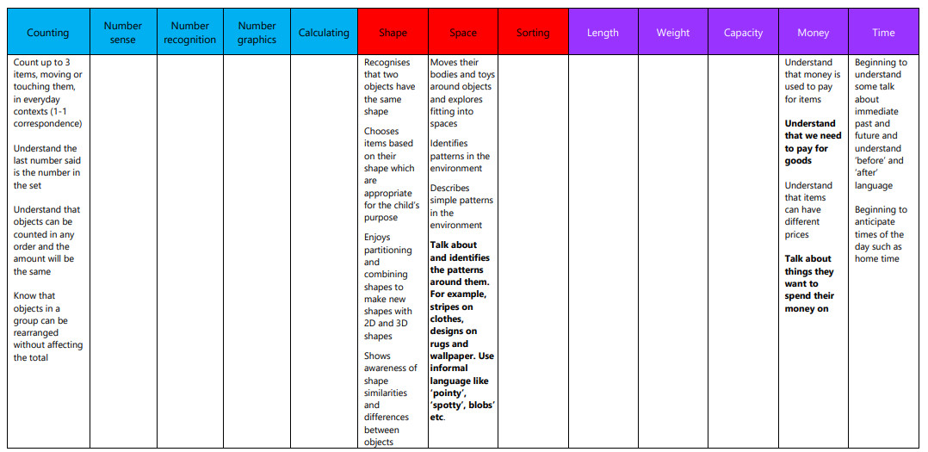  Pre School- Autumn 1  Pre School- Autumn 2  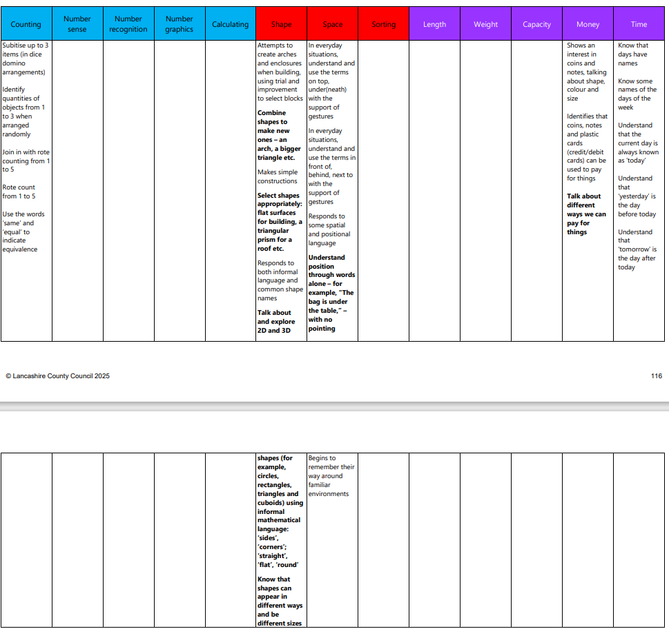  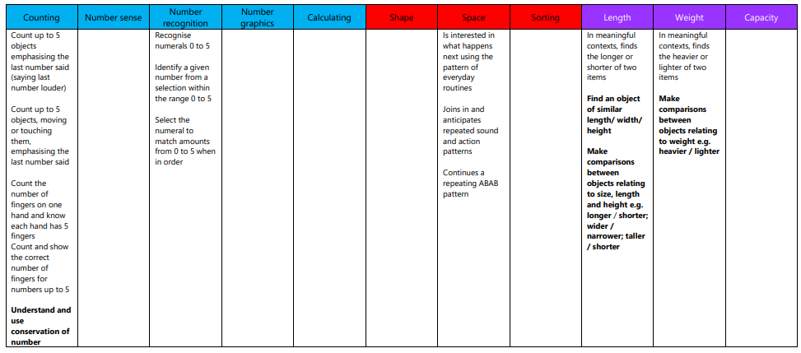  Pre-School- Spring 1  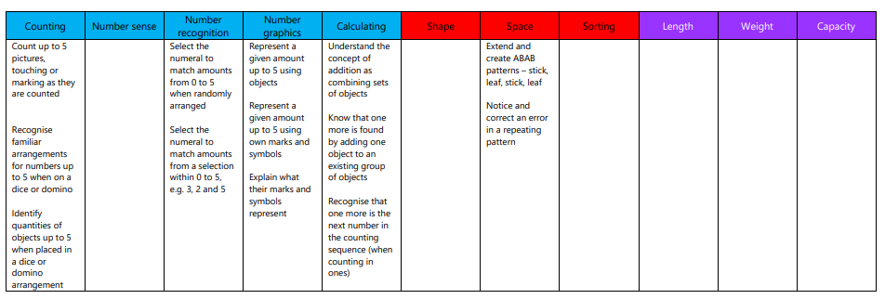  Pre-School- Spring 2  Pre- School- Summer 1  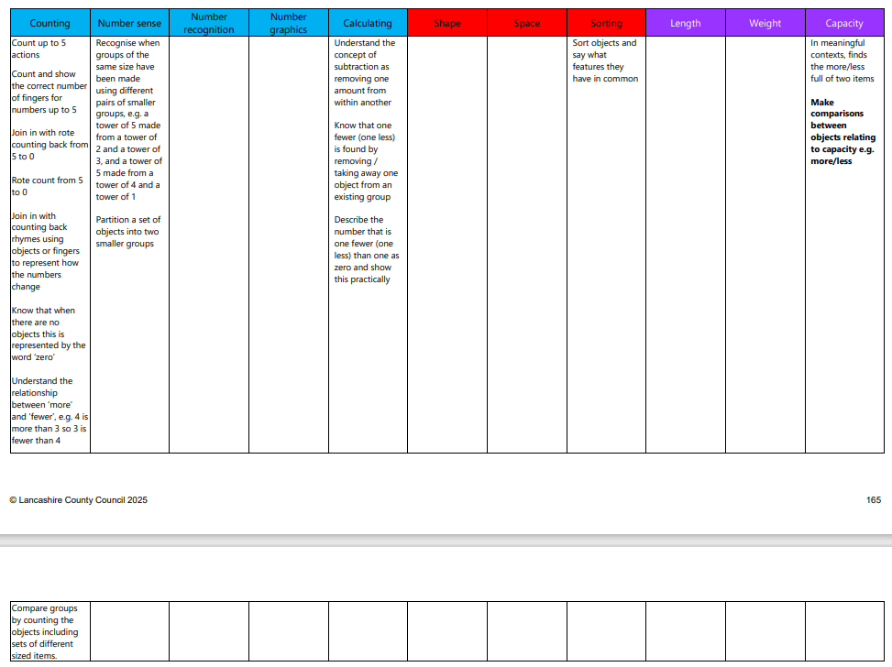  Pre-School- Summer 2  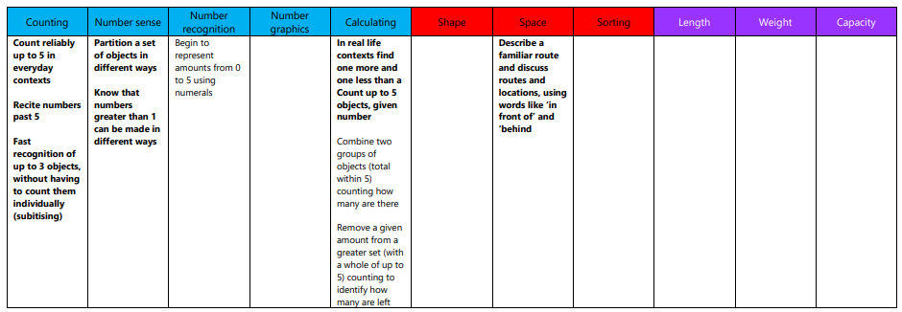  Reception- Yearly overview  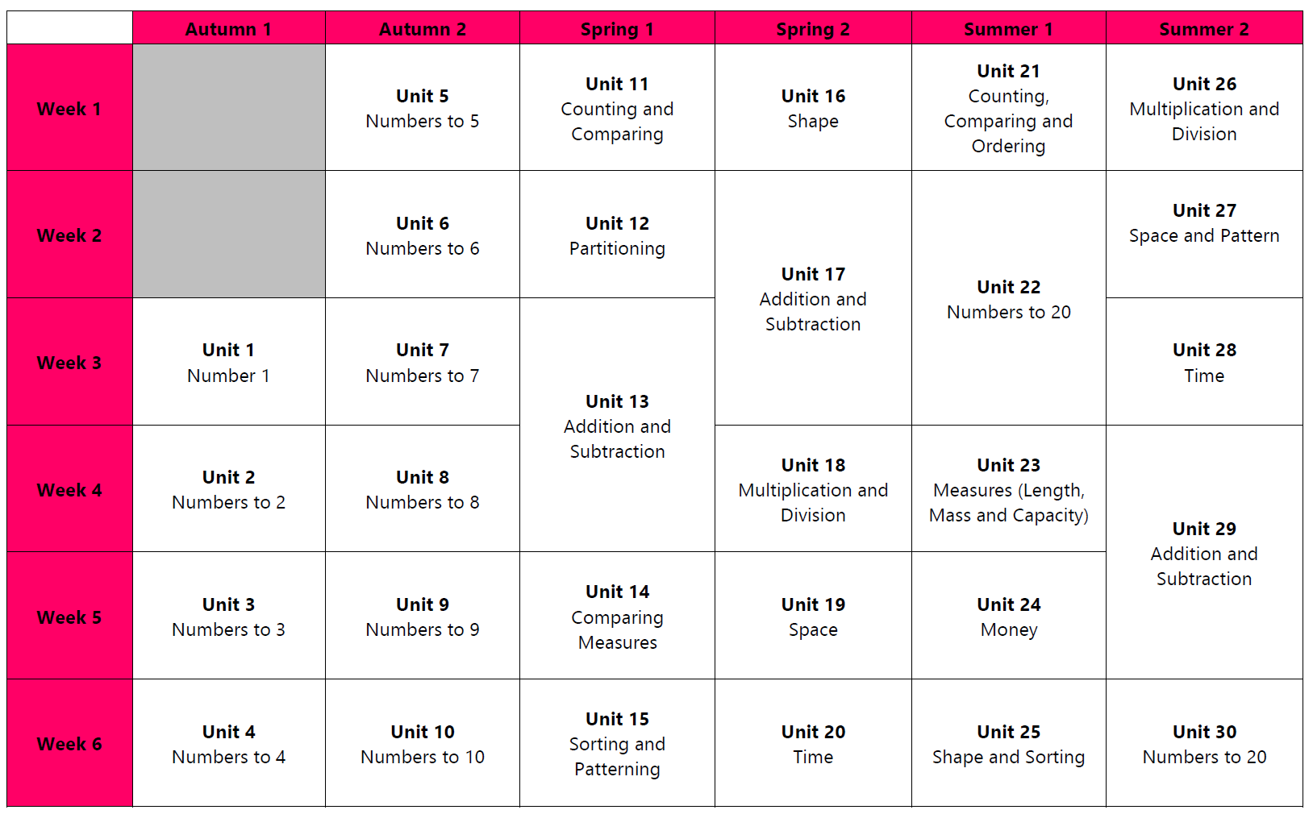

 | Statutory Framework - Developing a strong grounding in number is essential so that all children develop the necessary building blocks to excel mathematically. Children should be able to count confidently, develop a deep understanding of the numbers to 10, the relationships between them and the patterns within those numbers. By providing frequent and varied opportunities to build and apply this understanding - such as using manipulatives, including small pebbles and tens frames for organising counting - children will develop a secure base of knowledge and vocabulary from which mastery of mathematics is built. In addition, it is important that the curriculum includes rich opportunities for children to develop their spatial reasoning skills across all areas of mathematics including shape, space and measures. It is important that children develop positive attitudes and interests in mathematics, look for patterns and relationships, spot connections, ‘have a go’, talk to adults and peers about what they notice and not be afraid to make mistakes.
Expressive Arts and Design Creating with Materials  Being Imaginative and Expressive | Pre-School:  -Recognise colours and chooses them for a purpose.  -Uses thick paint brushes.  -Uses playdough to roll, cut, ball, sausage.  -Builds towers with large construction equipment.  -Children dancing to music.  -Children exploring moving to music in different ways  -Children showing an interest in the small world and roleplay areas, children roleplaying their first- hand experiences.  Reception:  -Safely use and explore a variety of materials, tools and techniques, | Pre-School:  -Uses a glue stick to join materials together. - Creates an independent craft using available materials e.g. An independent Christmas Card.  -Children developing storylines in their play, children using familiar props in their play  -Children singing to familiar songs and nursery rhymes they have learnt or are learning.  -Make breadstick firework sparklers  - Clay Diwali pinch pots  Reception:  -Sing a range of well- known nursery rhymes and songs | Pre-School:  Be confident when drawing e.g. potato people,  -Names what they have drawn and draws from memory  -Adding more to their pictures and creations  e.g. pom-poms, glitter.  -Children including their experiences in their roleplay, children talking about music (their favourite songs or songs they do not like)  -Children knowing and singing along to more nursery rhymes  -Children listening to songs from different cultures.  Reception: | Pre-School:  -Using spring loaded scissors to snip, using printing materials in the paint such as sponges and shapes  -Continues to develop their drawing skill.  -Children exploring a range of musical instruments and learning to hold a beat  -Children using vocals and instruments to make music either together or separately  -Children linking real life and stories into the small world  -Children using props in their play.  Reception:  -Design with a purpose in mind and explain the process I have used | Pre-School:  -Building using smaller construction kits correctly, uses a range of painting and printing materials to explore form and function.  -Children experimenting and mixing colours together  -Children may create with a friend.  -Children joining in with the actions to songs  -Children engaging in roleplay in and out of the home-corner and becoming more immersed in their play.  Reception:  -Create collaboratively sharing | Pre-School:  -Children cutting with more confidence, children independently creating and making using the ideas they have seen and come up with  -Children building for a purpose using a range of construction equipment.  -Children using a range of ‘sticking’ tools to join their artwork e.g. sellotape, masking tape, PVA glue, and glue stick.  -Children making up stories verbally while playing  -Children acting out stories with the small world or in their play  -Children performing songs either vocally or with an instrument,  Reception:

 | experimenting with colour, design, texture, form and function  -Follow drawings and curved and straight lines to create line drawings of different buildings  -Detailed self-portraits using a choice of materials  -Know a range of songs related to myself and my community  -Sing in a group or on my own, following the melody and increasingly matching the pitch  -Copy-clap the rhythm of names--Explore high sounds and low sounds using voices  -Begin to move in response to music  -Begin to use observation skills to draw things with increasing details.  -make pumpkin soup (KAPOW unit) | -Explore colour mixing using primary colours  -Explore warm and cool colours looking at Autumn and Winter  -Print or collage to create a pattern or image  -Select colours appropriately for tasks  -Learn about arts and crafts from different countries - Diwali lamps, Christmas cards, Hanukah cards, Rangoli  -Listen to and explore the beats of different music from around the world  -Know that different music is played for different celebration  -Learn to play percussion instruments and listen to the sounds they make  -Know that sounds can be changed by altering the way they are made  -Move to musical stimuli and keep in time to the music. | -Start to create my own storylines that include peers  -Know different songs and dances from around the world  -Join in simple songs remembering some of the words  -Participate in action songs which call for movement  -Move to musical stimuli in a variety of ways, e.g., hopping, marching, skipping and jumping  -Explore and engage in music making and have a simple understanding of a beat  -Share creative ideas with peers and begin to work together, sharing skills  -Continue to draw and paint pictures with increasing complexity  -Construct with a purpose in mind, using a variety of resources  -Safely construct with a purpose and evaluate my designs  -Select tools and techniques needed to shape, assemble and  join materials I am | -Plan and make 3D models.  -Draw an object from careful observation talking about the features that I have included  -Make props to use in role play and small world play  -Know a repertoire of songs – nursery, topical, seasonal, interdenominational and multi-cultural  -Imitate and create movement in response to music  -Tap out simple repeated rhythms and make some up showing interest in the way musical instruments sound  -Explore high pitch and low pitch in the context of songs  -Create collaboratively sharing ideas, resources and skills  -Use tools and techniques with increased care and precision  -Mix a range of colours  needed for a purpose | ideas, resources and skills  -Change the tempo and dynamics whilst playing music  -Know how to use a wide variety of instruments  -Begin to understand emotion through music and can describe music in simple terms  KAPOW Unit- textiles to make a bookmark- weaving. | ELG: Creating with Materials  I can…..  -safely use and explore a variety of materials, tools and techniques, experimenting with colour, design, texture, form and function  -share my creations, explaining the process I have used  -make use of props and materials when role playing characters in narratives and stories ELG: Being Imaginative and Expressive  I can…..  -invent, adapt and recount narratives and stories  -sing a range of well- known nursery rhymes and songs perform songs, rhymes, poems and stories with others and – when appropriate – try to move in time with music

 |  |  | using and explain the process I have used  -Make observations and draw pictures of Arctic/Antarctic animals  -Return to and build on their previous learning, refining ideas and developing the ability to represent them  -Know that different materials can be used to create art  -Explore art from different places around the world | -Execute a sequence of instructions on a programming toy or app to guide a robot
 | Statutory Framework for Expressive Arts and Design - The development of children’s artistic and cultural awareness supports their imagination and creativity. It is important that children have regular opportunities to engage with the arts, enabling them to explore and play with a wide range of media and materials. The quality and variety of what children see, hear and participate in is crucial for developing their understanding, self-expression, vocabulary and ability to communicate through the arts. The frequency, repetition and depth of their experiences are fundamental to their progress in interpreting and appreciating what they hear, respond to and observe.
Understanding the World Past and Present | Pre-School:  -Children using words  ‘now’ and ‘next’.  -Children talking about their family, who they live with and any pets.  Reception:  -Begin to talk about my life story and how I have change  -Guess baby pictures –  how I have grown  -Look at similarities and differences between the natural world around me in the past and present | Pre-School:  -Children talking about their past life experiences e.g. birthdays, Christmas.  -Children using the words ‘then’ ‘now’ ‘next’ ‘before’.  Reception:  -Talk about past family holidays  -Begin to look closely at pictures in books and notice similarities and differences between now and the past  -Know and talk about influential figures from the past - Guy Fawkes  -Talk about the soldiers, | Pre-School:  -Children understanding the  terms ‘old’ and ‘new’ and recognising old and new objects e.g. cars, shops, photos  Reception:  -Know about influential figures from the past and discuss historical events that have happened in the past  -Use vocabulary such as in the past, a long time ago  -Recognise some  similarities and | Pre-School:  -Children commenting on their own past experiences e.g. Easter.  -Children showing curiosity about objects from the past.  Reception:  -Talk about members of my immediate family and community and their roles in society.  -Know and talk about influential figures from the past | Pre-School:  -Children confidently talking about who they are and who they live with,  -Children asking questions to family members about when they were young.  Reception:  -Understand the past through settings, characters and events encountered in books read in class and storytelling  make comparisons of settings and fictional settings | Pre-School:  -Children beginning to understand how to sequence two events.  -Children sequencing family members e.g. baby, mum, grandma  Reception:  ELG:Past and Present:  I can……  -talk about the lives of the people around me and their roles in society  -know some similarities and differences between  things in the past and

 |  | poppies, two minutes silence  -Know some historical facts and stories from different religions and celebrations – Bonfire night, Guy Fawkes, Poppy Day | differences between life in this country and life in other countries  -Comment on images of familiar situations in the past  -Compare characters from stories, including figures from the past  -Talk about how homes have changed  -Comment on images showing homes in the past |  |  | now, drawing on my experiences and what has been read in class understand the past through settings, characters and events encountered in books read in class and through storytelling
Understanding the World People, Culture and Communities | Pre-School:  -Children talking about their families.  -Children talking about who is special to them and why.  -Children naming their family members.  Reception:  -Talk about members of my immediate family and community  -Name and describe people who are familiar to me  -Recognise the differences between myself and my friends (appearance, likes/dislikes, families)  -Talk about what makes | Pre-School:  -Children talking about how we look after our friends and families.  -Children talking about their homes and what they have inside their homes.  -Children talking about the celebration of Christmas.  Reception:  -To be able to draw information from a simple map  -Talk about the features of different celebrations for different faiths  -Know why different people celebrate different things  -Talk about special past  times | Pre-School:  -Children recognising familiar signs, shops in the local environment.  -I can talk about the transport used in my community.  -I can talk about the similarities and differences between celebrations  Reception:  -Learn about different cultures in other places in the world  -Find out how the lives of people in different countries are the same and different to mine  -Talk about safer internet day  -Talk about who is special to me and why? | Pre-School:  -Children speaking positively about differences between people and ways of life.  -Children showing an interest in people with a range of occupations.  Reception:  -Understand how to care for nature  -Know that some places are special to people in my community  - Recognise that people have different beliefs and celebrate special times in different ways. | Pre-School:  -Children developing  an idea of ‘belonging’.  -Children beginning to understand what the  ‘wider world’ is and how we all play a part and get along with one another.  Reception:  -Understand why some people say the world is special  -Talk about what I think is special about the world  -Describe my local habitat and compare with a contrasting country | Pre-School:  -Children using the correct vocabulary to name different features of their community.  -Children know there are other countries than England and that they look different to ours.  Reception: ELG: people, culture and communities:  I can….. Describe my immediate  environment using knowledge from observations, discussions, stories, non-fiction texts and maps

 | me feel special  -Know what groups I belong to  -Understand how we show people they are welcome  -Know that I have a right to learn and play, safely and happily  -Know that hands can be used kindly and unkindly  -Know special things about myself  -Know how happiness and sadness can be expressed  -Know that being kind is good | -Know about the Jewish celebration Hanukkah  -To know what happens at Diwali and why  -Advent/Christmas around the world  -To know what happens at Christmas, and why  -To know what being unique means  -To know the names of some emotions such as happy, sad, frightened, angry | -Understand why some people are special  -Talk about what a good friend is like  -Understand the similarities and differences between different people’s special stories  -Know what a challenge is  -Know that it is important to keep trying  -Know what a goal is  -Know how to set goals and work towards them  -Know when I have achieved a goal  -Know which words are kind  -Know some jobs I might like to do when I am older  -Know that I must work hard now in order to be able to achieve the job I  want when I am older |  |  | Know some similarities and differences between different religious and cultural communities in this country, drawing on my experiences and what has been read in class Explain some similarities and differences between life in this country and life in other countries, drawing on knowledge from stories, nonfiction texts and – when appropriate – maps
Understanding the World The Natural  World | Pre-School: All about me  -Children showing respect and care for their environment.  -Children talking about their home environment and school environment.  -Children exploring  their world and | Pre-School: Colour  -Children exploring the changing weather and seasons  -Children continuing to explore using their senses. | Pre-School: People who help us  -Children understanding how and why we respect and care for animals.  -Children exploring a range of materials and natural objects. | Pre-School: British Science week  -Children exploring the changing weather and seasons (Spring),  -Children learning about new life and plants based around Spring time | Pre-School: Traditional Tales  -Children growing plants from seeds and caring for them  -Children exploring how these plants grow and change over time. | Pre-School: Materials  -Children exploring the changing weather and seasons (Summer),  -Children noticing changes such as ice melting in the sun and offering a reason why.  -Children exploring a range of materials and natural objects.

 | environment through their senses.  -Children naming parts of the body.  Reception: Keeping Healthy  -Explore the natural world and describe what I see, hear and feel when outside  -Understand the effects of the changing seasons around me – autumn  -Talk about harvest | -Children showing more of an interest in the world.  Reception: Celebrations  -Begin to describe what I see, smell and feel in the natural world  -Talk about recycling –  linked to recycling week  -Begin to understand the negative impact that humans can have on the environment | Reception: Animals  -Know the name of the road, and the name of the village where my school is located  -Find and name the arctic and Antarctic on a globe/map  -Talk about why something melts or freezes and the changes that happen  -Make observations of the animals that live in the arctic/Antarctic/desert and talk about what makes them special  -Compare the weather in winter to the weather in autumn  -Recognise the similarities and differences between hotter and colder regions and where we live  Talk about endangered and vulnerable animals  -To begin to understand the negative impact that humans can have  on the environment | Reception: British Science Week  -Talk about signs of spring / changes from winter to spring – spring walk.  -Understand the effect of changing seasons on the natural world around me  -Know some similarities and differences between the natural world around me and contrasting environments, drawing on my experiences and what I have read | Reception: Minibeasts  -Explore the natural world around me, making observations and drawing pictures of animals and plants  -Identifying land and water on a map or globe.  -Making observations about the characteristics of places (in stories, photographs or in the school grounds/local area).  -Discussing how environments in stories and images are different to the environment they live in.  -Making observations about the features of places (in stories, photographs or in the school grounds/local area).  -Making observations about the characteristics of places (in stories, photographs or in the school grounds/local area).  -Beginning to look at and talk about maps (real or imaginary) in stories, non-fiction books, atlases and on globes.  -Beginning to use modelled directional vocabulary when describing features in the surrounding environment.  -Recognising features on maps (real or imaginary).  -Creating real or imaginary maps even if features are indistinguishable. | Reception: Under the sea  ELG: The Natural World:  I can…..  -Explore the natural world around me, making observations and drawing pictures of animals and plants  -Know some similarities and differences between the natural world around me and contrasting environments, drawing on my experiences and what has been read in class  -Understand some important processes and changes in the natural world around me, including the seasons and changing states of matter
 | Statutory Framework for Understanding the World - Understanding the world involves guiding children to make sense of their physical world and their community. The frequency and range of children’s personal experiences increases their knowledge and sense of the world around them – from visiting parks, libraries and museums to meeting important members of society such as police officers, nurses and firefighters. In addition, listening to a broad selection of stories, non-fiction, rhymes and poems will foster their understanding of our culturally, socially, technologically and ecologically diverse world. As well as building important knowledge, this extends their familiarity with words that support understanding across domains. Enriching and widening children’s vocabulary will support later reading comprehension.

