

Teaching and Learning Long Term Curriculum Plan

2025 – 2026



Teaching and Learning Long Term Curriculum Plan
Early Years

2025 – 2026

Teaching and Learning Long Term Curriculum Plan
Key Stage 1

2025 – 2026

Key Stage 1 Example Timetable

A timetable can be requested from your child’s class teacher.
These are examples timings only and will be amended as required.

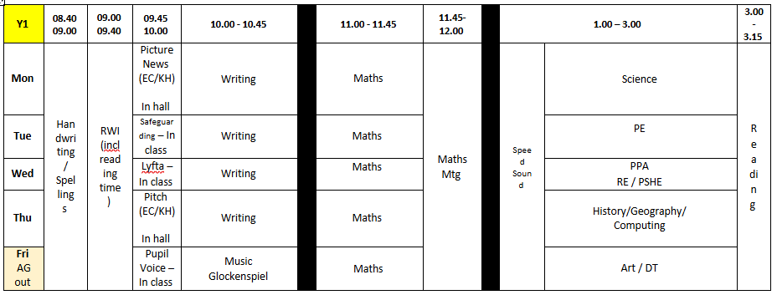

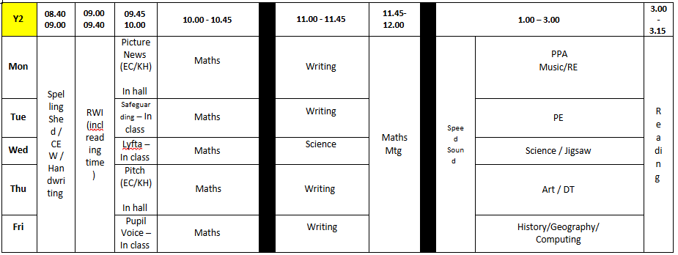

Year 1 Single Age Sequence 2025 – 2026
Autumn 2025 |  |  | Spring 2026 |  |  |  | Summer 2026
Reading  - Funny Bones  - Beegu  - The Dark  - Polar Express |  |  | - The Little Prince  - Where the Wild Things Are  - The Owl and the Pussycat  - Dinosaurs Love Underpants  - Ravi’s Roar |  |  |  | - Traction Man Mini  - Man on the Moon  - Ning Nang Nong  - Look Up!  - The Way Back Home  - The Darkest Dark
Pathways Writing  - Lost and Found (Oliver Jeffers) – Fictional Adventure Story  - Katie in London (James Mayhew) – Non Fiction  - Non-Chronological Report. |  |  | - The Lion Inside (Rachel Bright) – Fiction – Journey Story  - The Curious Case of the Missing Mammoth (Ellie Hattie) – Fiction – Adventure Story change of character |  |  |  | - Someone Swallowed Stanley (Sarah Roberts) – Non Fiction – Information text about the sea.  - A Midsummer Nights Dream (Lit for Little Hands) – Fiction – Character description
NCETM Maths  - Counting within 100  - Comparison of quantities & part-whole relationship  - Numbers 0-5 |  |  | - Recognise, compose, decompose and manipulate 2D and 3D shape  - Numbers 0-10  - Additive structures  - Addition and subtraction facts |  |  |  | - Numbers 0-20  - Unitising and coin recognition  - Pattern and direction  - Time
CUSP Science  - Seasonal changes and daily weather  - Introduce Plants – (trees)  - Animals, including humans |  |  | - Everyday materials  - Revisit 1: Animals, including humans  (or alternative focus for insecure knowledge) |  |  |  | - Plants  - Revisit 2: Plants, Animals including humans  (or alternative focus for insecure knowledge)
CUSP Art and Design  - Drawing Block A  - Painting Block B |  |  | - Creative Response Block 2026  - Printmaking Block C |  |  |  | - Textiles Block D  - 3D Block E
CUSP Design and Technology  - Mechanisms Block A  Instructional writing A  - Structures Block B |  |  | - Food and Nutrition Block C  Animals including humans  - Materials Block D |  |  |  | - Textiles Block E  Hot and cold places  - Food and Nutrition Block F  Instructional writing B
CUSP Geography  - Continents  - Oceans  - Countries of UK |  |  | - Capital cities of UK  - Seas around UK  - Hot and cold locations |  |  |  | - Hot and cold places  - Mapping and fieldwork
CUSP History  - Changes within living memory |  |  | - The lives of significant people (Mary Anning and David Attenborough) |  |  |  | - More lives of significant people  (Neil Armstrong, Mae Jemison, Bernard Harris Jr, Tim Peake.)
Teach Computing  - Technology around us (Assembly time) |  | - Digital Painting | - Digital Painting  - Moving a robot |  |  | - Moving a robot  - Grouping data | - Grouping data  - Digital writing | - Digital writing
Digital Citizenship  - Pause for People  - Jessie & Friends: Episode 2 - Sharing Pictures |  | - Media Balance Is Important  - Barefoot Computing:  Safety Snakes | - Device Advice - Why We Pause for People  - Jessie & Friends: Episode 3 |  |  | - Media Balance Is Important - Quick Bite  - Smartie the Penguin (Lesson Plan for Year 1 Lesson A) | - Safety in My Online Neighbourhood  - Smartie the Penguin (Lesson Plan for Year 1 Lesson B) | - Device Advice - Caring for Our Devices  - Digiduck Saves the Day
Charanga Music  - My Musical Heartbeat |  | - Dance, sing and play! | - Exploring sounds |  |  | - Learning to listen | - Having fun with improvisation | - Let’s Perform Together
Your PE  - Fundamental movement skills  - Ball skills  - Invasion games |  |  | - Gymnastics  - Target games  - Dance |  |  |  | - Athletics  - Striking, fielding and catching  - Sports Day
Jigsaw PSHE  - Being in my world | - Celebrating difference |  |  | - Dreams and Goals | - Healthy Me |  | - Relationships | - Changing me
Jigsaw RE  - What do Christians believe about God? | - What gifts might Christians in my town have given to Jesus if he had been born in Doncaster? |  |  | - Who is God to the Jews? | - Why was Jesus welcomed like a king by the crowds of Palm Sunday? |  | - Is Shabbat important to Jews? | - Who is God to Muslims?
Lyfta  - Theme: Recycling and sustaibability. Net Zero campaign. Story World: Beechcomber | - Theme: Celebrating Difference Story World: The Circus Family |  |  | - Theme: Dreams and Goals Story World: Boxing clever | - Theme: Healthy Me Story World: Beekeepers Garden |  | - Theme: Relationships Story World: Dog’s Best Friend | - Theme: Changing Me / Transition Story World: Home wasn’t built in a day

Suggested Sequence KS1
YEAR 1 Autumn 2025 |  |  |  |  | Science (1.5 hours)
Sep  1 | Geography | Continents, Oceans, UK countries, capital cities and seas  Drawing Block A |  |  | STRONG START | Seasonal changes and daily weather
Sep  1 | Art
8 | History | Changes within living memory  Drawing |  |  | What are the four seasons? | Seasonal changes and daily weather
8 | Art
15 | Computing | How we paint using computers / Using shapes and lines  Drawing |  |  | What’s the weather like in Autumn, Winter, Spring and Summer? | Seasonal changes and daily weather
15 | Art
22 | Geography | Continents, Oceans, UK countries, capital cities and seas  CUSP Money Matters Festival – Tuesday 23rd September  Mechanisms Block A |  |  | Why does day become night? | Seasonal changes and daily weather
22 | DT
29 | History | Changes within living memory  Mechanisms |  |  | What makes a tree? | Introduce Plants – evergreen and deciduous trees
29 | DT
Oct  6 | Computing | Making careful choices / Why did I choose that  Mechanisms |  |  | What trees live around my school? | Introduce Plants – evergreen and deciduous trees
Oct  6 | DT
13 | Geography | Continents, Oceans, UK countries, capital cities and seas  Painting Block B |  |  | What’s the difference between trees? | Introduce Plants – evergreen and deciduous trees
13 | Art
20 | History | Changes within living memory  Painting |  |  |  | Introduce Plants – evergreen and deciduous trees
20 | Art
Oct  27 | ENRICHMENT - Use these flexible blocks to enrich the curriculum. The time can be allocated to any subject you choose, for example you could use it to support local mapwork, science fieldwork or museum visits. |  |  |  | What is an animal? | Animals, including humans
Nov  3 | Half term
10 | Computing | Painting all by myself / Comparing computer art and painting  Painting |  |  | What types of animals are there?
10 | Art
17 | Geography | Continents, Oceans, UK countries, capital cities and seas  Structures Block B |  |  | What types of animals are there?
17 | DT
24 | History | Changes within living memory  CUSP Spoken Language Festival – Tuesday 25th November  Structures |  |  | What is similar and what is different?
24 | DT
Dec  1 | Computing | Buttons and directions  Structures |  |  | What does food tell us about an animal?  What makes me an animal? What senses do I have?
Dec  1 | DT
8 | Geography | Continents, Oceans, UK countries, capital cities and seas  Changes within living memory | Optional sessions in the learning sequence where you can adapt and add what you want to teach, given the understanding and provision of the children.
8 | History
15 | Use these flexible blocks to enrich the curriculum. The time can be allocated to any term you choose. For example, you could use it to support local mapwork, science fieldwork or museum visits. Possible term ends Friday 19th December 2025.

Suggested Sequence KS1
YEAR 1 Spring 2026 |  |  |  | Science
Jan  5 | Geography | Continents, Oceans, UK countries, capital cities and seas  Food and Nutrition Block C |  | STRONG START | Introduce Materials
Jan  5 | DT
12 | History | The lives of significant people  Food and Nutrition |  | What are materials? | Introduce Materials
12 | DT
19 | Computing | Forwards and backwards and four directions  Food and Nutrition |  | What are things made of in school? | Introduce Materials
19 | DT
26 | Geography | Hot and cold locations  CUSP Art Festival  Creative Response Block 2026 |  | How can I describe materials? | Introduce Materials
26 | Art
Feb 2 | History | The lives of significant people  Creative Response |  | Which materials are waterproof and which are not? | Introduce Materials
Feb 2 | Art
9 | Computing | Getting there and routes  Creative Response |  | Which materials are transparent and which are opaque? | Introduce Materials
9 | Art
16 | Half term
23 | Geography | Hot and cold locations  Printmaking Block C |  | What’s the best material for the job? Why?
23 | Art
Mar  2 | History | The lives of significant people  Printmaking |  | Revisit and name it | Revisit Animals including humans
Mar  2 | Art
9 | Computing | Label and match / Group and count  Printmaking |  | Describe it | Revisit Animals including humans
9 | Art
16 | Geography | Hot and cold locations  Materials Block D |  | Sort it | Revisit Animals including humans
16 | DT
23 | History | The lives of significant people  Materials |  |  | Revisit Animals including humans
23 | DT
Easter – possible dates are 30th April – 10th April 2026

Suggested Sequence KS1

YEAR 1 Summer 2026 |  |  |  | Science
Apr  13 | Computing | Describe an object/ Making different groups  Materials |  | STRONG START
Apr  13 | DT
20 | Geography | Hot and cold locations  Textiles Block B |  | What are the parts of a plant? | Plants
20 | Art
27 | History | More lives of significant people  Textiles |  | What are wild plants and where do you find them? | Plants
27 | Art
May 4 | Computing | Comparing groups / Answering questions  Textiles |  | What are garden plants and where do find you them? | Plants
May 4 | Art
11 | Geography | Hot and cold locations  Textiles Block E |  |  | Plants
11 | DT
18 | History | More lives of significant people  Textiles |  |  | Plants
18 | DT
25 | Half Term
Jun  1 | Computing | Exploring the keyboard / Adding and removing text  Textiles |  | Animals, including humans  Remember it | Revisit Plants, Animals including humans, Seasonal change and weather
Jun  1 | DT
8 | Geography | Mapping and fieldwork  3D Block E |  | Animals, including humans  Elaborate it
8 | Art
15 | History | More lives of significant people  CUSP Food Festival  3D |  | Plants  Remember it
15 | Art
22 | Computing | Exploring the tool bar/ Making changes to text.  3D
22 | Art
29 | Geography | Mapping and fieldwork  Food and Nutrition Block F |  |  | Class focused science to address misconceptions or deepen understanding
29 | DT
Jul  6 | History | School study  Food and Nutrition
Jul  6 | DT
13 | Computing | Explaining my choices/ Pencils or keyboard  Food and Nutrition
13 | DT
20 | Term ends 20th July 2026.

Year 2 Single Age Sequence 2025 – 2026
Autumn 2025 |  | Spring 2026 |  | Summer 2026
Reading  - Meerkat Mail Bringing the Rain to Kapiti  - Plain Little Hen and the Great War The  - Christmas Truce Flo of Somme The Start of World War One |  | - The Jolly Postman The True Story of the Three Little Pigs  - Into the Forest Hansel and Gretel Little Red Fantastic Mr Fox  - Revolting Rhymes Fox |  | - The Owl Who was Afraid of The Dark  - George’s Marvellous Medicine
Pathways Writing  - Look Up! (Nathan Bryon) – Recount –  - Diary The Great Fire of London – Non Fiction – Fact Sheet |  | - The Dragon Macchine (Helen Wrd) – Fiction – Adventure Story – change of character  - Major Glad, Major Dizzy (Jan Oke) – Recount - Diary |  | - The Last Wolf (Mini Grey) – Letter – in role of a character Grandad’s  - Secret Giant (David Litchfield) – Fiction – story with a moral
NCETM Maths  - Numbers 10 to 100  - Calculations within 20  - Fluently add and subtract within 10  - Addition and Subtraction of 2 digit numbers  - Introduction to multiplication |  | - Introduction to multiplication  - Introduction to division structures  - Shape  - Addition and subtraction of 2 digit numbers |  | - Money  - Fractions  - Time  - Position and Direction  - Multiplcation and division, doubling, halving, quotitive and partitive  - Sense of measure, capacity, volume and mass
CUSP Science  - Living things and their habitats  - Animals, including humans |  | - Uses of everyday materials  - Revisit Living things and their habitats / materials (or alternative focus for insecure knowledge) |  | - Plants  - Revisit Living things and their habitats / Animals, including humans (or alternative focus for insecure knowledge)
CUSP Art and Design  - Drawing Block A  - Painting Block B |  | - Creative Response Block 2026  - Printmaking Block C |  | - Textiles and collage Block D  - 3D Block E
CUSP Design and Technology  - Textiles Block A  - Food and Nutrition Block B  Sci Living things |  | - Mechanisms Block C  - Materials Block D  Sci Use of Everyday materials |  | - Food and Nutrition Block E  - Structures Block F
CUSP Geography  - Human and Physical features  - Compare a small part of the UK to a non-European location – London and Nairobi |  | - Compare a small part of the UK to a non-European location – London and Nairobi  - Fieldwork and map skills |  | - Fieldwork and map skills  - Compare a different non-European location to our locality - Amazon Rainforest
CUSP History  - Events beyond living memory |  | - Significant historical events, people, places in our locality |  | - Significant historical events, people, places in our locality  - Revisit – Events beyond living memory (or alternative focus for insecure knowledge)
Teach Computing  - Information technology around us  - Digital photography | - Digital photography  - Pictograms | - Pictograms | - Digital music | - Digital music | - Programming quizzes
Digital Citizenship  - How Technology Makes  You Feel  - Jessie & Friends: Episode 3 - Playing Games | - Pause  for people  - Smartie the Penguin (Lesson Plan, Year 2 Lesson A) | - Device Advice - Our Device Charter  - Barefoot - Who does this belong to? | - Device Advice - Managing Device Distractions  - The Adventures of Smartie the Penguin (Year 2 Lesson B) | - Internet Traffic Light  30 mins  - Pantosaurus and His PANTS song | - Pause  for People - Quick Bite  - BBC Own  It: Digital Footprint: What Is It and Why Should I Care?
Charanga Music  - Pulse, rhythm and pitch. | - Playing in an orchestra | - Inventing a musical story | - Recognising different sounds | - Exploring improvisation | - Our big concert
Your PE  - Fundamental movement skills  - Ball Skills  - Invasion games |  | - Gymnastics  - Target Games  - Dance |  | - Athletics  - Striking, fielding and catching  - Sports Day
Jigsaw PSHE  - Being me in my world | - Celebrating difference | - Dreams and Goals | - Healthy Me | - Relationships | - Changing me
Jigsaw RE  - Is it possible to be kind to everyone all of the time? | - Why do Christians believe God gave Jesus to the world? | - How important is the Prophet Mohammed to Muslims? | - How important is it to Christians that Jesus came back to life after his Crucifixion? | - Who is God to the Sikhs? | - How important is the Quran to Muslims?
Lyfta  - Theme: Living things  - Storyworld: Animal Friends | - Theme: Living things  - Storyworld: Animal Friends | - Theme:  Everyday materials and properites.  - Storyworld: KS1 Science Everyday Materials | - Theme: Animals and habitats  - Storyworld: The Island Biologist | - Theme: Rainforest  - Storyworld  Amazonian Treats | - Theme: Ambition and passion  - Storyworld: Building Imagination

Suggested Sequence
YEAR 2 Autumn 2025 |  |  |  | Science 1.5 hours
Sep  1 | Geography | Human and physical features  Drawing Block A |  | STRONG START | Living things and their habitats
Sep  1 | Art
8 | History | Events beyond living memory – Great Fire of London  Drawing |  | What is alive and what is not? | Living things and their habitats
8 | Art
15 | Computing | Taking photographs / Landscape of portrait  Drawing |  | What do all living things have in common? | Living things and their habitats
15 | Art
22 | Geography | Human and physical features  CUSP Money Matters Festival – Tuesday 23rd September  Textiles Block A |  | Where do plants and animals live? | Living things and their habitats
22 | DT
29 | History | Events beyond living memory - Great Fire of London  Textiles |  | What plants and animals live in our local environment? | Living things and their habitats
29 | DT
Oct  6 | Computing | What makes a good photograph/ Lighting  Textiles |  | What are food chains? How are they connected? | Living things and their habitats
Oct  6 | DT
13 | Geography | Human and physical features  Painting Block B |  | Why do plants and animals need each other? | Living things and their habitats
13 | Art
20 | History | Events beyond living memory - Great Fire of London  Painting |  | REMEMBER: what is an animal?
20 | Art
Oct  27 | ENRICHMENT - Use these flexible blocks to enrich the curriculum. The time can be allocated to any subject you choose, for example you could use it to support local mapwork, science fieldwork or museum visits.
Nov  3 | Half term
10 | Computing | Effects / Is it real?  Painting |  | How do animals change as they mature? | Animals, including humans
10 | Art
17 | Geography | Compare a small part of the UK to a non-European location  Food and Nutrition Block B |  | How do we change as we mature? | Animals, including humans
17 | DT
24 | History | Events beyond living memory - Great Fire of London  CUSP Spoken Language Festival – Tuesday 25th November  Food and Nutrition |  | What do all animals need to stay alive? | Animals, including humans
24 | DT
Dec  1 | Computing | Counting and comparing/ Entering data  Food and Nutrition |  | Keeping healthy: why do we exercise? | Animals, including humans
Dec  1 | DT
8 | Geog | Optional sessions in the learning sequence where you can adapt and add what you want to teach, given the understanding and provision of the children. |  | Keeping healthy: why do we eat different types of food? | Animals, including humans
8 | History
15 | Use these flexible blocks to enrich the curriculum. The time can be allocated to any term you choose, for example you could use it to support local mapwork, science fieldwork or museum visits. Term ends possibly Friday 19th December 2025 |  |  |  | Animals, including humans

Suggested Sequence
YEAR 2 Spring 2026 |  |  |  | Science
Jan  5 | Geography | Compare a small part of the UK to a non-European location  Mechansims Block C |  | STRONG START | Uses of everyday materials
Jan  5 | DT
12 | History | Significant historical events, people, places in our locality  Mechansims |  | What are materials used for? Categorise and compare wood, metal, plastic and glass. | Uses of everyday materials
12 | DT
19 | Computing | Creating pictograms/ What is an atribute?  Mechansims |  | What are materials used for? Categorise and compare ceramics, rock, paper and card, and fabric. | Uses of everyday materials
19 | DT
26 | Geography | Compare a small part of the UK to a non-European location  CUSP Art Festival  Creative Response Block 2026 |  | What happens when we squash, bend, twist or stretch a material? | Uses of everyday materials
26 | Art
Feb 2 | History | Significant historical events, people, places in our locality.  Creative Response |  | What’s the right material for the job? | Uses of everyday materials
Feb 2 | Art
9 | Computing | Comparing people / Presenting information  Creative Response |  | What’s the best absorbent material? | Uses of everyday materials
9 | Art
16 | Half term
23 | Geography | Compare a small part of the UK to a non-European location  Printmaking Block C |  | Who invented waterproofing?
23 | Art
Mar  2 | History | Significant historical events, people, places in our locality  Printmaking |  | What is it made from? | Revisit Living things and their habitats / materials
Mar  2 | Art
9 | Computing | How music makes us feel/ Rhythms and patterns  Printmaking |  | Compare: what is alive, what is not alive and what has never been alive? | Revisit Living things and their habitats / materials
9 | Art
16 | Geography | Fieldwork and map skills  Materials Block D |  | What materials do our pets have or need? Why is that? | Revisit Living things and their habitats / materials
16 | DT
23 | History | Significant historical events, people, places in our locality  Materials |  |  | Revisit Living things and their habitats / materials
23 | DT
Easter – possible dates are 30th April – 10th April 2026

Suggested Sequence
YEAR 2 Summer 2026 |  |  |  | Science
Apr  13 | Computing | How music can be used / Notes and tempo  Materials |  | STRONG START
Apr  13 | DT | How music can be used / Notes and tempo  Materials
21 | Geography | Fieldwork and map skills  Textiles and collage Block D |  | How do seeds germinate and what happens? | Plants
21 | Art
27 | History | Significant historical events, people, places in our locality  Textiles and collage |  | What happens when bulbs sprout? | Plants
27 | Art
May 4 | Computing | Creating digitial music/ Reviewing and editing music  Textiles and collage |  | What do plants need to thrive and be healthy? | Plants
May 4 | Art
11 | Geography | Fieldwork and map skills  Food and Nutrition Block E |  | What can happen if plants don’t get the things they need? | Plants
11 | DT
18 | History | Significant historical events, people, places in our locality  Food and Nutrition |  | What do I notice about plants around the school? How are they healthy? How are they unhealthy? | Plants
18 | DT
25 | Half Term
Jun  1 | Computing | ScratchJr recap/ Outcomes  Food and Nutrition |  | Show what you know  How do seeds and bulbs grow? What do plants need to be healthy?
Jun  1 | DT
8 | Geography | Compare a different non-European location to ours – Amazon rainforest  3D Block E
8 | Art
15 | History | Revisit – Events beyond living memory  CUSP Food Festival  3D
15 | Art
22 | Computing | Using a design and changing a design  3D |  | How do seeds and bulbs grow? | Revisit Living things and their habitats  / Animals, including humans
22 | Art
29 | Geography | Compare a different non-European location to ours – Amazon rainforest  Structures |  | What do I know about animals, including humans?
29 | DT
Jul  6 | History | Revisit – Events beyond living memory  Structures |  | What do plants need to thrive and be healthy?
Jul  6 | DT
13 | Computing | Design and creating a program / Evaluating  Structures
13 | DT
20 | Term possibly ends 20th July 2026

Teaching and Learning Long Term Curriculum Plan
Key Stage 2

2025 – 2026

Key Stage 2 Example Timetable

A timetable can be requested from your child’s class teacher.
These are examples timings only and will be amended as required.
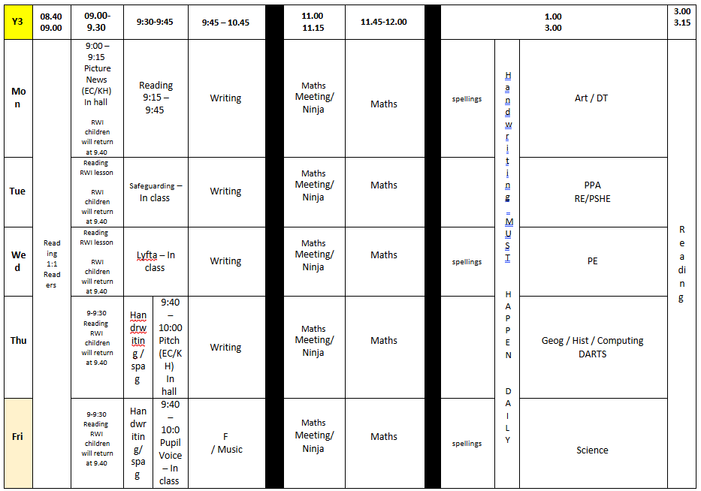
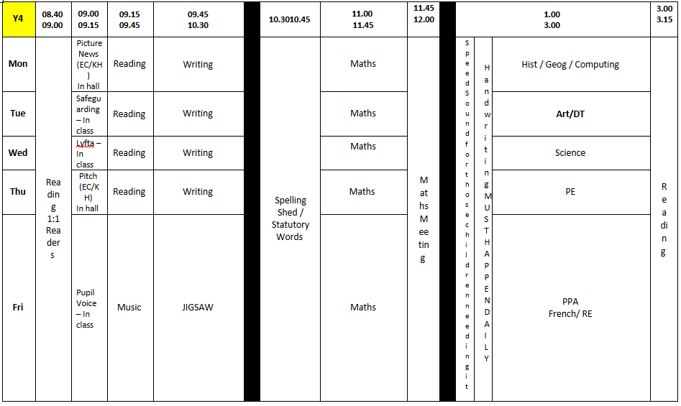

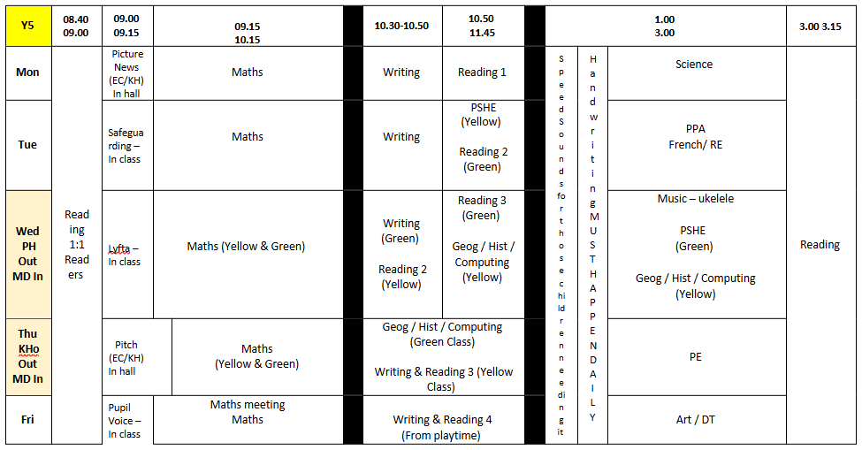

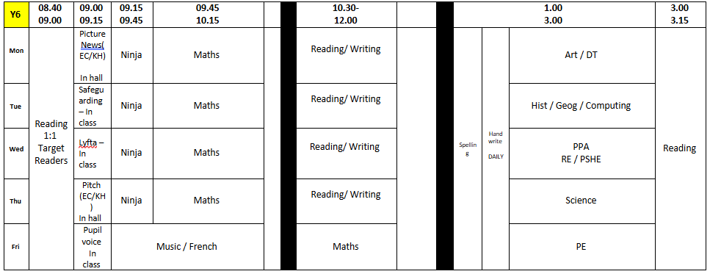

Year 3 Single Age Sequence 2025 – 2026
Autumn 2025 |  | Spring 2026 |  | Summer 2026
Reading  - Flat Stanley – Jeff Brown  - The Door – Miraskav Holub  - Esio Trot – Roald Dahl  - The Hare and Tortoise Greta and the Giants  - How Doth the Little Crocodile – Lewis Carroll |  | - Charlottes Web – E B White  - The Wild Way Home – Sophie Kirtley  - Stone Age Boy  - Ug  - Albatros – Laura Mucha  - Topsy Turvey World – William Brightly  - Rounds |  | - Roman Soldiers Handbook – Usborne  - Captive Celt – Terry Deary The River –  - Valarie Bloom Catch a little Thyme – Eve Merriam
Pathways Writing  - Seal Surfer – Michael Foreman – Recount / Letter in role  - Nen and the Lonely Fisherman – Ian Eagleton – Fiction – Fantasy Story |  | - The Fossil Girl – Catherine Brighton – Recount – Fossil journal  - The Silence Seeker – Ben Morley – Fiction – Story in 3rd person |  | - Journey – Aaron Becker – Fiction – Adventure Story  - A Stage full of Shakespeare – Angela McAllister – Non Fiction – Write a guide
NCETM Maths  - Adding and subtracting across 10  - Numbers to 1000 |  | - Right angles  - Multiplicative and additive relationship and securing mental calculation  - Column addition  - 2, 4, 8 times tables  - Column subtraction |  | - Unit fraction  - Non-unit fractions  - Parallel and perpendicular sides in polygons  - Time
CUSP Science  - Rocks  - Animals, including humans  - Revisit Rocks  (or alternative focus for insecure knowledge) |  | - Forces and magnets  - Plants |  | - Plants continued…  - Light
CUSP Art and Design  - Drawing and painting Block A  - Printmaking Block B |  | - Creative Response Block 2026  - Textiles and collage Block C |  | - 3D Block D  - Painting Block E
CUSP Design and Technology  - Textiles Block A  - Food and Nutrition Block B  Science – Animals including humans |  | - Mechanisms Block C  Science – Forces and magnets  Writing – Advanced instructional writing A  - Food and Nutrition Block D  Science – Animals including humans |  | - Systems Block E  - Structures Block F
CUSP Geography  - KS2 fieldwork and map skills – physical and human geography  - OS map skills and fieldwork |  | - UK Study |  | - UK Study continued  - Revisit countries, counties and regions of the UK  (or alternative focus for insecure knowledge)
CUSP History  - Stone Age – Iron Age |  | - Stone Age – Iron Age  - Rome and the impact on Britain |  | - Rome and the impact on Britain
CUSP French  - Greetings in the classroom  - Numbers, colours and emotions |  | - Introduictions and Questions  - Working together |  | - Playing together  - Eating together
Teach Computing  - Network Hunt  - Stop frame animation | - Stop frame animation  - Sequencing sounds | - Branching databases | Branching databases  Desk Top Publishing | Desk top publishing  - Events and actions in programs | - Events and actions in programs
Digital citizenship  - Device-Free Moments  - Lego Build & Talk: Screen Time  - Interland: Reality River | - Putting a STOP to Online Meanness  - Interland: Kind Kingdom | - Who Is in Your Online Community?  - Band Runner: Share | - We the  Digital Citizens  - Digital Trails  - Lego Build & Talk: False Information Online  - Interland: Reality River | - That's Private!  - Interland: Tower of Treasure  - Barefoot - Do the Right Thing | - We the  Digital Citizens  - BBC Own It: Where Are Your Photos Going?  - Lego Build & Talk: Digital Footprints
Charanga Music  - Writing music down | - Playing in a band | - Compose using your imagination | - More musical styles | - Enjoying improvisation | - Opening night concert
Your PE  - HOCKE  - TAG RUGBY  - Fundamental movement skills  - Ball skills  - Invasion skills |  | - Gymnastics  - Target games  - Dance |  | - Athletics  - Striking, fielding and catching  - Sports Day
Jigsaw PSHE  - Being me in my world | - Celebrating difference | - Dreams and goals | - Healthy Me | - Relationships | - Changing Me
Jigsaw RE  - Does visiting the Ganges make a person a better sanatani? | - Has Christmas lost its true meaning? | - Could Jesus heal people? Did he perform miracles or was there some other explanation | - What is ‘good’ about Good Friday? | - What do some deities tell Sanatanis about God? | - What motivates Humanists to lead good lives?
Lyfta  - Theme: Recycling and sustaibability. Net Zero campaign.  - Story World: One Billion Trees | - Theme: Celebrating Difference  - Story World: The Big Ballet Studio | - Theme: Dreams and Goals  - Story World: Ethiopian treasures | - Theme: Healthy Me  - Story World: Keep London Smiling | - Theme: Relationships  - Story World: Togetherness | - Theme: Changing Me / Transition  - Storyworld:  Last Child of Arki

Suggested Sequence
YEAR 3 Autumn 2025 |  |  |  | Weekly Science
Sep  1 | Geography | KS2 fieldwork and map skills – physical and human geography  Drawing and painting Block A |  | STRONG START | Rocks
Sep  1 | Art
8 | History | Stone Age – Iron Age  Drawing and painting |  | How are rocks formed? | Rocks
8 | Art
15 | Computing | Can a picture move? Frame by frame  Drawing and painting |  | What types of rocks are there? | Rocks
15 | Art
22 | Geography | KS2 fieldwork and map skills – physical and human geography  CUSP Money Matters Festival – Tuesday 23rd September  Textiles Block A |  | Can rocks change? | Rocks
22 | DT
29 | History | Stone Age – Iron Age  Textiles |  | How can we test a rock to see if it is limestone or chalk? | Rocks
29 | DT
Oct  6 | Computing | What’s the story? / Picture perfect  Textiles |  | Is soil just dirt? What makes soil? | Rocks
Oct  6 | DT
13 | Geography | KS2 fieldwork and map skills – physical and human geography  Printmaking Block B |  | How are fossils formed? | Rocks
13 | Art
20 | History | Stone Age – Iron Age  Printmaking
20 | Art
Oct  27 | ENRICHMENT - Use these flexible blocks to enrich the curriculum. The time can be allocated to any subject you choose, for example you could use it to support local mapwork, science fieldwork or museum visits.
Nov  3 | Half term
10 | Computing | Evaluate and make it great/ Lights camera action  Printmaking |  | What effect does the food we eat have? | Animals, including humans
10 | Art
17 | Geography | OS map skills and fieldwork  Food and Nutrition Block B |  | Where is my skeleton and what does it do? | Animals, including humans
17 | DT
24 | History | Stone Age – Iron Age  CUSP Spoken Language Festival – Tuesday 25th November  Food and Nutrition |  | Where are my muscles and what do they do? | Animals, including humans
24 | DT
Dec  1 | Computing | Introduction to Scratch / Programming Sprites  Food and Nutrition |  | How are rocks formed and what types are there? | Revisit Rocks
Dec  1 | DT
8 | Computing | Sequences/ Ordering commands |  | Remember: how can rocks change? | Revisit Rocks
8 | Computing | Looking good/ Making an instruments |  | Remember: how can rocks change? | Revisit Rocks
15 | Use these flexible blocks to enrich the curriculum. The time can be allocated to any term you choose, for example you could use it to support local mapwork, science fieldwork or museum visits. Term ends possibly Friday 20th December 2025. |  |  | Remember: how are fossils formed and how do we know? | Revisit Rocks

Suggested Sequence
YEAR 3 Spring 2026 |  |  |  | Weekly Science
Jan  5 | Geography | UK Study  Mechanisms Block C |  | STRONG START | Forces and magnets
Jan  5 | DT
12 | History | Stone Age – Iron Age  Mechanisms |  | What are contact forces? | Forces and magnets
12 | DT
19 | Computing | Yes or no questions/ Making groups  Mechanisms |  | How do surfaces affect the motion of an object? | Forces and magnets
19 | DT
26 | Geography | UK Study  CUSP Art Festival  Creative Response Block 2026 |  | How does friction affect moving objects? | Forces and magnets
26 | Art
Feb 2 | History | Stone Age – Iron Age  Creative Response |  | What is a non-contact force?  How is this different to a contact force? | Forces and magnets
Feb 2 | Art
9 | Computing | Creating a branching database/ Structuring a branching database  Creative Response |  | How do magnets attract and repel? | Forces and magnets
9 | Art
16 | Half term
23 | Geography | UK Study  Textiles and collage Block C |  | Which materials are magnetic? Forces and magnetism summary
23 | Art
Mar  2 | History | Rome and the impact on Britain  Textiles and collage |  | What are the parts of a flowering plant? What do they do? | Plants
Mar  2 | Art
9 | Computing | Planning a branching database / Two ways of presenting information  Textiles and collage |  | Do all plants need the same things to thrive and grow? | Plants
9 | Art
16 | Geography | UK Study  Food and Nutrition Block D |  | How do leaves make food for the plant? | Plants
16 | DT
23 | History | Rome and the impact on Britain  Food and Nutrition |  |  | Plants
23 | DT
 | Computing | Words and pictures/ Can you edit it?
Easter – possible dates are 30th April – 10th April 2026

Suggested Sequence

YEAR 3 Summer 2026 |  |  |  | Weekly Science
Apr  13 | Computing | Great template! / Becoming a designer  Food and Nutrition |  | STRONG START
Apr  13 | DT
20 | Geography | UK Study continued  3D Block D |  | How does water move through a plant? | Plants
20 | Art
27 | History | Rome and the impact on Britain  3D |  | What do flowers do? | Plants
27 | Art
May 4 | Computing | Lay it out/ why desktop publishing?  3D |  | What is pollination? | Plants
May 4 | Art
11 | Geography | UK Study continued  Systems Block E |  |  | Plants
11 | DT
18 | History | Rome and the impact on Britain  Systems |  |  | Plants
18 | DT
 | Computing | Moving a sprite / Maze movement
5 | Half Term
Jun  1 | Computing | Drawing lines / Adding features  Systems |  | Do we need light to see things? Remember: what are light sources and what are not light sources? | Light
Jun  1 | DT
8 | Geography | Revisit countries, counties and regions of the UK  Painting Block E |  | How are shadows formed? | Light
8 | Art
15 | History | Rome and the impact on Britain  CUSP Food Festival  Painting Block E |  | What happens to the size of a shadow when the object moves closer to, or away? | Light
15 | Art
22 | Computing | Debugging movement/ Making a project  Painting Block E
22 | Art
29 | Geography | Revisit countries, counties and regions of the UK  Structures Block F
29 | DT
Jul  6 | History | Rome and the impact on Britain  Structures
Jul  6 | DT
13 | Computing | Consolidation lesson.  Structures
13 | DT
20 | Term possibly ends 20th July 2026

Year 4 Single Age Sequence 2025 – 2026
Autumn 2025 |  | Spring 2026 |  | Summer 2026
Reading  - Hodgeheg – Dick king Smith  - Poetry – I’m walking with my Iguana – Brian Moses  - The Iron Man – Ted Hughes  - Robotics  - Rosie Revere Engineer  - The Night Before Christmas – Clement Clarke Moor |  | - The Pebble in my Pocket – Meredith Hooper  - How to Train a Dragon – Cressida Cowell  - I Get Loud – David Ouimet  - A Life in Dreams – Jacob Sam La Rose  - Wolf Wilder – Katherine Rundell  - The Wolves of Currumpaw – William Grill  - Wolves – Emily Gravett  - Wolves in the Walls – Neil Gaiman  - Dream Variations – Langston Hughes |  | - Wold Wilder – Katherine Rundell  - Something Told the Wild Geese – Rachel Field  - Beowulf – Michael Morpurgo  - A Small Dragon – Brian Pattern
Pathways Writing  - Gorilla – Anthony Browne – Fiction – Fantasy Story  - Leon and the Place Between – Graham Baker-Smith – Recount - Diary |  | - Our Tower – Joseph Coelho – Recount – Adventure from a viewpoint  - Amazing Islands – Sabrina Weiss & Kerry Hyndman  - Koji’s Island – The Literacy Company – Fiction – Adventure Story |  | - Alba the Hundred Year Old Fish – Lara Hawthorne – Non Fiction – Information Board  - Blue John – Berlie Doherty – Explanation/Letter in role as a caving expert
NCETM Maths  - Review of column addition and subtraction  - Numbers up to 10000  - Perimeter  - 3,6, 9 times tables |  | - 7 times tables and patterns  - Understanding and manipulating multiplicative relationships  - Co-ordinates  - Review of fractions |  | - Fractions greater than 1  - Symmetry in 2D shapes  - Time  - Division with remainder
CUSP Science  - Living things and their habitats  - States of matter |  | - Animals, including humans |  | - Electricity  - Sound
CUSP Art and Design  - Drawing Block A  - Painting Block B |  | - Creative Response Block 2026  - Printmaking and textiles Block C |  | - 3D and collage Block D  - Painting Block E
CUSP Design and Technology  - Food and Nutrition Block A  - Mechanisms Block B |  | - Textiles Block C  - Structures Block D |  | - Electrical systems Block E  Science - Electricity  - Food and Nutrition Block F  Science – Animals including humans
CUSP Geography  - Rivers  - Latitude and longitude |  | - Latitude and longitude  - Water cycle |  | - Water cycle  - Map skills & Environmental regions
CUSP History  - Britain’s settlement by Anglo-Saxons and Scots  - Viking and Anglo-Saxon struggle for the Kingdom of England to the time of Edward the Confessor |  | - Viking and Anglo-Saxon struggle for the Kingdom of England to the time of Edward the Confessor  - Ancient civilisation: Egypt or Shang Dynasty |  | - Ancient civilisation – Egypt or Shang Dynasty
CUSP French  - The calendar  - Colours, numbers and emotions  - Items from Daily life |  | - Items from Daily life  - Learning together |  | - The Natural World  - Celebration  - Local Places
Teach Computing  - Selecting search activity & ranking  - Audio production | - Repition in shapes  - Data logging | - Data logging | - Photo editing | - Photo editing | - Repetition in games
Digital citizenship  - Your Rings of Responsibility  - The Adventures of Kara, Winston and the SMART Crew: Chapter 1 | - The Power of Words  - Lego Build & Talk: Cyberbullying  - Band Runner: Like | - Our Digital Citizenship Pledge  - Band Runner: Chat | - Is Seeing Believing?  - Interland: Mindful Mountain | - Password Power-Up  - Lego Build & Talk: Online Security  - Barefoot - You’re the Jury | - This Is Me  - The Adventures of Kara, Winston and the SMART Crew: Chapter 4
Charanga Music  - Musical structures | - Exploring feelings when you play | - Music with your friends | - Feelings through music | - Expression and improvisation | - The show must go on
Your PE  - Fundamental movement skills  - Ball Skills  - Invasion games |  | - Gymnastics  - Target games  - Dance |  | - Athletics  - Striking, fielding and catching  - Sports Day
Jigsaw PSHE  - Being me in my world | - Celebrating difference | - Dreams and goals | - Healthy me | - Relationships | - Changing me
Jigsaw RE  - Does joining Khalsa make someone a better Sikh? | - What is the most significant part of the nativity story for Christians today? | - Do Sikhs think it is important to share? | - Is forgiveness always possible for Christians? | - Do people need to go to Church to show they are Christians? | - Does praying at regular intervals help Muslims in their everyday lives?
Lyfta  - Theme: 7-11 years, KS2, Science, Living Things and Their Habitats | - Theme: 7-11 years, KS2, Geography, Rivers | - Theme: Exploring Egypt | - Theme:Ambition and success  - Storyworld: Secrets of the Opera: Big Ballet Studio (Finland) | - Theme: 7-11 years, KS2, Science, Electricity | - Theme: Passion and Dreams  - StoryWorld: The Hip Hop Star (Belgium)

Suggested Sequence
YEAR 4 Autumn 2025 |  |  |  | Weekly Science 1.5 hours
Sep  1 | Geography | Rivers  Drawing Block A |  | STRONG START | Living things and their habitats
Sep  1 | Art
8 | History | Britain’s settlement by Anglo-Saxons and Scots  Drawing |  | What are the characteristics of living things? | Living things and their habitats
8 | Art
15 | Computing | Recording sound/ Editing audio  Drawing |  | What animals are vertebrates? | Living things and their habitats
15 | Art
22 | Geography | Rivers  CUSP Money Matters Festival – Tuesday 23rd September  Food and Nutrition Block A |  | What animals are invertebrates? | Living things and their habitats
22 | DT
29 | History | Britain’s settlement by Anglo-Saxons and Scots  Food and Nutrition |  | What groups are plants classified in? | Living things and their habitats
29 | DT
Oct  6 | Computing | Planning a podcast / Creating a podcast  Food and Nutrition |  | What is classification?  How do I use a key? | Living things and their habitats
Oct  6 | DT
13 | Geography | Rivers  Painting Block B |  | What happens if the environment in a habitat changes? | Living things and their habitats
13 | Art
20 | History | Britain’s settlement by Anglo-Saxons and Scots  Painting
20 | Art
 | Computing | Behind the scenes/ Evaluating podcasts |  | Computing
Oct  27 | ENRICHMENT - Use these flexible blocks to enrich the curriculum. The time can be allocated to any subject you choose, for example you could use it to support local mapwork, science fieldwork or museum visits. |  |  | What is matter?  What does ‘state’ mean?
Nov  3 | Half term
10 | Computing | Programming a screen turtle/ Programming letters  Painting |  | What are solids, liquids and gases? | States of matter
10 | Art
17 | Geography | Latitude and longitude  Mechanisms Block B |  | Melting: how do materials change state? | States of matter
17 | DT
24 | History | Britain’s settlement by Anglo-Saxons and Scots  CUSP Spoken Language Festival – Tuesday 25th November  Mechanisms |  | Evaporating: how do materials change state? | States of matter
24 | DT
Dec  1 | Computing | Patterns and repeats/ Using loops to create shapes  Mechanisms |  | Condensing: how do materials change state? | States of matter
Dec  1 | DT
8 | Computing | Breaking things down / Creating a program.  Answering questions/ Data collection |  | Summary: how do materials change their state of matter? | States of matter
8 | Computing
15 | Use these flexible blocks to enrich the curriculum. The time can be allocated to any term you choose, for example you could use it to support local mapwork, science fieldwork or museum visits. Term ends possibly Friday 19th December 2025.

Suggested sequence
YEAR 4 Spring 2026 |  |  |  | Weekly Science
Jan  5 | Geography | Latitude and longitude  Textiles Block C |  | STRONG START | Animals, including humans
Jan  5 | DT
12 | History | Viking and Anglo-Saxon struggle for the Kingdom of England to the time of Edward the Confessor  Textiles |  | What teeth do humans have?  What do they do? | Animals, including humans
12 | DT
19 | Computing | Logging/ Analysing data  Textiles |  | How does our mouth and teeth help digestion? What’s the process? | Animals, including humans
19 | DT
26 | Geography | Latitude and longitude  CUSP Art Festival  Creative Response Block 2026 |  | Can teeth tell us what animals eat? | Animals, including humans
26 | Art
Feb  2 | History | Viking and Anglo-Saxon struggle for the Kingdom of England to the time of Edward the Confessor  Creative Response |  | What are the parts of the digestive system?  What do they do? | Animals, including humans
Feb  2 | Art
9 | Computing | Data for answers / Answering my question  Creative Response |  | How does digestion work? What’s the process? | Animals, including humans
9 | Art
16 | Half term
23 | Geography | Latitude and longitude  Printmaking and textiles Block C |  | How does digestion work? What’s the process?
23 | Art
Mar  2 | History | Viking and Anglo-Saxon struggle for the Kingdom of England to the time of Edward the Confessor  Printmaking and textiles |  | What are food chains How do they work? | Animals, including humans
Mar  2 | Art
9 | Computing | Changing digital images / Recolouring  Printmaking and textiles |  | How do I construct and interpret a food chain? | Animals, including humans
9 | Art
16 | Geography | Water cycle  Structures Block D |  | SUMMARY  How are teeth, digestion and food chains connected?? | Animals, including humans
16 | DT
23 | History | Ancient civilisation – Egypt / Shang Dynasty  Structures |  |  | Animals, including humans
23 | DT
Easter – possible dates are 30th April – 10th April 2026

Suggested sequence

YEAR 4 Summer 2026 |  |  |  | Weekly Science
Apr  13 | Computing | Cloning / Combining  Structures |  | STRONG START
Apr  13 | DT
20 | Geography | Water cycle  3D and collage Block D |  | What appliances use electricity? What sort of power makes them work? | Electricity
20 | Art
27 | History | Ancient civilisation – Egypt / Shang Dynasty  3D and collage |  | What are the components in a simple series circuit? | Electricity
27 | Art
May 4 | Computing | Creating / Evaluating  3D and collage |  | What are the effects of changing circuit components and batteries? | Electricity
May 4 | Art
11 | Geography | Environmental regions – map skills  Electrical systems Block E |  |  | Electricity
11 | DT
18 | History | Ancient civilisation – Egypt / Shang Dynasty  Electrical systems |  |  | Electricity
18 | DT
25 | Half Term
Jun  1 | Computing | Using Loops to creat shapes/ DIfferent loops  Electrical systems |  | What is sound? | Sound
Jun  1 | DT
8 | Geography | Environmental regions – map skills  Painting Block E |  | How does sound travel? | Sound
8 | Art
15 | History | Ancient civilisation – Egypt / Shang Dynasty  CUSP Food Festival  Painting |  | What is the pitch and loudness of sound? | Sound
15 | Art
22 | Computing | Animate your name/ Modifying a game  Painting |  |  | Sound
22 | Art
29 | Geography | Environmental regions – map skills  Food and Nutrition Block F
29 | DT
Jul  6 | History | Ancient civilisation – Egypt / Shang Dynasty  Food and Nutrition
Jul  6 | DT
13 | Computing | Designing a game / Creating our games.  Food and Nutrition
13 | DT
20 | Term possibly ends 20th July 2026

Year 5 Single Age Sequence 2025 – 2026
Autumn 2025 |  | Spring 2026 |  | Summer 2026
Reading  - Put Out the Light – Terry Deary  - Charge of the Light Brigade – Alfred Lord Tennyson  - Polar Bear Explorers Club – Alex Bell Everest – Alexandra Stewart / Joe Todd Stanton |  | - Who Let the Gods Out – Maz Evans Greek Myths and Mazes  - Mythologica If – Rudyard Kipling |  | - Nowhere Emporium – Ross MacKenzie  - Bubble Boy – Stewart Foster Poetry  - The Pobble who Had no Toes – Edward Lear  - The Great Kapok Tree – Lynne Cherry  - The Quest for Z – Greg Pizzoli  - The tiger – William Blake Jabberwocky – Lewis Carroll
Pathways Writing  - Queen of the Falls – Chris Van Allsburg – Recount - Series of diary entries  - The Lost Happy Endings – Carol Ann Duffy – Fiction – Traditional Tale with alternative ending |  | - Arthur and the Golden Rope – Joe Todd Stanton – Fiction – Myth  - The Darkest Dark – Chris Hadfield – Recount – Formal Biography of Chris Hadfield |  | - The Brilliant Deep – Kate Messner – Persuasion information leaflet  - Bold and Brave Women – Shakespeare – Recount - write and perform soliloquys
NCETM Maths  - Decimal fractions  - Money  - Negative numbers  - Short multiplication and short division |  | - Area and scaling  - Calculating with decimal fractions  - Factors, multiples and primes  - Fractions |  | - Fractions  - Converting units  - Angles  - Shape  - Transformations
CUSP Science  - Properties and changes of materials  - Animals, including humans |  | - Forces (Gravity and Galileo)  - Earth in space |  | - Living things and their habitats  - Forces (continued)
CUSP Art and Design  - Drawing and painting Block A  - Printmaking Block B |  | - Creative Response Block 2026  - Textiles and collage Block C |  | - 3D Block D  - Painting Block E
CUSP Design and Technology  - Food and Nutrition Block A  - Systems Block B |  | - Textiles Block C  Writing Formal Letters of Application B  - Food and Nutrition Block D  Geography World Biomes |  | - Structures Block E  - Mechanisms Block F  Science Forces
CUSP Geography  - World countries – biomes and environmental regions |  | - 4 and 6 figure grid references |  | - OS maps and fieldwork
CUSP History  - Ancient Greece |  | - Ancient Greece  - Comparison study – Maya or Benin and Anglo-Saxons  or Golden Age of Islam (New) |  | - Comparison study  Maya or Benin and Anglo-Saxons
CUSP French  - Local places  - Emotions and numbers 0-100  - Friends and family  - Working together |  | - Working together  - Playing together  - Eating together  - Where I live |  | - Emotions and numbers beyond 100  - Items from daily life  - Learning together  - The Natural World  - Visiting France
Teach Computing  - Modelling the internet  - Video production | - Selection in physical computing | - Flat file databases | - Flat file databases | - Vector graphics | - Vector graphics  - Quizzes
Digital citizenship  - My Media Choices  - Social Media Test Drive  - Band Runner: Lock  - BBC Own It - Health, Wellbeing and Lifestyle | - Be a Super Digital Citizen  - BBC Own It: Cyberbullying Quiz  - BBC Own It - Online Bullying | - Keeping Games Fun and Friendly  - What is AI?  - Adventures of Kara, Winston and the SMART Crew: Ch. 5  - BBC Own It - Online Relationships + Online Reputation | - A Creator's Rights and Responsibilities  - Digital Matters - Introduction to Thinking Critically Online  - BBC Own It - Managing Online Information  - NCSC Cyber Sprinters | - Private and Personal Information  - Barefoot - The Phisherman game  - BBC Own It - Privacy & Security | - Our Online Tracks  - Search It Up: My Popstar Disaster  - BBC Own It - Self-Image & Identity
Charanga Music  - Melody and harmony in music | - Sing and play in different styles | - Composing and chords | - Enjoying musical styles | - Freedom to improvise | - Battle of the bands
Your PE  - Fundamental movement skills  - Ball skills  - Invasion games |  | - Gymnastics  - Target fames  - Dance |  | - Athletics  - Striking, fielding and catching  - Sports day
Jigsaw PSHE  - Being in my world | - Celebrating difference | - Dreams and goals | - Healthy Me | - Relationships | - Changing Me
Jigsaw RE  - What is the best way for a Muslim to show committment to God? | - Is the Christmas Story true? | - What is the best way for a Sanatani to show committment to God? | - How significant is it for Christians to believe that God intended Jesus to die? | - How is Qur’an vital to Muslims today? | - What is the best way for a Christian to show commitment to God?
Lyfta  - Theme: Recycling and sustaibability. Net Zero campaign.  - Story World: Amazonian Treats | - Theme: Celebrating Difference  - Story World: Diverse Families | - Theme: Dreams and Goals  - Story World: Becoming Me: The Brave on the Pitch | - Theme: Healthy Me  - Story World: Kihamba Life | - Theme: Relationships  - Story World:  Muhammed’s Home | - Theme: Changing Me / Transition  - Story World: Becoming Me

Suggested Sequence
YEAR 5 Autumn 2025 |  |  |  | Weekly Science 1.5 hours
Sep  1 | Geography | World countries - biomes and environmental regions  Drawing and painting Block A |  | STRONG START | Properties and changes of materials
Sep  1 | Art
8 | History | Ancient Greece  Drawing and painting |  | What properties do materials have? How do we use them? | Properties and changes of materials
8 | Art
15 | Computing | What is video? / Filming techniques  Drawing and painting |  | What is a solution and what is a mixture? | Properties and changes of materials
15 | Art
22 | Geography | World countries - biomes and environmental regions  CUSP Money Matters Festival – Tuesday 23rd September  Food and Nutrition Block A |  | How can we separate materials from a mixture? | Properties and changes of materials
22 | DT
29 | History | Ancient Greece  Food and Nutrition |  | How can we separate materials from a solution? | Properties and changes of materials
29 | DT
Oct  6 | Computing | Using a storyboard/ Planning a video  Food and Nutrition |  | What changes are reversible? | Properties and changes of materials
Oct  6 | DT
13 | Geography | World countries - biomes and environmental regions  Printmaking Block B |  | What changes are irreversible? | Properties and changes of materials
13 | Art
20 | History | Ancient Greece  Printmaking  Importing and editing video/ Video evaluation |  | Computing | Properties and changes of materials
20 | Art
20 | Computing
Oct  27 | ENRICHMENT - Use these flexible blocks to enrich the curriculum. The time can be allocated to any subject you choose, for example you could use it to support local mapwork, science fieldwork or museum visits.
Nov  3 | Half term
10 | Computing | Connecting crumbles / Combining output components  Printmaking |  | What is the human timeline? | Animals, including humans
10 | Art
17 | Geography | World countries - biomes and environmental regions  Systems Block B |  | How do we change into adults? | Animals, including humans
17 | DT
24 | History | Ancient Greece  CUSP Spoken Language Festival – Tuesday 25th November  Systems |  | How do human and animal lifespans compare? | Animals, including humans
24 | DT
Dec  1 | Computing | Controlling with conditions/ Starting with selection  Systems |  |  | Animals, including humans
Dec  1 | DT
8 | Geography | World countries – biomes and environmental regions  Ancient Greece  Drawing designs / Writing and testing algorithms |  |  | Animals, including humans
8 | History
8 | Computing
15 | Use these flexible blocks to enrich the curriculum. The time can be allocated to any term you choose, for example you could use it to support local mapwork, science fieldwork or museum visits. Term ends possibly Friday 19th December 2025.

Suggested Sequence
YEAR 5 Spring 2026 |  |  |  | Weekly Science
Jan  5 | Geography | 4 and 6 figure grid references  Textiles Block C |  | STRONG START | Forces
Jan  5 | DT
12 | History | Ancient Greece  Textiles |  | Remember gravity  When is friction helpful and when is it not? | Forces
12 | DT
19 | Computing | Creating a paper-based database/ Computer databases  Textiles |  | What’s the effect of  air resistance? | Forces
19 | DT
26 | Geography | 4 and 6 figure grid references  CUSP Art Festival  Creative Response Block 2026 |  | What’s the effect of water resistance? | Forces
26 | Art
Feb  2 | History | Ancient Greece  Creative Response Block 2026 |  | Who was Galileo Galilei? | Forces
Feb  2 | Art
9 | Computing | Using a database/ Using search tools  Creative Response Block 2026 |  |  | Forces
9 | Art
16 | Half Term
23 | Geography | 4 and 6 figure grid references  Textiles and collage Block C |  | What are the planets in our solar system? | Earth and space
23 | Art
Mar  2 | History | Comparison study – Maya and Anglo-Saxons or Benin  Textiles and collage |  | How does our view of the Moon change in a lunar month? | Earth and space
Mar  2 | Art
9 | Computing | Comparing data visually/ Databases in real life  Textiles and collage |  | Why does the rotation of Earth result in night and day? | Earth and space
9 | Art
16 | Geography | 4 and 6 figure grid references  Food and Nutrition Block D |  | Why is the Earth’s tilt (axis) responsible for the seasons? | Earth and space
16 | DT
23 | History | Comparison study – Maya or Benin and Anglo-Saxons  Food and Nutrition |  | Review, summarise and present what you know about Earth and Space | Earth and space
23 | DT
Easter – possible dates are 30th April – 10th April 2026

Suggested Sequence
YEAR 5 Summer 2026 |  |  |  | Weekly Science
Apr  13 | Computing | The drawing tools/ Creating images  Food and Nutrition |  | STRONG START
Apr  13 | DT
20 | Geography | OS maps and fieldwork  3D Block D |  | Life cycle differences – what’s the difference between a mammal and an amphibian? | Living things sand their habitats
20 | Art
27 | History | Comparison study – Maya or Benin and Anglo-Saxons  3D |  | Life cycle differences – what’s the difference between an insect and a bird? | Living things sand their habitats
27 | Art
May 4 | Computing | Making effective drawings / Layers and objects  3D |  | What is similar and what is different between the life cycles of a mammal, an insect, an amphibian and a bird? | Living things sand their habitats
May 4 | Art
11 | Geography | OS maps and fieldwork  Structures Block E |  | Summer birds – who was Maria Merion and what did she do? | Living things sand their habitats
11 | DT
18 | History | Comparison study – Maya or Benin and Anglo-Saxons  Strutures |  | The science of life - how do living things reproduce? | Living things sand their habitats
18 | DT
25 | Half Term
Jun  1 | Computing | Manipulating objects / Becoming a graphic designer.  Structures |  | Plants and animals: what’s the life process of reproduction?
Jun  1 | DT
8 | Geography | OS maps and fieldwork  Painting Block E
8 | Art
15 | History | Comparison study – Maya or Benin and Anglo-Saxons  CUSP Food Festival  Painting |  | How do levers help us? | Forces continued
15 | Art
22 | Computing | Exploring conditions/ Selecting outcomes  Painting |  | How do pulleys and gears help us? | Forces continued
22 | Art
29 | Geography | OS maps and fieldwork  Mechanisms Block F |  |  | Forces continued
29 | DT
Jul  6 | History | Comparison study – Maya or Benin and Anglo-Saxons  Mechanisms  Asking questions / Planning a quiz |  |  | Forces continued
Jul  6 | DT
Jul  6 | Computing
13 | Computing | Testing a quiz/ Evaluating a quiz  Mechanisms |  |  | Forces continued
13 | DT
20 | Term possibly ends 20th July 2026

Year 6 Single Age Sequence 2025 – 2026
Autumn 2025 |  | Spring 2026 |  | Summer 2026
Reading  - Granny – Anthony Horowitz Dementia Leaflet – NHS  - Little Red Riding Hood and the Wolf – Roald Dahl  - The Explorer – Katherine Rundell  - In Flanders Field A Ballard of London – Richard Le Galliean |  | - Holes – Luis Sachar  - I Wandered Lonely as a Cloud – William Wordsworth  - Tell Tale Heart – Edgar Alan Poe  - The Highway Man – Alfred Noyes |  | - Silver Sword – Ian Serriallier Skyward  - Diary of Anne Frank Refugees  - SATs revision – short text extracts  - The Flower Boy – Keith Champion  - Oh the Places You Will Go – Dr Seuss  - Transitional Text
Pathways Writing  - Star of Fear, Star of Hope – Jo Hoestlandt – Fiction – Flashback and Non Chronological Report  - The Place for Me: Stories about the Windrush Generation – K N Chimbiri – Information / Recount / Explanation Hybrid Leaflet |  | - Shackleton’s Journey – William Grill – Recount – Writing a journal  - The Day War Came – Nicola Davies – Persuasion – Letter |  | - Manfish – Jennifer Berne – Recount – Biography of Jacques Cousteau – Fiction – Adventure Story  - Sky Chasers – Emma Carroll – Fiction – Adventure Story and Recount - autobiography
NCETM Maths  - Calculating using knowledge of structures  - Multiples of 1000  - Numbers up to 10,000,000  - Draw, compose and decompose shapes |  | - Multiplication and division  - Area, perimeter, position and direction  - Fractions and percentages |  | - Statistics  - Ratio and proportions  - Calculating using knowledge of structures  - Solving problems with two unknowns  - Ordere of operations  - Mean average
CUSP Science  - Electricity  - Animals including humans |  | - Animals including humans (+ water transport)  - Light |  | - Living things and their habitats  - Evolution and inheritance
CUSP Art and Design  - Drawing Block A  - Painting and collage Block B |  | - Creative Response Block 2026  - Printmaking and textiles Block C |  | - 3D Block D  - Painting Block E
CUSP Design and Technology  - Food and Nutrition Block A  Writing – Discursive writing and speeches  - Mechanisms Block B |  | - Food and Nutrition Block C  - Structures Block D |  | - Electrical systems Block E  Science – Electricity  - Textiles Block F
CUSP Geography  - Physical processes |  | - Human and Physical Geography: Economic, settlement and trade links  - UK, Europe and N America comparison study |  | - UK, Europe and N America comparison study  - OS Maps and fieldwork (orienteering)
CUSP History  - Beyond 1066  - Local History Study - how did conflict change our locality in World War 2? |  | - Windrush generation |  | - 5 significant monarchs or  Battle of Britain
CUSP French
Teach Computing  - Computing systems and networks (2 weeks)  - Webpage creation | - Variables and games | - Introduction to spreadsheets | - Introduction to spreadsheets | - 3D modelling | - Sensing movement
Digital citizenship  - Finding My Media Balance  Social Media Test Drive  - Internet Matters - Health, Wellbeing and Lifestyle  - Children's Commissioner: Digital 5 a Day | - Is It Cyberbullying?  - Internet Matters - Online Bullying  - Chicken-Shop Grooming (Childnet) | - Digital Friendships  - What is AI? How is AI Trained? AI Chatbots: Who’s Behind the Screen?  - Internet Matters - Online Relationships + Online Reputation  - Childnet: Trust Me Lessons | - Reading  News Online  - Digital Matters - Once Upon Online  - Internet Matters - Managing Online Information + Copyright & Ownership  - BBC Young Reporter - Fake News  - Project Real Fake News | - You Won't Believe This!  - NCSC Cyber Sprinters  - Internet Matters - Privacy & Security +  - Digital Matters  - Barefoot - You’re the Cyber Security Expert | - Beyond Gender Stereotypes  - Internet Matters - Self-Image & Identity  - Are You Living an Insta Lie? Social Media vs. Reality
Charanga Music  - Music and technology | - Developing ensemble skills | - Creative composition | - Musical styles connect us | - Improvising with confidence | - Farewell Tour
Your PE  - Fundamental movement skills  - Ball skills  - Invasion games |  | - Gymnastics  - Target games  - Dance |  | - Athletics  - Striking, fielding and catching  - Sports day
Jigsaw PSHE  - Being me in my world | - Celebrating difference | - Dreams and goals | - Healthy Me | - Relationship | - Changing Me
Jigsaw RE  - How do inspirational people impact on how Humanists live today?  Humanism Unit 1 | - How significant is it that Mary was Jesus’ mother? | - Is anything ever eternal? | - Is Christianity still a strong religion over 2000 years after Jesus was on Earth | - Does belief in Akhirah (life after death) help Muslims lead a good life? | - How do inspirational people impact on how Humanists live today?
Lyfta  - Theme: Diversity and difference  - Storyworld: Becoming Me (Denmark) Series |  | - Theme: Dreams and dancing  - Storyworld: Dancing in the Land of Fire (Azerbaijan) | - Theme: Mountains and volcanoes  - Storyworld: We live among volcanoes. | - Theme: War and anomosity – recall from Autumn term  - Storyworld: 7-11 years, Y5 Summer 2025 - Is war ever right? | - Theme: Electricity  - Storyworld: 7-11 years, KS2, Science, Electricity

Suggested Sequence
Year 6 Autumn 2025 |  |  |  | Weekly Science
Sep  1 | Geography | Physical processes  Drawing Block A |  | STRONG START
Sep  1 | Art
8 | History | Local History Study - how did conflict change our locality in World War 2?  Drawing |  | What is electricity? How does it work? | Electricity
8 | Art
15 | Computing | What makes a good website/ Becoming a web designer  Drawing |  | What are the components in a series circuit? | Electricity
15 | Art
22 | Geography | Physical processes  CUSP Money Matters Festival – Tuesday 23rd September  Food and Nutrition Block A |  | What are the effects and consequences of changing circuit components and batteries? | Electricity
22 | DT
29 | History | Local History Study - how did conflict change our locality in World War 2?  Food and Nutrition |  |  | Electricity
29 | DT
Oct  6 | Computing | Copyright or copy wrong/ How does it look?  Food and Nutrition |  |  | Electricity
Oct  6 | DT
13 | Geography | Physical processes  Painting and collage Block B  Follow the breadcrumbs/ Think before you link! |  | Computing | Electricity
13 | Art
13 | Computing
20 | History | Local History Study - how did conflict change our locality in World War 2?  Painting and collage |  | What is blood made of and why do we need it?
20 | Art
Oct  27 | ENRICHMENT - Use these flexible blocks to enrich the curriculum. The time can be allocated to any subject you choose, for example you could use it to support local mapwork, science fieldwork or museum visits. |  |  | Why do our bodies need nutrients and how are they transported?
Nov  3 | Half term
10 | Computing | Introducing variables / Variables in programming  Painting and collage |  | What is our circulatory system? | Y6 Animals including humans
10 | Art
17 | Geography | Physical processes  Electrical systems Block E |  | What is our heart like inside?  How does it work? | Y6 Animals including humans
17 | DT
24 | History | Local History Study - how did conflict change our locality in World War 2?  CUSP Spoken Language Festival – Tuesday 25th November  Electrical systems |  | Who influenced what we know about our circulatory system? | Y6 Animals including humans
24 | DT
Dec  1 | Computing | Improving a game/ Becoming a games designer  Electrical systems |  | What can we do to keep healthy? | Y6 Animals including humans
Dec  1 | DT
8 | Geography | Physical processes  Local History Study - how did conflict change our locality in World War 2?  Design to code/ Improving and sharing. |  | Present and explain what we know about the circulatory system, nutrients and keeping healthy | Y6 Animals including humans
8 | History
8 | Computing
15 | Use these flexible blocks to enrich the curriculum. The time can be allocated to any term you choose, for example you could use it to support local mapwork, science fieldwork or museum visits. Term ends possibly Friday 19th December 2025

Suggested Sequence
Year 6  Spring 2026 |  |  |  | Weekly Science
Jan  5 | Geography | Settlements  Food and Nutrition Block C |  | STONG START | Animals, including humans
Jan  5 | DT
12 | History | Windrush generation  Food and Nutrition |  | Remember circulation and digestion: how are these two systems connected? | Animals, including humans
12 | DT
19 | Computing | Collecting data/ Formatting a spreadsheet  Food and Nutrition |  | Where are the kidneys and what do they do? | Animals, including humans
19 | DT
26 | Geography | Settlements  CUSP Art Festival  Creative Response Block 2026 |  | How do kidneys keep us healthy? | Animals, including humans
26 | Art
Feb  2 | History | Windrush generation  Creative Response |  |  | Animals, including humans
Feb  2 | Art
9 | Computing | What’s the formula? / Calculate and duplicate  Creative Response
9 | Art
16 | Half term
23 | Geography | UK, Europe and N America comparison study  Printmaking and textiles Block C |  | How does light travel? | Light
23 | Art
Mar  3 | History | Windrush generation  Printmaking and textiles |  | What colour is light made of? | Light
Mar  3 | Art
10 | Computing | Event planning / Presenting Data  Printmaking and textiles |  | Reflection - how does light help us to see objects? | Light
10 | Art
17 | Geography | UK, Europe and N America comparison study  Structures Block D |  | Which surfaces make the best reflectors? | Light
17 | DT
24 | History | Windrush generation  Structures |  | Why do we see objects as a particular colour? | Light
24 | DT
31 | Computing | Introduction to 3D modelling/ Modifying 3D objects  Structures |  | What happens to the appearance of objects when placed in water? | Light
31 | DT
Easter – possible dates are 30th April – 10th April 2026

Suggested Sequence
Year 6  Summer 2026 |  |  |  | Weekly Science
Apr  13 | Computing | Make your own name badge/ Making a desk tidy  Structures |  | STRONG START
Apr  13 | DT
20 | Geography | UK, Europe and N America comparison study  3D Block D |  | Who was the scientist Carl Linnaeus and what did he do? | Living things and their habitats
20 | Art
27 | History | Five significant monarchs Or Battle of Britain  3D |  | How do we classify vertebrates? | Living things and their habitats
27 | Art
May 4 | Computing | Planning a 3D model/ Make your own 3D model.  3D |  | How do we classify invertebrates we know? | Living things and their habitats
May 4 | Art
11 | Geography | UK, Europe and N America comparison study  Electrical systems Block E |  | SATS Week  How do we classify invertebrates we don’t know? (Sponges, Jellyfish and Flatworms) | Living things and their habitats
11 | DT
18 | History | Five significant monarchs Or Battle of Britain  Electrical systems |  | What are microorganisms? | Living things and their habitats
18 | DT
25 | Half Term
Jun  1 | Computing | The Microbit / Go with the flow  Electrical systems |  | How do we classify plants?
Jun  1 | DT
8 | Geography | OS Maps and fieldwork (orienteering)  Painting Block E |  | How have living things changed over time? How do we know? | Y6 Evolution and inheritance
8 | Art
15 | History | Five significant monarchs Or Battle of Britain  CUSP Food Festival  Painting |  | How has life evolved over time? | Y6 Evolution and inheritance
15 | Art
22 | Computing | Sensing inputs / Finding your way  Painting |  | What is DNA and what does it do? Working scientifically | Y6 Evolution and inheritance
22 | Art
29 | Geography | OS Maps and fieldwork (orienteering)  Textiles Block F |  | Are all offspring identical to their parents? | Y6 Evolution and inheritance
29 | DT
Jul  6 | History | Five significant monarchs Or Battle of Britain  Textiles |  | Darwin and Wallace – what evidence did they share to argue the case for evolution? | Y6 Evolution and inheritance
Jul  6 | DT
13 | Computing | Designing a step counter  Textiles |  | Survival of the fittest - how have animals adapted and evolved to suit their environment? | Y6 Evolution and inheritance
13 | DT
20 | Term possibly ends 20th July 2026 |  |  |  | Y6 Evolution and inheritance

