
Date | September 2026
Prepared by | Town Field Primary
Approved by | Local Governing Body
Review Date | September 2027  or earlier if there are changes to the relevant legislation
Version | V1
Supporting Children with Medical Needs Policy


Contents
1. Aims 3
2. Legislation and statutory responsibilities 3
3. Roles and responsibilities 4
4. Equal opportunities 5
5. Being notified that a child has a medical condition 5
6. Individual healthcare plans 5
7. Managing medicines 6
8. Emergency procedures 7
9. Training 7
10. Medical conditions register 8
11. Record keeping 8
12. Liability and indemnity 8
13. Complaints 8
14. Monitoring arrangements 8
15. Links to other policies 8

Appendix 1: Being notified a child has a medical condition 9

1. Aims
This policy aims to ensure that:
- Pupils, staff and parents/carers understand how our school will support pupils with medical conditions
- Pupils with medical conditions are properly supported to allow them to access the same education as other pupils, including school trips and sporting activities
The governing board will implement this policy by:
- Making sure sufficient staff are suitably trained
- Making staff aware of pupils’ conditions, where appropriate
- Making sure there are cover arrangements to ensure someone is always available to support pupils with medical conditions
- Providing supply teachers with appropriate information about the policy and relevant pupils
- Developing and monitoring individual healthcare plans (IHPs)

2. Legislation and statutory responsibilities
This policy meets the requirements under Section 100 of the Children and Families Act 2014, which places a duty on governing boards to make arrangements for supporting pupils at their school with medical conditions.
It is also based on the Department for Education (DfE)’s statutory guidance on supporting pupils with medical conditions at school.

3. Roles and responsibilities
3.1 The governing board
The governing board has ultimate responsibility to make arrangements to support pupils with medical conditions. The governing board will ensure that sufficient staff have received suitable training and are competent before they are responsible for supporting children with medical conditions.
3.2 The headteacher
The headteacher will:
- Make sure all staff are aware of this policy and understand their role in its implementation
- Ensure that there is a sufficient number of trained staff available to implement this policy and deliver against all individual healthcare plans (IHPs), including in contingency and emergency situations
- Ensure that all staff who need to know are aware of a child’s condition
- Take overall responsibility for the development of IHPs
- Make sure that school staff are appropriately insured and aware that they are insured to support pupils in this way
- Contact the school nursing service in the case of any pupil who has a medical condition that may require support at school, but who has not yet been brought to the attention of the school nurse
- Ensure that systems are in place for obtaining information about a child’s medical needs and that this information is kept up to date

3.3 Staff
Supporting pupils with medical conditions during school hours is not the sole responsibility of 1 person. Any member of staff may be asked to provide support to pupils with medical conditions, although they will not be required to do so. This includes the administration of medicines.
Those staff who take on the responsibility to support pupils with medical conditions will receive sufficient and suitable training, and will achieve the necessary level of competency before doing so.
Teachers will take into account the needs of pupils with medical conditions that they teach. All staff will know what to do and respond accordingly when they become aware that a pupil with a medical condition needs help.
3.4 Parents/carers
Parents/carers will:
- Provide the school with sufficient and up-to-date information about their child’s medical needs
- Be involved in the development and review of their child’s IHP and may be involved in its drafting
- Carry out any action they have agreed to as part of the implementation of the IHP, e.g. provide medicines and equipment, and ensure they or another nominated adult are contactable at all times
3.5 Pupils
Pupils with medical conditions will often be best placed to provide information about how their condition affects them. Pupils should be fully involved in discussions about their medical support needs and contribute as much as possible to the development of their IHPs.
3.6 School nurses and other healthcare professionals
Our school nursing service will notify the school when a pupil has been identified as having a medical condition that will require support in school. This will be before the pupil starts school, wherever possible. They may also support staff to implement a child’s IHP.
Healthcare professionals, such as GPs and paediatricians, will liaise with the school’s nurses and notify them of any pupils identified as having a medical condition. They may also provide advice on developing IHPs.

4. Equal opportunities
Our school is clear about the need to actively support pupils with medical conditions to participate in school trips and visits, or in sporting activities, and not prevent them from doing so.
The school will consider what reasonable adjustments need to be made to enable these pupils to participate fully and safely on school trips, visits and sporting activities.
Risk assessments will be carried out so that planning arrangements take account of any steps needed to ensure that pupils with medical conditions are included. In doing so, pupils, their parents/carers and any relevant healthcare professionals will be consulted.

5. Being notified that a child has a medical condition
When the school is notified that a pupil has a medical condition, the process outlined below will be followed to decide whether the pupil requires an IHP.
The school will make every effort to ensure that arrangements are put into place within 2 weeks, or by the beginning of the relevant term for pupils who are new to our school.
See Appendix 1.

6. Individual healthcare plans (IHPs)
The headteacher has overall responsibility for the development of IHPs for pupils with medical conditions.
Plans will be reviewed at least annually, or earlier if there is evidence that the pupil’s needs have changed.
Plans will be developed with the pupil’s best interests in mind and will set out:
- What needs to be done
- When
- By whom
Not all pupils with a medical condition will require an IHP. It will be agreed with a healthcare professional and the parents/carers when an IHP would be inappropriate or disproportionate. This will be based on evidence. If there is no consensus, the headteacher will make the final decision.
Plans will be drawn up in partnership with the school, parents/carers and a relevant healthcare professional, such as the school nurse, specialist or paediatrician, who can best advise on the pupil’s specific needs. The pupil will be involved wherever appropriate.
IHPs will be linked to, or become part of, any education, health and care (EHC) plan. If a pupil has special educational needs (SEN) but does not have an EHC plan, the SEN will be mentioned in the IHP.
The level of detail in the plan will depend on the complexity of the child’s condition and how much support is needed. The governing board and the headteacher will consider the following when deciding what information to record on IHPs:
- The medical condition, its triggers, signs, symptoms and treatments
- The pupil’s resulting needs, including medication (dose, side effects and storage) and other treatments, time, facilities, equipment, testing, access to food and drink where this is used to manage their condition, dietary requirements and environmental issues, e.g. crowded corridors, travel time between lessons
- Specific support for the pupil’s educational, social and emotional needs. For example, how absences will be managed, requirements for extra time to complete exams, use of rest periods or additional support in catching up with lessons, counselling sessions
- The level of support needed, including in emergencies. If a pupil is self-managing their medication, this will be clearly stated with appropriate arrangements for monitoring
- Who will provide this support, their training needs, expectations of their role and confirmation of proficiency to provide support for the pupil’s medical condition from a healthcare professional, and cover arrangements for when they are unavailable
- Who in the school needs to be aware of the pupil’s condition and the support required
- Arrangements for written permission from parents/carers and the headteacher for medication to be administered by a member of staff, or self-administered by the pupil during school hours
- Separate arrangements or procedures required for school trips or other school activities outside of the normal school timetable that will ensure the pupil can participate, e.g. risk assessments
- Where confidentiality issues are raised by the parent/carer or pupil, the designated individuals to be entrusted with information about the pupil’s condition
- What to do in an emergency, including who to contact and contingency arrangements

7. Managing medicines
Prescription and non-prescription medicines will only be administered at school:
- When it would be detrimental to the pupil’s health or school attendance not to do so and
- Where we have parents/carers’ written consent
Anyone giving a pupil any medication (for example, for pain relief) will first check maximum dosages and when the previous dosage was taken. Parents/carers will always be informed.
The school will only accept prescribed medicines that are:
- In-date
- Labelled
- Provided in the original container, as dispensed by the pharmacist, and include instructions for administration, dosage and storage
The school will accept insulin that is inside an insulin pen or pump rather than its original container, but it must be in date.
All medicines will be stored safely. Medicines and devices such as asthma inhalers, blood glucose testing meters and adrenaline pens will always be labelled and stored within the child’s classroom store cupboard. All relevant staff will be made aware of medical needs within school.
Medicines will be returned to parents/carers to arrange for safe disposal when no longer required.
7.1 Pupils managing their own needs
Pupils who are competent will be encouraged to take responsibility for managing their own medicines and procedures (with staff supervision). This will be discussed with parents/carers and it will be reflected in their IHPs.

8. Emergency procedures
Staff will follow the school’s normal emergency procedures (for example, calling 999). All pupils’ IHPs will clearly set out what constitutes an emergency and will explain what to do.
If a pupil needs to be taken to hospital, staff will stay with the pupil until the parent/carer arrives, or accompany the pupil to hospital by ambulance.

9. Training
Staff who are responsible for supporting pupils with medical needs will receive suitable and sufficient training to do so.
The training will be identified during the development or review of IHPs. Staff who provide support to pupils with medical conditions will be included in meetings where this is discussed.
The relevant healthcare professionals will lead on identifying the type and level of training required and will agree this with the headteacher. Training will be kept up to date.
Training will:
- Be sufficient to ensure that staff are competent and have confidence in their ability to support the pupils
- Fulfil the requirements in the IHPs
- Help staff to understand the specific medical conditions they are being asked to deal with, their implications and preventative measures
Healthcare professionals will provide confirmation of the proficiency of staff in a medical procedure, or in providing medication.
All staff will receive training so that they are aware of this policy and understand their role in implementing it, for example, with preventative and emergency measures so they can recognise and act quickly when a problem occurs. This will be provided for new staff during their induction.

10. Medical conditions register

Schools admissions forms should request information on pre-existing medical conditions. Parents must have easy pathway to inform school at any point in the school year if a condition develops or is diagnosed. Consideration could be given to seeking consent from GPs to have input into the IHP and also to share information for recording attendance.

A medical conditions register is kept in the school system on our Medical Tracker system. It is updated and reviewed regularly by Mrs J Myers. All staff have an overview of the list for the pupils in their care, within easy access. Supply staff have access on a need to know basis. Parents should be assured data sharing principles are adhered to. For pupils on the medical conditions register, key stage transition points meetings should take place in advance of transferring to enable parents, school and health professionals to prepare IHP and train staff if appropriate.

11. Record keeping

The governing board will ensure that written records are kept of all medicine administered to pupils for as long as these pupils are at the school. Parents will be informed if their pupil has been unwell at school. IHPs are kept in a readily accessible place in the school office which all staff are aware of. These are logged on Medical Tracker and reviewed/updated regularly as necessary.

12. Liability and indemnity
The governing board will ensure that the appropriate level of insurance is in place and appropriately reflects the school’s level of risk. Staff who undertake responsibilities within this policy will be assured by the Head teacher that they are covered by the Trust / school’s insurance. The school’s insurance is with RPA (Department for Education).

13. Complaints
Parents/carers with a complaint about the school’s actions in regard to their child’s medical condition should discuss these directly with the headteacher in the first instance. If the headteacher cannot resolve the matter, they will direct parents/carers to the school’s complaints procedure.

14. Monitoring arrangements
This policy will be reviewed and approved by the governing board every two years.

15. Links to other policies
This policy links to the following policies:
- Accessibility plan
- Complaints
- Equality information and objectives
- First aid
- Health and safety
- Safeguarding
- Special educational needs information report and policy

Appendix 1: Being notified a child has a medical condition

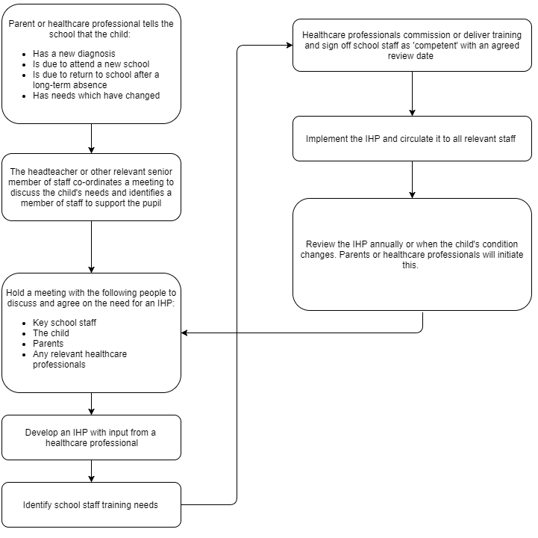

Appendix 2: Parental form to update a child’s medical condition

Town Field Primary Medical Information

We are updating our Medical files. Please complete and return to the school office. Thank you

Name of Child______________________________________Class_________

Please tick all relevant boxes
Dietary Needs
Please supply any information
No Dairy Products
Halal Meat only
No Pork
No Beef
Vegetarian
Gelatine
Gluten Free
Other (Please state)
Allergies
Please supply any medical information
Nuts
Milk
Eggs
Seafood
Other (Please state)
Medical Requirements
Please supply any medical information
Diabetes
Epilepsy
Haemophilia
Asthma
Other (Please state)

Signature of Parent/Carer_________________________________Date___________

Appendix 3: Parental agreement for school to administer medicine

Parental agreement for school to administer medicine
The school will not give your child medicine unless you complete and sign this form, and the school has a policy that the staff can administer medicine.
Name of School: |  | Town Field Primary School
Date:
Child’s Name:
Year / Class:
Name and strength of medicine:
Expiry date:
How much to give (ie dose to be given):
When to be given:
Any other instructions:
Number of tablets/quantity to be given to school:
NOTE: MEDICINES MUST BE IN THE ORIGINAL CONTAINER AS DISPENSED BY THE PHARMACY
Daytime phone number of parent or adult contact
Name & phone number of GP
Agreed review date to be initiated by
The above information is, to the best of my knowledge, accurate at the time of writing and I give consent to school staff administering medicine in accordance with the school policy. I will inform the school immediately, in writing, if there is any change in dosage or frequency of the medication or if the medicine is stopped.
Parent’s Signature
Print Name
Date

Appendix 4: Parental form for completing for children with asthma


Town Field Primary Asthma Plan

Childs Name |  |  |  |  | Emergency contact
Date of birth |  | Year |  |  | Telephone number
Address |  |  |  |  | Emergency contact No2

Name of GP & Surgery
Telephone number

Date asthma was diagnosed |  | Name of medication
Asthma Triggers
Symptoms of an asthma attack
What action should be taken?

Details confirmed by |  | Date

