Autumn - Me and my family and Celebrations
Key Texts:  F1 | 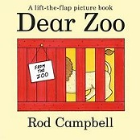  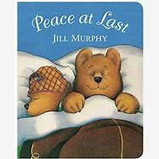  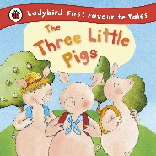  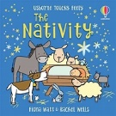  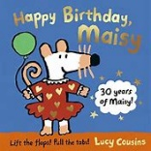  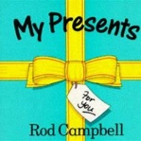
  Key Themes | Routine | Family | Home | Birthday | Season | Christmas
Taught vocabulary | Play  Tidy  Friends  Inside/outside  Share | Brother  Sister  Baby | House  Door  Roof  Bricks  Chimney | Party  Presents  Cake  Candles  Cards | Leaves  Rain  Wellies  Gloves  Hat | Tree  Jesus  Mary  Joseph  Stable
Key Texts:  F2 | 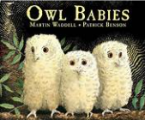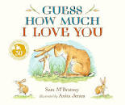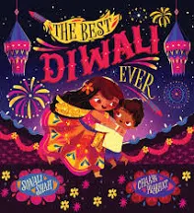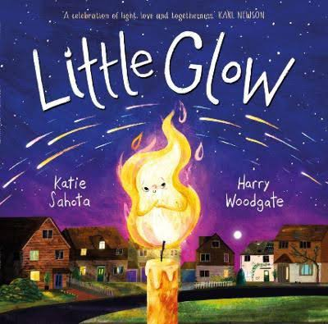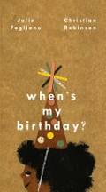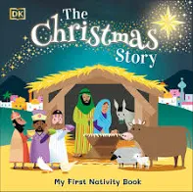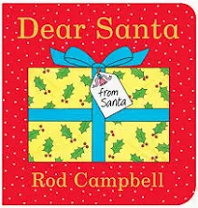
Key Themes | Routine | Family | Emotions | Celebrations | Seasons | Christmas
Taught vocabulary | Dinner time  Playground  Calm  Careful  Considerate. | Grandma  Grandad  Aunty  Uncle  Cousin | Worried  Brave  Excited  Angry  Love | Firework  Diwali  Festival  Invitation  Age | Autumn  Calendar  Month  Conker  Harvest | Bethlehem  Manger  Shepherds  Angel  Nativity

Spring - Healthy Me and Growing
Key Texts:  F1 | 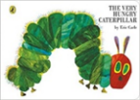  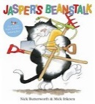  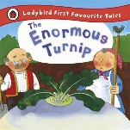  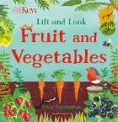  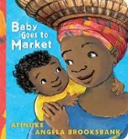  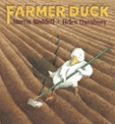
  Key Themes | Animals/Homes | Food | Growing/Planting | Life cycles- Butterfly
Taught vocabulary | Farmer  Work  Spade  bed | Fruit  Vegetables  shop  fruit/vegetable names | Grow  Plant  Soil  Beanstalk  Bean | Caterpillar  Cocoon  Egg  Butterfly  Change
Key Texts:  F2 | 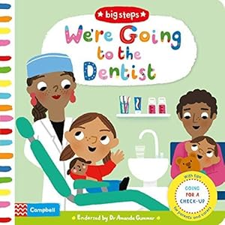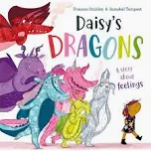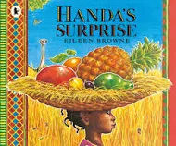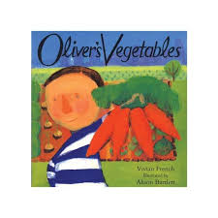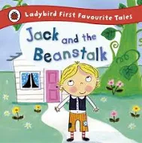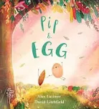
  Key Themes | People who help us | Healthy Food | Healthy Mind and body | Life Cycles | Growing
Taught vocabulary | Doctor  Nurse  Dentist  Firefighter  Police Officer | Breakfast  Healthy  Unhealthy  Decay  Sugar | Heartbeat  Exercise  Muscles  Feelings  Health | Root  Shoot  Lay  Crack  Chick | Air  Sunlight  Watering  Seed  Bulb

Summer - Adventures
Key Texts:  F1 | 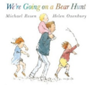  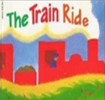  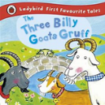
  Key Themes | Adventures | Wild | Place |  | Oceans/Seaside | Famous Person
Taught vocabulary | Ride  Tunnel  Map  Hunt  train | Cave,  mud,  Snowstorm,  Troll | Forest  Bridge  Road  River, |  | Beach  Sea  Sand  shell | Mrs Honeybone
Key Texts:  F2 | 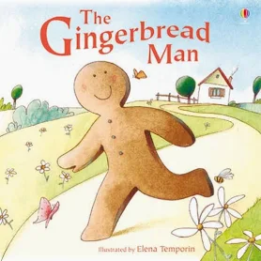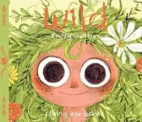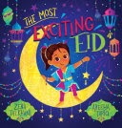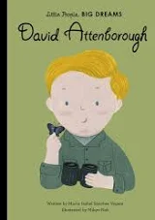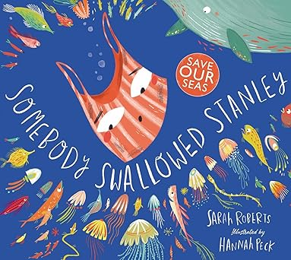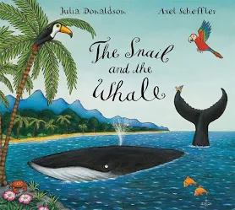
Key Themes | Adventures | Wild | Place | Environment | Oceans | Famous Person
Taught vocabulary | Explore  Catch  Escape  Chase  Journey | Forest  Woodland  Creature  Habitat | Land  Sea  World  Earth  River | Pollution  Litter  Plastic  Rescue  Extinct | Whale  Waves  Rock  World | David Attenborough

