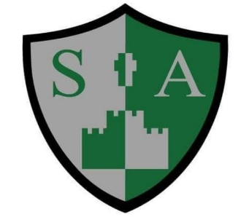
St Augustine’s Catholic Primary School
PE Progression

Early Years Foundation stage | • Moving and handling: Children show good control and co-ordination in large and small movements. They move confidently in a range of ways, safely negotiating space. They handle equipment and tools effectively, including pencils for writing.  • Health and self-care: Children know the importance for good health of physical exercise and a healthy diet and talk about ways to keep healthy and safe. They manage their own basic hygiene and personal needs successfully, including dressing and going to the toilet independently
End of Key Stage 1 | • Master basic movements including running, jumping, throwing and catching, as well as developing balance, agility and co-ordination, and begin to apply these in a range of activities  • Participate in team games, developing simple tactics for attacking and defending  • Perform dances using simple movement patterns.
End of Key Stage 2 | • Use running, jumping, throwing and catching in isolation and in combination  • Play competitive games, modified where appropriate [for example, badminton, basketball, cricket, football, hockey, netball, rounders and tennis], and apply basic principles suitable for attacking and defending  • Develop flexibility, strength, technique, control and balance [for example, through athletics and gymnastics]  • Perform dances using a range of movement patterns  • Take part in outdoor and adventurous activity challenges both individually and within a team  • Compare their performances with previous ones and demonstrate improvement to achieve their personal best
Swimming and water safety (KS2) | • Swim competently, confidently and proficiently over a distance of at least 25 metres  • Use a range of strokes effectively [for example, front crawl, backstroke and breaststroke]  • Perform safe self-rescue in different water-based situations.

