

Year 1 Phonics information
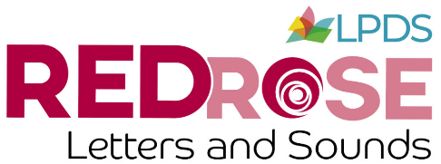  We use the Red Rose phonics scheme from Lancashire. | Reception cover phase 2, 3 and 4  Year 1 cover phase 3, 4 and 5. |  |  | Phase 2 phonemes:  Set 1: s a t p  Set 2: i n m d  Set 3: g o c k  Set 4: ck e u r  Set 5: h b f, ff l, ll ss
Phase 3 phonemes:  Set 6: j v w x  Set 7: y z, zz qu  4 consonant digraphs: ch sh th ng  Introduce 1 representation of each long vowel phoneme:  ai, ee, igh, oa, oo (as in boot & look), ar, or, ur, ow (as in cow), oi, ear, air, er, ure |  |  | Phase 4:  Phase 4 is a transition phase; there are no new phonemes introduced.  Phase 4 consolidates graphemes and phonemes introduced in phase 2 & 3 lasting 4 weeks.  Phase 4 focuses on blending initial and final consonants.
Phase 5 teaches the alternative phonemes (e.g. ‘ai’ as in rain and ‘ay’ as in tray make the same ‘a’ sound.  The goal of phase 5 is to improve fluency and accuracy in reading unfamiliar words.  New graphemes for reading:  ay, oy, wh, a-e, ou, ir,  ph, e-e, ie, ue, ew, i-e, ea, aw, oe, o-e, au, u-e  Common alternative  pronunciations for graphemes:  i, o, c, g, u, ow, ie, ea, er, ea, a, y, ch, ou  Phonemes will be checked each half term using a phoneme checker and results will be sent home. The words highlighted will need to be practiced. |  | Alternative spellings for phonemes:  ai – ay, a-e  ee - ea, y, e, e-e  ie - igh, y ,i-e  oa – oe, ow, o-e, o  oo – oul, u  or – au, aw, al  ar – a  er – ur, ir  ow – ou  oy – oi  air – are, ear  ear – eer, ere  ure – ure, our  Phonics screening check  Takes place in June, it consists of 40 words, 20 real words and 20 alien words. The alien words are nonsense words and are there to assess ability to decode words just using phonics knowledge. The pass rate has been 32/40 since it was introduced in the curriculum in 2014, however last year it changed to 31/40. The results of the screening check will be shared in the end of year report. If your child doesn’t achieve the expected standard, they will get further support with phonics in Year 2 and will repeat the screening check at the end of Year 2. Weekly mock screening checks will be carried out from the end of February.
Blending hands for reading.  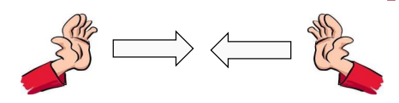 | 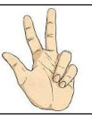  Phonics fingers for spelling. |  |  | Homework  The spellings that are set are chosen from the phonemes that they have learned during the week. At the bottom of the sheet, there is a table with all the phonemes for the week.
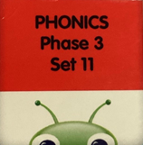
Reading books
Set 1 - 5: Phase 2
Set 6 - 11: Phase 3
Set 12 and blue books: Phase 4
Set 13 - 27: Phase 5

- Reading level will only be changed when children can read their current level smoothly without stopping too much.
- The children are listened to in school each week.
- Please continue to read at home, re-read books and record the reading in the reading record.

