
Welcome to Year 1!
We work, learn and grow together in God’s love


Dear Year 1,

I have been so excited to welcome you into my classroom this year and I am
looking forward to getting to know you better. You have all had a fantastic first week in Year 1 and I know we will have a great year ahead filled with lots of exciting learning, laughter and fun!
I thought I’d to share a few hobbies that I like doing before you get to know me better. I love swimming and I go to the pool a couple of times a week. I also love woodworking and making things, I spend most of my time in my workshop at home. I even made the bookstand for the bible in the hall! So, my favourite area in our classroom is the construction area! I also love going back to Ireland to spend time with my family when I can.
We have an amazing year ahead learning lots of new and exciting things!
Miss Egan

Religious Education
In Year 1 we will study the following themes from To Know You More Clearly.
- Branch 1 – Covenant and Creation – Genesis the story of Creation
- Branch 2 – Prophecy and Promise – God’s love – Mary
- Branch 3 – Galilee to Jerusalem – Jesus’ Mission as the Son of God
- Branch 4 – Desert to Garden – Lent – Jesus in the desert
- Branch 5 – To the Ends of the Earth – The Road to Emmaus, Pentecost,
- Branch 6 – Dialogue and Encounter – Christianity – Judaism special clothes
We will also be introducing the new Prayer and Liturgy directory To Love You More Clearly so our weekly worship will be in the form of:
- Daily prayers
- Meditation
- Celebration of the Word – whole school and in class
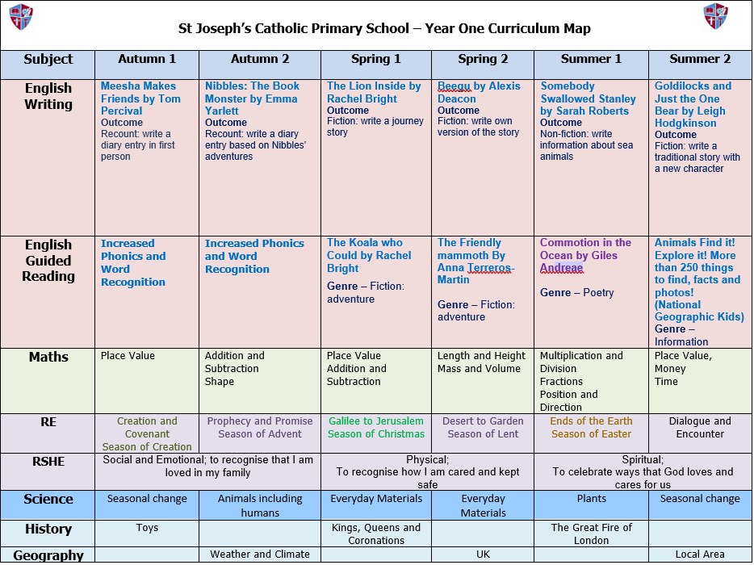
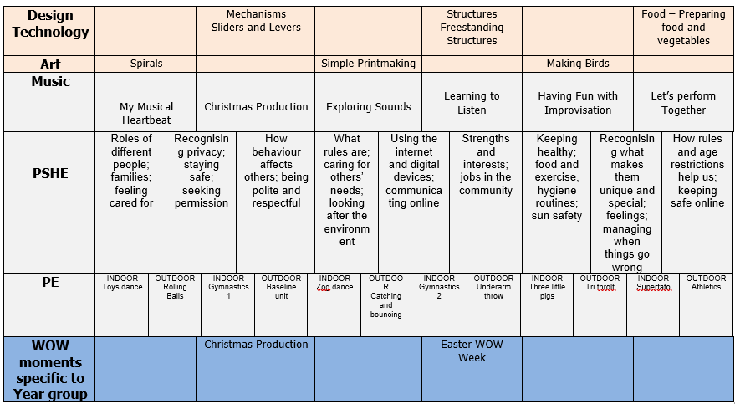

Are you ready for Year 1?
Parents and Carers
- There continues to be a huge focus on Phonics and Reading in Year One. We encourage you to hear your child read every day.
- Reading books will be changed on a Monday and Thursday, please keep a record of what your child has read in the reading record book. The children will choose their own book. The reading record books are monitored in school each day.
- There will be a phonics information session for parents on Wednesday the 16th of September to share information about phonics and the work the children will be covering this year.

Home Learning
- Homework will be sent out every Wednesday and expected to be handed in the following Wednesday. There will be a spelling test on that Wednesday also. The spelling books will be sent home for you to look at, could you please keep them in the book bags and they will be collected and kept in school on Thursdays.
- Homework will be start on the 16th of September.
- The readers will be sent home on the 7th of September, please don’t be concerned if you child has moved down a level, it is not unusual over the summer, the children have been assessed reading and assigned a level that is appropriate for them, they will be moved up a level when they can read a level fluently.

Snack
- Please remember to bring a labelled water bottle containing only water, no juice allowed.
- You can also bring a piece of fruit or purchase toast for snack at break time.
- If you would like to order toast please visit school spider, if you would like to order milk visit coolmilk.com.

PE Days
- Our PE days are Wednesday and Thursday. Please wear full school PE kit and trainers on these days.
- Running Track- We will do our daily run a mile each day in school, the children can do this in their school shoes but if they would prefer to run in trainers, they can bring a pair of trainers in a small bag to hang on their peg. They can leave these in school so that they can change into them before going on the track.

