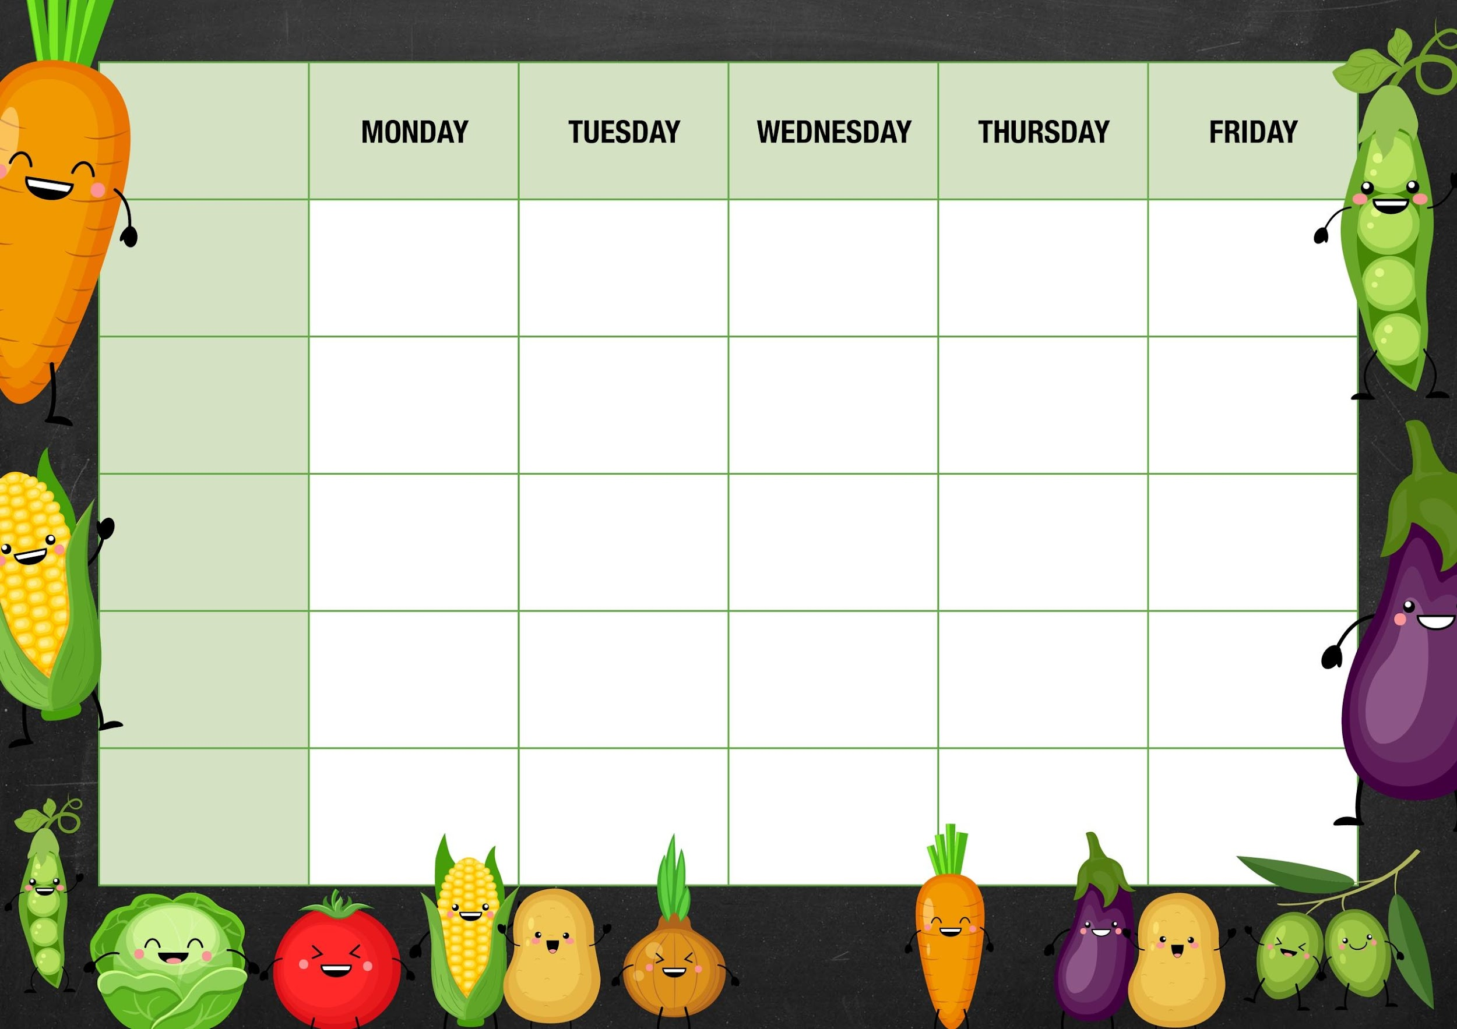
MM
Cheese and crackers and fruit salad

Apple and cinnamon oaty crumble with custard

Peas/beans

Cheese and beans

Deli Counter and a selection of fruit

Freshly Baked Bread

Cheese quiche with chips

Creamy quorn and spinach pasta bake with garlic bread slices

Chicken roast dinner with roast potatoes and Yorkshire puddings

Quorn roast dinner with roast potatoes and Yorkshire puddings
Tomato and basil pasta bake with garlic bread slices

Sweetcorn

Tuna
Cheese and
Beans
Week 2

Jaffa cake sponge

Broccoli/cauliflower

Tuna
Cheese and beans

Cauliflower cheese

Beans
Cheese and beans
Vegan pepperoni pizza with seasoned
Wedges

Homemade peperoni pizza with seasoned wedges

Carrot batons

Cheese and beans
Beef Bolognese with garlic bread slices

Fishy Friday

Cod Fish fingers with chips and ketchup

Meat Free Monday

Sweet potato curry with savory rice and naan bread
Salad and Deli Bar
Chocolate mousse slice

Mains
Vegetarian
Option
Vegetable

Jacket Potato Choice

Muller smooth yoghurts with fruit

Deli Counter and a selection of fruit

Freshly Baked Bread

Deli Counter and a selection of fruit

Freshly Baked Bread

Deli Counter and a selection of fruit

Freshly Baked Bread

Deli Counter and a selection of fruit

Freshly Baked Bread

Dessert

