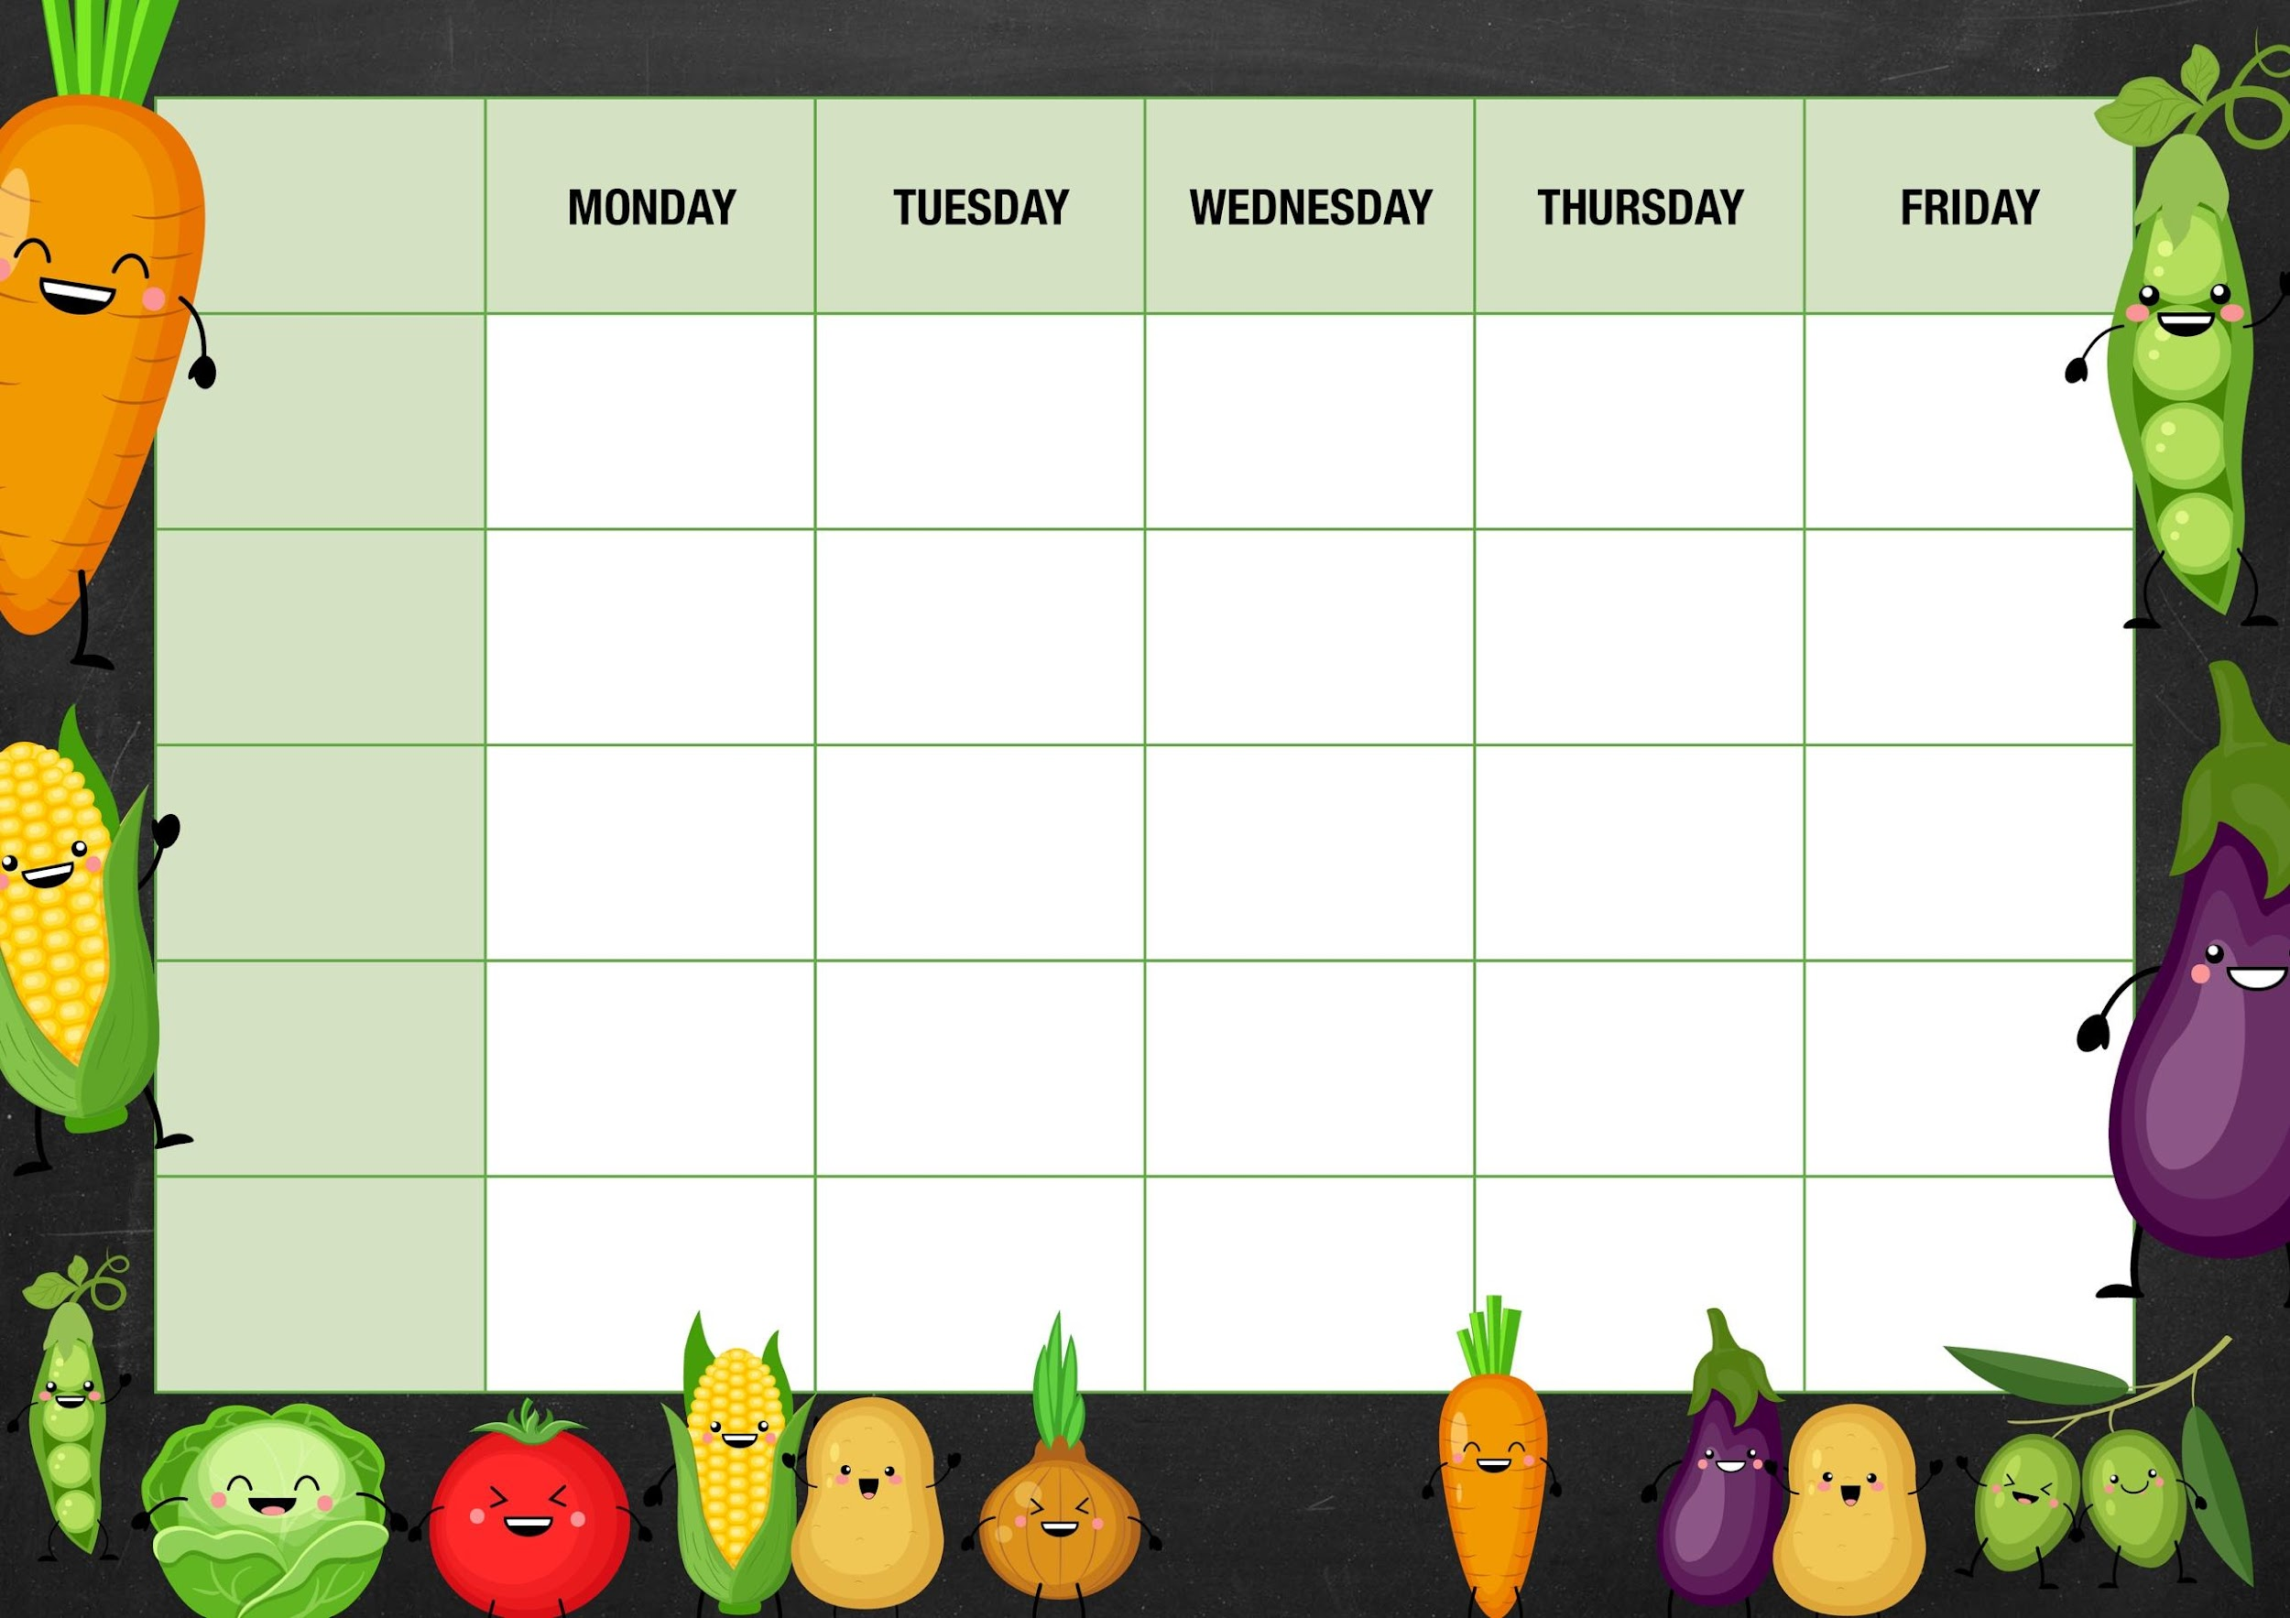
MM
Veggie meatball Bolognese with spaghetti pasta and
garlic bread slices

Sweetcorn

Tuna
Cheese and Beans

Deli Counter and a selection of fruit

Freshly Baked Bread
Picnic day
Ham sandwiches cheese rolls, crisps
Cucumber/carrot sticks

Cheese sandwiches, cheese rolls crisps cucumber/carrot sticks

Mixed vegetable/beans

Cheese and beans

Pork sausage with mash potato gravy and Yorkshire puddings

carrots

Cheese and beans

Sweetcorn

Tuna
Cheese and
Beans
Ice lollies

Peas

Cheese and beans

Deli Counter and a selection of fruit

Freshly Baked Bread

Deli Counter and a selection of fruit

Freshly Baked Bread

Chicken Balti curry with basmati rice and naan bread

Ice cream tubs with fruit

Meat Free Monday
Cheese pasties with new potatoes and beans

Veggie fingers with chips and ketchup

Old school sprinkle cake

Sticky toffee pudding with custard

Vegetarian sausage with mash potato gravy and Yorkshire puddings
Week 1

Mixed salad

Tuna
Cheese and beans
Quorn Balti curry with basmati rice and naan bread

Fishy Friday

Harry Ramsdens fish fillet with chips and ketchup

Salad and Deli Bar
Cheese crackers with chutney and melon

Mains
Vegetarian
Option
Vegetable

Jacket Potato Choice

Deli Counter and a selection of fruit

Freshly Baked Bread

Deli Counter and a selection of fruit

Freshly Baked Bread

Deli Counter and a selection of fruit

Freshly Baked Bread

Dessert

