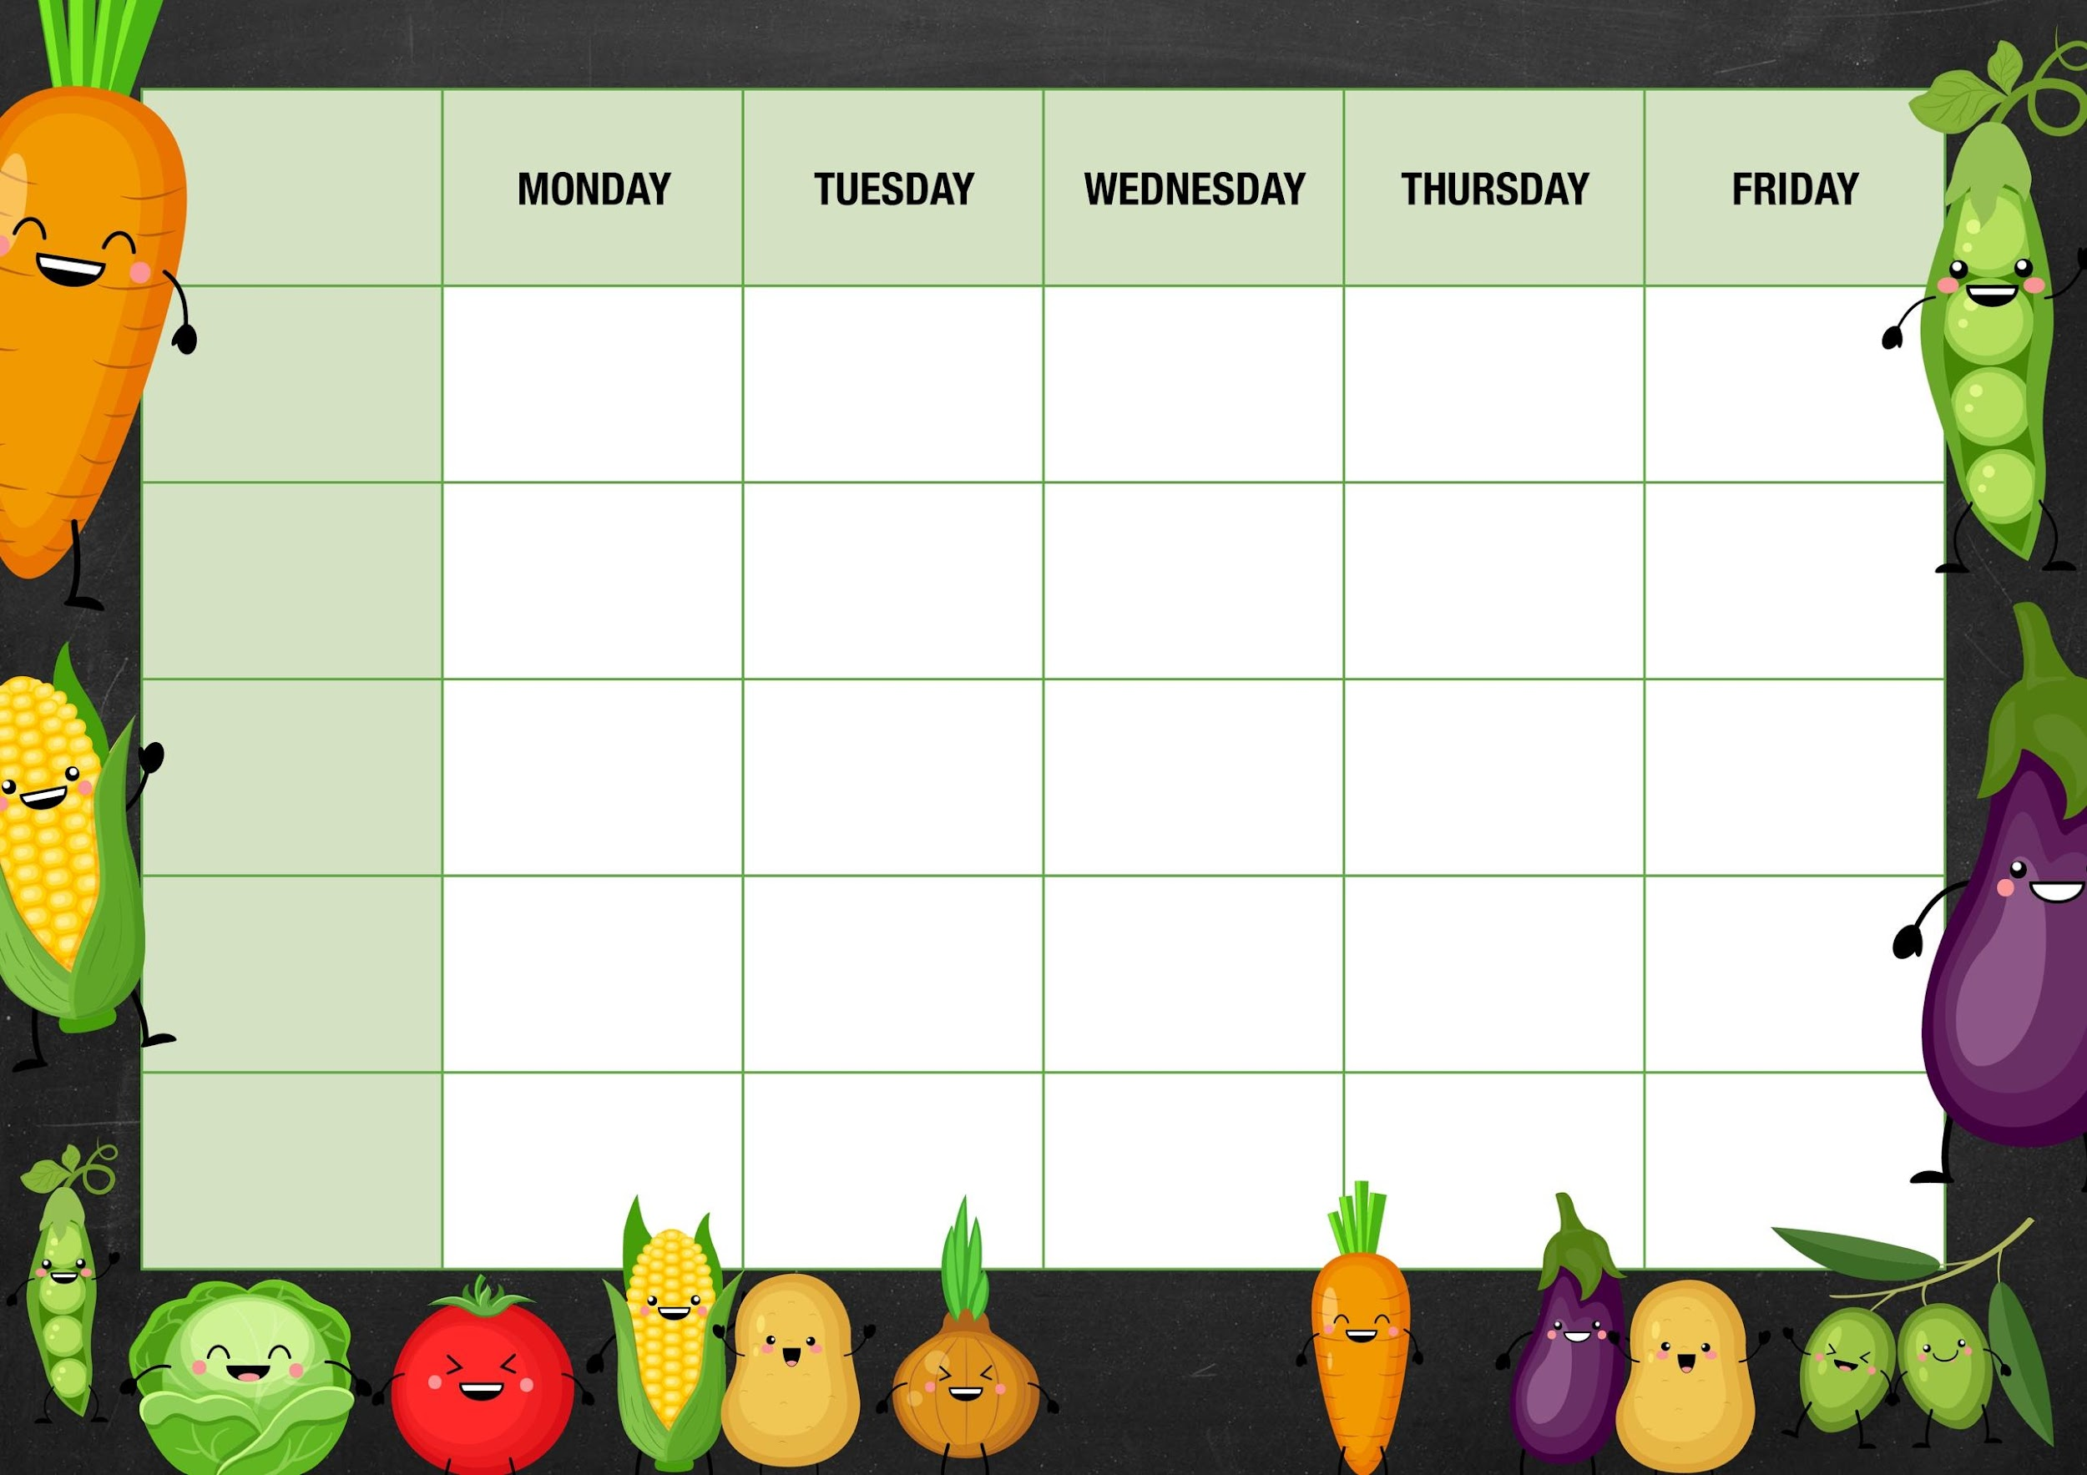
MM
Jelly and mandarins

Carrots/green
Beans

Tuna
Cheese and
Beans
Veggie lasagna with garlic bread slices

Cheese pizza with chips and ketchup

Peas

Cheese and beans

Deli Counter and a selection of fruit

Freshly Baked Bread

Roast beef dinner with mashed potatoes Yorkshire puddings and gravy

Strawberry cheese cake

Quorn fillet dinner with mashed potatoes Yorkshire puddings and gravy

Week 3

Chocolate chip
Cookies

Corn on the cobs

Tuna
Cheese and beans

Mixed veg

Cheese and beans

Bean burger in a bun with baked wedges

Mixed bean chilli with mixed rice and nacho chips

Beef chili con carne with whole meal and white rice and nacho chips

Sweetcorn and peppers

Cheese and beans
Chicken burgers in a bun with baked wedges

Fishy Friday

Salmon/broccoli quiche with chips
Meat Free Monday

Tomato and basil pasta with garlic bread slices

Salad and Deli Bar
Mini ring doughnuts

Mains
Vegetarian
Option
Vegetable

Jacket Potato Choice

Arctic ice cream roll cake

Deli Counter and a selection of fruit

Freshly Baked Bread

Deli Counter and a selection of fruit

Freshly Baked Bread

Deli Counter and a selection of fruit

Freshly Baked Bread

Deli Counter and a selection of fruit

Freshly Baked Bread

Dessert

