Pupil premium strategy statement – Haveley Hey Community School
This statement details our school’s use of pupil premium (and recovery premium) funding to help improve the attainment of our disadvantaged pupils.
It outlines our pupil premium strategy, how we intend to spend the funding in this academic year and the outcomes for disadvantaged pupils last academic year.

School overview
Detail | Data
Number of pupils in school | 488
Proportion (%) of pupil premium eligible pupils | 68%
Academic year/years that our current pupil premium strategy plan covers (3 year plans are recommended – you must still publish an updated statement each academic year) | 2023-26
Date this statement was published | July 2025
Date on which it will be reviewed | July 2026
Statement authorised by | Sue Spiteri
Pupil premium lead | Sue Spiteri
Governor / Trustee lead | Liam McGonagle

Funding overview
Detail | Amount
Pupil premium funding allocation this academic year | £437,350
Recovery premium funding allocation this academic year  Recovery premium received in academic year 2023/24 cannot be carried forward beyond August 31, 2024. | £0

Pupil premium funding carried forward from previous years (enter £0 if not applicable) | £0
Total budget for this academic year  If your school is an academy in a trust that pools this funding, state the amount available to your school this academic year | £437,350

Part A: Pupil premium strategy plan

Statement of intent
At Haveley Hey, 34.24% of school live in the top 1% most deprived postcodes, 69.34% live in the top 5% most deprived postcodes and 94% pupils live in the top 10% most deprived postcodes (IDACI- 1%-10%). We know that deprivation consists of more than just poverty. Poverty is related to not having enough money to live on, whereas deprivation refers to a much broader lack of resources and opportunities. It is our intent to dispel the gap between disadvantaged and their non-disadvantaged peers.
Overcoming barriers to learning is at the heart of our Pupil Premium Strategy; we will identify the barrier to be addressed and allocate budget accordingly. Our priorities are to:
- Ensure all pupils receive Quality First Teaching
- Close the attainment gap between disadvantaged and their peers
- Provide targeted academic support and intervention in a timely manner for those children not making expected progress
- Address non-academic barriers to attainment such as attendance
- Ensure the Pupil Premium Strategy reaches those that need it most
At Haveley Hey Primary School we recognise that a number of pupils within the school population, some of who are eligible for pupil premium funding, may at some point during their school career require additional support and intervention. We are committed to meeting our pupils’ pastoral, social and academic needs. As with every child in our care, a child who is in receipt of the pupil premium is valued, respected and entitled to develop to their full potential.
At Haveley Hey Primary School we have high expectations of all our pupils, irrespective of their background or challenges they face. Our intention is that all pupils make good progress and achieve high attainment across all subject areas. The focus of our pupil premium strategy is to support disadvantaged pupils to achieve that goal, including progress for those who are already high attainers.
We will consider the challenges faced by vulnerable pupils, such as those who have a social worker and young carers. The activity we have outlined in this statement is also intended to support their needs, regardless of whether they are disadvantaged or not.
High-quality teaching is at the heart of our approach, with a focus on areas in which disadvantaged pupils require the most support. This is proven to have the greatest impact on closing the disadvantage attainment gap and at the same time will benefit the non-disadvantaged pupils in our school. Implicit in the intended outcomes detailed below, is the intention that non-disadvantaged pupils’ attainment will be sustained and improved alongside progress for their disadvantaged peers.
We know that children learn best when they attend school regularly. In our strategy we focus on encouraging good attendance through meeting the well-being needs of pupils and families and by providing exciting learning opportunities. Our Attendance Lead and Family Worker actively engages with families to encourage and support good attendance in school. Our approach will be responsive to common challenges and individual needs, rooted in robust
diagnostic assessment, not assumptions about the impact of disadvantage. The approaches we have adopted complement each other to help pupils excel. To ensure they are effective we will:
- ensure disadvantaged pupils are challenged in the work that they’re set
- act early to intervene at the point need is identified
- adopt a whole school approach in which all staff take responsibility for disadvantaged pupils’ outcomes and raise expectations of what they can achieve

Challenges
This details the key challenges to achievement that we have identified among our disadvantaged pupils.
Challenge number | Detail of challenge
1-  Academic performance in  writing | On entry to Nursery our disadvantaged pupils arrive below or well below age related expectations compared to other pupils. This gap results in children being significantly behind their peers academically and as a result, reaching their potential is significantly more challenging. This has also been seen nationally.  Internal data and monitoring and evaluation of writing shows that writing results are low. NPP children are outperforming PP children.
2-  Reading and  phonics | On entry assessments into school show that children begin with their access to books and early reading ability significantly behind their peers. This results in a significant gap between disadvantaged children and their peers on reading attainment. This has also been shown nationally.
3-  Attendan ce | Attendance is always a key component for children achieving their capabilities. Internal and national data shows attendance of disadvantaged children to be lower than that of their peers. This then results in missed learning opportunities, creating further gaps in academic performance. The role of the attendance worker and the parental support worker are vital in this.
4- Missed enrichme nt opportunit y | Children from disadvantaged backgrounds have often had less enrichment opportunities than their peers outside of school. This has resulted in children not having the range of language and experience to support their oral development and their academic achievement, resulting in them falling further behind. With the cost of living crisis, we are seeing a further gap between disadvantaged children and their peers of their opportunities to access enrichment opportunities outside of school.
5- Parent  engagem  ent | Parent engagement to support children to achieve well can be a challenge. We have identified that parent engagement with some of our disadvantaged children to be lower than their peers. This results in the support from home for their academic achievement to be lower than that of their peers. Increased financial pressure on families is having a large impact on our community.

Intended outcomes
This explains the outcomes we are aiming for by the end of our current strategy plan, and how we will measure whether they have been achieved.
Intended outcome | Success criteria
1. Improved attainment in Writing and Maths among disadvantaged pupils | Writing and Maths outcomes across the school to show that the those for disadvantaged pupils are in line with their peers.
2. Improved reading and phonics attainment for disadvantaged pupils at the end of Year 1 and KS2. | Year 1 and KS2 outcomes to show that the outcomes for disadvantaged pupils are in line with their peers for the expected standard in reading and phonics
3. To achieve and sustain improved attendance for all pupils, particularly our disadvantaged pupils. | Sustained high attendance demonstrated by:  • The overall absence rate for all pupils matching national averages and the attendance gap between disadvantaged pupils and their non-disadvantaged peers being reduced.
4. To continue to provide a range of enrichment and therapeutic opportunities which improve attainment and progress of our disadvantaged pupils | Curriculum enrichment offer is varied and supports learning  Children show increased resilience when tackling new learning  Low level behaviour incident reduced
5. Increased parental engagement | Increased participation in children’s learning at home.  • Families supported effectively with cost-of-living pressures.
 | • Families clear on where they can find support both in school and out of school.
6. To ensure children have access to the equipment and resources that they need to fully access the curriculum and achieve well | Children have access to equipment and resources to access the full curriculum

Activity in this academic year
This details how we intend to spend our pupil premium (and recovery premium) funding this academic year to address the challenges listed above.

Teaching (for example, CPD, recruitment and retention)
Budgeted cost:
Activity | Evidence that supports this approach | Challenge number(s) addressed
Literacy Counts Writing Programme purchased (£1800) | https://educationendowmentfound ation.org.uk/education-evidence/guidance-reports/literacy-ks2 | 1
White Rose Maths CPD and workbooks | https://educationendowmentfoundation.org.uk/education-evidence/guidance-reports/early-maths  https://educationendowmentfoundation.org.uk/education-evidence/guidance-reports/maths-ks-2-3 | 1
Additional teacher in Y6 3 days a week | https://educationendowmentfoundation.org.uk/support-for-schools/school-planning-support/1-high-quality-teaching | 1
Cost of Supply x6 days per year to release Phonics lead to work with English  Hub (£1200) | https://educationendowmentfoundation.org.uk/education-evidence/teaching-learning-toolkit/phonics | 2
Restorative practice training (£1800) | https://educationendowmentfound ation.org.uk/news/new-findings-from -eef-commissioned-evaluations | 3, 5
CPD professional memberships (£3000) | https://www.gov.uk/government/pu blications/teachers-professional-dev elopment-in-schools/independent-re view-of-teachers-professional-devel opment-in-schools-phase-1-findings | 1, 2
Program subscriptions  (Twinkl, Accelerated Reader, target tracker) |  | 1, 2
IT resources |  | 6

Targeted academic support (for example, tutoring, one-to-one support, structured interventions)
Budgeted cost:
Activity | Evidence that supports this approach | Challenge number(s) addressed
EYFS / KS1 - Reading  Teaching Assistants Reading teaching assistants to ensure every child in Reception and KS1 is heard read twice a week, with pupil premium children having an additional reading slot. | The Reading Teaching Assistants model means that disadvantaged children are heard to read several times a week. This has shown to make a significant difference to reading progress and attainment for these children.  Reading Teaching Assistants also support with the delivery of phonics and catch up phonic interventions  EEF (education endowment foundation.org.uk) | 2
Outsource Speech and Language | https://educationendowmentfound ation.org.uk/education-evidence/guidance-reports/teaching-assistants | 2
Specialist teaching -  Music | https://royalschoolofmusic.es/en/the -importance-of-using-qualified-music  -teachers-in-schools/ | 4
Targeted support and intervention | Specific targeted teaching delivered in SEND provision, SALT, Specialist SEND teachers, EP support | 3
 | and outreach enables quality first teaching impacting on outcomes for our children with additional needs

Wider strategies (for example, related to attendance, behaviour, wellbeing)
Budgeted cost:
Activity | Evidence that supports this approach | Challenge number(s) addressed
Attendance support and challenge for targeted families through an  Attendance Support  Lead and  Attendance support worker. Targeted monitoring of key families.  Rewards and incentives. | Parents/ children openly value the incentives for good attendance which the Attendance Support  Worker facilitates. Intensive targeted work from the Attendance Support Worker has resulted in better attendance for families including those who are PP. Internal case studies have shown that when support is in place and parents are challenged the attendance of targeted children improves | 3
Enrichment opportunities through Passport for Learning ensures that all children leave our schools with a minimum number of key experiences. Opportunities to build confidence, independence, improve risk taking and develop vocabulary are given through subsidised residential visits in year 5 and 6. | Our Passport for Learning is a vision that aims to extend children’s horizons and experiences so that by the time they leave our schools they will have experienced trips in each year group which include natural world experience: farm, seaside, countryside etc alongside cultural and arts events: museums, theatre and sporting events. This is an incredibly valued and impactful initiative and gives the children memorable experiences that broaden perspectives. These experiences have shown an increased ability for the children to be able to contextualise their learning and as a result develop a | 4

 | greater vocabulary which in turn impacts on their ability to develop both their reading and writing. Pupils cite residentials as their most significant memory of school and demonstrate significant impact.
Parent support for target disadvantaged families, Family Support Worker | The Family Support Worker supports specific disadvantaged families and through the high level of skill that he brings to the role is able to support the provision and improve outcomes for these children and families. His remit includes supporting financially, with parenting techniques, with housing issues and with wider agency support. Families who he supports gain huge benefit from his involvement and the measures of impact: stability, welfare, attendance etc are all demonstrably improved. Parental engagement EEF (education endowment fund.org.uk) | 5
Behaviour support worker | Behaviour support worker actively supports behaviour throughout school teaching strategies to support regulation and engagement in learning | 3
Before and After  School programme | Our Before and After School programme ensures high quality provision outside of the school day supporting healthy life choices and supporting children with homework as well as developing problem solving and team work  https://www.understood.org/en/arti cles/benefits-afterschool-programs-k ids-with-learning-thinking-differences | 4
RRSA | Our commitment to the Rights  Respecting framework enables Pupil  Parliament leadership, Residential | 4
opportunities and engagement with the Unicef programme
https://www.unicef.org.uk/rights-res pecting-schools/wp-content/upload s/sites/4/2019/10/Ofsted-and-RRSA_fi nal-Oct-2019v1.pdf
Wider therapeutic intervention  (Place2Be, Growing  Outdoors, Forest  School) |  | 4
Professional supervision | https://discovery.ucl.ac.uk/id/eprint/10090818/1/Carroll_SENCO%20Supervision%20Guidance%20February%202020.pdf | 4
Uniform provision |  | 6

Part B: Review of the previous academic year (2024-25)

Outcomes for disadvantaged pupils
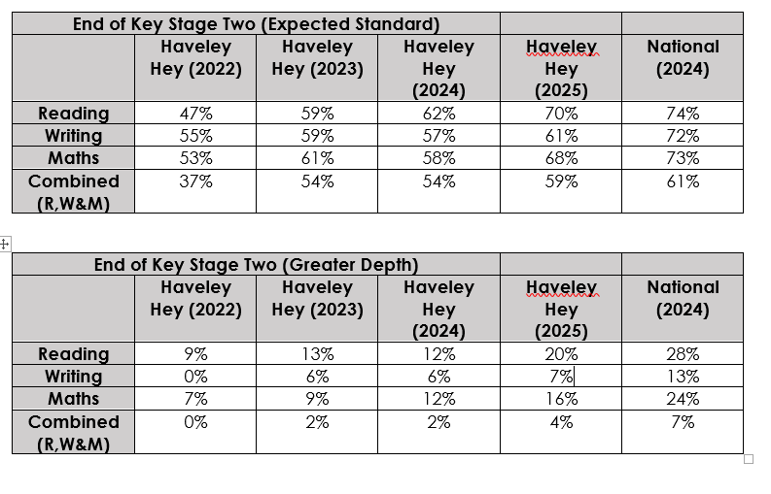
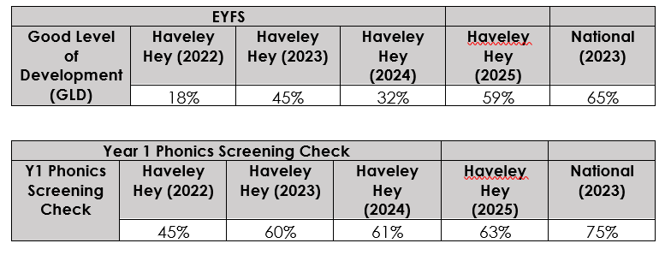
ATTAINMENT
OUTCOMES
While
local
and
national
attainment
figures
for
2025
must
be
looked
at
in
the
light
of
COVID
catch
up,
as
with
previous
years
before
COVID,
the
disadvantaged
children
within
school
make
good
progress
from
their
starting
points and achieve well.

Externally provided programmes
Please include the names of any non-DfE programmes that you used your pupil premium (or recovery premium) to fund in the previous academic year.

Programme | Provider
Boxing intervention | Walkden Amateur Boxing Club

Service pupil premium funding (optional)
For schools that receive this funding, you may wish to provide the following information: How our service pupil premium allocation was spent last academic year
The impact of that spending on service pupil premium eligible pupils

Further information (optional)
Use this space to provide any further information about your pupil premium strategy. For example, about your strategy planning, implementation and evaluation, or other activity that you are delivering to support disadvantaged pupils, that is not dependent on pupil premium or recovery premium funding.

