ATTENDANCE POLICY
2025 – 2026

Contents

- Introduction…………………………………………………………………………………………………………..1

- Legal Framework……………………………………………………………………………………………………1

- Safeguarding………………………………………………………………………………………………………….2

- Categorising Absence…………………………………………………………………………………………….2

- Roles and Responsibilities………………………………………………………………………………………4

- Attendance Data…………………………………………………………………………………………………….6

- Support Systems…………………………………………………………………………………………………….7

- Legal Sanctions………………………………………………………………………………………………………8
Appendix 1: Attendance Codes .............................................................................................9
Appendix 2: Distributed Leadership Model...........................................................................11
Appendix 3: Traveller Family Absence………………………………………………………………………………13
Appendix 4: Attendance letters for parents and carers…………………………………………………….14
Appendix 5: Penalty Notice Guidance for Parents and Carers…………………………………………..18

Appendix 6: Managing pupil attendance procedures………………………………………………………..19
Appendix 7: First day absence procedures………………………………………………………………………..20

1.0 Introduction
1.1 Regular school attendance is essential if children are to achieve their full potential.
1.2 Haveley Hey Community School believe that regular school attendance is the key to enabling children to maximise the educational opportunities available to them and become emotionally resilient, confident and competent adults who can realise their full potential and make a positive contribution to their community.
1.3 Haveley Hey Community School values all pupils. As set out in this policy, we will build strong relationships with families to ensure pupils have the support in place to attend school and identify the reasons for poor attendance.
1.4 Haveley Hey Community School recognises that attendance is a matter for the whole school community. Our Attendance Policy should not be viewed in isolation; it is a strand that runs through all aspects of school improvement, supported by our policies on admissions, safeguarding, anti-bullying, child protection, safeguarding and behaviour and inclusive learning. This policy takes into account the Human Rights Act 1998, the Disability Discrimination Act 1995 and the Race Relations Act 2000.
1.5 This policy aims to show our commitment to meeting our obligations with regards to school attendance, including those laid out in the Department for Education’s (DfE’s) statutory guidance on working together to improve school attendance (applies from 19 August 2024), through our whole-school culture and ethos that values good attendance, including:
- Setting high expectations for the attendance and punctuality of all pupils
- Promoting good attendance and the benefits of good attendance
- Reducing absence, including persistent and severe absence
- Ensuring every pupil has access to the full-time education to which they are entitled
- Acting early to address patterns of absence
- Building strong relationships with families to make sure pupils have the support in place to attend school

We will also promote and support punctuality in attending lessons.

2.0 Legal Framework
2.1 This policy is based on the Department for Education’s (DfE’s) statutory guidance ‘Working together to improve school attendance (effective from 19th August 2024) and school attendance parental responsibility measures.
The guidance is based on the following legislation, which set out the legal powers and duties that govern school attendance:
- Part 6 of the Education Act 1996
- Part 3 of the Education Act 2002
- Part 7 of the Education and Inspections Act 2006
- The Education (Pupil Registration) (England) Regulations 2006 (and 2010, 2011, 2013, and 2016 amendments)
- The Education (Penalty Notices) (England) (Amendment) Regulations 2013

It also refers to:
- School Census Guidance
- Keeping Children Safe in Education
- Mental health issues affecting a pupil's attendance: guidance for schools

3.0 Safeguarding

3.1 Every pupil should be able learn in an enjoyable and safe environment and be protected from harm. We respect and value all children and are committed to providing a caring, friendly and safe environment for all our pupils so they can learn and participate in all school activities in a relaxed and secure atmosphere.
3.2 Attending school regularly promotes the welfare and safety of children whilst they are not in the care of their parents/carers. Safeguarding is about offering early help and support to children and families and difficulties with attendance and lateness may be signs that something is worrying the child or that there are difficulties within the family. Poor or irregular attendance, persistent lateness, or children missing from education may be considered a safeguarding matter if this places a child at risk of harm.
3.3 Safeguarding the interests of each child is everyone’s responsibility and within the context of this school; safeguarding and promoting the welfare and life opportunities for children encompasses: Attendance, Behaviour Management, Health and Safety, Access to the Curriculum and Anti- bullying, protecting children from abuse and neglect, online safety, radicalisation and extremism, FGM and CSE.
3.4 More information on safeguarding and the protection of children can be found in the schools Safeguarding Policy.
3.5 In order to allow us to safeguard the children in our care it is important that parents and carers provide the school with their current contact details and provide at least three other contact numbers in case of emergency.
3.6 It is also important for parents inform the school of any specific vulnerability in relation to their child or home circumstances.

4.0 Categorising Absence

4.1 Where pupils of compulsory school age are recorded as absent, the register must show whether the absence is authorised or unauthorised.
4.2 Absence can only be authorised by the Executive Headteacher or the Head of School and cannot be authorised by parents. All absences will be treated as unauthorised unless a satisfactory explanation for the pupil’s absence has been received.
4.3 Parents must advise the school by telephone on the first day of absence and provide the school with an expected date of return. This should be followed up in the form of a written note from the parent/carer, though verbal explanations may be acceptable where this is considered appropriate.
4.4 Absence will be categorised as follows:
4.4.1 Illness Parents may be asked to provide medical evidence to allow the Head of School to authorise absence where appropriate. This will usually be in the form of an appointment card, prescription etc.
4.4.2 Medical/Dental Appointments Parents are advised where possible to make medical and dental appointments outside of the school day. Where this is not possible, pupils must attend school for part of the day. Parents must show the appointment card to school.
4.4.3 Other Authorised Circumstances This relates to where there is cause for absence due to exceptional circumstances.
4.4.4 Suspended or Excluded (No alternative provision made) Exclusion from attending school is counted as an authorised absence. The child’s class teacher will make arrangements for work to be sent home.
4.4.5 Religious Observance Haveley Hey Community School acknowledges the multi-faith nature of British society and recognises that on some occasions, religious festivals may fall outside school holiday periods or weekends and this necessitates a consideration by written request by the parent of authorised absence.
4.4.6 Traveller Absence It is expected that Traveller children, in common with all other children are to attend school as regularly and as frequently as possible (see Appendix 3)
4.4.7 Late Arrival Registration is at 8:35am, pupils arriving after this time will be marked as present but arriving late (code L). The register will close at 9:05am (no more than thirty minutes after the opening of the register) pupils arriving after the close of register will be recorded as late (code U). This is not authorised.
On arrival after the close of register, the pupil’s parent or carer must sign them in at the main office. The absence will only be authorised if a satisfactory explanation for the late arrival can be provided, for example, attendance at a medical appointment. The absence will be recorded as unauthorised if the pupil has arrived late without justifiable cause
4.4.8 Unauthorised absence - Absence will not be authorised unless parents have provided a satisfactory explanation and that it has been accepted as such by the Head of School.
4.4.9 A full list of the Department for Education (DfE) Registration Codes can be found in Appendix 1.
4.5 All requests for leave of absence in term, including holidays, will be responded to in writing.
4.5.1 If a pupil fails to return from a leave of absence and contact with the parents has not been made or received, school may take the pupil off the school’s roll in compliance with the Education (Pupil Registration) (England) Regulations 2013. This means that the child will lose their school place.
4.5.2 If the permission to take leave is not granted and the parent takes their child out of school the absence will be unauthorised. In such cases the school may request the local authority issue a Penalty Notice or consider other legal sanctions including prosecution in the magistrate’s court. This will follow Manchester Statutory Action Escalation Pathway.
5.0 Roles and Responsibilities

5.1 Governance:
The governing board is responsible for:
- Promoting the importance of school attendance across the school’s policies and ethos
- Making sure school leaders fulfil expectations and statutory duties
- Regularly reviewing and challenging attendance data
- Monitoring attendance figures for the whole school
- Making sure staff receive adequate training on attendance
- Holding the headteacher to account for the implementation of this policy
- Making sure that the schools attendance management system is delivered effectively Making sure the school has high aspirations for all pupils but adapts processes to pupils individual needs

5.2 The Head of School
The Head of School and other senior leaders are responsible for:
- Implementation of this policy at the school
- Monitoring school-level absence data and reporting it to governors
- Supporting staff with monitoring the attendance of individual pupils
- Monitoring the impact of any implemented attendance strategies
- Requesting statutory action in line with Manchester’s Statutory Action Escalation
- Pathway or authorising the school Attendance Officer to do so.
- Ensuring effective communication between school, the Local Authority and parents/carers of pupils with Special Educational Needs (SEND) where there are barriers to attendance which relates to the pupils needs
- Following Manchester City Council’s Children Missing Education (CME) Protocol when a pupil’s whereabouts is unknown
- Leading attendance across the school
- Offering a clear vision for attendance improvement
- Evaluating and monitoring expectations and processes
- Having an oversight of data analysis
- Devising specific strategies to address areas of poor attendance identified through data
- Arranging calls and meetings with parents to discuss attendance issues
- Delivering targeted intervention and support to pupils and families
- Establishing and maintaining effective systems for tackling absence and making sure they are followed by all staff.

5.3 The Strategic Attendance Lead:
The Strategic Attendance Lead is responsible for:
- Monitoring and analysing attendance data (see section 7)
- Benchmarking attendance data to identify areas of focus for improvement
- Providing regular attendance reports to school staff and reporting concerns about attendance to the designated senior leader responsible for attendance and the headteacher
- Working with the local authority and other key stakeholders to tackle persistent and severe absence
- Liaising with the Head of School as to when a request for statutory action in line with Manchester’s Statutory Action Escalation Pathway is appropriate.
The attendance officer is Melissa Burbidge and can be contacted via 0161 498 9509 or by email at m.burbidge@haveleyhey.manchester.sch.uk

5.4 A Senior Mental Health Lead is responsible for:
- Strategic oversight for setting a whole school approach to mental health and wellbeing
- Promoting the health and wellbeing of children and young people in school
- Action taken aligned to Manchester’s Emotional Barriers to School Attendance (EBSA) pathway
5.5 Class Teachers:
Class teachers are responsible for:
- Recording attendance on a daily basis, using the correct codes, and submitting this information to the school office. Registers are completed each morning and each afternoon.
5.6 School office staff:
School office staff are responsible for:
- Taking calls from parents about absence on a day-to-day basis and record it on the school system
- Transfer calls from parents to the attendance lead in order to provide them with more detailed support on attendance
5.7 Parents/carers:
Parents/carers are expected to:
Make sure that their child attends school every day on time.
Call the school to report their child’s absence before 8:50am on the day of the absence and each subsequent day of absence, and advise when they are expected to return
- Provide the school with more than 1 emergency contact number for their child
- Ensure that, where possible, appointments for their child are made outside of the school day
- Engage with school support aimed at improving school attendance
- Seek support, where necessary, for maintaining good attendance by contacting the attendance officer in school

5.8 Pupils:
Pupils are expected to:
- Attend school every day on time

6.0 Attendance Data

6.1 Use of Attendance Data
The school will:
- Monitor attendance and absence data half-termly, termly, and yearly across the school and at an individual pupil level.
- Identify whether there are groups of children whose absences may be a cause for concern or particular cohorts of pupils where attendance is affecting their achievement/outcomes.
- Pupil-level absence data will be collected each term and published at national and Local Authority level through the DfE’s school absence national statistics releases.
- The underlying school-level absence data is published alongside the national statistics. The school will compare attendance data to the national average and share this with the Governing Board.
6.2 Analysing attendance data
The school will:
- Analyse attendance and absence data regularly to identify pupils or cohorts that need additional support with their attendance, and use this analysis to provide targeted support to these pupils and their families
- Look at historic and emerging patterns of attendance and absence, and then develop strategies to address these patterns
- Identify pupils whose absences may be a cause for concern, especially those who demonstrate patterns of persistent or severe absence
6.3 Using data to improve attendance
The school will:
- Provide regular attendance reports to class teachers and other school leaders, to facilitate discussions with pupils and families
- Use data to monitor and evaluate the impact of any interventions put in place in order to modify them and inform future strategies
- Provide targeted support to the pupils it has identified whose absences may be a cause for concern, especially those who demonstrate patterns of persistent or severed absence, and their families
6.4 Reducing persistent and severe absence
Persistent absence is where a pupil misses 10% or more of school, and severe absence is where a pupil misses 50% or more of school.
The school will:
- Use attendance data to find patterns and trends of persistent and severe absence
- Hold regular meetings with the parents of pupils who the school (and/or local authority) considers to be vulnerable, or are persistently or severely absent, to discuss attendance and engagement at school
- Provide access to wider support services to remove the barriers to attendance
- Consider potential safeguarding issues and, where suspected or present, address them in line with Keeping Children Safe in Education

More information about the strategies in place to target unauthorised absence are included in Appendix 2.

7.0 Support Systems

7.1 School recognise that poor attendance is often an indication of difficulties and trauma in a child’s life. This may be related to problems at home and/or in school. Parents should make school aware of any difficulties or changes in circumstances that may affect their child’s attendance and/or behaviour in school, for example, bereavement, divorce/separation, incidents of domestic abuse. This will help the school identify any additional support that may be required. It is expected that the child and their family work collaboratively with school to identify the anxiety-based school avoidance resources most appropriate for support and to accept the support that is offered or advised
7.2 Haveley Hey Community School also recognises that some pupils are more likely to require additional support to attain good attendance, for example, those pupils with special educational needs, those with physical or mental health needs, migrant and refugee pupils and children with a social worker
7.3 The school will implement a range of strategies to support improved attendance for all pupils. Strategies used will include:
- Wake up calls
- Informal discussions
- Attendance meetings
- Letters to inform parents of concerns (Appendix 4)
- Referrals to support agencies
- Offer of Early Help Assessment
- Home visits
- Pupil Voice activities
- Attendance contracts
- Time limited part-time timetables
- Use of the Inclusion Strategy Toolkit
- General school support systems (SEND, behaviour, Place 2 Be, breakfast club, etc)
- Attendance Champions work alongside our attendance lead to promote weekly class attendance

There is also an Attendance Reward System in place to support good attendance and to celebrate improvements. Good attendance is celebrated in weekly assemblies and is promoted in displays around school and in communications with parents via our school app.

More information about our Attendance Distributed Leadership Model can be found in Appendix 2.

7.4 If a pupil has an Education, Health & Care Plan, Haveley Hey will communicate with Manchester City Council EHCP Team at an early stage once they become aware of barriers to attendance that relates to the child’s needs.
7.5 Where parents fail or refuse to engage with the support offered and further unauthorised absence occurs, Haveley Hey may consider the use of legal sanctions following Manchester City Councils Code of Conduct.

8.0 Legal Sanctions
8.1 Haveley Hey will make use of the full range of potential sanctions – including, but not limited to, those listed below – to tackle poor attendance. Decisions will be made on an individual, case-by-case basis
Penalty notices
8.2 Manchester City Council, upon a request from school, can fine parents for the unauthorised absence of their child from school, where the child is of compulsory school age, by issuing a penalty notice
8.3 Before requesting a legal sanction, the school will consider the individual case, including:
- Whether the national threshold for considering a penalty notice has been met (10 sessions of unauthorised absence in a rolling period of 10 school weeks)
- Whether a penalty notice is the best available tool to improve attendance for that pupil
- Whether appropriate support has been put in place
- Whether any obligations that the school has under the Equality Act 2010 make issuing a penalty notice inappropriate
  - Each parent who is liable for the pupil’s offence(s) can be issued with a penalty notice, but this will usually only be the parent/parents who allowed the absence
  - The payment must be made directly to the local authority. If the payment has not been made after 28 days, the local authority can decide whether to prosecute or withdraw the notice
  - If issued with a first penalty notice, the parent must pay £80 within 21 days, or £160 within 28 days
  - If a second penalty notice is issued to the same parent in respect of the same pupil, the parent must pay £160 if paid within 28 days
  - A third penalty notice cannot be issued to the same parent in respect of the same child within 3 years of the date of the issue of the first penalty notice. In a case where the national threshold is met for a third time within those 3 years, alternative action will be taken instead.
Notice to Improve
If the national threshold has been met and support is appropriate, but parents do not engage with offers of support, a Notice to Improve letter will be issued in line with processes set out in by Manchester City Council’s Code of Conduct. This will include a clear warning that a penalty notice may be issued if attendance doesn’t improve within the monitoring period which will be up to 6 weeks. Sufficient improvement will be decided on a case-by-case basis.
Appendix 1 – Attendance Codes
The following codes are taken from the DfE’s guidance on school attendance.
Code Definition Scenario
/ | Present (am) | Pupil is present at morning registration
\ | Present (pm) | Pupil is present at afternoon registration
L | Late arrival | Pupil arrives late before register has closed
Attending at a place other than at school
K | Attending education provision arranged by the local authority | Pupil is attending a place other than a school at which they are registered, for educational provision arranged by the local authority
V | Attending an educational  visit or trip | Pupil is on an educational visit/trip organised or approved by the school
P | Participating in a sporting activity | Pupil is participating in a supervised sporting activity approved by the school
W | Attending work experience | Pupil is on an approved work experience placement
B | Attending any other  approved educational  activity | Pupil is attending a place for an approved educational activity that is not a sporting activity or work experience
D | Dual registration | Pupil is attending a session at another setting where they are also registered
Absent – approved leave of absence
C1 | Participating in a regulated  performance or undertaking regulated employment abroad | Pupil is undertaking employment (paid or unpaid) during school hours, approved by the school
M | Medical/dental appointment | Pupil is at a medical or dental appointment
J1 | Interview | Pupil has an interview with a prospective employer/educational establishment
S | Study leave | Pupil has been granted leave of absence to study for a public examination
X | Not required to be in school | Pupil of non-compulsory school age is not required to attend
C2 | Part-time timetable | Pupil is not in school due to having a part-time timetable
C | Exceptional circumstances | Pupil has been granted a leave of absence due to exceptional circumstances
Absent – other authorised reasons
T | Parent travelling for occupational purposes | Pupil is a ‘mobile child’ who is travelling with their parent(s) who are travelling for occupational purposes
R | Religious observance | Pupil is taking part in a day of religious observance
I | Illness (not medical or dental appointment) | Pupil is unable to attend due to illness (either related to physical or mental health)
E | Suspended or excluded | Pupil has been suspended or excluded from school and no alternative provision has been made
 | Absent – unable to attend school because of unavoidable cause
Q | Lack of access arrangements | Pupil is unable to attend school because the local authority has failed to make access arrangements to enable attendance at school
Y1 | Transport not available | Pupil is unable to attend because school is not within walking distance of their home and the transport normally provided is not available
Y2 | Widespread disruption to travel | Pupil is unable to attend because of widespread disruption to travel caused by a local, national or international emergency
Y3 | Part of school premises closed | Pupil is unable to attend because they cannot practicably be accommodated in the part of the premises that remains open
Y4 | Whole school site unexpectedly | Every pupil absent as the school is closed closed unexpectedly (e.g. due to adverse weather)
Y5 | Criminal justice detention | Pupil is unable to attend as they are:  - In police detention  - Remanded to youth detention, awaiting trial or sentencing, or  - Detained under a sentence of detention
Y6 | Public health guidance or law | Pupil’s travel to or attendance at the school would be prohibited under public health guidance or law
Y7 | Any other unavoidable cause | To be used where an unavoidable cause is not covered by the other codes
 | Absent – unauthorised absence
G | Holiday not granted by the school | Pupil is absent for the purpose of a holiday, not approved by the school
N | Reason for absence not yet established | Reason for absence has not been established before the register closes (must be cleared at least weekly)
O | Absent in other or unknown circumstances | No reason for absence has been established, or the school isn’t satisfied that the reason given would be recorded using one of the codes for authorised absence
U | Arrived in school after registration closed | Pupil has arrived late, after the register has closed but before the end of session
 | Administrative codes
Z | Prospective pupil not on admission register | Pupil has not joined school yet but has been registered
# | Planned whole-school closure | Whole-school closures that are known and planned in advance, including school holidays

Appendix 2 – Distributed Leadership Model
Pupils with attendance between 100% to 96%
What class teachers will do:
- Celebrate good attendance with children in their classes.
- Make the link with children between good attendance and good progress.
What the attendance lead will do:
- Parents / Carers will receive letters home congratulating them on their child’s good/excellent attendance.
- Pupils with 100% attendance will receive a badge at the end of each half term to celebrate their achievement.
- Pupils with 100% attendance at the end of the year will receive a trophy in recognition of their excellent attendance.
What the Senior Leadership Team will do:
- The Senior Leadership Team will monitor the effectiveness of interventions. This will be used to review and inform whole school self-evaluation and impact of interventions.
- Good attendance will be celebrated in weekly assemblies.

Pupils with attendance below 96%
What class teachers will do:
- Speak to the pupil to confirm with the pupil the reason for absence and offer any support that may be required.
- Update the pupil on work they have missed and support any catch up required.
What the attendance lead will do:
- Where unauthorised absence has occurred or attendance has not improved, a letter will be sent to parents advising of concerns and outlining the parents’ responsibilities (Appendix 4)
- Where improvement has not occurred following this intervention, parents will be invited to a meeting where the possible outcomes will be:
- All parties confident that issues have been resolved and the attendance will improve.
- Consider support for the family through an Early Help Assessment?
- Are any referrals needed or additional support for the pupil?
What the Senior Leadership Team will do:
- The Senior Leadership Team will monitor attendance in line with the ‘Managing Attendance Procedures’ flowchart.

Pupils with attendance of 90% or below
Pupils who have attendance below 90% are persistently absent and pupils below 50% are considered severely absent from school.
What the class teacher will do:
- Review the pupil’s academic progress and make links to the pupil’s attendance
- Make arrangements for the pupil to catch up on work they have missed
- Talk to parents / carers to identify any underlying factors that may be causing the pupil’s absence
- Work with the Attendance Lead to identify any underlying factors that may be causing the pupil’s absence
What the Attendance Lead will do:
- Speak to the pupil to identify underlying in school barriers that may be causing the pupil’s absence
- Identify any underlying out of school barriers that may be causing the pupil’s absence and consider appropriate support such as Early Help, Manchester Thrive Hubs etc.
- Set an individual attendance target for the pupil before the next review dates and agree a review date
- Where unauthorised absence has occurred or attendance does not improve, a letter will be sent to parent/carer (Appendix 4) advising of continuing concern and possible future statutory action. Support will be offered to parents.
What The Senior Leadership Team will do:
Invite parents / carers into school for a meeting where
- All parties confident that issues have been resolved and the attendance will improve.
- Parenting contract agreed
- Penalty Notice 15 school day monitoring period commences
- Agree a review date
- Where parents fail to attend the meeting without a satisfactory reason and unauthorised absence has occurred, the penalty notice monitoring period will automatically commence.
Where these interventions have already been implemented and have had unsatisfactory impact, the parent will be invited to an Attendance Panel where the possible outcomes will be:
- Offer support through an Early Help Assessment (EHA) with the school acting as lead professional
- Where a parent fails to attend the meeting without providing a satisfactory reason, a minimum of two home visits with the purpose to engage with the parent will be carried out prior to referral to the Local Authority
Attendance will be a standing item on the agenda of the Senior Leadership Team meetings where the progress of key groups will be reported and the effectiveness of interventions measured. This will be used to review and inform interventions.
The Head of School will report termly to the Governing Body on whole school attenace and the percentages of Persistent Absence and Severe Absence.

Appendix 3 - Traveller Family Absence

To protect Traveller parents from unreasonable prosecution for non-attendance, the Education Act 1996, section 444(6), states that a Traveller parent is safe from prosecution if their child accrues 200 attendances (i.e. 200 half days) in the year preceding the absence. This applies only when the family proves it is engaged in a trade or business that requires it to travel and when the child is attending school as regularly as that trade permits.
When in or around Manchester, if a family can reasonably travel back to their Base School (see below) then the expectation is that their child will attend full-time.
Haveley Hey will be regarded as the base school if it is the school where the child normally attends when they are not travelling. However, the pupil must have attended in the last 18 months. Traveller children can register at other schools temporarily while away from their base school, in such cases, the pupil’s school place at xxx will be kept open for them whilst travelling. This is to protect them from unfairly losing their place at their school of usual attendance.
Haveley Hey can only effectively operate as the child’s base school if it is engaged in ongoing dialogue with Traveller families. This means that parents must: advise of their forthcoming travelling patterns before they happen; and inform the school regarding proposed return dates
Haveley Hey will authorise absence of Traveller children if we are satisfied that a family is travelling for work or trade purposes and has given indication that they intend to return.
Traveller children will be recorded as attending an approved educational activity when:
The child is on roll and attending another visited school
Undertaking supervised educational activity under the jurisdiction of another Local Authority’s Traveller Education Service
The child is undertaking computer-based distance learning that is time evidenced
Where Traveller children are registered pupils at a school and are known to be present either at a site (official or otherwise) or in a house and are not attending school, the absence will be investigated in the same way as that for any pupil and appropriate statutory action may be undertaken.

Appendix 4 – Attendance Letters to Parents and Carers LETTER ONE


ADDRESS DATE

Re: NAME D.O.B: ATTENDANCE:

Dear Parent / Carer

I am concerned that your child’s attendance has fallen to %. A copy of their attendance record is enclosed.

As I am sure you are aware, it is important that your child maintains regular school attendance, as any absences could impact on their academic progress. You should also be aware that regular attendance is a legal requirement. Information about statutory requirements regarding school attendance is enclosed. If your child’s attendance does not improve, you will be invited into school for a meeting.

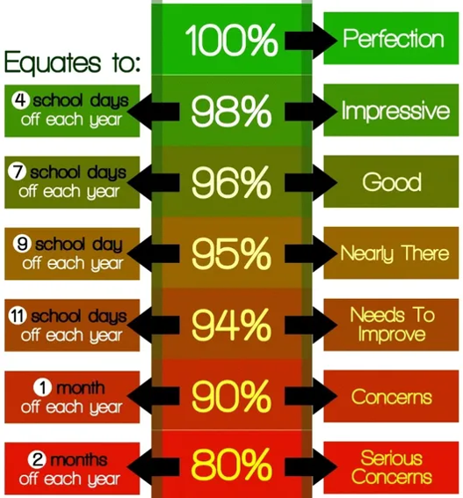

If you would like to discuss your child’s attendance, please contact Miss Burbidge on 0161 498 9508. Your child’s attendance will continue to be monitored and I look forward to seeing a significant improvement.

Yours sincerely

Mrs F Docker
Head of school

LETTER TWO

ADDRESS DATE

Re: NAME D.O.B: ATTENDANCE:

Dear Parent / Carer

On DATE I wrote to you advising that your child’s attendance was a concern to us. Unfortunately, there has been no significant improvement and your child’s attendance is now %.

I must remind you that regular attendance is a legal requirement and it is important that any issues that may be the cause of this poor attendance are addressed as soon as possible. With this in mind we would like you to attend a meeting in school with Mrs Burbidge, on DATE AND TIME to address these concerns.

If for any reason you are unable to attend, please contact Mrs Burbidge on 0161 498 9508 as soon as possible to arrange an alternative appointment.
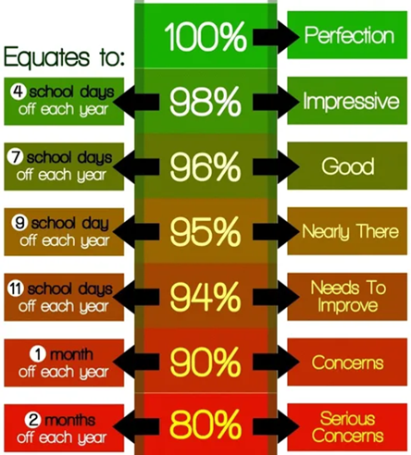

Yours sincerely

Mrs F Docker
Head of School

LETTER THREE

ADDRESS DATE

Re: NAME D.O.B: ATTENDANCE:

Dear Parent / Carer

We have written to you previously expressing concern about NAME’s poor attendance. We also invited you into school to discuss this on DATE. NAME’s attendance has failed to improve and remains well below School, Local and National expectations.

Your child is now classed as a persistently absent pupil as defined by the Government. As such, a referral to One Education is being considered and could result in a Penalty Notice or Legal Proceedings being incurred. We would also like to offer you the opportunity of completing an Early Help Assessment should you require support.

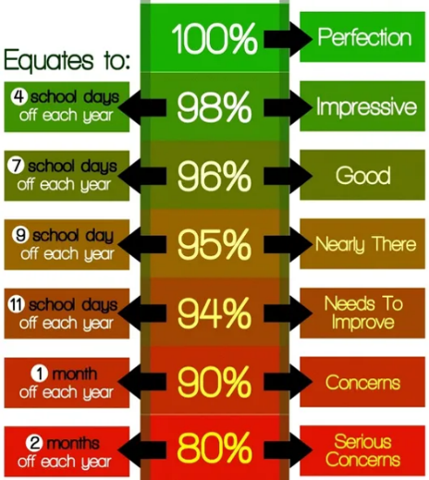

It is essential that you contact Mrs Burbidge on 0161 498 9508 to arrange a meeting to discuss these concerns.

Yours sincerely

Mrs F Docker
Head of School

Term Time Unauthorised Absence Letter

Absence from school

Dear Parent/Carer of Date:

During a conversation on DATE, you informed us that CHILD’S NAME was on holiday during term time. Unfortunately, this period of absence cannot be authorised. Please find below some important changes to Penalty Notices for unauthorised absences from school. These changes came into force from August 2024.

What happens if my child has a period of unauthorised absence?
One of the main changes from the Department for Education is how sanctions for unauthorised absence are used. If you take an unauthorised holiday in term time or have other periods of unauthorised absence the school will request that Manchester City Council issue a fine (known as a fixed-penalty notice). If issued with one, you will need to pay this directly to the local authority – £80 within 21 days, or £160 within 28 days.

The decision whether to issue a fine will take into account whether a national threshold has been met – this is 10 sessions of unauthorised absence in a rolling period of 10 school weeks – as well as other factors. One school day is equal to two sessions. If there was a second period of unauthorised absence within a three-year period then a second penalty notice could be issued, and this would be at the higher rate of £160. Further periods of absence within three years, could mean that you are taken to court with no option of a penalty notice. These rules have come into force as part of the Department for Education’s drive to improve school attendance.

Please be aware that information regarding your child’s attendance is recorded and shared with the Local Education Authority in the case of statutory action being implemented. The attendance of siblings who are of compulsory school age will also be taken into consideration.

If you have any further questions regarding this matter please contact Mrs Burbidge on 0161 498 9508

Yours Sincerely

Mrs F Docker
Head of School

Appendix 5 – Penalty Notice Guidance for Parents and Carers
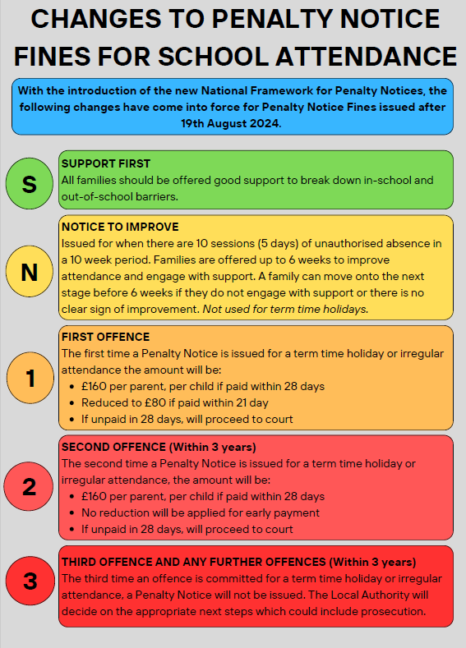

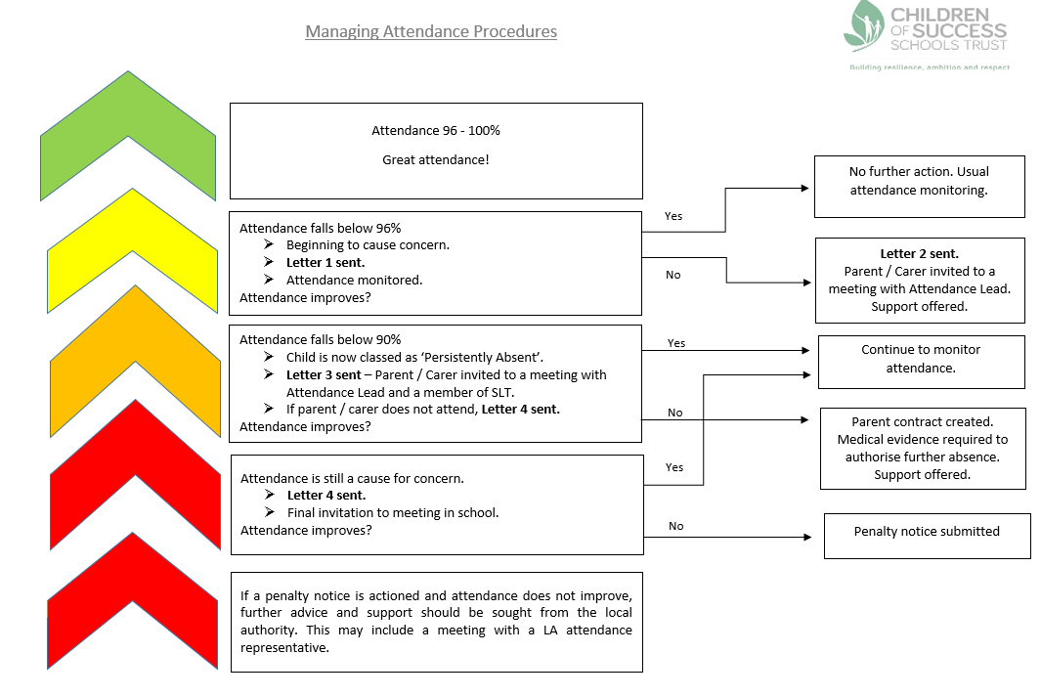
Appendix 6 – Managing Pupil Attendance Procedures

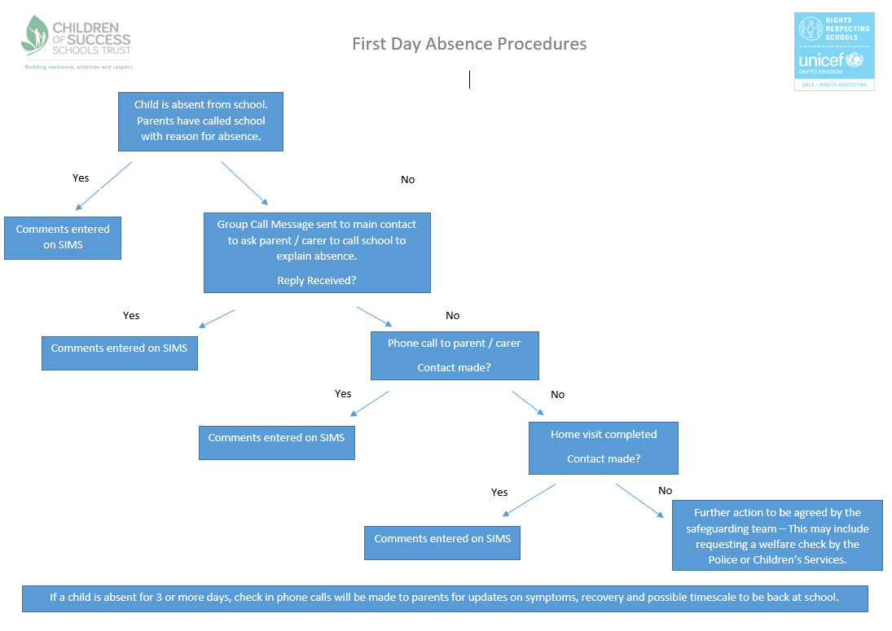
Appendix 7 – First Day Absence Procedures

