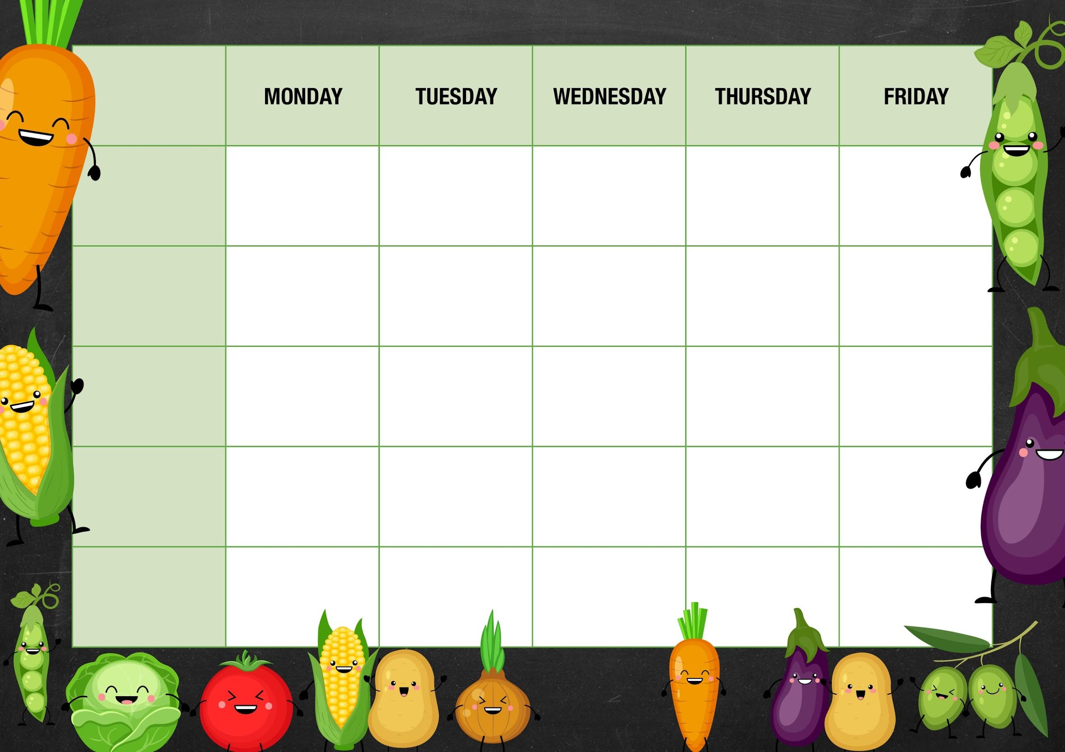
MM

Peas

Cheese and beans

Deli Counter and a selection of fruit

Freshly Baked Bread

Deli Counter and a selection of fruit

Freshly Baked Bread

Veggie meatballs with chunky veg and chips

Quorn cottage pie with crusty bread and beetroot

Choc chip cookies

Gammon roast dinner with roast potatoes Yorkshire pudding and gravy

Peas

Tuna
Cheese and
Beans
Old school sprinkle cake

Quorn roast with roast potatoes Yorkshire puddings and gravy

Tomato and mascarpone pasta with garlic bread

Week 1

Red cabbage

Tuna
Cheese and beans

Carrots

Cheese and beans
Quorn tikka with rice and naan bread

Chicken tikka with rice and naan bread

Mixed veg

Cheese and beans
Cottage pie with crusty bread and beetroot

Fishy Friday

Harry Ramsdens fish fillet with chips and ketchup

Meat Free Monday

Cheese pasty with mash potato and beans

Lemon sponge and custard

Salad and Deli Bar
Arctic roll and mandarins

Mains
Vegetarian
Option
Vegetable

Jacket Potato Choice

Smooth yoghurts and fruit

Deli Counter and a selection of fruit

Freshly Baked Bread

Deli Counter and a selection of fruit

Freshly Baked Bread

Deli Counter and a selection of fruit

Freshly Baked Bread

Deli Counter and a selection of fruit

Freshly Baked Bread

Dessert

