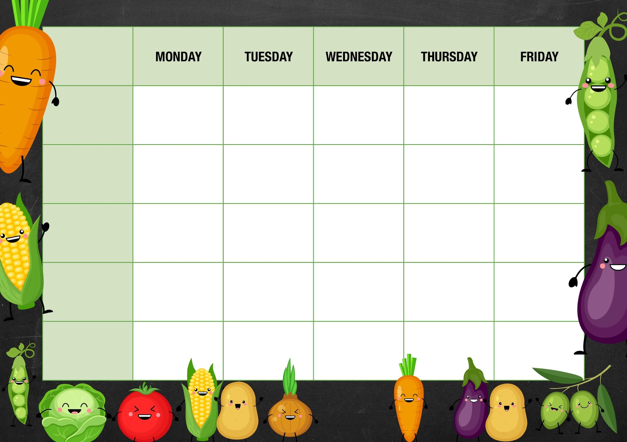
MM

Beans/Peas

Cheese and beans

Deli Counter and a selection of fruit

Freshly Baked Bread

Sweetcorn/peppers

Tuna
Cheese and
Beans
Lancashire biscuits

Vegetarian sausage mash and gravy

Sausage mash and gravy

Sweet potato Balti curry with rice and naan bread

Quorn nuggets with chunky chips and ketchup

Week 2

Cheese crackers and grapes

Carrots

Tuna
Cheese and beans

Beans
Cheese and beans

Tomato and basil pasta with garlic ciabatta slices

Cheese and tomato pizza with French fries

Peperoni pizza with French fries

Carrot batons

Cheese and beans
Beef lasagna with garlic ciabatta slices

Fishy Friday

Fish fingers with chunky chips and ketchup

Meat Free Monday

Macaroni cheese and garlic bread slices
Apple crumble and custard

Salad and Deli Bar
Choc and beetroot muffin

Mains
Vegetarian
Option
Vegetable

Jacket Potato Choice

Ice cream tubs with fruit cocktail

Deli Counter and a selection of fruit

Freshly Baked Bread

Deli Counter and a selection of fruit

Freshly Baked Bread

Deli Counter and a selection of fruit

Freshly Baked Bread

Deli Counter and a selection of fruit

Freshly Baked Bread

Dessert

