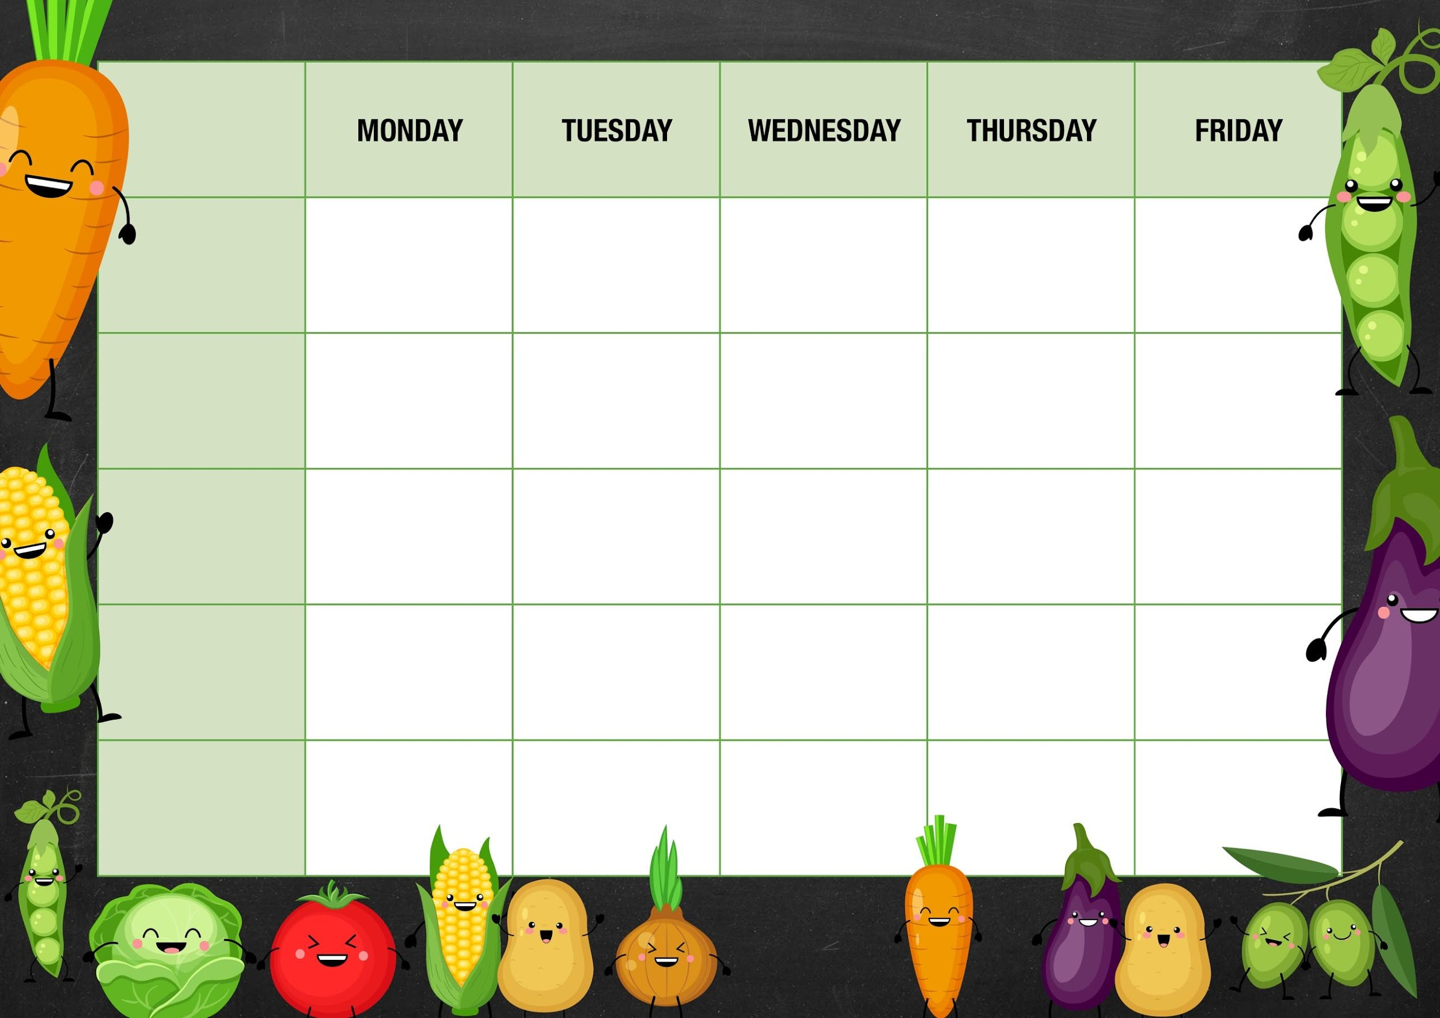
MM
Toasted cheese Panini with chips and ketchup

Sweetcorn/peas

Cheese and beans

Deli Counter and a selection of fruit

Freshly Baked Bread

Chicken dinner with roast potatoes Yorkshire puddings and gravy

Mushy peas

Tuna
Cheese and
Beans
Jam sponge and custard

Quorn fillet dinner with roast potatoes Yorkshire puddings and gravy

Tomato and basil pasta bake

Week 3

Choc chip muffin

Red onion/mango chutney

Tuna
Cheese and beans

Carrot/swede

Cheese and beans

Quorn korma with rice and naan bread

Cheese whirl mash and gravy

Sausage whirl mash and gravy

Mixed veg

Cheese and beans
Chicken korma with rice and naan bread

Fishy Friday

Salmon fish cakes with chips and ketchup

Meat Free Monday

Veg chili with rice
Strawberry jelly and fruit

Salad and Deli Bar
Frozen fruit mousse

Mains
Vegetarian
Option
Vegetable

Jacket Potato Choice

Choc ices

Deli Counter and a selection of fruit

Freshly Baked Bread

Deli Counter and a selection of fruit

Freshly Baked Bread

Deli Counter and a selection of fruit

Freshly Baked Bread

Deli Counter and a selection of fruit

Freshly Baked Bread

Dessert

