

Spanish Curriculum

Booklet

Why is Spanish important at Bredbury St Marks?

- Spanish will deepen children’s understanding of the world.
- Children will learn and appreciate stories, songs, rhymes and poems in Spanish.
- It will encourage a deeper love and understanding of another culture and country.
- It will help pupils to develop knowledge to become a global citizen.
- Our ultimate aim is that our children will feel willing and able to continue studying Spanish beyond KS2.

Knowledge / Concepts / Skills

- Awareness/appreciation of other cultures
- Listen to spoken language
- Engage in conversations
- Read carefully and show understanding of words
- Writing phrases/simple sentences from memory
- Appreciate stories, songs, poems and rhymes
- Read great literature from other cultures

Language Learning Skills by Year Group
 | Year 1 | Year 2 | Year 3 | Year 4  (Assuming at least 1 year of previous foreign language learning) | Year 5  (Assuming at least 2 years of previous foreign language learning) | Year 6  (Assuming at least 3 years of previous foreign language learning)
Listening | Appreciate and actively participate in traditional short stories & fairy tales. | Appreciate short stories & fairy tales and start to understand some of the familiar words in what we hear. | Listen to and enjoy short stories, nursery rhymes & songs. Recognise familiar words and short phrases covered in the units taught. | Learn to listen to longer passages and understand more of what we hear by picking out key words and phrases covered in current and previous units. | Listen more attentively and for longer. Understand more of what we hear even when some of the language may be unfamiliar by using the decoding skills we have developed. | Listen to longer text and more authentic foreign language material. Learn to pick out cognates and familiar words and learn to 'gist listen' even when hearing language that has not been taught or covered.
Speaking | Learn to repeat and reproduce the language I hear with accurate pronunciation. | Learn to articulate key words introduced in the lesson and understand their meaning. | Communicate with others using simple words and short phrases covered in the units. | Communicate with others with improved confidence and accuracy. Learn to ask and answer questions based on the language covered in the units and incorporate a negative reply if and when required. | Communicate on a wider range of topics and themes. Remember and recall a range of vocabulary with increased knowledge, confidence and spontaneity. | Learn to recall previously learnt language and recycle / incorporate it with new language with increased speed and spontaneity. Engage in short conversations on familiar topics, responding with opinions and justifications where appropriate.
Reading | Be able to identify written versions of the words I hear. | Being able to identify the written version of a wider range of the words I hear. | Read familiar words and short phrases accurately by applying knowledge from 'Phonics Lesson 1'. Understand the meaning in English of short words I read in the foreign language. | Read aloud short pieces of text applying knowledge learnt from 'Phonics Lessons 1 & 2'. Understand most of what we read in the foreign language when it is based on familiar language. | Understand longer passages in the foreign language and start to decode meaning of unknown words using cognates and context. Increase our knowledge of phonemes and letter strings using knowledge learnt from 'Phonics Lessons 1  to 3'. | Be able to tackle unknown language with increased accuracy by applying knowledge learnt from 'Phonics Lessons 1 to 4' including awareness of accents, silent letters etc. Decode unknown language using bilingual dictionaries.
Writing | Consolidate letter formation skills by copying words in the foreign language from a model. | Start to reproduce nouns and determiners/articles from a model. | Write familiar words & short phrases using a model or vocabulary list. EG: 'I play the piano'. 'I like apples'. | Write some short phrases based on familiar topics and begin to use connectives/conjunctions and the negative form where appropriate. EG: My name, where I live and my age. | Write a paragraph using familiar language incorporating connectives/conjunctions, a negative response and adjectival agreement where required. Learn to manipulate the language and be able to substitute words for suitable alternatives.  EG: My name, my age, where I live, a pet I have, a pet I don't have and my pet's name. | Write a piece of text using language from a variety of units covered and learn to adapt any models provided to show solid understanding of any grammar covered.  Also start to incorporate conjugated verbs and learn to be comfortable using connectives/conjunctions, adjectives and possessive adjectives. EG: A presentation or description of a typical school day including subjects, time and opinions.
Grammar | Start to understand that foreign languages can have different structures to English. | Start to understand that foreign languages can have different structures to English. EG: Many nouns have a determiner/article in foreign languages which we don't have in English. | Start to understand the concept of noun gender and the use of articles. Use the first person singular version of high frequency verbs. EG: 'I like…' 'I play…' 'I am called…' | Better understand the concept of gender and which articles to use for meaning (EG: 'the', 'a' or 'some'). Introduce simple adjectival agreement (EG: adjectival agreement when describing nationality), the negative form and possessive adjectives. EG: 'In my pencil case I have…' or 'In my pencil case I do not have...' | Revision of gender and nouns and learn to use and recognise the terminology of articles (EG: definite, indefinite and partitive). Understand better the rules of adjectival agreement and possessive adjectives. Start to explore full verb conjugation (EG: 'I wear...', 'he/she wears...' and also be able to describe clothes in terms of colour EG: 'My blue coat'. | Consolidate our understanding of gender and nouns, use of the negative, adjectival agreement and possessive adjectives (EG: which subjects I like at school and also which subjects I do not like). Become familiar with a wider range of connectives/conjunctions and more confident with full verb conjugation ‐ both regular and irregular. EG: 'to go', 'to do', 'to have' and 'to be'.
How is Spanish taught at Bredbury St Marks?

- Spanish is taught weekly at Bredbury St Marks using the scheme Language Angels
- Each lesson lasts a minimum of 30 minutes
- Each lesson focuses on a combination of the 5 key language learning skills: speaking , listening, reading, writing and grammar.
- Children will progressively acquire, use and apply a growing bank of vocabulary, language skills and grammatical knowledge organised around age-appropriate topics and themes - building blocks of language into more complex, fluent and authentic language.
- Language Angels are categorised by ‘Teaching Type’ to make it easier for teachers to choose units that will offer the appropriate level of challenge and stretch for the classes they are teaching.
- Early Language units are entry level units and are most appropriate for KS1 and Year 3 pupils or pupils with little or no previous foreign language learning. Intermediate units increase the level of challenge by increasing the amount and complexity (including foreign language grammar concepts) of the foreign language presented to pupils. Intermediate units are suitable for Year 4-5 pupils or pupils with embedded basic knowledge of the foreign language. Progressive and Creative Curriculum units are the most challenging units and are suitable for Year 6 pupils or pupils with a good understanding of the basics of the language they are learning. Grouping units into these Teaching Type categories ensures that the language taught is appropriate to the level of the class and introduced when the children are ready. Children will be taught how to listen and read longer pieces of text gradually in the foreign language and they will have ample opportunities to speak, listen to, read and write the language being taught with and without scaffolds, frames and varying levels of support.
- Each teaching unit is divided into 6 fully planned lessons.
- Each unit and lesson has clearly defined objectives and aims.
- Each lesson will incorporate interactive whiteboard materials to include ample speaking and listening tasks within a lesson.
- Lessons will incorporate challenge sections and desk-based activities that will be offered will three levels of stretch and differentiation. These may be sent home as homework if not completed in class.
- Reading and writing activities are offered in all units. Some extended reading and writing activities are provided so that native speakers can also be catered for.
- Every unit includes a grammar concept which will increase in complexity as pupils move from Early Language units, through Intermediate units and into Progressive units.
- Extending writing activities are provided to ensure that pupils are recalling previously learnt language and, by reusing it, will be able to recall it and use it with greater ease and accuracy. These tasks will help to link units together and show that pupils are retaining and recalling the language taught with increased fluency and ease.
- Units are progressive within themselves as subsequent lessons within a unit build on the language and knowledge taught in previous lessons. As pupils progress though the lessons in a unit they will build their knowledge and develop the complexity of the language they use. We think of the progression within the 6 lessons in a unit as ‘language Lego’. We provide blocks of language knowledge and, over the course of a 6-week unit, encourage pupils to build more complex and sophisticated language structures with their blocks of language knowledge.

Curriculum at a glance
KS1 Unit Planner (Limited Foreign Language Experience)
 | Year 1 | Year 2
Autumn | Greetings (E) | Fruits (E)
Spring | Numbers (1-10)  Colours (E) | Vegetables (E)
Summer | Shapes (E) | Ice-creams (E)

Key
C = core vocabulary
E = Early Learning Teaching Units
I = Intermediate Teaching Units
P = Progressive Teaching Units

Curriculum at a glance
KS2 Unit Planner (Limited Foreign Language Experience)
 | Year 3/4  Cycle-23/24 | Year 5/6 Cycle 1-23/24 | Year 3/4/5  Cycle 2-22/23 | Year 6  Cycle 2-22/23
Autumn 1 | Phonic lessons 1&2 (C)  I’m learning fr/sp/it (E) | Phonic lessons 1&2 (C)  The weather (I) | Phonic lessons 1&2 (C)  Shapes (E) | Phonic lessons 3&4 (C)  The date (I)
Autumn 2 | Animals (E) | Family (I) | Musical instruments (E) | Home (I)
Spring 1 | I can (E) | Pets (I) | Vegetables (E) | Clothes (I)
Spring 2 | Fruits (E) | Olympics (I) | Ancient Britain (E) | Planets (P)
Summer 1 | Presenting myself (I) | At school (P) | In class (I) | Healthy living (P) or Regular verbs (P)
Summer 2 | At the café (I) | The weekend (P) | Habitats or Goldilocks (I) | Me in the world (P)
Key
C = core vocabulary / E = Early Learning Teaching Units / I = Intermediate Teaching Units / P = Progressive Teaching Units

Core Vocabulary Mat
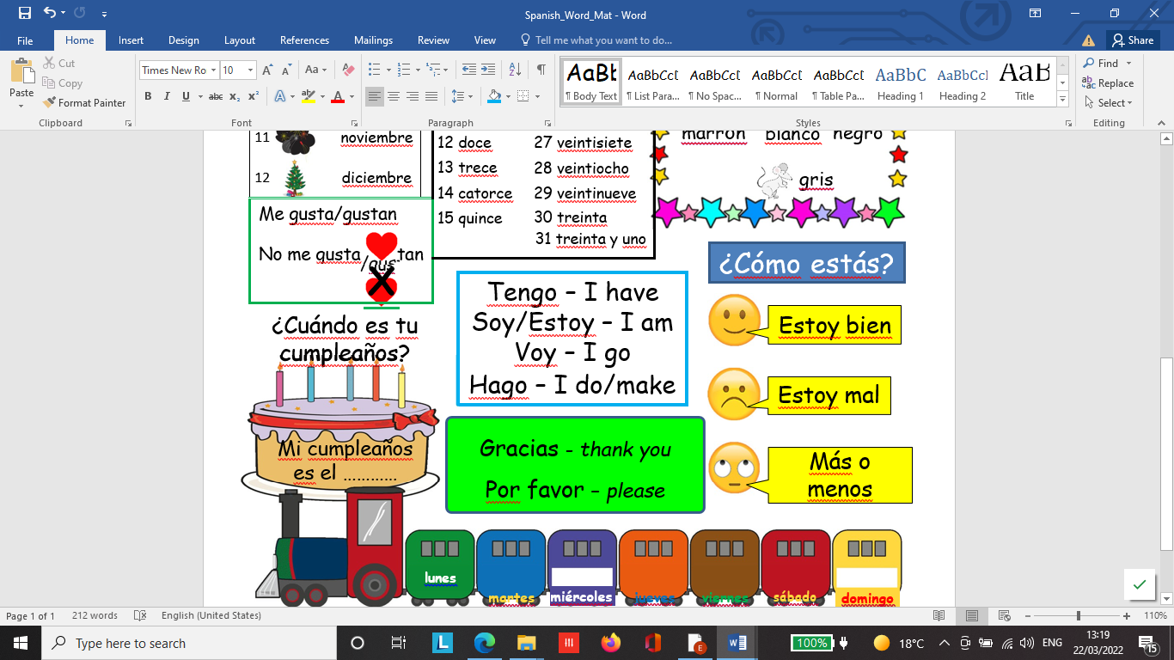
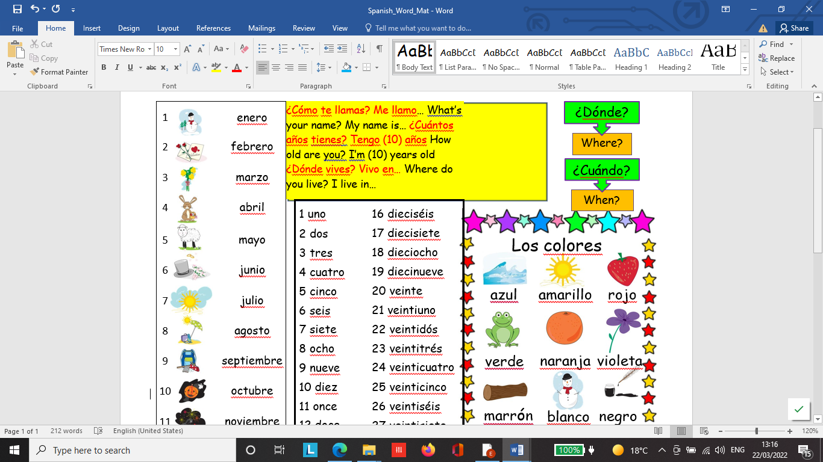

Vocabulary Lists
All units come with a vocabulary list for children. A few examples are provided below.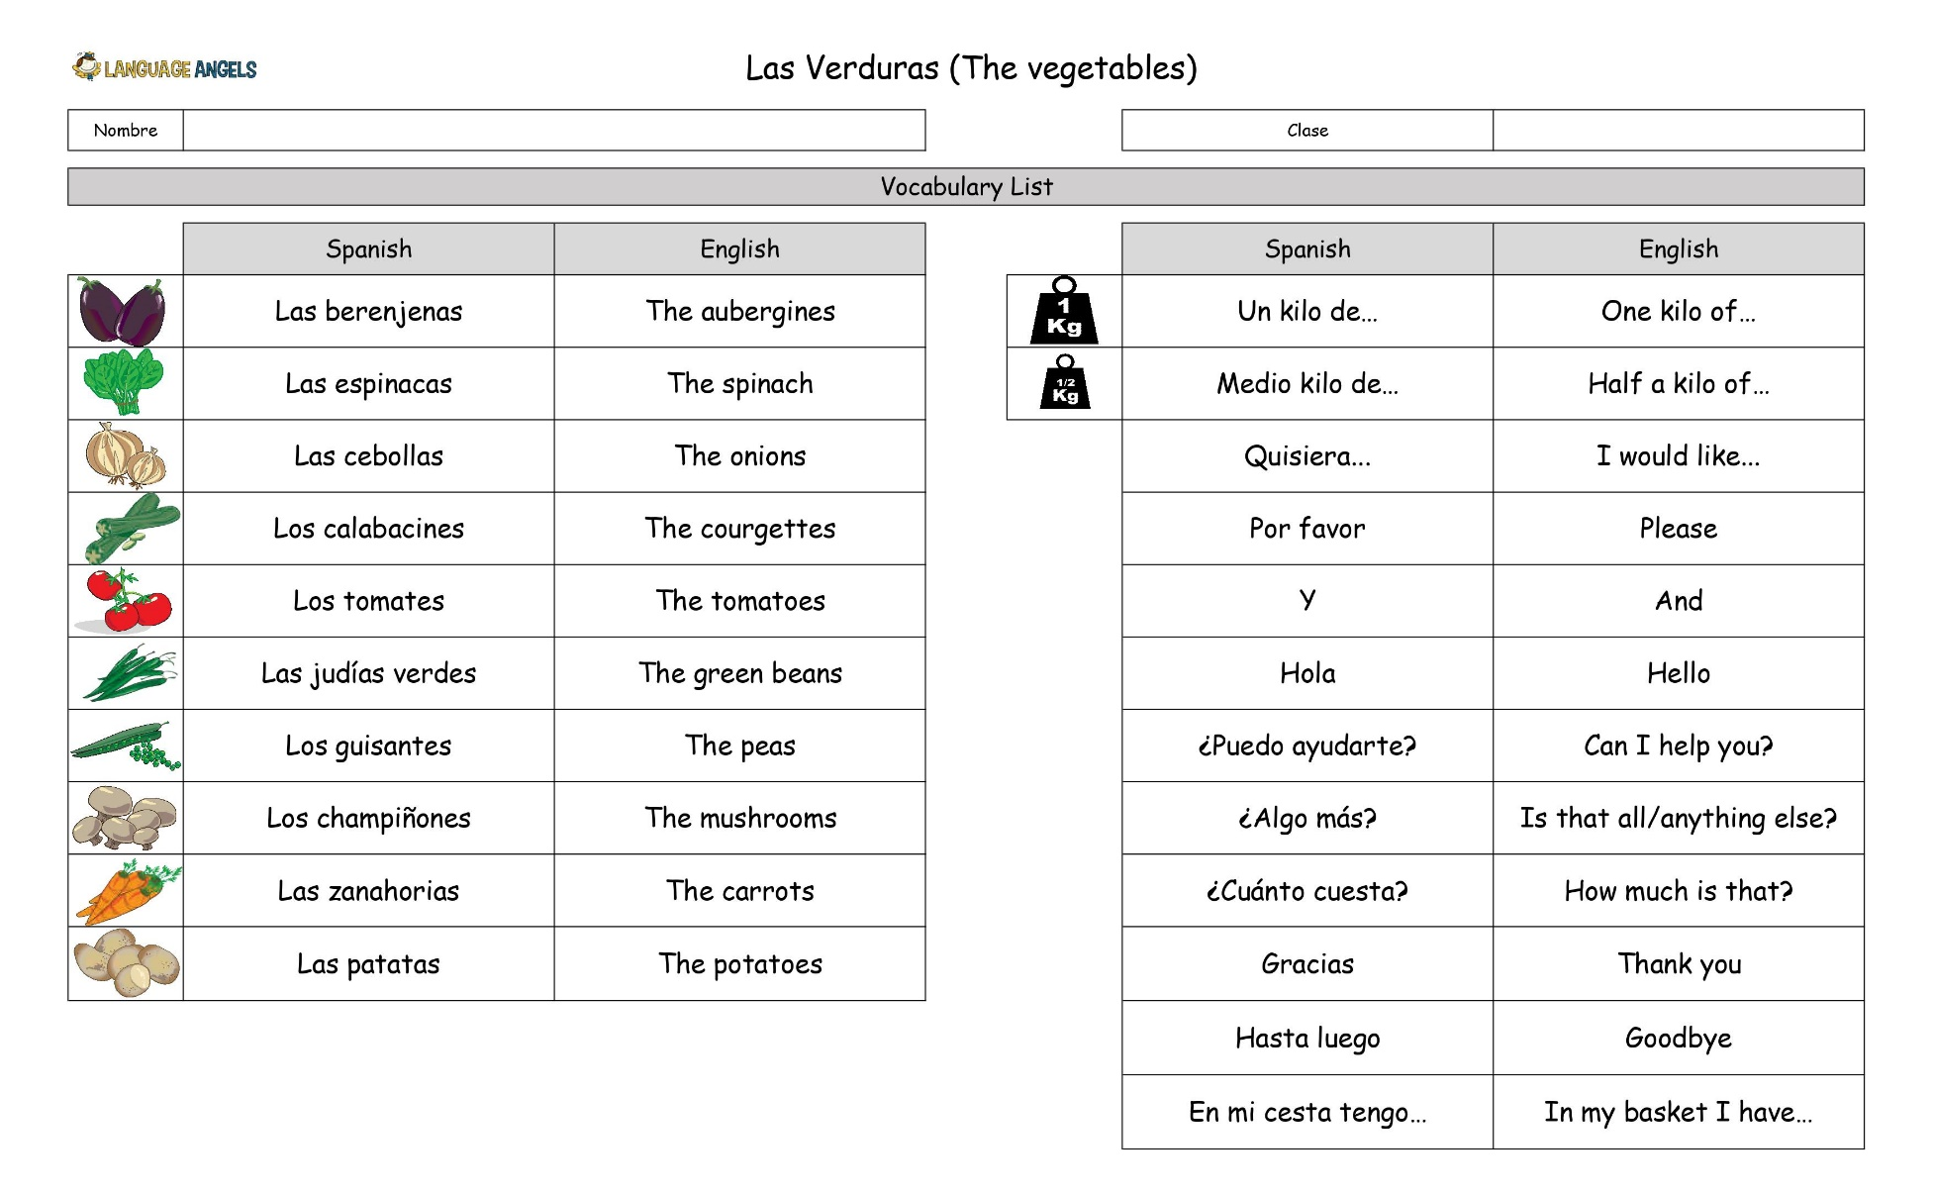
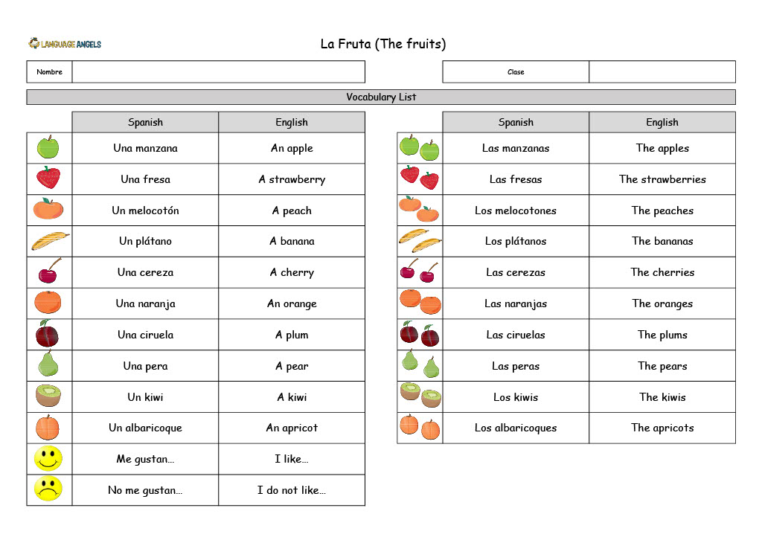
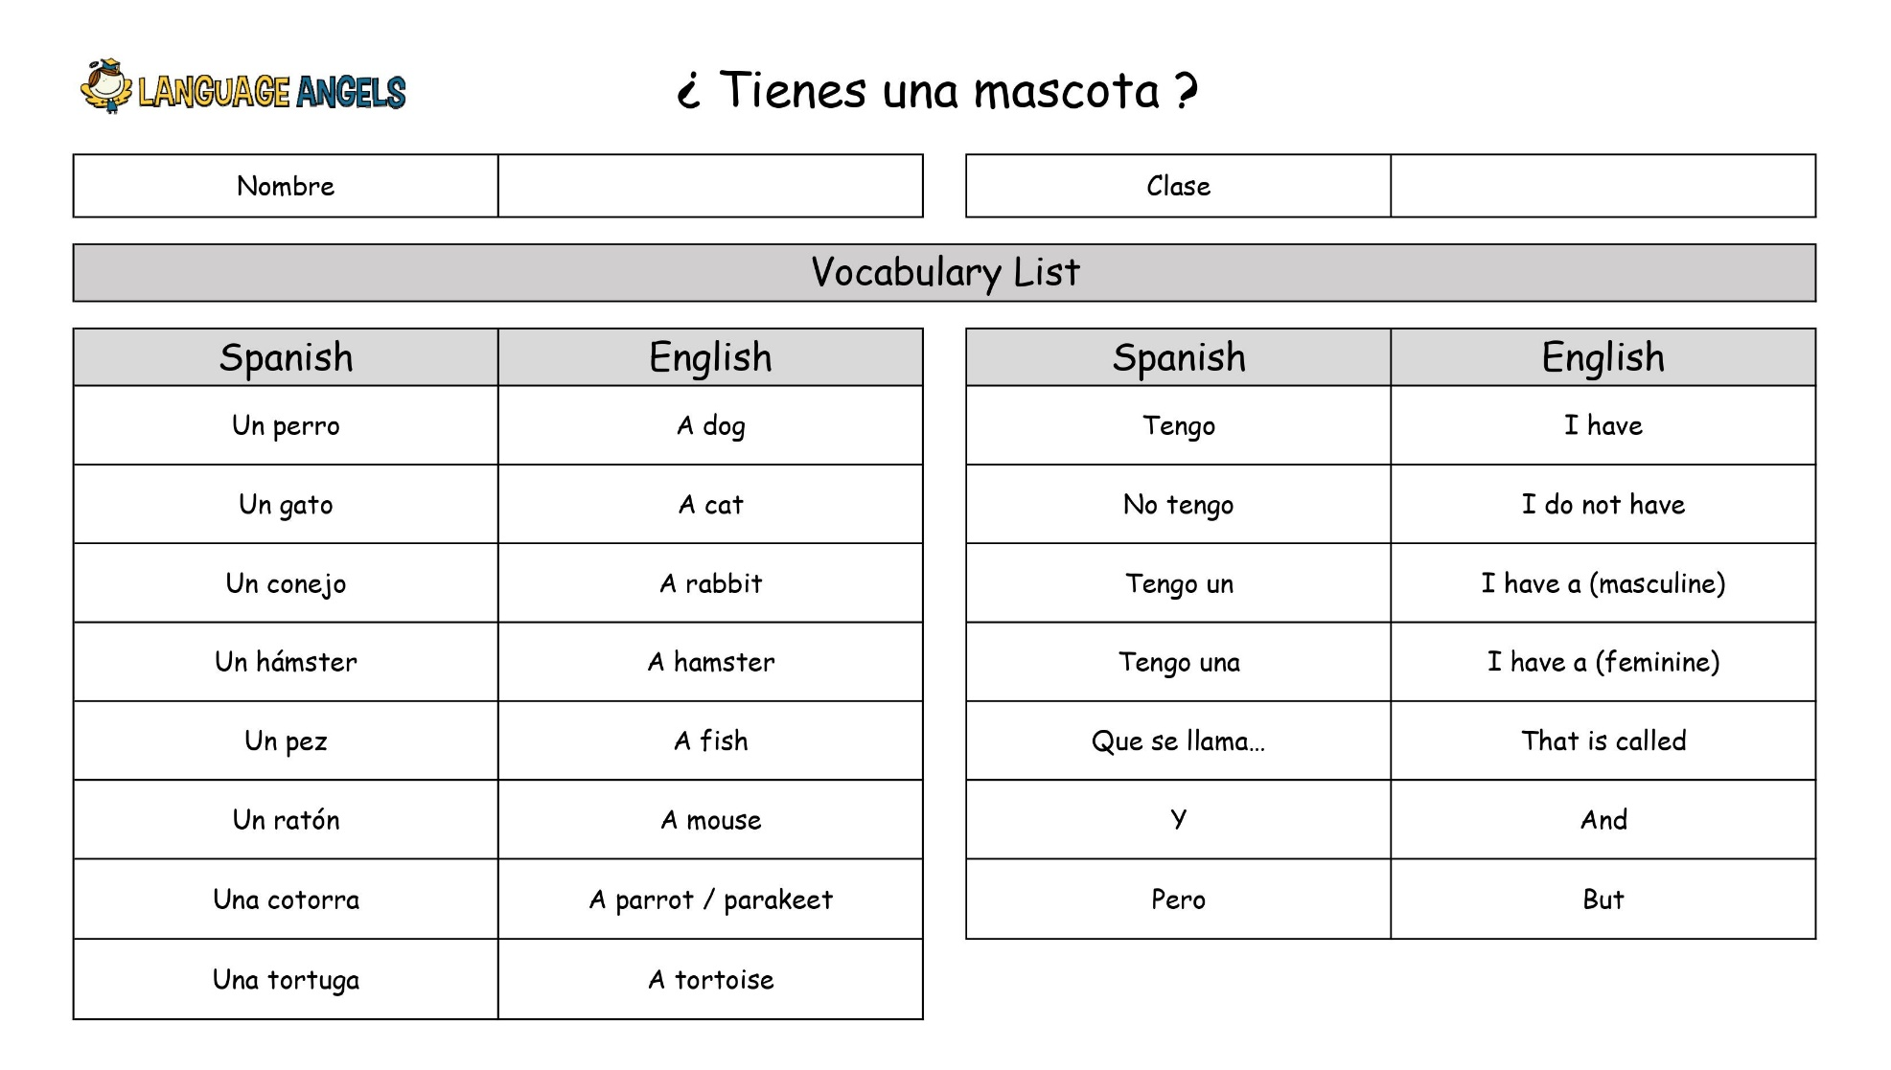

Knowledge Organisers
These are available for all units. They are used to keep units focussed to ensure key content is taught. They are not necessarily shared with the children.
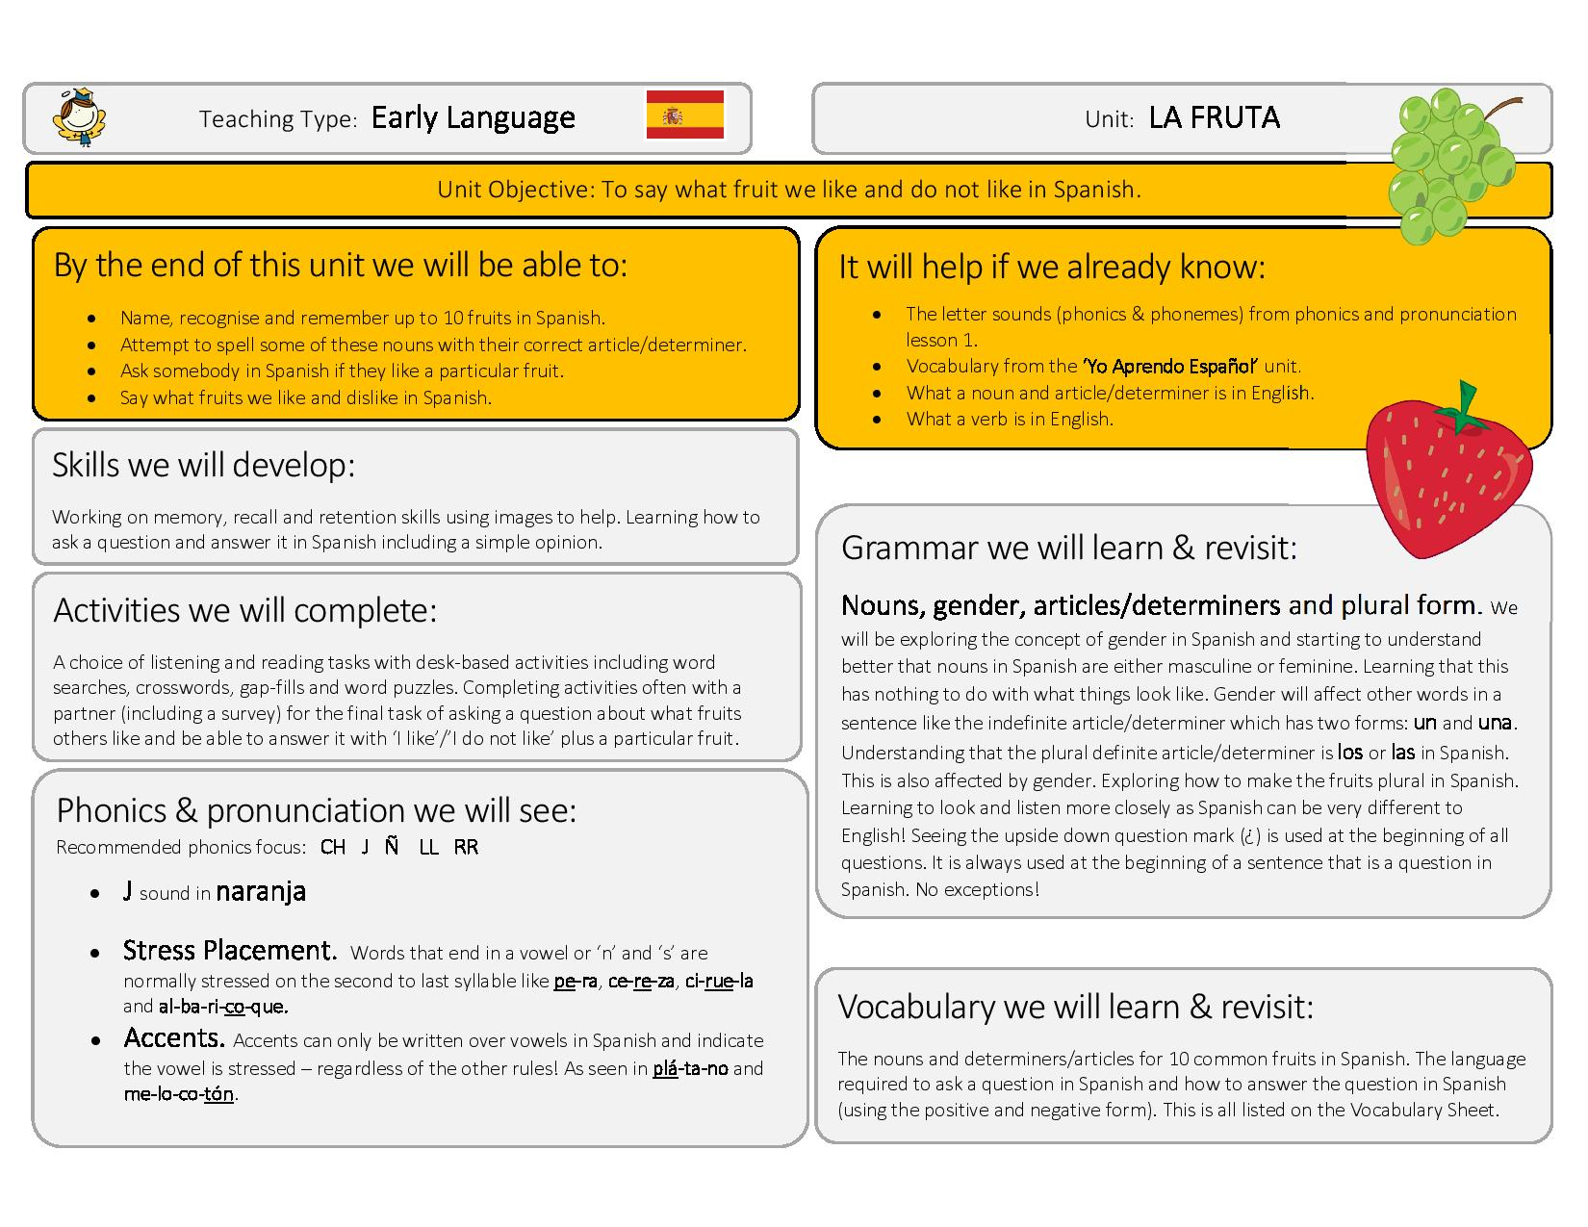
End points for Key Stage 2
It is only statutory to assess MFL at the end of Key Stage 2. Although we will track progress in all units we will only formally report at the end of Key Stage 2. The compliance grid below demonstrates how we meet the requirements of the National Curriculum.
Early Language Teaching Type
KS2 Programme Of Study Requirement |  | Main Skill Focus | Early Language Units
1 | "Listen attentively to spoken language and show understanding by joining in and responding." | LISTENING | All units (except: I Am Learning…)
2 | "Explore the patterns and sounds of language through songs and rhymes and link the spelling, sound and meaning of words." | LISTENING | Phonetics 1, Instruments, Little Red Riding Hood
3 | "Engage in conversations; ask and answer questions; express opinions and respond to those of others; seek clarification and help." | SPEAKING | I Am Learning…, Animals, Instruments, I Can…, Fruit, Vegetables
4 | "Speak in sentences, using familiar vocabulary, phrases and basic language structures." | SPEAKING | All units
5 | "Develop accurate pronunciation and intonation so that others understand when they are reading aloud or using familiar words and phrases." | SPEAKING | All units (plus: Phonetics 1)
6 | "Present ideas and information orally to a range of audiences." | SPEAKING | All units
7 | "Read carefully and show understanding of words, phrases and simple writing." | READING | All units
8 | "Appreciate stories, songs, poems and rhymes in the language." | READING | Instruments, Little Red Riding Hood, Shapes
9 | "Broaden their vocabulary and develop their ability to understand new words that are introduced into familiar written material, including through using a dictionary." | READING | All units
10 | "Write phrases from memory, and adapt these to create new sentences, to express ideas clearly." | WRITING | All units
11 | "Describe people, places, things and actions orally and in writing." | WRITING | Animals (THINGS), I Can… (ACTIONS), Ancient Britain (PEOPLE)

 | KS2 Programme Of Study Requirement |  |  |  | Main Skill Focus |  | Early Language Units
 | 12 |  | "Understand basic grammar appropriate to the language being studied, including (where relevant): feminine, masculine and neuter forms and the conjugation of high-frequency verbs; key features and patterns of the language; how to apply these, for instance, to build sentences; and how these differ from or are similar to English." * |  | GRAMMAR (GENDER & ARTICLES) |  | Animals, Instruments, Ancient Britain, Fruits, Vegetables, Shapes
 |  |  |  |  | GRAMMAR  (FIRST PERSON SINGULAR OF HIGH FREQUENCY VERBS) |  | I Am Learning…, Animals, Instruments, I Can…, Ancient Britain, Fruit, Vegetables
 |  |  |  |  | GRAMMAR (POSSESSIVES)
 |  |  |  |  | GRAMMAR (ADJECTIVAL AGREEMENT)
 |  |  |  |  | GRAMMAR (USING THE NEGATIVE) |  | Fruit
 |  |  |  |  | GRAMMAR (USING CONJUNCTIONS / CONNECTIVES)
 |  |  |  |  | GRAMMAR (OPINIONS) |  | Fruit
GRAMMAR (WHOLE CONJUGATION OF HIGH FREQUENCY
VERBS)
Intermediate Language Teaching Type  KS2 Programme Of Study Requirement |  |  |  | Main Skill Focus |  | Intermediate Language Units
1 |  | "Listen attentively to spoken language and show understanding by joining in and responding." |  | LISTENING |  | All units
2 |  | "Explore the patterns and sounds of language through songs and rhymes and link the spelling, sound and meaning of words." |  | LISTENING |  | Phonetics 2, Phonetics 3, Family, Tudors, Goldilocks, Olympics, Romans, Habitats
3 |  | "Engage in conversations; ask and answer questions; express opinions and respond to those of others; seek clarification and help." |  | SPEAKING |  | Presenting Myself, Family, Do You Have A Pet?, At The Café, In The Classroom, What Is The Date?, The Weather,  Clothes, My Home
4 |  | "Speak in sentences, using familiar vocabulary, phrases and basic language structures." |  | SPEAKING |  | All units
5 |  | "Develop accurate pronunciation and intonation so that others understand when they are reading aloud or using familiar words and phrases." |  | SPEAKING |  | All units (plus: Phonetics 2 + 3)
6 |  | "Present ideas and information orally to a range of audiences." |  | SPEAKING |  | All units
7 |  | "Read carefully and show understanding of words, phrases and simple writing." |  | READING |  | All units
8 |  | "Appreciate stories, songs, poems and rhymes in the language." |  | READING |  | Family, Goldilocks, Tudors, Olympics, Romans
9 |  | "Broaden their vocabulary and develop their ability to understand new words that are introduced into familiar written material, including through using a dictionary." |  | READING |  | All units
10 |  | "Write phrases from memory, and adapt these to create new sentences, to express ideas clearly." |  | WRITING |  | All units  (except: At The Café, Goldilocks)
11 |  | "Describe people, places, things and actions orally and in writing." |  | WRITING |  | Presenting Myself (PEOPLE), Family (PEOPLE), Tudors (PEOPLE), In The  Classroom (THINGS), Pets (THINGS), The Weather (THINGS), Clothes (THINGS), Habitats (PEOPLE, PLACES & THINGS), Romans (PEOPLE, PLACES & THINGS), Olympics (PEOPLE, PLACES & THINGS), My  Home (PLACES)

KS2 Programme Of Study Requirement |  | Main Skill Focus | Intermediate Language Units
12 | "Understand basic grammar appropriate to the language being studied, including (where relevant): feminine, masculine and neuter forms and the conjugation of high-frequency verbs; key features and patterns of the language; how to apply these, for instance, to build sentences; and how these differ from or are similar to English." * | GRAMMAR (GENDER & ARTICLES) | Family, At The Café, In The Classroom, Pets, Clothes, Olympics, My Home
12 |  | GRAMMAR (FIRST PERSON  SINGULAR OF HIGH FREQUENCY VERBS) | Presenting Myself, At The Café, In The Classroom, Pets, Clothes, Olympics, Romans, My Home
12 |  | GRAMMAR (POSSESSIVES) | Family, In The Classroom, Clothes
12 |  | GRAMMAR (ADJECTIVAL AGREEMENT) | Presenting Myself, Clothes
12 |  | GRAMMAR (USING THE NEGATIVE) | In The Classroom, Pets, Romans, My Home
12 |  | GRAMMAR (USING CONJUNCTIONS / CONNECTIVES) | In The Classroom, Pets, My Home
12 |  | GRAMMAR (OPINIONS)
12 |  | GRAMMAR (WHOLE CONJUGATION OF HIGH FREQUENCY  VERBS) | Clothes, Olympics

Progressive Language Teaching Type
KS2 Programme Of Study Requirement |  | Main Skill Focus | Progressive Language Units
1 | "Listen attentively to spoken language and show understanding by joining in and responding." | LISTENING | All units
2 | "Explore the patterns and sounds of language through songs and rhymes and link the spelling, sound and meaning of words." | LISTENING | Phonetics 4, At School
3 | "Engage in conversations; ask and answer questions; express opinions and respond to those of others; seek clarification and help." | SPEAKING | All units  (except: Regular Verbs, Irregular Verbs)
4 | "Speak in sentences, using familiar vocabulary, phrases and basic language structures." | SPEAKING | All units  (except: Regular Verbs, Irregular Verbs)
5 | "Develop accurate pronunciation and intonation so that others understand when they are reading aloud or using familiar words and phrases." | SPEAKING | All units (plus: Phonetics 4)
6 | "Present ideas and information orally to a range of audiences." | SPEAKING | All units  (except: Regular Verbs, Irregular Verbs)
7 | "Read carefully and show understanding of words, phrases and simple writing." | READING | World War II, Planets, Habitats
8 | "Appreciate stories, songs, poems and rhymes in the language." | READING | At School, World War II, Me In The World
9 | "Broaden their vocabulary and develop their ability to understand new words that are introduced into familiar written material, including through using a dictionary." | READING | All units
10 | "Write phrases from memory, and adapt these to create new sentences, to express ideas clearly." | WRITING | All units  (except: Regular Verbs, Irregular Verbs)
11 | "Describe people, places, things and actions orally and in writing." | WRITING | At School (THINGS), Weekend Activities (THINGS & ACTIONS), World War II  (THINGS & PLACES), Healthy Lifestyles (THINGS & ACTIONS), Planets (THINGS & PLACES), Habitats (PEOPLE, PLACES  & THINGS), Me In The World (PEOPLE & PLACES)

KS2 Programme Of Study Requirement |  | Main Skill Focus | Progressive Language Units
12 | "Understand basic grammar appropriate to the language being studied, including (where relevant): feminine, masculine and neuter forms and the conjugation of high-frequency verbs; key features and patterns of the language; how to apply these, for instance, to build sentences; and how these differ from or are similar to English." * | GRAMMAR (GENDER & ARTICLES) | At School, Healthy Lifestyles
12 |  | GRAMMAR (FIRST PERSON  SINGULAR OF HIGH FREQUENCY VERBS) | At School, Weekend, World War II, Healthy Lifestyles, Regular Verbs, Irregular Verbs, Me In The World
12 |  | GRAMMAR (POSSESSIVES)
12 |  | GRAMMAR (ADJECTIVAL AGREEMENT) | At School, Planets
12 |  | GRAMMAR (USING THE NEGATIVE) | At School, Weekend, Healthy Lifestyles, Planets
12 |  | GRAMMAR (USING CONJUNCTIONS / CONNECTIVES) | At School, Weekend, Me In The World
12 |  | GRAMMAR (OPINIONS) | At School, Weekend
12 |  | GRAMMAR (WHOLE CONJUGATION OF HIGH FREQUENCY  VERBS) | At School, Habitats, Regular Verbs, Irregular Verbs

Unit Mapping against Attainment Targets
EARLY LANGUAGE UNITS
Ice Creams | Shapes | Vegetables | Fruits | Ancient Britain | I Can… | Little Red Riding  Hood | Instruments | Animals | I'm Learning | PoS Attainment  Target | LISTENING  SPEAKING  READING  WRITING  GRAMMAR
X | X | X | X | X | X | X | X | X |  | 1 | Listen attentively to spoken language and show understanding by joining in and responding.
X | X |  |  |  |  | X | X |  |  | 2 | Explore the patterns and sounds of language through songs and rhymes and link the spelling, sound and meaning of words.
X |  | X | X |  | X |  | X | X | X | 3 | Engage in conversations; ask and answer questions; express opinions and respond to those of others; seek clarification and help.
X | X | X | X | X | X | X | X | X | X | 4 | Speak in sentences, using familiar vocabulary, phrases and basic language structures.
X | X | X | X | X | X | X | X | X | X | 5 | Develop accurate pronunciation and intonation so that others understand when they are reading aloud or using familiar words and phrases.
X | X | X | X | X | X | X | X | X | X | 6 | Present ideas and information orally to a range of audiences.
X | X | X | X | X | X | X | X | X | X | 7 | Read carefully and show understanding of words, phrases and simple writing.
X | X |  |  |  |  | X | X |  |  | 8 | Appreciate stories, songs, poems and rhymes in the language.
X | X | X | X | X | X | X | X | X | X | 9 | Broaden their vocabulary and develop their ability to understand new words that are introduced into familiar written material, including through using a  dictionary.
X | X | X | X | X | X | X | X | X | X | 10 | Write phrases from memory, and adapt these to create new sentences, to express ideas clearly.
 | X |  |  | X | X |  |  | X |  | 11 | Describe people, places, things and actions orally and in writing.
X | X | X | X | X |  |  | X | X |  | 12 | Understand basic grammar appropriate to the language being studied, including (where relevant): feminine, masculine and neuter forms and the conjugation of high‐frequency verbs; key features and patterns of the language; how to apply these to build sentences; and how these differ from or are similar to English.

INTERMEDIATE UNITS
What Is The Date? | Goldilocks & The  Three Bears | Do You Have A  Pet? | In Class | At The Café | The Tudors | My Family | Presenting Myself | PoS Attainment  Target | LISTENING  SPEAKING  READING  WRITING  GRAMMAR
X | X | X | X | X | X | X | X | 1 | Listen attentively to spoken language and show understanding by joining in and responding.
 | X |  |  |  | X | X |  | 2 | Explore the patterns and sounds of language through songs and rhymes and link the spelling, sound and meaning of words.
X |  | X | X | X |  | X | X | 3 | Engage in conversations; ask and answer questions; express opinions and respond to those of others; seek clarification and help.
X | X | X | X | X | X | X | X | 4 | Speak in sentences, using familiar vocabulary, phrases and basic language structures.
X | X | X | X | X | X | X | X | 5 | Develop accurate pronunciation and intonation so that others understand when they are reading aloud or using familiar words and phrases.
X | X | X | X | X | X | X | X | 6 | Present ideas and information orally to a range of audiences.
X | X | X | X | X | X | X | X | 7 | Read carefully and show understanding of words, phrases and simple writing.
 | X |  |  |  | X | X |  | 8 | Appreciate stories, songs, poems and rhymes in the language.
X | X | X | X | X | X | X | X | 9 | Broaden their vocabulary and develop their ability to understand new words that are introduced into familiar written material, including through using a  dictionary.
X |  | X | X |  | X | X | X | 10 | Write phrases from memory, and adapt these to create new sentences, to express ideas clearly.
 |  | X | X | X | X | X |  | 11 | Describe people, places, things and actions orally and in writing.
 |  | X | X | X |  | X | X | 12 | Understand basic grammar appropriate to the language being studied, including (where relevant): feminine, masculine and neuter forms and the conjugation of high‐frequency verbs; key features and patterns of the language; how to apply these to build sentences; and how these differ from or are similar to English.

INTERMEDIATE UNITS
My Home | Habitats | The Romans | The Olympics | Clothes | The Weather | PoS Attainment  Target | LISTENING  SPEAKING  READING  WRITING  GRAMMAR
X | X | X | X | X | X | 1 | Listen attentively to spoken language and show understanding by joining in and responding.
 | X | X | X |  |  | 2 | Explore the patterns and sounds of language through songs and rhymes and link the spelling, sound and meaning of words.
X |  |  |  | X | X | 3 | Engage in conversations; ask and answer questions; express opinions and respond to those of others; seek clarification and help.
X | X | X | X | X | X | 4 | Speak in sentences, using familiar vocabulary, phrases and basic language structures.
X | X | X | X | X | X | 5 | Develop accurate pronunciation and intonation so that others understand when they are reading aloud or using familiar words and phrases.
X | X | X | X | X | X | 6 | Present ideas and information orally to a range of audiences.
X | X | X | X | X | X | 7 | Read carefully and show understanding of words, phrases and simple writing.
 |  | X | X |  |  | 8 | Appreciate stories, songs, poems and rhymes in the language.
X | X | X | X | X | X | 9 | Broaden their vocabulary and develop their ability to understand new words that are introduced into familiar written material, including through using a  dictionary.
X | X | X | X | X | X | 10 | Write phrases from memory, and adapt these to create new sentences, to express ideas clearly.
X | X | X | X | X | X | 11 | Describe people, places, things and actions orally and in writing.
X |  | X | X | X |  | 12 | Understand basic grammar appropriate to the language being studied, including (where relevant): feminine, masculine and neuter forms and the conjugation of high‐frequency verbs; key features and patterns of the language; how to apply these to build sentences; and how these differ from or are similar to English.

PROGRESSIVE UNITS
Me In The World | Irregular Verbs | Regular Verbs | Habitats | The Planets | Healthy Lifestyles | World War II | The Weekend | At School | PoS Attainment  Target | LISTENING  SPEAKING  READING  WRITING  GRAMMAR
X | X | X | X | X | X | X | X | X | 1 | Listen attentively to spoken language and show understanding by joining in and responding.
 |  |  |  |  |  |  |  | X | 2 | Explore the patterns and sounds of language through songs and rhymes and link the spelling, sound and meaning of words.
X |  |  | X | X | X | X | X | X | 3 | Engage in conversations; ask and answer questions; express opinions and respond to those of others; seek clarification and help.
X |  |  | X | X | X | X | X | X | 4 | Speak in sentences, using familiar vocabulary, phrases and basic language structures.
X | X | X | X | X | X | X | X | X | 5 | Develop accurate pronunciation and intonation so that others understand when they are reading aloud or using familiar words and phrases.
X |  |  | X | X | X | X | X | X | 6 | Present ideas and information orally to a range of audiences.
 |  |  | X | X |  | X |  |  | 7 | Read carefully and show understanding of words, phrases and simple writing.
X |  |  |  |  |  | X |  | X | 8 | Appreciate stories, songs, poems and rhymes in the language.
X | X | X | X | X | X | X | X | X | 9 | Broaden their vocabulary and develop their ability to understand new words that are introduced into familiar written material, including through using a  dictionary.
X |  |  | X | X | X | X | X | X | 10 | Write phrases from memory, and adapt these to create new sentences, to express ideas clearly.
X |  |  | X | X | X | X | X | X | 11 | Describe people, places, things and actions orally and in writing.
X | X | X | X | X | X | X | X | X | 12 | Understand basic grammar appropriate to the language being studied, including (where relevant): feminine, masculine and neuter forms and the conjugation of high‐frequency verbs; key features and patterns of the language; how to apply these to build sentences; and how these differ from or are similar to English.

Assessment
Assessment of Pupil Learning & Progression
Two forms of assessment are available at the end of every Language Angels unit:
- Peer and self-assessment ‘I can do…’ grids. A quick and easy way for all pupils in the class to record which units they have completed and the progress they are making.
- More detailed skills based assessments using bespoke skills assessment worksheets. This form of assessment enables us to determine the learning and progression of all pupils in the key language learning skills as well as monitoring their progress against the 12 attainment targets stipulated in the DfE Languages Programme of Study for Key Stage 2.

The Language Angels Tracking & Progression Tool records, analyses and interpret data for Spanish. We use this tool to:
• View and plot the position on the Learning and Progression Timeline of a class or individual pupil. This visually demonstrates the progress classes are making against the 12 teaching targets stipulated in the DfE Key Stage 2 Languages Programme of Study.
• View and analyse overall class performance against each of the four key language learning skills (speaking, listening, reading and writing)
• View and analyse individual pupil performance against each of the four key language learning skills (speaking, listening, reading and writing) • All results are given as a total score, a percentage score and a standard achieved described by 5 performance bands (Below Expectation, Towards Expectation, Meeting Expectation, Exceeding Expectation and Mastery.

Each unit has a skills unit assessment activity which each child completes. This tends to be the last lesson in the unit.

SEND
How we include pupils with SEN and or/disabilities in Spanish lessons; .
- Pupils sat close to the teacher for support and so they can see and hear clearly prompts given.
- Resources are readily available in the classroom to help pupils learn.
-Pencil grips.
-Headphones to block out background noise.
-Fiddle toys.
-Individual Whiteboard and pen.
- Clear, informative and engaging displays including key words for the topic.
- A multi-sensory approach is used when teaching Spanish. This includes; - Visual prompts, such as videos and pictures and hand gestures / puppets / real life objects, for example food and clothes / interactive games / songs and chants used each lesson.
- Alternatives to written recording are offered. For example drawing, scribing, word processing, mind maps and voice recording.
- These alternatives are also considered when assessing a pupil with additional needs. They may have shown understanding of the lesson and demonstrated key skills just in a different form.
- Support from additional adults is planned into the lesson.
- Support staff know how to break tasks into more manageable chunks, using brain breaks when necessary.
- Support staff report pupils progress to the teacher to help monitor and assess progress.
- At the start of the lesson the whole class is told what the lesson will include. For example, today we will be doing a group activity or today we will be working independently.
- Worksheets can be differentiated. Questions are prepared in different styles/levels for different pupils
- Picture aids are used and complex vocabulary and sentence structures are avoided.
- Word mats are provided with key vocabulary on, including picture prompts.

.

