Personal Social Health and Economic  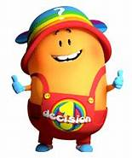  We will be learning about caring and sharing with adults and peers. We will also be beginning to understand learning behaviours – good sitting, good looking and good listening. This is our settling in term to build relationships and feel safe and secure in our new setting. | Religious Education  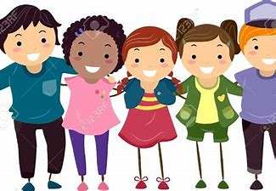  We will be learning about “Special Stories” including the bible. We are going to listen to stories from the bible and begin to understand what they mean and how they can help us be better people. | Physical Development  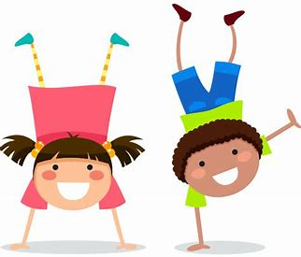  This term we will be doing indoor PE. We will be learning about different ways of travelling and shapes we can make using our body. We will also learn how we can change our speed – moving fast or slow. We will learn to listen and follow instructions and continue to be safe.
Literacy  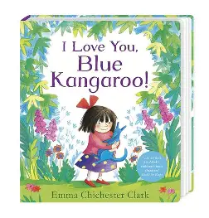  This term we will be reading lots of books about colours including “Blue Kangaroo”. We will be learning how to turn pages, the front cover, the back cover, pictures and writing. We will make simple predictions about what we think the story might be about and draw our favourite part of stories. | Special People  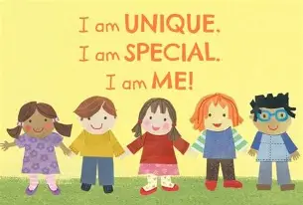  Autumn 1 Reception EYFS | 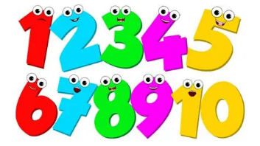  Mathematics  We will be learning about colours, 2d shapes and repeating patterns. We will be recognising, counting and ordering numbers to 10. We will learn to recognise numbers without counting called “subitising”. We love to learn about maths in our inside and outside classroom.
Understanding the World  We will be learning about Ourselves. We will be learning about the different parts of our bodies, our senses and are families. We are also going to learn about where we live and parts of our school. 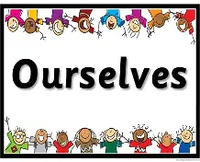 | Notes/Dates  - Our PE Day will be on Friday  - Please provide some kind of school bag so we can put letters, invitations and their special pictures in for them  - Please name label all your child’s clothing  - Your child is provided a healthy snack both in morning and afternoon  - Please download our Class DoJo app which we use to communicate our learning and events  - Term ends on Thursday 23rd October | Express Arts and Design  We will be learning a variety of songs related to our topic – Special People. We will explore simple instruments and listen to a mix of styles of music.  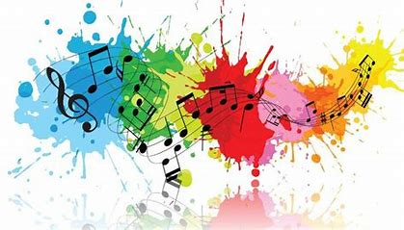  We will be learning to draw ourselves adding more detail. We will also be developing our cutting skills to ensure accuracy and precision.

