BOLLINGTON CROSS C.E. PRIMARY SCHOOL
Internet Access & E-Safety Policy

General Statement

The purpose of Internet access in schools is to raise educational standards, to support the professional work of staff and to enhance the school’s management information and business administration systems. Therefore, it is a necessary tool for staff and an entitlement for pupils of all ages. Access to the Internet at home has also increased over time and has become an important part of the way we learn and communicate.

The school will take all reasonable precautions to ensure that users only access appropriate material. However, due to the international scale and linked nature of the Internet and its content, it is not possible to guarantee that unsuitable material will never appear on a school computer. Neither the school nor the local authority can accept liability for the material accessed, or any consequences of Internet access. However, we believe that the educational benefits of Internet access far outweigh the possible risks and that good planning and management will ensure appropriate and effective pupil use. Our children must be fully prepared to get the most out of accessing the Internet, whilst keeping themselves and others safe.

How will the school ensure use of the Internet provides effective learning?
- Curriculum planning will identify opportunities to enrich and extend learning activities via access to the Internet.
- Pupils will be given clear objectives for Internet use.
- Pupils will be provided with lists of relevant and suitable website.
- Pupils will be taught to assess the value and credibility of Web materials in relation to other media, to validate information before accepting it is true and to discriminate between fact and opinion.
- Pupils will be taught to observe copyright when copying materials from the Web.
- Pupils will be made aware that the writer of an email or the author of a Web page may not be the person claimed.
- Pupils will be taught to accept a wider range of content, both in level and in audience, than is found in the school library or on TV.

How will the school ensure Internet access is appropriate and safe?
- Guidelines set out in this policy will be strictly adhered to by all staff and pupils and a ‘Safe Internet Use’ statement will be read and signed by all staff (Appendix One).

Teaching and Learning
- Internet access will be purchased from a supplier that provides a service designed for pupils. This will include filtering appropriate to the age of the pupils;
- Pupils will be taught what Internet use is acceptable / unacceptable and be given clear objectives for Internet use.
- All staff members have a duty to prevent radicalisation and will monitor the use of websites, ensuring that they are age-appropriate. The Head teacher will be immediately informed of any concerns.
- Staff will check that the sites selected for pupil use are appropriate to the age and maturity of pupils.
- Virus protection will be installed and updated regularly.

Pupil Responsibilities
- Pupils may only use approved accounts on the school system.
- Pupils must log in to the network using their own username and password. This will ensure that when the ‘websites visited’ is reviewed, staff will be able to identify any users that have not used the Internet appropriately and the correct authorities can be notified and sanctions implemented.
- Pupils must keep their personal passwords private.
- Pupils are taught never to give out personal details of any kind which may identify them or their location.
- Pupils must never arrange to meet anyone without specific permission.
- Pupils have a duty to report cyberbullying and must immediately tell a teacher if they receive offensive messages or see inappropriate materials.
- Pupils must ask for permission from a teacher before making or answering voice or video calls and sending or opening emails.

Published Content
- Personal data will be recorded, processed, transferred and made available according to the Data Protection Act 2003.
- Social networking sites will be filtered or blocked at the discretion of the Head teacher.
- Staff are advised of the possible consequences and repercussions of any information that they make available online, for example on a social networking site. Particular care should be taken in the posting of photographs, videos and information related to the school, school life, staff and pupils and the highest levels of privacy settings should be in place.
Website
- The Head teacher will take overall editorial responsibility and ensure that content is accurate and appropriate.
- The website will comply with the school’s guidelines for publications.
- All material must be the author’s own work, credit the sources used and state clearly the author’s identity or status.
- The contact details on the website should be the school address, e-mail and telephone number.
- Written permission from parents or carers will be obtained before photographs of pupils are published on the school website.
- Photographs of identifiable pupils will not have their full names published on the website.
- The use of pupil blogs and forums will be encouraged and contributions will be monitored by teaching staff.
- Pupils will be taught to publish for a wide range of audiences which might include governors, parents or young children.

Filtering Content
- The school will work with the LA to ensure systems to protect pupils are reviewed and improved.
- If staff or pupils discover an unsuitable site, it must be reported to the Computing Co-ordinator, who should be known to all staff members.
- Virus protection will be installed on every computer and will be set to update automatically.

Introducing Technologies
- Emerging technologies will be examined for educational benefit and a risk assessment will be carried out before use in school is allowed.
- During the school day, mobile phones will be stored safely and only used for personal calls at the discretion of the Head teacher.
- Mobile phones must not be used to take photographs of pupils.
- The use of portable media will be monitored closely as potential sources of computer viruses and inappropriate material.
- Staff will only use the school phone where contact with pupils is required.

Handling Incidents
- Incidents of Internet misuse, either by pupils or staff, will be dealt with by the Head teacher.
- Complaints of a child protection nature must be dealt with in accordance with school child protection procedures.
- The Head teacher may hold interviews with pupils and inform parents or carers;
- Pupils may have Internet or computer access denied for a period.
- If staff or pupils discover unsuitable sites, the URL (address) and content will be reported to the Internet Service Provider.
- There may be occasions when the police must be contacted. Early contact will be made to establish the legal position and discuss strategies.
- Any material that the school suspects is illegal will be referred to the Internet Watch Foundation.

Policy Communication
- Pupils will be taught about responsible use of the Internet, which covers both home and school use, appropriate to each key stage.
- Age-appropriate e-safety rules will be posted near all computer systems and discussed with the pupils at the start of each year (Appendix Two).
- Pupils will be informed that their use of our school network and the Internet will be monitored.
- All staff will be given access to this e-safety policy and its importance explained.
- The Computing Coordinator will audit Computing provision annually to establish if this e-safety policy is adequate and that its implementation is effective.
- Staff should be aware that Internet traffic can be monitored and traced to the individual user. Discretion and professional conduct is essential.
- Parents’ will be advised that this e-safety policy is published on the school web site and is also available in hard copy by application to the school.

BOLLINGTON CROSS C.E. PRIMARY SCHOOL

Safe Internet Use
for Staff and Students

The computer system may be used by students and staff to enhance their professional activities. The use of a computer system without permission or for a purpose not agreed by the school could constitute a criminal offence under the Computer Misuse Act 1990.
The school’s Internet Access & E-Safety Policy has been drawn up to protect all parties – the pupils, the staff and the school. Therefore, all staff are required to sign this ‘Safe Internet Use’ statement.

I understand that:

- All staff members have a duty to prevent radicalisation and should monitor the use of websites, ensuring that they are age-appropriate. The Head teacher must be immediately informed of any concerns.
- Pupils must be taught what Internet use is acceptable / unacceptable and be given clear objectives for Internet use.
- Written permission from parents or carers will be obtained before photographs of pupils are published on the school website.
- Photographs of identifiable pupils will not have their full names published on the website.
- The use of pupil blogs and forums will be encouraged and contributions should be monitored by all teaching staff.
- All Internet activity should be appropriate to staff's professional activity or the student’s education.
- Internet traffic can be monitored and traced to the individual user. Discretion and professional conduct is essential.
- The school reserves the right to examine or delete any files that may be held on its computer system and to monitor any Internet sites visited.
- Access should only be made via the authorised account and password.
- Activities that threaten the integrity of the school computing systems, or activity that attacks or corrupts other systems, is forbidden.
- Copyright of materials must be respected.
- Users are responsible for all emails sent and for contacts made that may result in emails being received.
- As emails can be forwarded or inadvertently sent to the wrong person, the same professional levels of language and content should be applied as for letters or other media.
- Use of the network to access inappropriate materials such as pornographic, racist or offensive material is forbidden.

I accept and comply with the ‘Safe Internet Use’ statements overleaf

Staff Name (Print): ....................................... Signature: .............................................

Staff Name (Print): ....................................... Signature: .............................................

Staff Name (Print): ....................................... Signature: .............................................

Staff Name (Print): ....................................... Signature: .............................................

Staff Name (Print): ....................................... Signature: .............................................

Staff Name (Print): ....................................... Signature: .............................................

Staff Name (Print): ....................................... Signature: .............................................

Staff Name (Print): ....................................... Signature: .............................................

Staff Name (Print): ....................................... Signature: .............................................

Staff Name (Print): ....................................... Signature: .............................................

Staff Name (Print): ....................................... Signature: .............................................

Staff Name (Print): ....................................... Signature: .............................................

Staff Name (Print): ....................................... Signature: .............................................

Staff Name (Print): ....................................... Signature: .............................................

Staff Name (Print): ....................................... Signature: .............................................

Staff Name (Print): ....................................... Signature: .............................................

Staff Name (Print): ....................................... Signature: .............................................

Staff Name (Print): ....................................... Signature: .............................................

Staff Name (Print): ....................................... Signature: .............................................

Staff Name (Print): ....................................... Signature: .............................................

Staff Name (Print): ....................................... Signature: .............................................

Staff Name (Print): ....................................... Signature: .............................................

Staff Name (Print): ....................................... Signature: .............................................

Key Stage Two: E-Safety Rules for Safe Computer Use
- I will only use my login and password, which I will keep secret
- I understand that the school can check my computer files and the Internet sites I visit
- We only use the internet when an adult is with us
- We ask permission before using the internet
- We only use websites our teacher has chosen
- We never give out personal information or passwords
- We immediately close any webpage we are uncomfortable with
- We tell an adult if we see anything we are uncomfortable with
- We never arrange to meet anyone we don’t know
- We only e-mail people an adult has approved
- We send e-mails and online messages that are polite and friendly
- We do not open e-mails sent by anyone we don’t know
- We understand that we have a duty to report cyberbullying and must immediately tell a teacher if we receive offensive messages
With great power
comes great responsibility
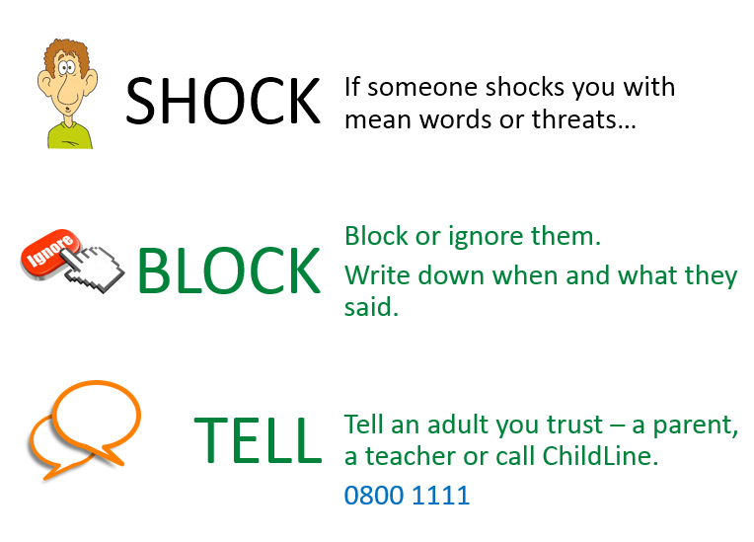







Stay Safe on the Computer!


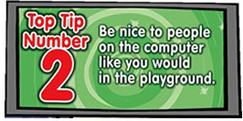

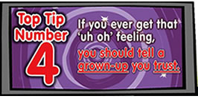




Early Years & Key Stage One E-Safety Rules

