RECEPTION CURRICULUM PLAN 2025 2026 | AUTUMN 1 | AUTUMN 2 | SPRING 1 | SPRING 2 | SUMMER 1 |  | SUMMER 2
FOCUS | I WONDER WHAT MAKES ME SPECIAL | I WONDER WHAT’S ABOVE ME | I WONDER WHAT MAKES ME STRONG | I WONDER WHO LIVES THERE | I WONDER WHAT GROWS |  | I WONDER HOW IT MOVES
TEXTS  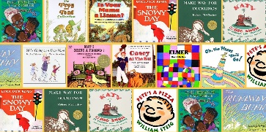 | The Great Big Book of Families  Colour me Happy  What Friends Do Best  The Colour Monster  Pete the Cat  All are Welcome  Our Class is Family  Incredible You  Let’s Make Faces  In Every House on Every Street  All Kinds of Families  Grandma’s Story | 10 Things I can do to change my World  Silly Billy  The Listening Walk  Papa, please get the moon for me  Whatever next  Q Pootle 5  Aliens Love Underpants  Have You Filled a Bucket Today?  Can’t You Sleep Little Bear?  Goodnight Moon | The Best Part of Me  My Body, Your Body  Kindness is my Superpower  Supertato  Handa’s Surprise  Kitchen Disco  Oliver’s Vegetables  A Great Big Cuddle  Jabari Jumps  The Word Collector  Almost Anything  Avocado Baby | Bog Baby  Harry’s Home  The Snail and the Whale  Rumble in the Jungle  We’re Going on a Bear Hunt  Owl Babies  Giraffes Can’t Dance  Monkey Puzzle  Brown Bear, Brown Bear..  Mr Gumpy’s Outing  The Tiger Who Came To Tea | The Very Hungry Caterpillar  Jack and the Beanstalk  Jasper’s Beanstalk  The Tell Me Tree  The Tiny Seed  The Growing Story  Tap the Magic Tree |  | Naughty Bus  The Train Ride  The Magic Bed  The Hundred Decker Bus  Mr Gumpy’s Motor Car  All Kinds of Cars  Emma Jane’s Aeroplane  All Aboard for the Bobo Road
KEY CELEBRATIONS/KEY DATES   | World Mental Health Day 10th October  Harvest 5th October | Diwali 20th October  Bonfire Night 5th Nov  Christmas | Chinese New Year 17th February  Martin Luther King Day 20th January  Pancake Day 17th February  Random Acts of Kindness Day 17th February | World Book Day 5th March  Women’s Day  8th March  Science Week 7th-16th March  Mother’s Day 15th March  Easter 5th April | Earth Day 22nd April  International Dance Day 29th April |  | Father’s Day 21st June
VIP   | My Family | Mae Jemison | Marie Curie | David Attenborough  Mary Anning | Captain Tom Moore |  | Frida Kahlo  Amelia Earhart
PERSONAL SOCIAL EMOTIONAL DEVELOPMENT   | What makes us special? Who is special to me? How are we the same/different? What feelings do I know? Can I follow simple instructions, understand our rules to keep me happy and safe?  Keeping myself safe – particularly with managing personal needs | Thinking about perseverance and the importance of not giving up.  Listening and focusing for adult led activities. Expressing my needs, managing my personal needs independently  Talking about ways to keep myself healthy  How can I be a good friend? | Thinking about other people’s feelings, being able to resolve conflicts with my friends. Continuing to develop strong relationships with others  How can I be kind to others? Respecting other people’s ideas when they are different from my own | Thinking about different ways to keep healthy including oral health  Talking about what is right and wrong  Thinking about how our choices make other people feel  Thinking about what I am good at | Trying new activities  Following several instructions  Talking about healthy food choices  Waiting for my requests and needs to be met |  | Setting personal goals  Being sensitive to other people’s needs  Working as a team, taking turns  Celebrating friendships
Personal, Social and Emotional Units   | My Feelings | Special Relationships | Taking on Challenges | Listening and Following Instructions | My Family and Friends |  | My Wellbeing
Wellbeing Units |  | Discover - Trying Something New | Take Notice - My Surroundings | Connect - Similarities and Differences | Give - Kind Words |  | Move - Being Animals
CONTINUOUS ENRICHED PROVISION | Understanding and following class/school rules, naming and managing our emotions, taking time to understand others’ feelings, resolving conflicts, developing strong, warm, supportive relationships, developing resilience and independence. Lots of opportunities for stories, circletimes and resources to support including books, puppets, props in a calm, nurturing environment. Specific, positive praise used by adults and use of WOW moments, shared with parents to promote specific moments of praise
COMMUNICATION LANGUAGE LITERACY   | Talking about what I think, what I know  Talking to others when I am playing, taking turns  Joining in with familiar stories/rhymes | Listening to stories and rhymes and joining in story times  Waiting for my turn to talk  Showing good listening skills  Retelling familiar stories  Saying how I feel, sharing my ideas clearly to others | Speaking in full sentences  Beginning to use past, present and future tenses  Sharing my ideas in small groups and with familiar adults | Explaining events that have happened in detail  Responding to what I have heard by asking questions and saying what I think | Listening carefully to my friends  Engaging in conversations with my friends and teachers  Taking part in whole class discussions |  | Using conjunctions to connect my ideas  Using vocabulary I have learned from stories, non-fiction, rhyme and poems
CONTINUOUS ENRICHED PROVISION | Developing the ability to focus and maintain attention during small group/adult led group times, listening to and following instructions. Lots of opportunities for back and forth conversations in provision using open ended resources as stimulus and ensuring adults have time to engage, commenting on children’s play. Resources to include books, resources for storytelling, role play
PHYSICAL DEVELOPMENT   | Fine Motor  Show a preference for a dominant hand. Use  one-handed tools and  equipment, ie, making snips in paper with scissors. | Fine Motor  Develop small motor skills so that  they can use a range  of tools competently, safely and  confidently.  Suggested tools:  pencils for drawing and writing,  paintbrushes,  scissors, knives, forks and spoons. | Fine Motor  Use a comfortable grip with good control when holding pens and pencils. | Fine Motor  Develop the foundations of a  handwriting style  which is accurate and efficient. | Fine Motor  Hold a pencil effectively in preparation for fluent writing – using the tripod grip in almost all cases.  Use a range of small tools  Begin to show accuracy and care when drawing.
 | Gross Motor  Start to eat independently and  learning how to use a  knife and fork. Develop skills they need to  manage school day  successfully: lining up and queuing;  mealtimes; personal hygiene  Dance Lessons | Gross Motor  Revise and refine fundamental  movement skills they have already  acquired: rolling;  crawling; walking;  jumping; running;  hopping; skipping and  climbing | Gross Motor  Know and talk about different factors that support their overall  health and wellbeing; regular physical  activity; healthy eating;  toothbrushing;  sensible amounts of screen time; good  sleep routine; being safe pedestrian.  Begin Swimming Lessons | Gross Motor  Develop overall body  strength,  coordination, balance and agility needed to engage successfully  with future physical education sessions and other physical  disciplines including dance, gymnastics, sport and swimming. | Gross Motor  Negotiate space and obstacles safely, with consideration for themselves and others. Demonstrate strength, balance and coordination when playing.  Move energetically, such as running, jumping, dancing, hopping, skipping and climbing.
CONTINUOUS ENRICHED PROVISION | Weekly PE lessons and Swimming Lessons  Gross Motor Skills – use of the Adventure Playground, the Astro and the Forest. Selection of trikes, taxi bikes, scooters, balance bikes, hoops, floor ladders, balancing blocks, cones  Fine Motor Skills – play dough station, painting, selection of scissors to suit different stages of development, vertical mark making opportunities using ladder and chalk wall, spray bottles, tweezers, pipettes, repeated opportunities for small world play, puzzles, selection of small tools
LITERACY DEVELOPMENT   | Talking about stories I have heard  Joining in with familiar rhymes, songs  What letters do I know? Practising oral blending  BEGIN RWI AFTER BASELINE | Retelling key events from stories  Begin our Word Wall  Recalling facts from non -fiction texts we have shared  Continuing and consolidating Set 1 sounds, blending and reading CVC words | Continuing RWI sessions  Reading simple captions  Building recognition of red words (high frequency) | Continuing RWI sessions  Reading and following simple baking instructions  Reading simple sentences  Developing recognition of red words (high frequency) | Continuing RWI sessions  Applying our phonic knowledge to help us write sentences independently  Building fluency when reading, talking about what we have read |  | Continuing RWI sessions  Read books confidently and with fluency, matched to my ability
 | Writing  Write some or all of their name.  Write some letters accurately. | Writing  Use some of their print and letter  knowledge in early writing.  Form lower case letters with increasing accuracy | Writing  Spell words by identifying the sounds and then writing the sound with letter/s | Writing  Write short sentences with words with known sound-letter  correspondences  using a capital letter and full stop. Re-read  what they have  written to check that it makes sense. | Writing  Write recognisable letters, most of which are correctly formed.  Spell words by identifying sounds in them and representing the sounds with a letter or letters. Write simple phrases and sentences that can be read by others.
Key Texts for Writing | 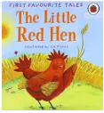 | 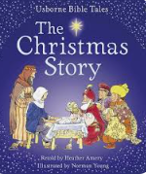  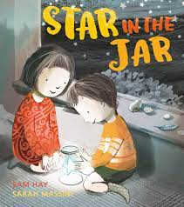 | 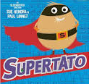  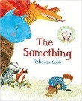 | 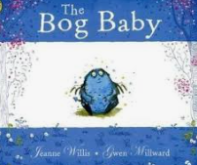  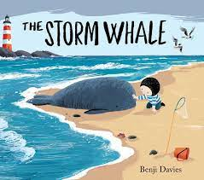 | 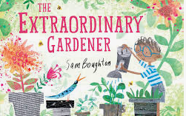  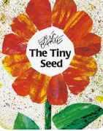 | 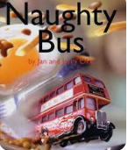  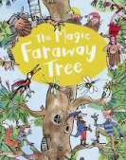
CONTINUOUS ENRICHED PROVISION | Resources clearly labelled in the environment, selection of story baskets to promote retelling, creating stories. Writing area with selection of mark making tools, selection of paper, pads, envelopes, magnetic boards and letters, sound mats, reading buddies (soft toys to read to)
MATHEMATICAL DEVELOPMENT  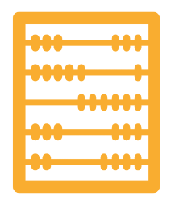   | Getting to Know You  Match Sort Compare  Talk about Measure and Patterns  It’s Me 123 | Circles and Triangles  1,2,3,4,5  Shapes with 4 Sides | Alive in 5  Mass and Capacity  Growing 6,7,8 | Length Height and Time  Building 9 and 10  Explore 3D Shapes | To 20 and Beyond  How Many Now  Manipulate, Compose and Decompose  Sharing and Grouping |  | Visualise Build and Map  Make Connections  Consolidation
CONTINUOUS ENRICHED PROVISION | Wide selection of Maths resources including number lines, five, and ten frames, loose parts to promote counting, adding, subtracting, sharing, measuring. Scales, shapes, timers, numicon, puzzles, matching games, dice  Routines – representing numbers, counting how many children are here etc
UNDERSTANDING OF THE WORLD   | Using lots of stories to think about different families and countries around the world | Thinking about how people celebrate  Talking about my own environment  Learning about planets, constellations, what makes day and night, nocturnal and diurnal animals | Using my senses to make detailed observations about the world around me | Talking about changes in the natural world, including seasons  Using stories to think about different cultures and countries  Observing changes we see when we mix ingredients to bake  Talking about animals and their young  Exploring habitats and their features | Looking at simple maps  Comparing my natural world with other environments  Planting beans and observing changes, including other plants |  | Making observations of transport and places we visit and drawing pictures  Talking about what is the same and different in life here and in other countries  Exploring floating and sinking
Geography Units |  | Explore Maps | Outdoor Adventures | Outdoor Adventures |  |  | Around the World
History Units |  | Adventures Through Time | Adventures Through Time | Adventures Through Time  Past and Present | Past and Present - Can you Guess who  Timeline  Toy Box |  | Adventures Through Time  Past and Present - ‘ Spot the Difference
Science Units | Autumn Treasures | Whatever the weather  Winter wildlife | Spring Magic  I am a Scientist | Animal Adventures x5  Sandcastle Science | Our beautiful planet  Summer senses
CONTINUOUS ENRICHED PROVISION | A variety of small and large construction materials, indoors and outdoors, developing a planting area for growing our own herbs, plants to attract wildlife, lots of high quality texts in provision representing culturally diverse society and places around the world
EXPRESSIVE ARTS AND DESIGN   | Using my imagination in role play and small world play  Joining in with familiar songs  Joining materials and exploring the craft area  Exploring collage – making faces using loose parts and other materials I want to choose | Using tools for independent art work and accessing resources to create with  Talking about my creations  Using clay to make Diwali pots  Van Gogh – Starry Night  Joining in Christmas songs, making Christmas cards for my friends and family, performing in our Nativity | Using one handed tools safely  Developing my confidence to try new techniques – collage, paint, clay  Listen carefully to music and move to it  Making Worry Dolls | Creating my own stories through role play and small world play  Joining in with singing and dancing  Talking about my creations  Matisse: Snail Art | Recounting narratives and stories with my friends  Using props and materials in role play  Andy Goldsworthy – transient art  Collage based on The Tiny Seed |  | Performing songs and poems with confidence alone and with my friends  Moving in time to music
Art Units | Seasonal Craft | Drawing - Marvellous Marks  Seasonal Craft | Painting and Mixed Media - Paint My World  Seasonal Craft | Seasonal Craft | Sculpture and 3D - Let’s get Crafty  Seasonal Craft |  | Seasonal Craft
CONTINUOUS ENRICHED PROVISION | Craft area with selection of resources for collage, junk modelling, painting – resources to include different ways of joining materials, plans for designing models, paint mixing station which children access independently

