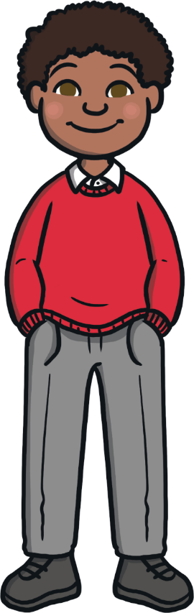
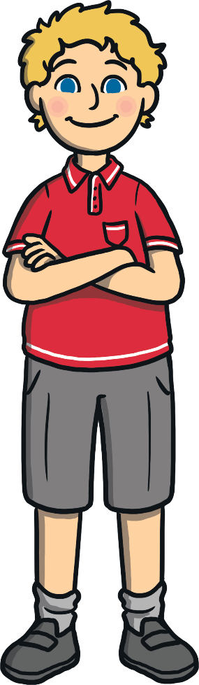
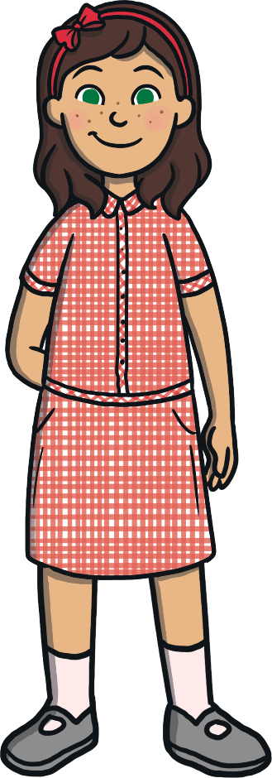
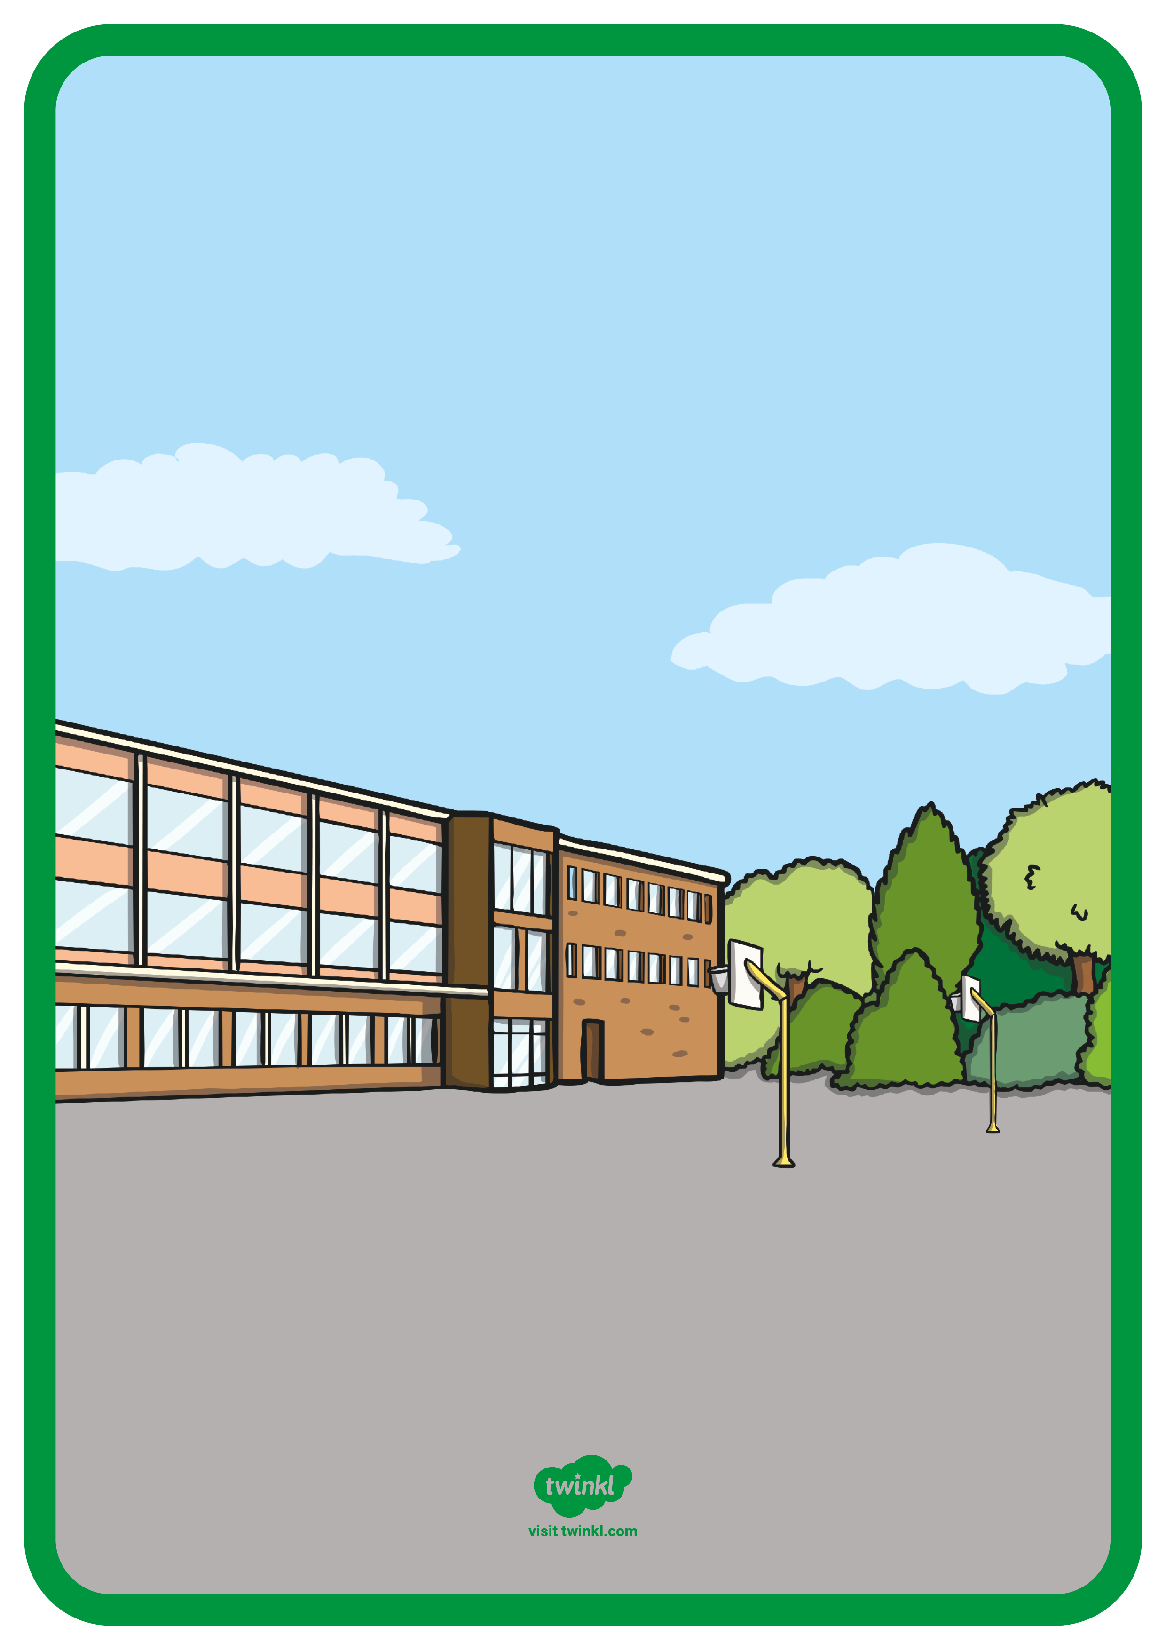
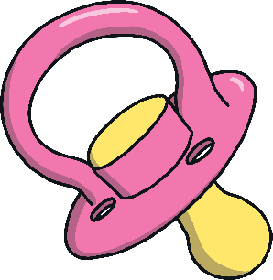
Giving Up
My Dummy


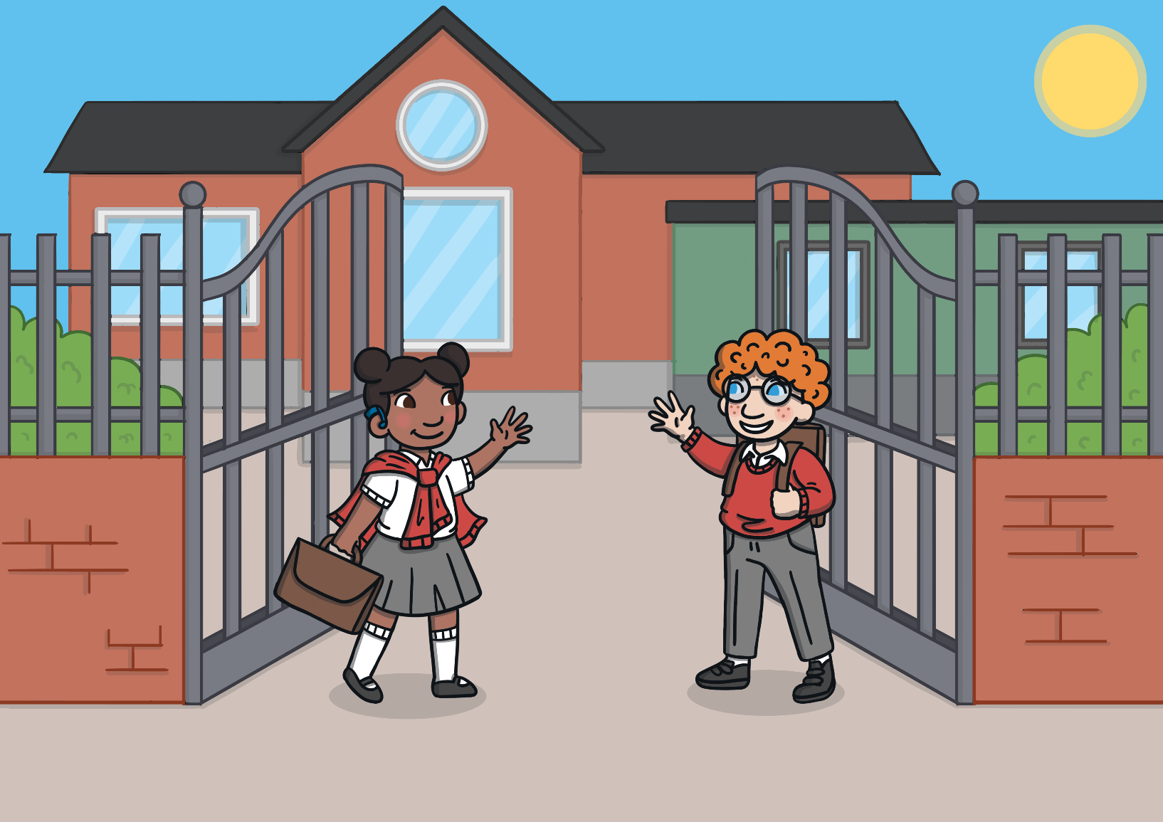
.
Giving Up My Dummy

My school is called
years old.
and I am
My name is

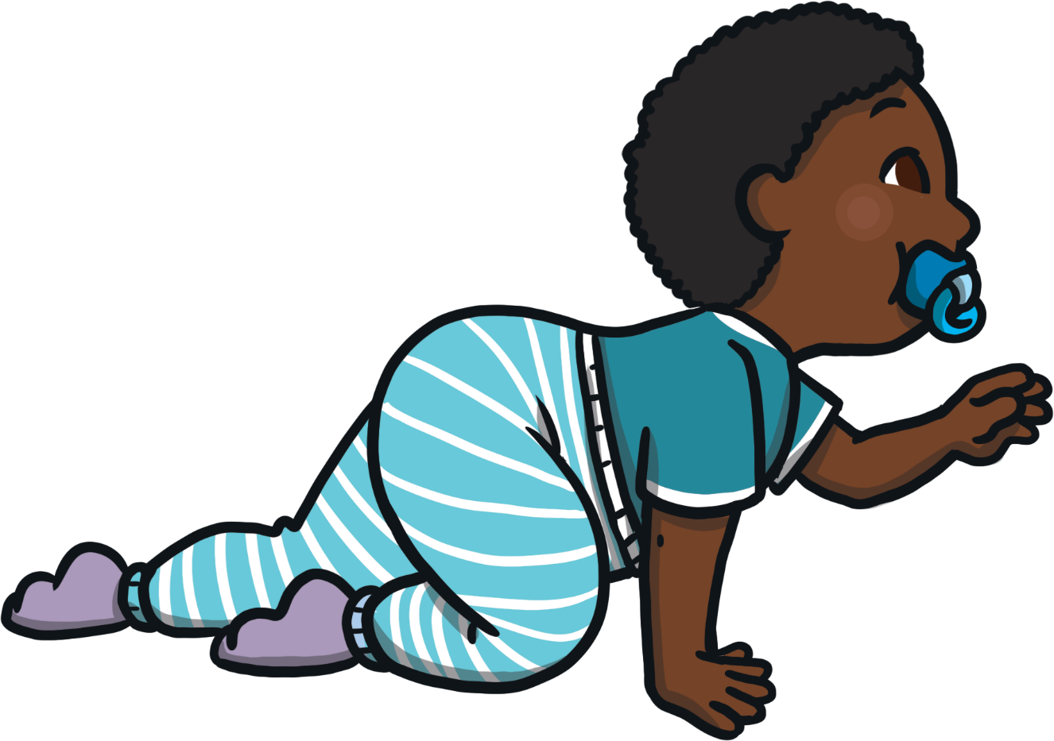
When I was born, my mummy and daddy/carers gave me a dummy. I would suck on the dummy and this would help me to feel calm, especially if I could not sleep or was upset.
It is OK for babies and toddlers to have a dummy.
Giving Up My Dummy
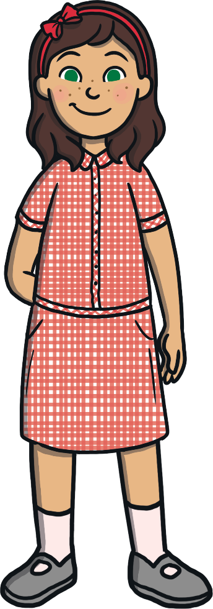
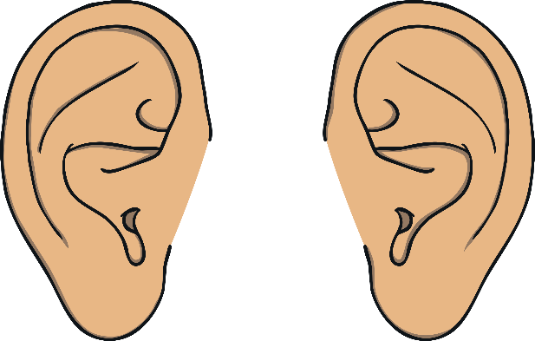
It may cause ear infections.
It may cause speech problems.
It may cause teeth problems.
Having a dummy when you are more than one year old can cause
some difficulties.
Giving Up My Dummy

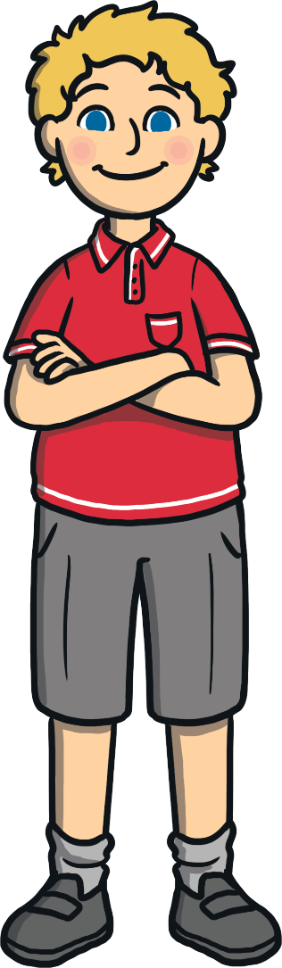
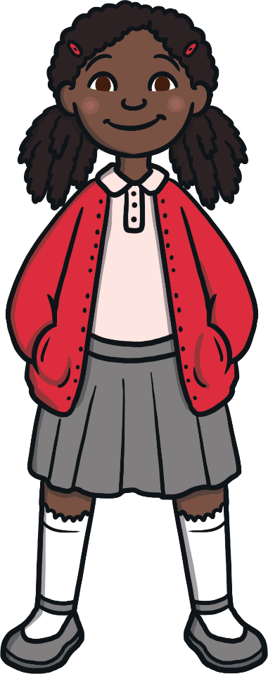
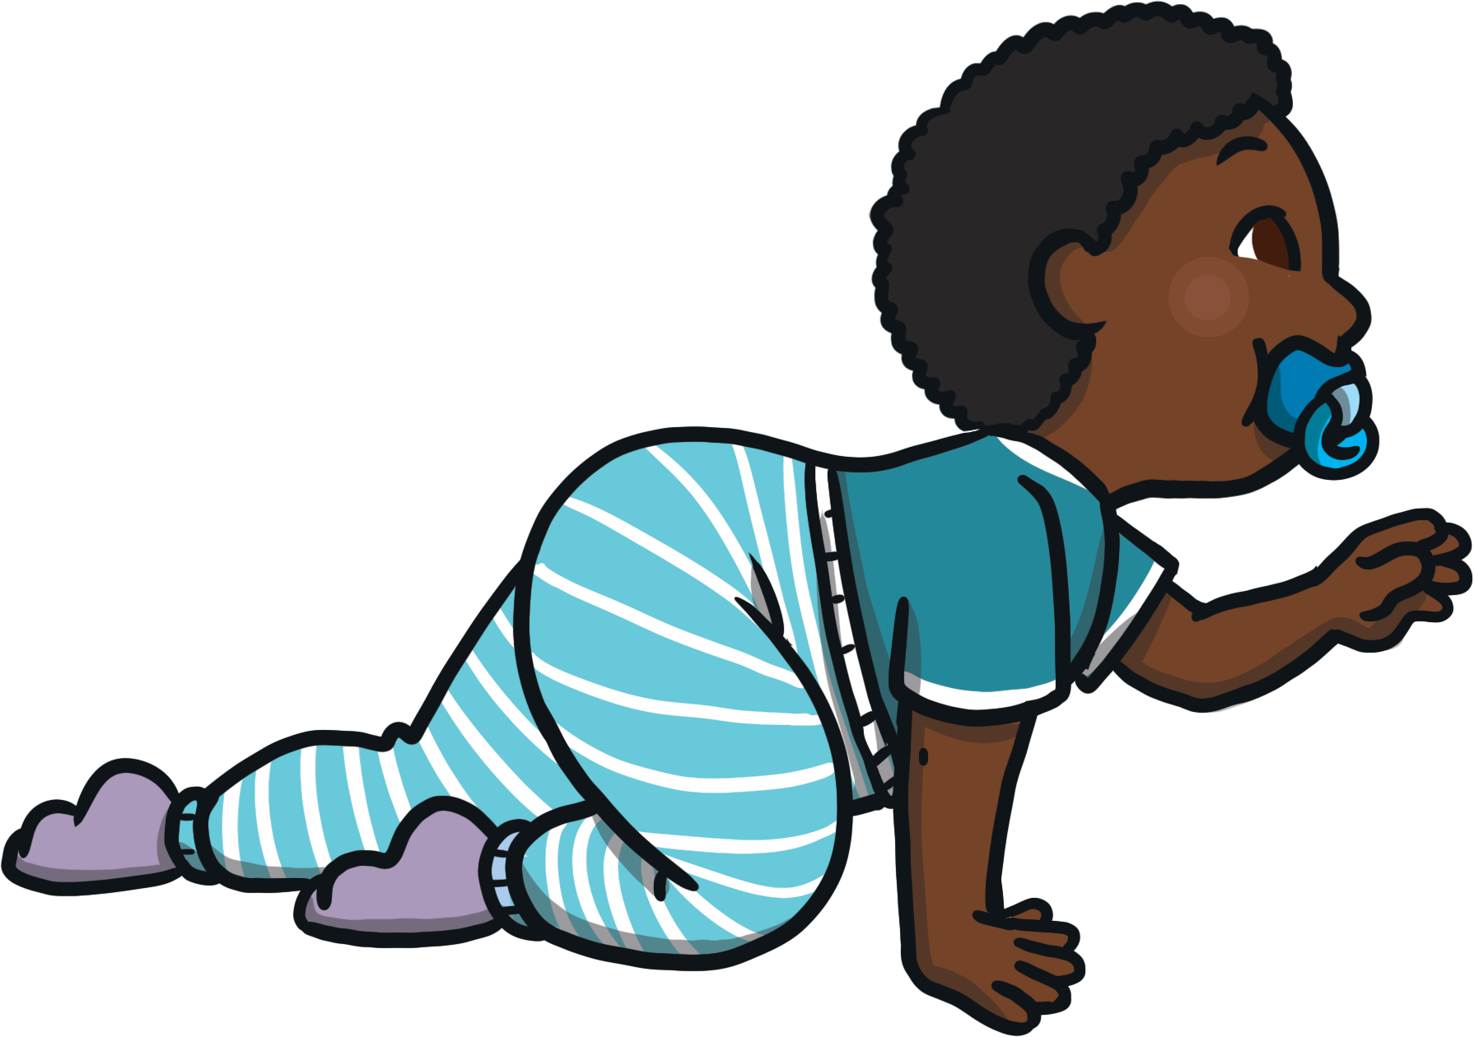
My mummy and daddy/carers will talk with me and we will decide the best way to give up my dummy. Giving up my dummy will be OK.
Some children give
their dummy to Santa.
Some children give their dummy
up for a blanket or a special toy.
Some children give their
dummy to the dummy fairy.
Giving up my dummy may be hard.
This is OK as my mummy and daddy/carers are going to help me.
Giving Up My Dummy
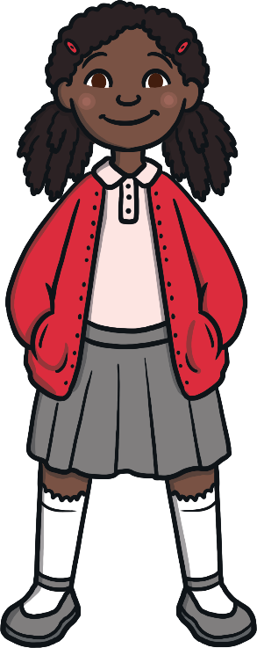
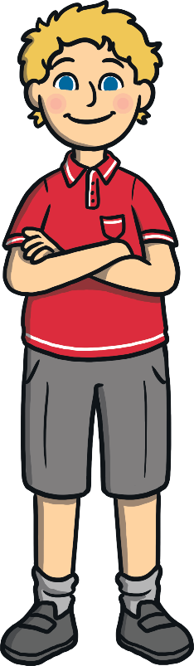
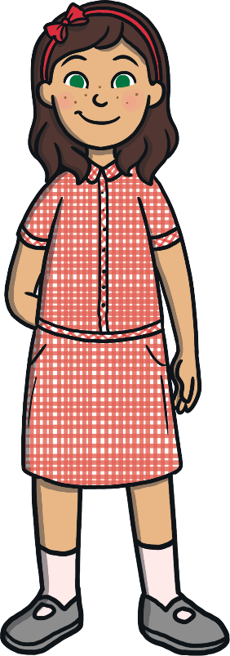
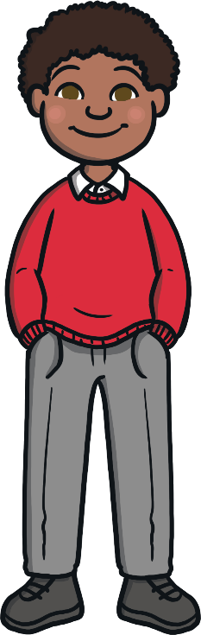
This will make my parents and my teachers happy.
I am going to try to give up my dummy.
I will try my best and this will make them proud.
Giving Up My Dummy

