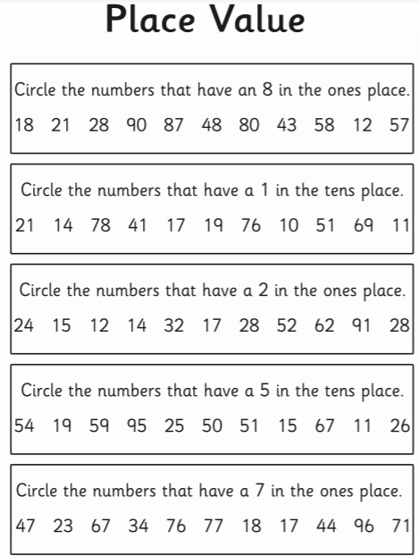
Date __________________________ Name _______________________________

