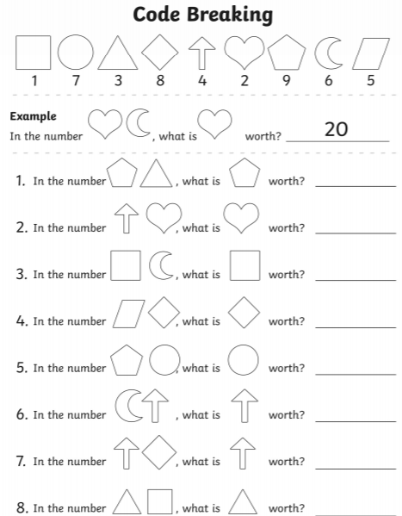
Date ___________________________ Name___________________________________________________
Use knowledge of tens and ones to work out the value of the digits.

