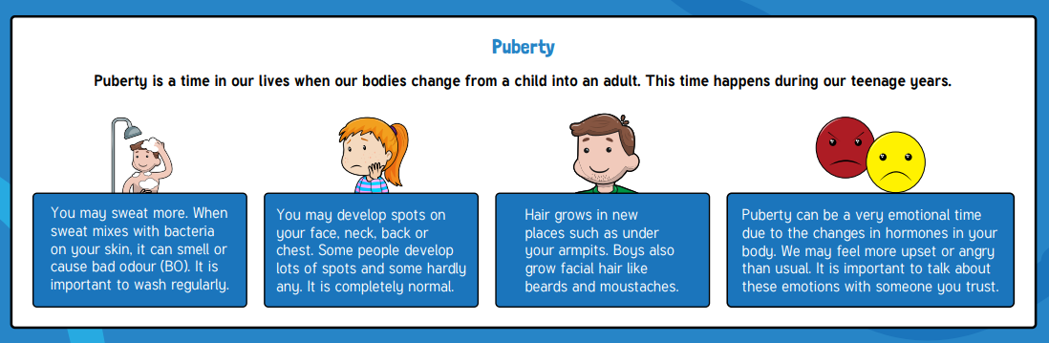
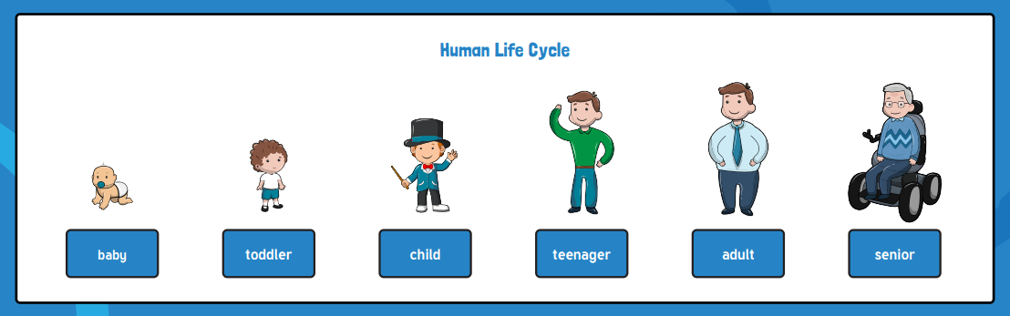
What I should already know:
- Birth and death are the start and end stages of the human life cycle.
- The different parts of a life cycle
- The meaning of a life cycle
- The definition of a living thing
- What living things need to stay alive
- The different parts of the human body

Key facts to retain:
- Fertilisation happens when a male sex cell and a female sex cell combine and begin to grow into a foetus.
- Women have a special organ called a womb which they grow the foetus in until the baby is ready to be born.
- Human babies develop for 9 months in the womb.
- To remember the different stages and what happens at each stage of the human life cycle.
- What puberty is and the different changes boys and girls go through.

Key vocabulary:
Birth - when your life starts as a physically separate being
Conception - when the egg and the sperm meet to begin the development of a foetus
Death - when the life cycle ends
Develop - to grow to become more mature or advanced
Egg - the female sex cell
Fertilisation - when the egg and the sperm meet to begin the development of a foetus
Foetus - a baby that is still developing in the womb
Puberty - a time in the human life cycle when the body goes through changes to become an adult
Sperm - the male sex cell
Womb - an organ in which the foetus grows and develops
Gestation – the process of time when prenatal development takes place before birth
Life cycle – the changes a living thing goes through, including reproduction
Focus: The Human Life Cycle
Newall Green Primary School: Knowledge Organiser
Science: The Human Life Cycle Year 5: Term: Summer 1

Supporting experiences:
PSHE/Dimension lessons

