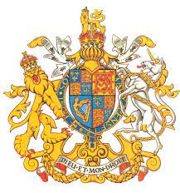
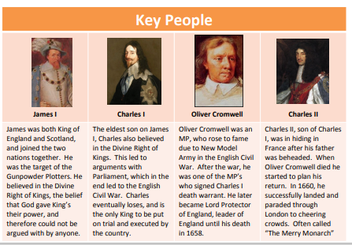
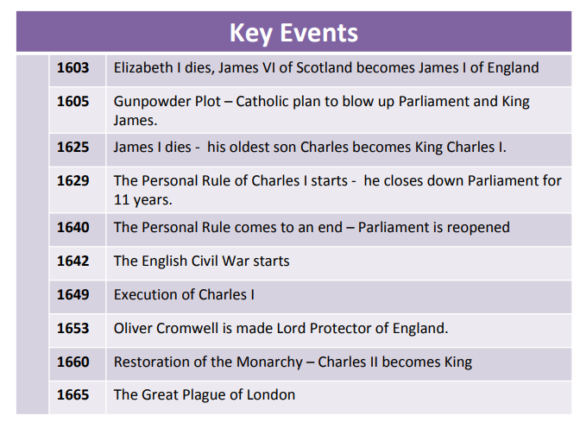
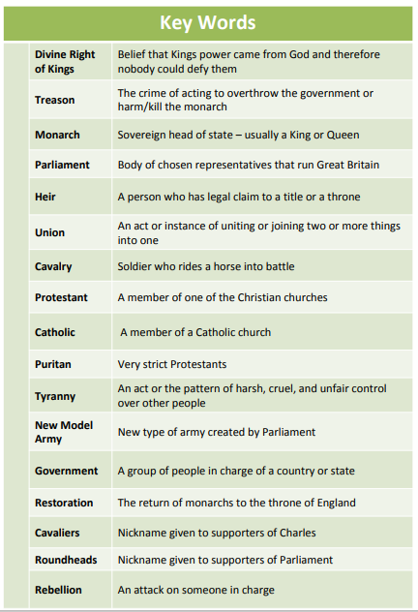
Key facts to retain:
- How the monarchy changed.
- The causes and effects of the Gunpowder plot.
- How the Civil War started, the causes and some of the battles.
- Why the Mayflower is an important part of history.
- Why Charles I thought he was a supreme ruler.
- Why Charles I was executed.

What I should already know:
- Other famous monarchs e.g. Henry VIII, Queen Elizabeth I.
- Key events which have happened in History e.g. Gunpowder plot, World War II, Great Fire of London, Spanish Armada.
- Different British civilisations.
- How people lived during different historical times.

Newall Green Primary School: Knowledge Organiser
History: The Stuarts Term: Summer 1 Year group: 5 Date: Ap 2022
Focus: Was England right in executing the King?

