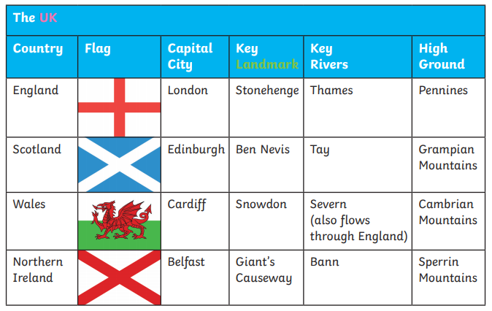
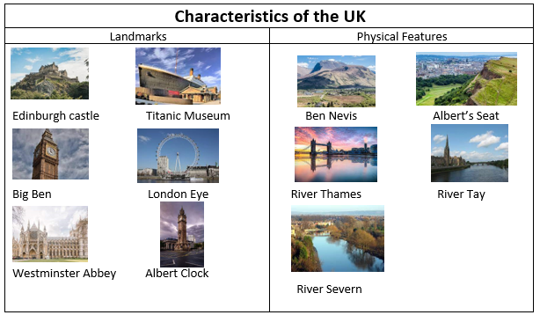
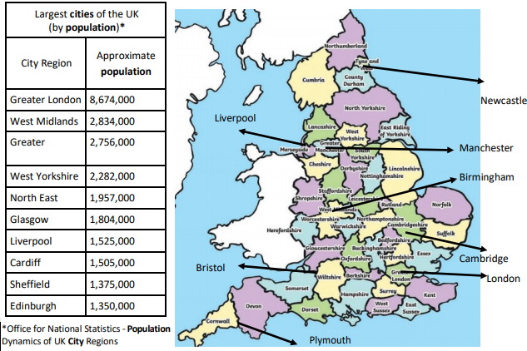
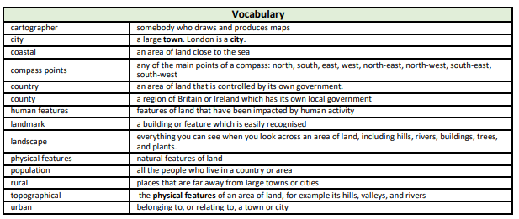
Focus: Why might people move to the UK?
Newall Green Primary School: Knowledge Organiser
Geography: Capital cities in the UK Term: Summer 1
Year group: 5 Date: April 2022
What I should already know:
- Where their local area of Wythenshawe is situated and what its city is called.
- Name local parks and amenities.
- The four countries that make up the United Kingdom and their characteristics.
- The different cities in the UK.
- The terms urban and rural and use them to describe areas of the UK.
- How to locate places using four figure grid references.
- How to identify features such as hills, mountains, coasts and rivers on a map.

Key facts to retain:
- The capital cities of the four countries that make up the United Kingdom and their characteristics.
- The surrounding seas of the United Kingdom.
- The difference between a county and a city.
- What makes a city.
- Famous UK landmarks.
- The flags of the four major capital cities of the UK.
- Different festivals each capital city celebrates.

