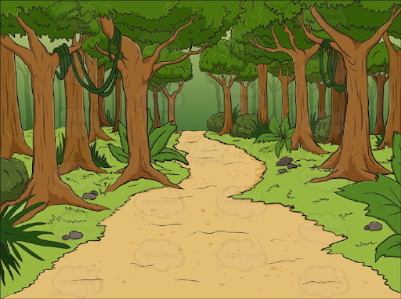
We will be asking children to Nursery dressed up as a character for our
‘Once upon a time day’
more details to follow.
Nursery Spring 1 Knowledge Organiser
Traditional Tales

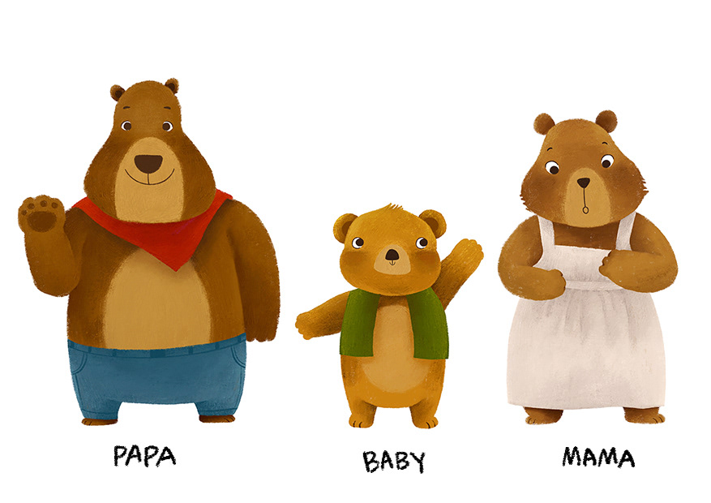
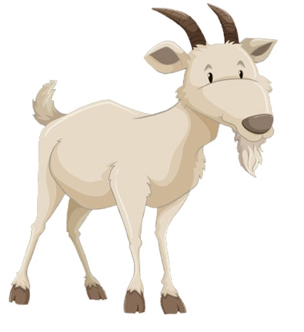
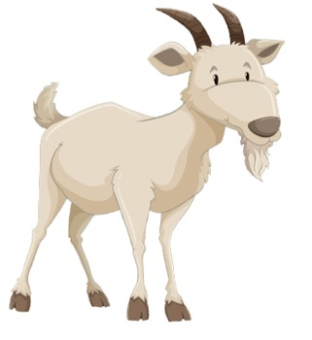
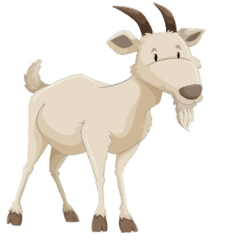
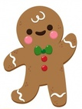
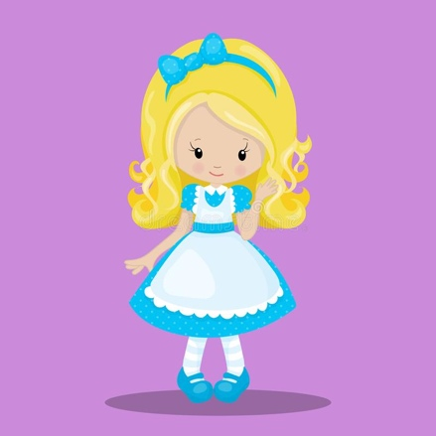
In Literacy ………
We will be doing lots of mark-making with purpose for example writing our name and becoming more confident towards holding a pencil in one hand a tripod grasp

We are learning to look at the ilistrations and make predictions to help us find out about the characters and events in a story

Key words for our topic:
positional language traditional predict rhyme ilistration

In Phonics ……….
We are learning about rhyming, What is rhyming? Which words rhyme? How do you know?

We will also be learning new rhyming songs such as:

‘Miss Polly had a Dolly’.

In Maths ……….
We will continue working on recognising numerals that we see all around us eg on buses, house numbers etc.

We will also be learning to use postitional language to describe where an object is eg on top of, under, next to, between, behind etc

Books for the term:

*The Gingerbread Man
*Goldilocks and the three bears
*The Billy Goats Gruff

