WALT 1: Discuss and define terminology linked to Climate Change – See day in the life folder
WALT 2: Understand the causes and effects of climate change
WALT 3: Describe the impact of plastic pollution on the world
WALT 4: Explore ways in which we can reduce the impact of climate change
WALT 5: Understand what bio-diversity is and why it is important.
WALT 6: Explore how animals need to adapt because of climate change - See day in the life folder
WALT 7: Research the positives and negatives of palm oil.

WALT 1: Discuss and define terminology linked to Climate Change – See day in the life folder
WALT 2: Understand the causes and effects of climate change
WALT 3: Describe the impact of plastic pollution on the world
WALT 4: Explore ways in which we can reduce the impact of climate change
WALT 5: Understand what bio-diversity is and why it is important.
WALT 6: Explore how animals need to adapt because of climate change - See day in the life folder
WALT 7: Research the positives and negatives of palm oil.

What I Should Already Know:
- Climate and weather are different things.
- People and animals are both threatened by climate change.
- Everyone can do their bit to help e.g., recycling and saving electricity.
What I
of things like playdough and snow.

Key Facts to retain:
- Understand that climate change is having a detrimental (negative) effect on our planet, with long term changes occurring such as ice caps melting/animals losing their habitats.
- Plastic pollution is damaging wildlife and our environment in many ways e.g. harming marine life which in turns affects the food chain.
- Bio-diversity is the huge variety of all living things on Earth and it is important because humans/animals wouldn’t survive otherwise e.g. many critical medicines come directly from plants, fungi, and other organisms.

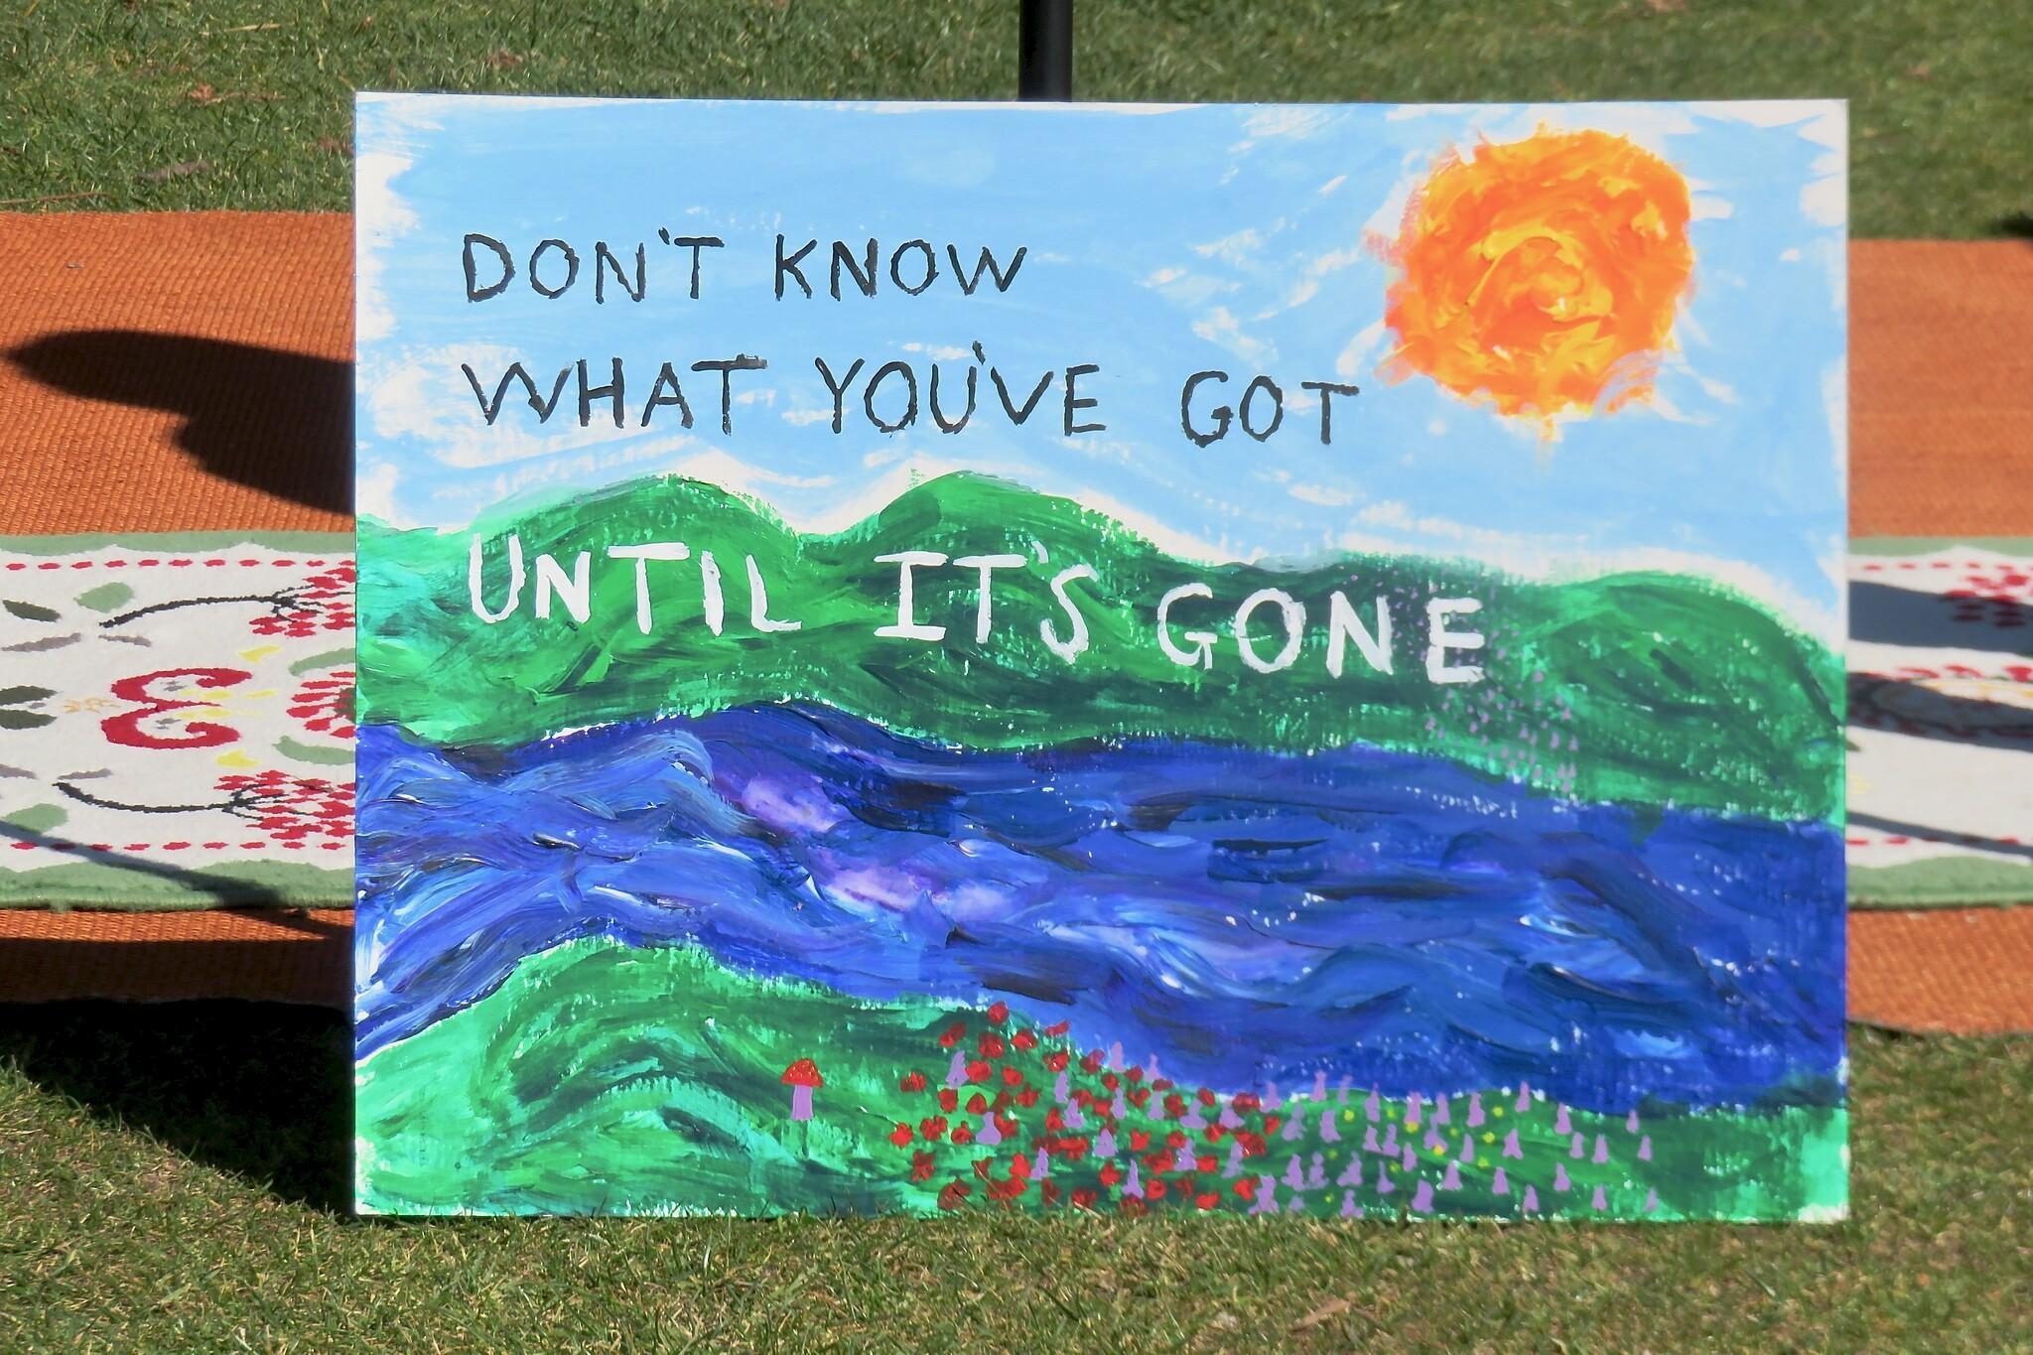
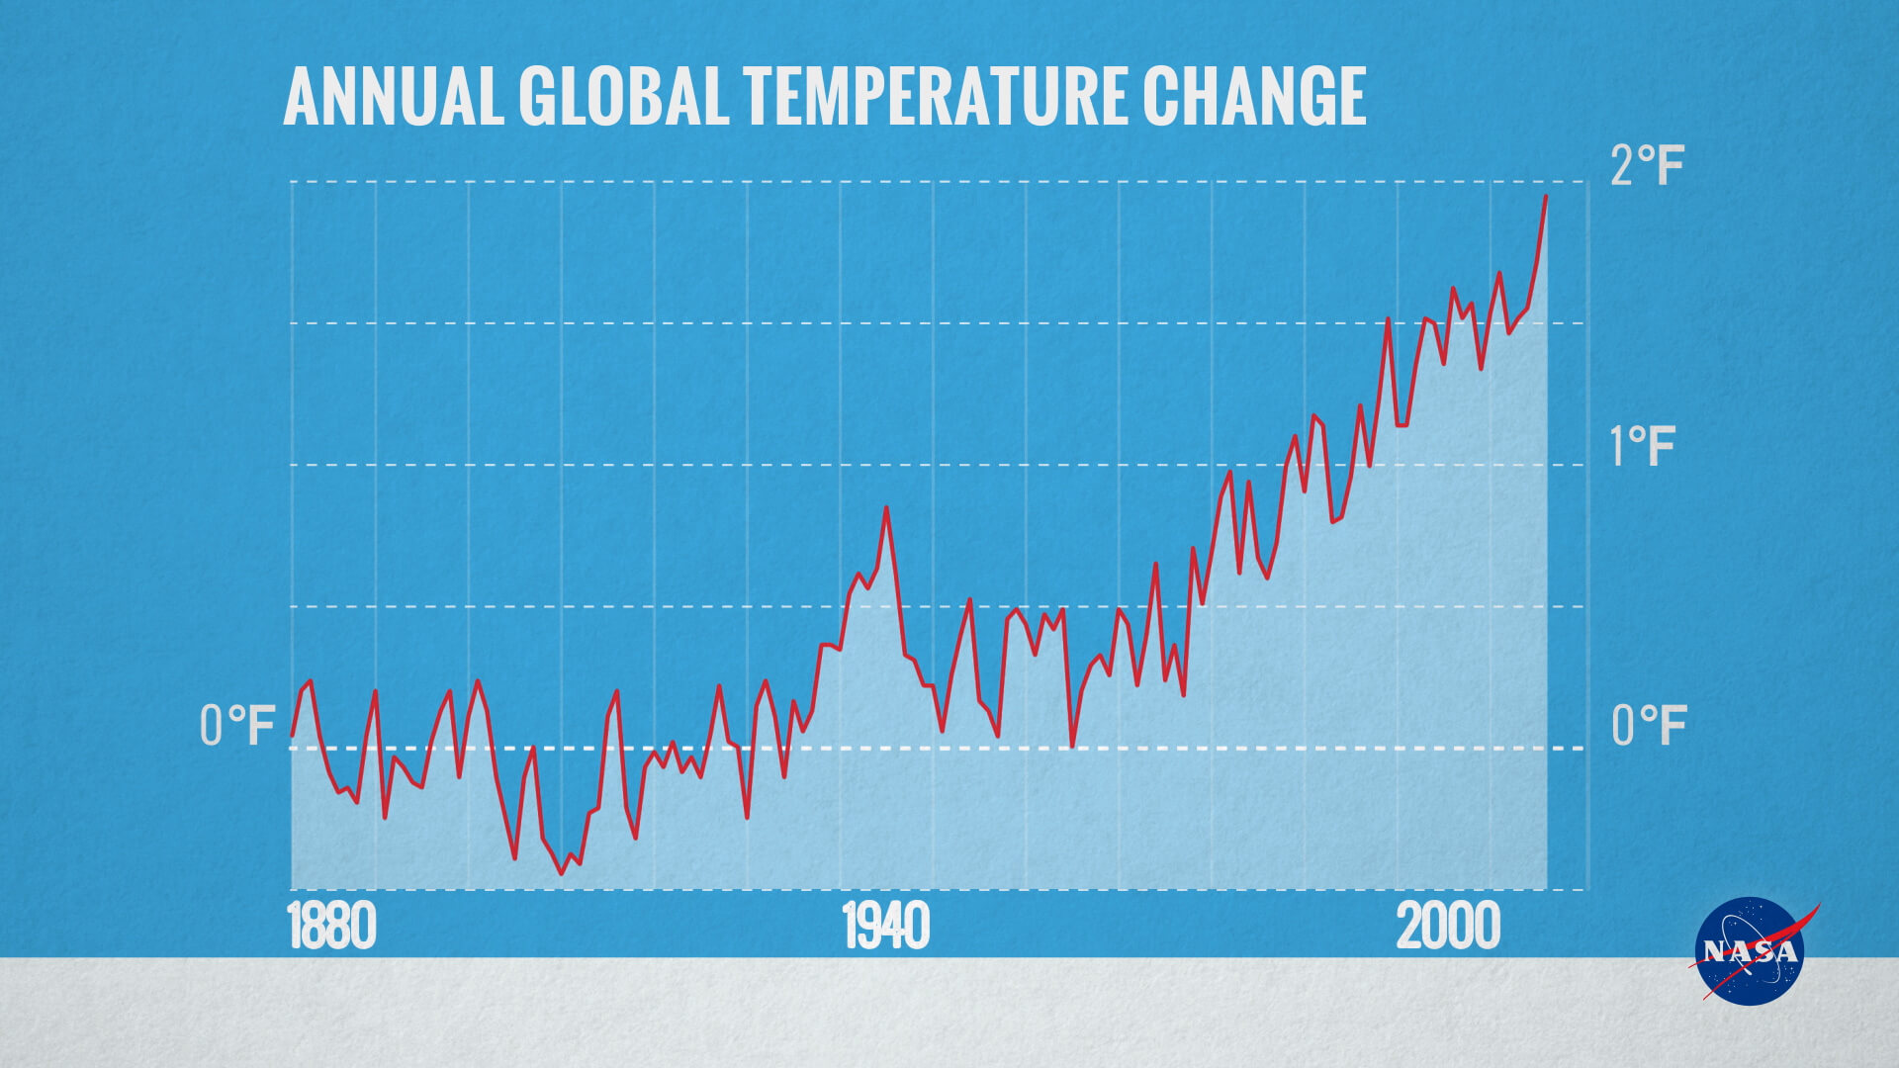
Newall Green Primary: Knowledge Organiser for Climate Change Year Group 6 Autumn 1
Key Vocabulary
Atmosphere | The mixture of gases around the earth
Greenhouse gases | Any of the gases which are responsible for the greenhouse effect.
Biodegradable | Capable of decaying through the action of living organisms.
Carbon dioxide | A colourless, odorless gas, CO₂, formed during respiration.
Carbon footprint | The amount of carbon dioxide emitted into the atmosphere by somebody.
Citizen | A member of a country.
Climate | Weather conditions of an area over a long period of time.
Fossil fuels | Fuels that are non-renewable (will run out).
Micro plastic | Very small pieces of plastic that pollute the environment
Climate Change | The long-term changes in global temperatures and other characteristics of the atmosphere.
Sustainability | The quality of not being harmful to the environment.
Weather | The daily state of the atmosphere, or air, in any given place

What I should already know
ggf
Geography
Names of the Oceans
Names of the continents
Countries in Europe
What climate is
Global Warming
Ozone

