Newall Green Primary: Knowledge Organiser for Classifying Organisms Year Group: 6 Autumn:1
Living things can be organised into 5 kingdoms:
Animal Kingdom Plant Kingdom
Bacteria Kingdom Fungi Kingdom
Protista Kingdom.

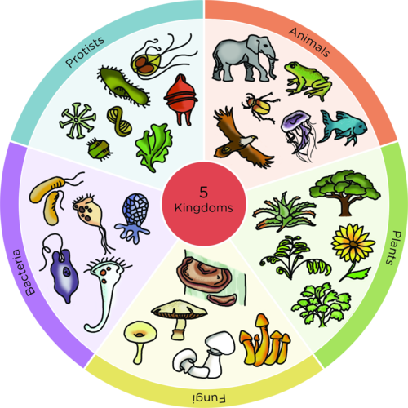
Key facts to retain:
Organisms can be organised based on their characteristics using classification systems.
In 1735, Carl Linnaeus published a classification and naming system for organisms that would eventually be used by scientists all over the world.
Yeast is a type of fungus.
Bacteria is used in food production e.g. turning milk into yogurt. Bacteria can also cause diseases.
Classification Key
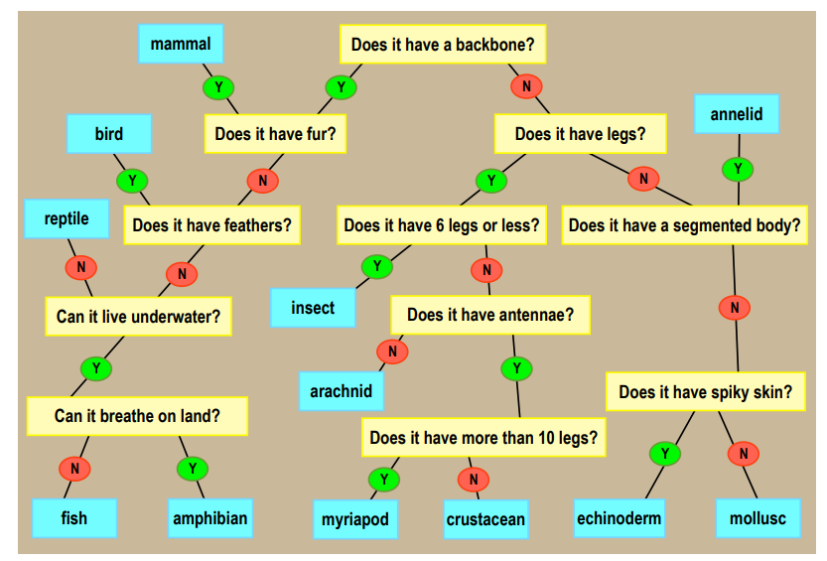
What I should already know:
That we can organise animals into groups based on their appearance, what they eat, where they live etc.
The difference between a vertebrate and an invertebrate.
That organisms can be classified as plants, birds, mammals, fish, reptiles, arachnids, amphibians and insects.
Key Vocabulary
Organism | A single living thing.
Micro-Organism | A single living thing that cannot be seen without a microscope.
Classification | The act or process of dividing things into groups according to their type.
Bacteria | A very small organism that can be found anywhere.
Fungus | An organism that’s food source derives from decaying material or other living things.
Protista | Micro-organisms that are usually made up of just one cell. Protista usually live in water and stay in one place. They can include algae and amoeba.
Vascular | Plants with roots and a stem to transport water and nutrients around the plant.
Non-vascular | Plants without roots or a stem that absorb water from their environment.
Echinoderm | Invertebrate with spiny skin, such as a starfish or sea urchin.
Annelid | Invertebrate with no legs and a segmented body, such as an earthworm.
Myriapod | Invertebrate with many legs and body segments, such as a centipede.

The
Big Question – How and Why do we classify living organisms?

WALT 1: To recap ways of grouping organisms according to their characteristics.
WALT 2: To explore ways of distinguishing between organisms that have similar characteristics
WALT 3: To be able to classify plants according to their characteristics
WALT 4: To find out about Carl Linnaeus and his classification system.
WALT 5: To explore what micro-organisms are and how they can be grouped + Yeast Experiment
WALT 6: To be able to identify and classify organisms in the local area
WALT 7: End of Unit Test

Big Question – How and Why do we classify living organisms?

WALT 1: To recap ways of grouping organisms according to their characteristics.
WALT 2: To explore ways of distinguishing between organisms that have similar characteristics
WALT 3: To be able to classify plants according to their characteristics
WALT 4: To find out about Carl Linnaeus and his classification system.
WALT 5: To explore what micro-organisms are and how they can be grouped + Yeast Experiment
WALT 6: To be able to identify and classify organisms in the local area
WALT 7: End of Unit Test

