Key Facts
Hindus believe the spark of God is eternal, so when their body dies it will be reborn into another body. (Reincarnation) Which body it goes into will depend on karma.
Hindus describe life as a journey towards moksha; freedom from the cycle of birth, death and rebirth towards oneness with God.
Hindus see their faith as being a complete way of life – all of life is part of their dharma (duty to act in the right way as God teaches). Hindus show their faith in God through puja (Hindu worship). During worship, the aarti lamp is lit and offered to the deity.
Hindus worship together at a mandir or temple where Puja is performed. There are many shrines inside the temple. Going to worship at a shrine is like visiting the gods and goddesses.
To know that Gandhi fought for human rights and understand the actions he took in order to help others such as the organising of Peaceful protests and the Salt March.

Newall Green Primary: Knowledge Organiser for RE Year Group 4 Autumn 1
L2: 2: What does it mean to be a Hindu in Britain today?
What I should already know
ggf
 | Objectives: | Abs | Int
WALT 1: | Can I explain how Hindus show their faith?
WALT 2: | Can I describe some aims in Hindu life?
WALT 3: | WALT 3: Know the importance of Ghandi and how the actions of Hindus can help others.
WALT 4: | WALT 4: To discuss what it is like to be a Hindu in Britain today and identify some positives and challenges of this.
WALT 5: | End of unit quiz (Kahoot)




Deities – Hindu Gods and Goddesses
Dharma – the idea of living life in the right way.
Karma – our actions build good and bad karma that is carried on over many lives.
Mandir – Name for Hindu temple or place of worship
Moksha – ultimate spiritual freedom and the end of the endless cycle of birth, death, and rebirth.
Puja – Worship ritual
Reincarnation – all living things have a soul that can’t be destroyed and are reborn.
Shrine – A place where Hindu deities are worshipped.

Vocabulary
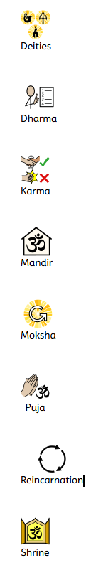

I know that different religions are celebrated and worshipped across the globe.
Recall facts about Christianity such as the ten commandments and they believe humans should live a good life.
Know how Judaism is worshipped and celebrated.

