We are learning to:
WALT 1: identify habitats and animals that live there
WALT 2: group organisms according to their characteristics
WALT 3: classify animals
WALT 4: use classification keys
WALT 5: identify and classify British plants
WALT 6: explore the human impact on habitats
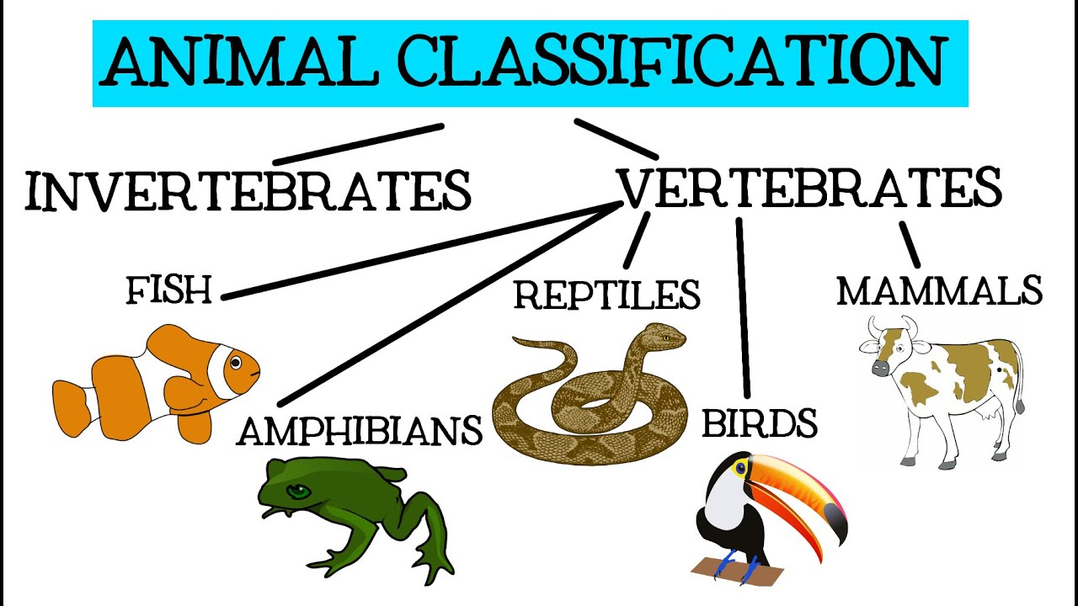

Vocabulary
Organism – An individual living thing, such as a plant or an animal.
Classifying – To put into groups according to things that are similar.
Unique – Being the only one of its type.
Vertebrate – Animals which have a backbone.
Invertebrate – Animals which do not have a backbone.
Mammal – Any animal that has hair and feeds its babies with milk from heir mother.
Habitat – The natural environment of an animal or plant.
Characteristics – A special quality or appearance that makes an individual or group different from others.

What I should already know
All around us, there are some things that are alive, some things that are dead, and some things that have never been alive.
All living things have certain characteristics that help to keep them alive and healthy.
Living things live in habitats that suit them, and which provide for their basic needs.

Newall Green Primary School: Knowledge Organiser for Science (Living in Environments) Year Group 4 Autumn 1
Supporting experiences
Invertebrate hunt to identify creatures using classification keys.
Classification Keys
A set of yes and no questions about the characteristics of living things.
They are used to sort animals and plants.
Answer the questions and follow the lines depending on whether the answer is yes or no.
