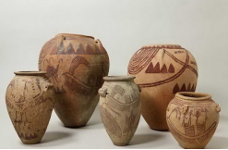
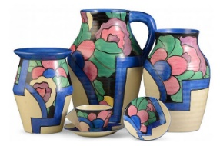
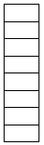
Key Vocabulary
Contemporary: existing at the present time.
Pottery: objects made out of clay and hardened with heat.
Nile Silt Ware: A ceramic paste that had a red-brown colour after being fired.
Marl Clay: Made from a material found around Qena in Upper Egypt.
Pre-dynasty: before the pharaohs.
Coiling technique: rolling clay until it forms one, long roll then placing one coil on top of the other.
Pinching and sculpting technique: pressing your thumb into the centre of the ball, then pressing the walls out evenly with the thumb into the inside and the fingers on the outside.

WALT 1: study a contemporary potter Intervention Absent
WALT 2: research the history of Egyptian pottery Intervention Absent
WALT 3: sketch Egyptian pots Intervention Absent
WALT 4: research different techniques Intervention Absent
WALT 5: create our own Egyptian pottery Intervention Absent
WALT 6: create a final design Intervention Absent
WALT 7: make an Egyptian pot Intervention Absent
WALT 8: evaluate our Egyptian pot Intervention Absent

What I already know:
- How to create a sketch in my sketch book.
- How to compare different pieces of art work.
- How to adapt and improve my work.
- How to evaluate my work.
- How to work with clay.
Key facts to retain
- Clarice Cliff was an English ceramic artist who was active from 1922 to 1963.
- The Egyptians used pottery to store food grains and food items, as well as to hold water and cook foods.
- Special pottery designs were made to be included in the tombs for those that had passed away.
- Egyptians used pottery to reflect their creativity and imagination.
- Pottery is made from clay.
- Due to the heat in Egypt, Egyptians were able to set their finished pottery in the Egyptian sun to bake and seal their pottery.
- By 3500 BC, artists began to add images to their pottery.
Key Focus
Art – compare and contrast contemporary and Egyptian pottery.
Newall Green Primary School Knowledge Organiser
Art: Pottery: Autumn 1
Year Group: 4

