#
Key Vocabulary
Monarchy – the monarch and royal family who rule a country 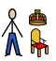
Heir – a person who inherits someone’s property or title after their death
Tudors –a British royal family that ruled from the 15th – 16th century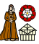
Divorce – the ending of a marriage through law
Behead – to remove a person or animal’s head
Middle Ages – period of European history between ancient times and the Renaissance
Civil War – a war within a country 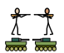
Reformation – a change in an original system 
Pope – the leader of the Catholic church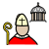
Catholic – a form of Christianity where the Pope is the leader and teaches from the Bible 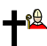
Protestant – a form of Christianity where the teachings come only from the Bible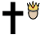
WALT 1: Explain the origins of The War of The Roses.
WALT 2: Understand Henry VIII’s childhood and his ascent to the throne. Day In The Life
WALT 3: Understand the dissolution of the monasteries due Henry’s divorce from Catherine of Aragon
WALT 4: Understand the significance of Henry’s marriage to Anne Boleyn Day In The Life
WALT 5: Explore Henry’s other marriages and the importance of the birth Edward.
WALT 6: Understand the key events in Edward’s life.
WALT 7: Understand Elizabeth’s ascent to the throne
WALT 8: Explore the role of Sir Francis Drake and his part in the Spanish Armada Day In The Life
END OF UNIT QUIZ

Newall Green Primary School: Knowledge Organiser
History: The Tudors Term: Autumn 1
Date: September 2026
Focus: The rise of the Tudors and life of Henry VIII
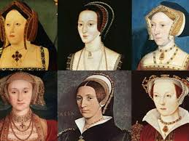
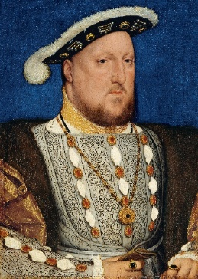

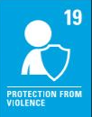
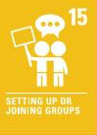
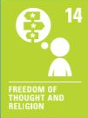

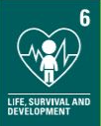
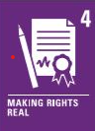
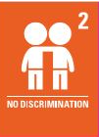
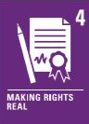
Supporting experience- Ordsall Hall
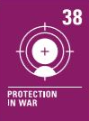
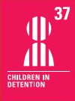
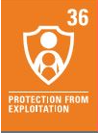
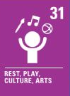
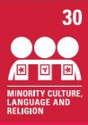
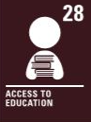
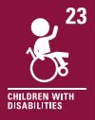
Key facts to retain:
- Henry VIII had six wives and three children
- He created the Church of England
- England’s main religion was dictated by the monarch
- Elizabeth 1 was the first queen of England
- England explored and took foreign land by force
- England had a famous, strong navy

What I should already know:
- England had been conquered by Romans, Normans, Vikings and Anglo-Saxons
- William the Conqueror ruled England in 1066 and his heirs since then
- English lords forced the signing of the Magna Carta
- Wales was constantly invaded by England in the Middle Ages
- Scotland was its own country and had its own King
- The United Kingdom didn’t exist
- The Pope led the Catholic church and influenced Kings and Queens across the world
- English Kings and Queens took part in the Crusades in the Middle East

