WALT 1: Evaluate the work of Hans Holbein
WALT 2: Accurately sketch eyes.
WALT 3: Accurately sketch ears.
WALT 4: Accurately sketch noses and mouths.
WALT 5: Accurately sketch a portrait.
WALT 6: Recreate the work of Guiseppe Arcimboldo.
WALT 7: Create a portrait with a hidden message in the style of Guiseppe Arcmiboldo. Day in the life
WALT 8: Evaluation

Key Vocabulary
Portrait – an artwork that has been created about a person or persons (sometimes of animals) that tells us something about them.
Scale 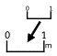 – the size of the parts of an object in relation to other parts.
Perspective 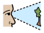 - what gives a three-dimensional feeling to a flat image such as a drawing or a painting.
Proportion 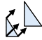 – how parts of the face compare to each other in relation to size, shape, colour.

Profile – the side view of a person or an object.
Shade 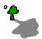 - to add depth to a sketch using a sketching pencil

Newall Green Primary School: Knowledge Organiser
Art: Portraits, Observational drawings and hidden meanings Term: Autumn 1 Date: September 2026
Focus: Portraits – Hans Holbein and Guiseppe Arcimboldo
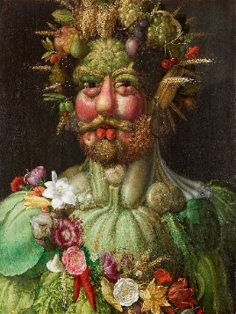
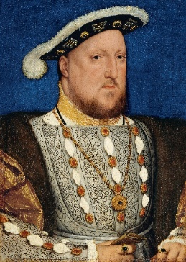

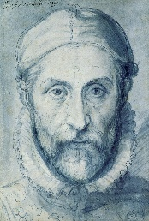
Portraits by Holbein and Arcimboldo

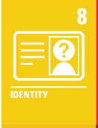
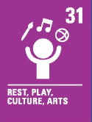
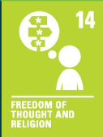
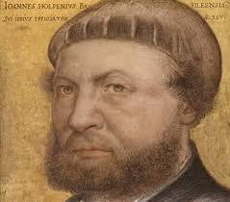
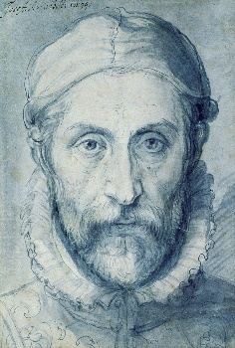
What I should already know:
- How to hold a pencil
- The name of some famous artists and their most famous art work
- The names of the primary and secondary colours
- The different tools and equipment to use to create different effects.
- The name of different types of medium (paint, charcoal, pastels etc)
- About proportions and facial features.
- Shading techniques.

Key facts to retain:
- Hans Holbein painted the portraits of the Tudor monarchs
- Guiseppe Arcimboldo created portraits of people using objects from their careers
- A realistic portrait should be in proportion
- How to accurately draw facial features.
- A self-portrait is a portrait of your own image

