Topic overview 2026-2027 Year group: 2
 |  | Autumn 1 | Autumn 2 | Spring 1 | Spring 2 | Summer 1 | Summer 2
Class novel | Class Novel  Must be read every day for 15 minutes  Monday & Friday GR focus | Fantastic Mr Fox  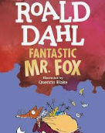 | Daisy and the trouble with coconuts  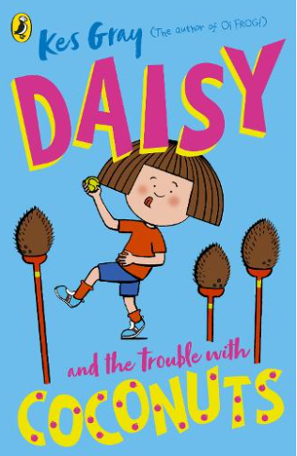 | The Mooncatcher’s Rescue  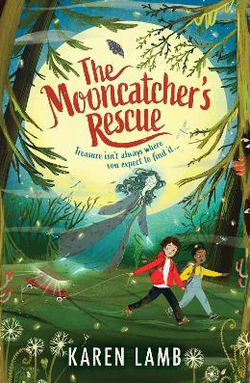 | Crazy Mayonnaisy Mum  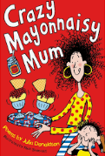 | Gangsta Granny  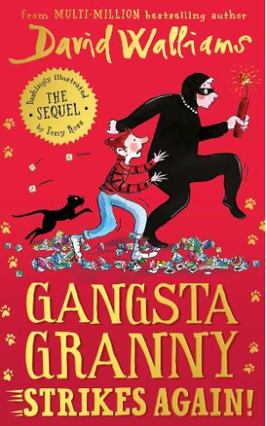 | Einstein the Penguin  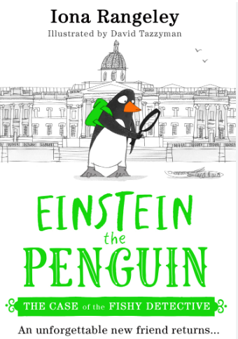
Class novel | Linked Reading Texts – Literacy shed +  From Aut1 – Those off RWI  From Summer 1 All Year 2 | Stage 1  Animals  Dinosaurs  Friendship  London  Underwater  Castles | Stage 1  Antarctica  Dragons  Food chains  The Royal Family  Transport  Looking after ourselves  Stage 2 - Christmas | Stage 2  Materials  Transport  Springtime  Explorers  Fairy tales – 5  Looking after ourselves | Stage 2  Oceans  Recycling  The Great Fire of London  Australia  Adventure stories  Product design | Stage 2  Growing plants  Activists  Habitats  Countries  Continents | Stage 2  Shakespeare  Towns and villages  Coasts  Fossils  Traditional tales
Teaching Writing | Key texts for literacy  (to teach the features or vocab for the genre) | Little Red  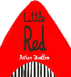  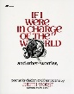  If I were in charge of the world  The lonely beast  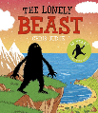 | The boy who loved maps  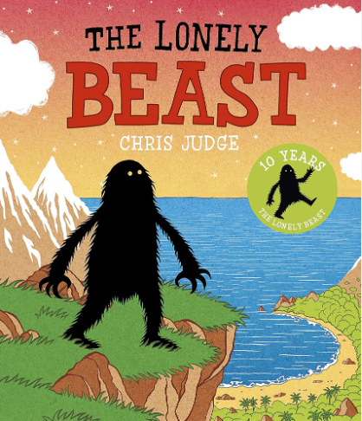  A world of food  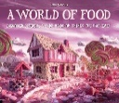  The Snowman  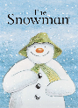 | Don’t let the pigeon drive the bus  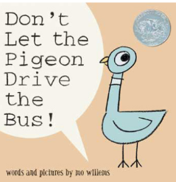  Daft Jack and the Beanstalk  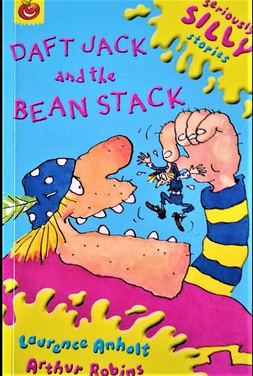 | The Bakers Boy and the Great Fire of London  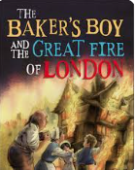  The Dragon Machine  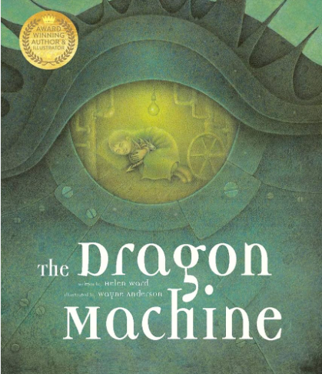  AeroZone Trip | My Two Grannies –  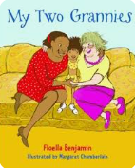  The Secret of Black Rock  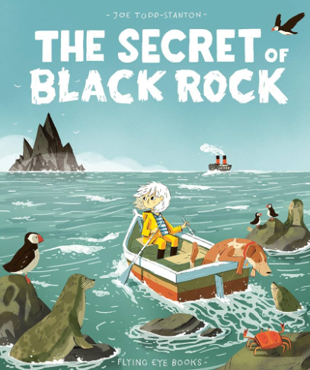  Mad Meals | Twisted Traditional Tale –The True Story of the 3 Little Pigs  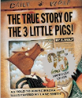  Plants  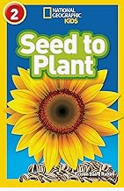  Katie goes to London  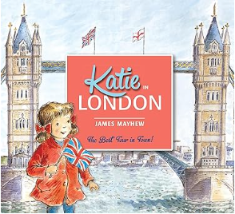
Teaching Writing | Text Outcomes | Little Red  – character description  If I were in charge of the world  – poetry recital  The Lonely Beast – non-chronological report. | The boy who loved maps – leaflet  A world of food -  Setting description and instructions  The Snowman -  Diary | Don’t let the pigeon drive the bus  Persuasive letter  Daft Jack and the Beanstalk  character description, Narrative retell | The Bakers Boy and the Great Fire of London  diary  The Dragon Machine  character description,  Narrative retell with character change  AeroZone Trip recount | My Two Grannies – character comparison  The Secret of Black Rock – diary of Erin  Mad Meals –  Nonsense poems | Twisted Traditional Tale –The Three Little Pigs  Retell with character change  Oceans – non-chronological report
 | Oracy/Poetry  Add one other opportunity | The Owl and the Pussycat – poetry | Discussing the trip. |  |  | Mad Meals - poem
 | Rights Respecting Gold evidence |  | Letter to MP- Example left in as example |  | Climate change – letter to parents.  Campaign speeches
 | Trips/Visitors |  | Mosque | AeroZone - airport | Michelle Leigh Artist | RHS Bridgewater
 | Celebrations/ festivals/  special events | National poetry day  Black history month | Harvest Festival  Diwali  Christmas  Remembrance Day | 1950s/1960s Day  Children’s mental health week  Embrace yourself day  Shrove Tuesday | World book day  Science week  Easter | Walk to School Week  Eid | Sports day  End of year parties
 | Parents/ carers involvement | Parents’ Evening  Black History Month Gallery | Class Assembly  Christmas target setting morning |  | Easter target setting morning  Parents Evening | Sports Day | Showcase Assembly  End of Year Reports
 | Maths | Place value  Addition and subtraction | Addition and subtraction  Shape | Money  Multiplication and Division | Length and Height  Mass, capacity and temperature | Fractions  Time  Statistics | Position and Direction  Consolidation
 | Science | Living in habitats | Growth and survival | Exploring everyday materials | Super sciences | Plants – growing | Super sciences
 | History | Royal Family |  | Transport – 1920’s  Aviators |  | 1950’s/1960’s
 |  | Articles: 8, 9, 14, 16, 31 |  | Articles: 7, 14, 31 |  | Articles: 9, 14, 27, 31
 | Geography |  | Autumn – Map Makers |  | Spring  Life in London |  | Summer  Tanzania
 |  |  | Articles: 2, 3, 14, 19, 28, 31 |  | Articles: 6, 7, 8, 24, 26, 27, 30 and 31. Articles: 6, 14, 24, 27, 31 |  | Articles:14, 26, 31
 | RE/Peace Mala | 1.2 Who is a Muslim and what do they believe? | 1.4: What can we learn from sacred books? | 1.3: Who is Jewish and what do they believe? | 1.6: How and why do we celebrate special and sacred times? (Part 2) | 1.8 How should we care for others and the world, and why does it matter? | Tribal and Native
 | PSHE/Dimensions | Healthy lifestyles | Healthy lifestyles | Mental and emotional health | Keeping safe | Relationships education | Living in the wider world
 | PE | Dance  Net and wall games skills | Target games  Gymnastics | Fundamental Movement  Invasion games | Gymnastics  Personal challenges | Dance  Striking and Field games | Yoga  Striking and Field games
 | Music | Pulse, Rhythm and Pitch | Playing in an orchestra | Inventing a musical story | Recognising different sounds | Exploring improvisation | Our big Concert
 | Computing | Creating Pictures  Making Music | Spreadsheets | Route Explorers  Questioning | Coding | Presenting Ideas
 | Art | Autumn Nature’s Sculptures  Andy Goldsworthy |  | The work of designers in creating transport that uses shape and form.  (in preparation for DT vehicles) | Perspective: foreground, background, getting smaller into the distance – Laurence Stephen Lowry | Compare Islamic / African pattern and use potato printing to recreate | Visual imagery in posters including fonts and slogans
 | DT |  | Puppets |  | Moving Vehicles |  | Pizza design

