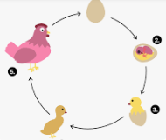
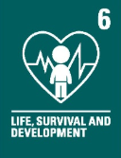
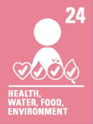
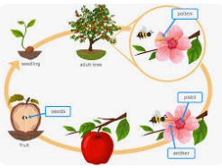
What I should already know:
Plants, animals and humans are alive and breathe
What plants and flowers need to grow and survive
That there are different species of plants, flowers and animals
The different habitats plants, flowers and animals live and survive.
Key facts to retain:
- Asexual reproduction involves one parent plant
- New plants are usually genetically identical to the parent plant (clones)
- Some animals undergo metamorphosis
- Fertilisation can be: Internal- Inside the female or external outside the body, often in water
- Animals have different life cycles
- Different animals provide different amounts of parental care
- Mammals generally give birth to live young
CVV
CVV
CVV
CVV
WALT 1: Describe the process of sexual reproduction in plants
Absent Intervention
WALT 2: Describe the process of asexual reproduction in plants
Absent Intervention
WALT 3: Describe the process of sexual reproduction in animals DITL
Absent Intervention
WALT 4: Compare the life cycles of animals in the local area and around the world
Absent Intervention
WALT 5: Compare how different animals reproduce and grow
Absent Intervention
WALT 6: Research the job of naturalists and the work they do DITL
Absent Intervention
END OF UNIT QUIZ
Absent Intervention

CVV
CVV
CVV
CVV
CVV
CVV
Focus: Reproduction in plants, animals and humans including sexual and asexual
Key vocabulary:
Pollination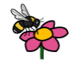- the ecological process where pollen grains are transferred from the male part of a flower (the anther) to the female part (the stigma).
Metamorphosis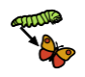 – dramatic change that some animals go through as they grow from a baby into an adult
Alternative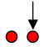– Perspectives, ideas and opinions that are different
Reproduction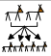 - the production of offspring by a sexual or asexual process
Asexual – reproduction without sexual activity.
Life cycle 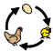 - the series of changes in the life of an organism
Naturalist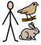 – an expert of natural history.
Male - the sex of an organism that produces sperm or pollen
Female - the sex that can bear offspring or produce eggs
Offspring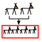- the immediate descendants or young produced by one or more parent organisms through reproduction

CVV
Newall Green Primary School: Knowledge Organiser
Science: Life Cycles – Humans, Animals and Plants Term: Autumn 1 Year group: 5 Date: Sept 2026

