Key vocabulary:
God – The creator and ruler of the universe and source of all moral authority; the supreme being
Belief - An acceptance that something exists or is true, especially one without proof
Opinion – A belief based on experience and on certain facts but not amounting to sure knowledge
Evidence - Suggests serving as proof of the actuality or existence of something
Fact – A thing that is known or proved to be true
Existence – The state of being real, or of being known or recognized
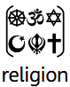Religion - a personal set or institutionalized system of religious attitudes, beliefs, and practices
Theism – Belief in the existence of a god or gods, specifically of a creator who intervenes in the universe
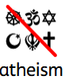Atheism – disbelief or lack of belief in the existence of God or gods
 Agnosticism - A person who holds the view that any ultimate reality (such as God) is unknown and probably unknowable
 Alternative – Perspectives which differ from those which are ‘conventionally’ understood

Focus:
Why do some people believe God exists?
Strand: Believing

Key facts to retain:
- People have different beliefs, and these should be respected.
- Christians believe God is Creator.
- Christians use the Bible to learn about God.
- Not all Christians interpret the Bible in the same way.
- Science and faith can both help people understand the world.
- People may reach different conclusions using the same evidence.
- Asking questions and listening respectfully are important parts of Religious Education.
Newall Green Primary School: Knowledge Organiser
Religion: Christians, non-religious e.g. Humanist
Term: Autumn 1
Year group: 5 Date: September 2026

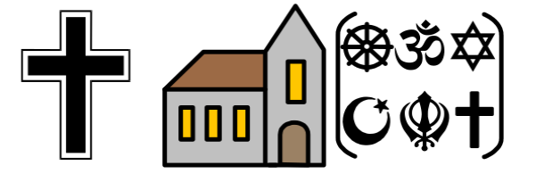
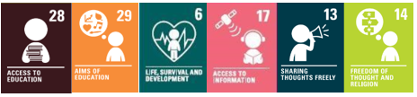

What I should already know:
- There is more than one version of ‘truth’
- Not every member of a faith or religion is going to believe in the exact same principles
- Everyone’s version of reality and life after death differs
- There are different perspectives on how the world began and this depends on evidence, belief, opinion, and fact
- Sacred texts range from the Bible, Quran, Torah, Veda, and The Guru Granth Sahib.
- These texts are interpreted to bring meaning to reality
- Some Hindus often lead a vegetarian diet as they believe that it would serve implications for the afterlife
- Zoroastrianism is one of the world's oldest monotheistic religions, having originated in ancient Persia.
WALT 1: investigate how many people believe in God around the world
WALT 2: understand what Christians believe God is like and explore why some people believe God exists.
WALT: 3 understand the difference between facts, beliefs and opinions and explore why people believe or do not believe in God.DITLF
WALT 4: understand what Christians believe about creation and explore how Christians may interpret the Genesis creation story in different ways.
WALT 5: explore different viewpoints about God's existence and explain my own ideas using evidence.
WALT 6: End of Unit Quiz

