NEW Topic overview 2026-2027 Year group: 5

 |  | Autumn 1 | Autumn 2 | Spring 1 | Spring 2 | Summer 1 |  | Summer 2
Fluency focus | Class Novel  Must be read every day for 15 minutes  Monday & Friday GR focus | I survived a Japanese Tsunami by Lauren Tarshis  Read Treason from week 3 | Treason by Bertie Doherty | Macbeth- Andrew Matthews Week 1  Romeo and Juliet- Andrew Matthews- share copies across corridor Week 2  Week 3- EOT Black Powder- Ally Sherrick Read during novel time at own pace | Holes by Louis Sachar | The Last Bear by Hannah Gold |  | The Last Bear by Hannah Gold  Finish  Black Powder by Ally Sherrick- as a reading for pleasure when last bear finished
Fluency focus | Linked Reading Texts – Literacy shed +  Tue, Wed, Thurs  (for fluency, one text may need to be read a number of times) | Letters  Living things  Japan  Carnival  Mountains  The Shang Dynasty | Ancient Egyptians  Volcanos  Rainforests  The Tudors  Frankenstein  Christmas | Aztecs  Materials  Sci-fi  William Shakespeare  Natural resources  Eco-Global warming | Space  The Solar System  Illness and medicine  Down the mines  Romani tales |  | Forces  Movies  weather  Cornwall  Animals | British mythology  Suffragettes  Magic and mystery  Crime and punishment  Migration  Traditional Greek myths  Titanic
Teaching Writing | Key stimuli for literacy  (to teach the features or vocab for the genre) | I survived a Japanese Tsunami  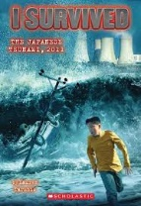  The Flood  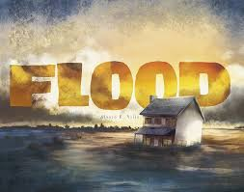 | Rembrance  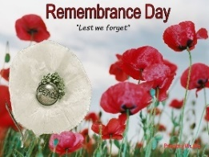  Treason  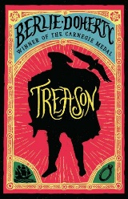 | Shakespeare  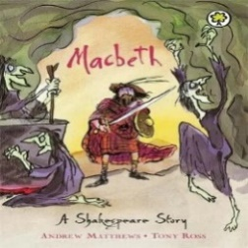 | Holes  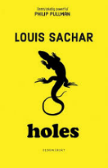 | The Last Bear  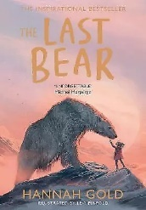 |  | The Last Bear
Teaching Writing | Text Outcomes | I survived a Japanese Tsunami  - Explanation text (tsunami)  - News oracy report-Report on a flood  The Flood  - Narrative (f full narrative based on a flood using the stimulus of the picture book.) | Remembrance poetry  See below  Treason  - Recount-Diary entry in the role as main character  - Narrative (write their own adventure story set in Tudor times based on Treason) | Stories from Shakespeare  - Poetry- see below  Additional setting description using ideas from the poem  - Recount – to write a diary entry in role as a character from Macbeth.)  Additional diary entry based on a different character  Play script – To write a play script inspired by William Shakespeare | Holes  - Informal letter (to mum about first day at camp)  - Narrative based around Holes | The Last Bear  - Non-chronological report – on an endangered animal of their choice.  - Narrative – To write a narrative based around their endangered animal.  - Separate setting and animal descriptions |  | The Last Bear  - Persuasive campaign poster/leaflet – raise awareness of the impact on climate change.  - Formal letter- write a formal letter to campaign for endangered animals  - News report- Report on endangered animals
 | Oracy | Ask relevant questions to extend their understanding and knowledge using games such as ‘The Question Game’ - pupils decide on a topic, one pupil asks an open-ended question, and the other pupil responds with a related open-ended question e.g. A. Why is there a light on? B. Where does light come from | Articulate and justify answers, arguments and opinions  Debate a point- e.g. why a character in the book did the right thing? | Participate in discussions, presentations, performances, role play/improvisations & debates  Speak audibly and fluently with an increasing command of Standard English  Sonnets- Romeo and Juliet | Use relevant strategies to build their vocabulary- Use a range of words related to time and measure.  Consider and evaluate different viewpoints, attending to and building on the contributions of others. | Maintain attention and participate actively in collaborative conversations, staying on topic and initiating and responding to comments. |  | Give well-structured descriptions, explanations and narratives for different purposes, including for expressing feelings  News report (from an event in the book)
 | Poetry |  | Remembrance  Emotive, performance poetry | To write an imagery poem inspired by Macbeth.- The Witches/Heath
 | Rights Respecting Gold evidence | Black history focus | Remembrance poetry |  |  |  |  | Climate change
 | Trips/Visitors | Ordsall Hall – Tudors |  | Manchester Cathedral (Lent) | Beeston Castle – Geography (self-led) | River Trip - Geography (Venture Out)
 | Celebrations/ festivals/  special events | Black History Month  National Poetry Day | Anti-bullying  Harvest Festival  Christmas  Remembrance Day  Diwali | Children’s mental health week  Shrove Tuesday | World book day  Science week?  Easter | Walk to School Week  Eid  Sports Day |  | End of year parties
 | Parents/ carers involvement | Parents’ Evening  Welcome presentation to parents | Class Assembly  Arts and Crafts (Christmas) Parent morning |  | Parents' Evening  Target setting morning (Easter)  Class Assembly |  |  | Celebration Assembly  End of Year Reports  Sports Day
 | Maths | Number: Place Value  Number: Addition and Subtraction | Number: Multiplication and Division A  Number: Fractions | Number: Multiplication and Division B  Number: Fractions B | Number: Decimals and Percentages  Measurement: Perimeter and Area  Statistics | Geometry: Shape  Geometry: Position and Direction |  | Number: Decimals  Number: Negative numbers  Measurement: Converting units  Measurement: Volume
 | Science | Life Cycles | Changes and Reproduction | Properties and changes of Materials | Earth and Space | Forces in Action |  | Forces in Action
 | History | Tudors  Articles: 2, 4, 6, 13, 14, 15, 19, 28, 30, 31, 36, 37 and 38 |  | Aztecs  Article 4, 6, 13, 14, 19, 27, 28, 38 |  |  |  | Stuarts  Article 2, 4, 6, 13, 14, 22, 19, 11, 30, 35, 38
 | Geography |  | Cities in the UK |  | Maps and Beeston Castle | Rivers
 | RE/Peace Mala | Why do some people believe God exists?  Link- Zoroastrianism | What does it mean to be a Muslim in Britain today?  Link- Zoroastrianism | If God is everywhere, why go to a place of worship?  Link- Zoroastrianism | Can we live by the values of Jesus in the twenty-first century?  Link- Zoroastrianism | Green religion? How and why should religion communities do more to care for the Earth?  Link- Zoroastrianism
 | PSHE/Dimensions | Keeping safe | Relationships and sex education | Mental and emotional health | Healthy Lifestyles | Living in the wider world
 | PE | Basketball  Cricket | Football  Dodgeball | Invasion Games  Netball | Invasion Games  Fitness | Athletics  Tennis |  | Cricket  Rounders
 | Music | Melody and harmony in music | Sing and play in different styles | Composing and chords | Enjoying musical styles | Freedom to improvise |  | Battle of the bands
 | ICT | Systems and searching | Creating media- videos | Programming A- selection in physical computing | Data and information | Creating media- vector graphics |  | Programming B- selection quizzes
 | Art | Self-portraits – accurate drawings Holbein | Self-portraits and hidden messages - Arcimboldo | Self-portraits – Frida Kahlo | Block printing -William Morris | Painting movement - Flemish Art |  | Still life – Louise Moillon
 | DT |  | Building Bridges (Thomas Pritchard) |  | Textiles (Stephanie Kwolek) |  |  | Chinese Inventions (Cai Lun)
 | French | Monster Pets | Shopping in France | French speaking world | The Solar System | Verbs |  | French family

